MANIFESTO

SOUTH SUDAN DEMOCRATIC MOVEMENT
&
SOUTH SUDAN DEFENCE ARMY (SSDM/SSDA)

Motto: SSDM/A up, up, up, SSDM/A up, up, up, SSDM/A up, up, up

Vision: build a democratic multiparty system which guarantee freedoms & human rights

Contents:

Chapter one
- Mission Statement.
- The Preamble.
- The Historical background.

Chapter two
- The Objectives.
2 - The Methods and Mechanism.

Chapter three
- The Membership.
- The Leadership.

Chapter four
- Sources of Finance.
- Programs and Projects.

Chapter five

- Basic Principles of the Movement.
- Guiding Principles
- Regulations and Orders.

Chapter six
- Amendments.
- Conclusion

Chapter seven

- Glossary.
- The South Sudan maps.

1:0 Chapter one:

1:1 Mission Statement:

To build and consolidate independent institutions which shall safe guards the rule of law, freedoms, and equity.

1:2 Preambles:

The people of the south have experience awful years in the Sudanese new history, and in order to establish a perfect state, justice, insure domestic tranquility, promote the general welfare, and secure liberty, do here ordain and establish this manifesto for liberating the marginalize communities and build a democratic south Sudan.

1:3 THE HISTORICAL ROOTS OF THE PROBLEM OF SUDAN:

The Turco-Egyptian conquest of 1821 marked the end of the early indigenous states and kingdoms in northern Sudan. It defeated the Funj Sultanate gradually penetrating the South, Centre and West in search of wealth and men (slaves); the two requirements which necessitated the conquest in the first place. Thus, the interest of the new regime was intertwined with that of the local and incoming traders and merchants who became its agents and middlemen in the market through which it strived to achieve its objectives. This is how hundreds of thousands of slaves were captured from Southern, Central and Western Sudan and carried away to the north, Egypt and beyond. The Turco-Egyptian rule did not go unchallenged. In the South it was resisted by the Dinka-Abilang and the Chollo, the tribes neighboring the north. In the North, it fought a number of battles with the local population such as Korti, Shendi and el-Musabaat in Kordofan.

When the economic burden of the Turkish Colonial rule became unbearable, the Mahdist revolution was waged. Although it managed to overthrow a colonial regime, the Mahdiyya, as the system was known, established an Islamic state and ruled with an iron fist alienating in the process many sections of the northern community. The Mahdiyya did not penetrate much into the South and where it did it was met with stiff resistance as was the case in Chollo land, Azande and many parts of the South.

The Anglo-Egyptian condominium did not fare any better. The Condominium spent most of its years in the South in pacification campaigns, known as “patrols” exemplified by the military punitive actions against the Nuer and Dinka revolts. In fact, the colonial policies sowed the seeds of the armed conflict in Sudan, by first following a policy of separate development for Southern Sudan which it suddenly reversed in favor of a united Sudan under pressure from external and northern forces just after the Second World War. The Juba Conference in 1947 was convened by the colonial authorities to announce this new policy to the Southerners.

At the threshold of independence, therefore, the Sudan emerged as an entity characterized by ethnic, religious and cultural diversity. Also, the practice of slavery left a legacy of enormous bitterness, suspicion and mistrust of the North by the South. The colonial policy by necessity created uneven development in the Sudan in all spheres of life especially Economic and educational. When at independence the administration of the country was handed over to the Northerners to the exclusion of others, the Southerners saw this as a mere change of masters.

The group that assumed the reins of power since independence insisted to perceive Sudan not in the way it really is but instead proceeded to run its political, cultural and economic affairs on a monolithic basis. A direct result of this behavior was that the identity of Sudan was reduced to mono-culture, the Arab-Islamic culture, marginalizing and sidelining the African dimension and the cultural heritage deep rooted in our history with its diverse cultures as a main and important component of the national Sudanese identity. Having taken over the state and economic power, the Khartoum rulers swiftly moved to use brutal force to suppress any voices of dissent from neglected and marginalized nationalities. All these culminated in the Torit Uprising on 18 August 1955, a fierce war that raged for seventeen years.

The central problem of the Sudan, therefore, was that the post-1956 Sudanese state was an artificial state, based on a political system and an institutional framework of ethnic and religious chauvinism, and additionally after 1989 on Islamic fundamentalism. It is a state that excluded the vast majority of its citizens. The African Sudanese have been excluded from the centre of power and wealth since 1956, and after 1989 NIF coup, the system further excluded sectarian northern Muslims that had hitherto ruled Sudan, while women have always extremely been excluded at all times.

1:4 THE ORIGIN OF THE LIBERATION MOVEMENTS IN SOUTH SUDAN:

The political dissatisfaction of the backward areas in the Sudan was a direct product of the phenomenon of African independence following the Second World War. This independence was predicated on the results of the policy of divide and rule which pitted some parts of the present Northern Sudan against the rest of the country in terms of colonial peripheral development, which trend was accentuated and aggravated by the regimes that came and went in Khartoum.

The South demanded a rectification of the imbalance and absence of equity and its politicians organized themselves in the early 1950s into political parties, such as the Liberal Party, that called for a federal system of governance in Sudan. This political demand was contemptuously dismissed by Khartoum, and its proponents persecuted, hence the resort to armed struggle. The early sixties saw the Southern politicians and youths joining the armed struggle in the southern bushes and the countries neighboring the South.

The reasons for the celebrated Torit Revolution and the subsequent formation of the Anya-nya armed Movement are traceable to the political development of the South during the colonial period, non-representation of the South in the independence talks in Cairo in 1953, broken promises on giving it a special political status within a united Sudan and lack of effective and equitable participation in the pre-independence national government (1954-1956). The report of the Sudanization Committee in 1955 and the disarming of the Equatorial Corps were the straw that broke the camel’s back and precipitated the revolt in Torit.

The repressive policies undertaken by the Khartoum government after the army takeover in 1958 fuelled the revolt and swelled the ranks of the Southern armed struggle led by the Anya-nya. The Anya-nya felt that the Southern grievances could only be addressed by creating a separate and an independent state in Southern Sudan. This position was arrived at out of their conviction that the intransigence of the ruling clique in Khartoum precluded any genuine unity based on justice and equality.

The first genuine attempt at reconciling differences between the North and the South was made in 1965 Round Table Conference (RTC) attended by all political parties in the North and South. The conference almost succeeded was it not that the Northern political parties which stood as one block, rejected the key demands of the South: that the South be treated as one entity, that the head of the Southern government be elected by the Southerners and that the Government in the South have control over the army there. This stubborn position left the Southerners in no doubt that the North is bent on continuing with its policies of hegemony and exclusion of others in running the affairs of Sudan. Clearly, a more repressive master has replaced the colonialists.

The May regime of Dictator Jaafer Mohammed Nimeiri issued the 9th of June declaration, within days from its assumption of power in 1969, as a blue print for the resolution of the conflict in Southern Sudan. But, the declaration made the solution conditional on the emergence of a democratic (read, communist) cadre in the South that would run the affairs there. Naturally, the declaration did not find support among the Southern politicians and died a natural death with the demise of the communist-led coup of July 1971. Thereafter, through the prompting and mediation of international bodies, especially the churches, the regime held peace talks with the Anya-nya and its political wing, the South Sudan Liberation Movement (SSLM) that culminated in the conclusion in February 1972 of the Addis Ababa Agreement. The government delegation in the talks conceded to the South the key issues that caused the failure of the Round Table Conference. Later developments were to prove that Nimeiri was not genuine in this peacemaking. The Addis Ababa Agreement was just one ring in the chain of Nimeiri’s survival politics and he disposed of the Agreement when it had served his purpose.

1:5 THE UNMAKING OF THE ADDIS ABABA AGREEMENT:

The regime of Nimeiri quickly moved to dismantle the Addis Ababa Agreement soon as it came into force. Politically, the ruling clique in Khartoum initiated policies designed to undermine the AAA. These policies include: interference in the election of the leadership of the Southern region, construction of the Jonglei canal, capricious and unconstitutional dissolutions of the Southern People’s Regional Assemblies, attempts to redraw the South-North boundary, the decision to build the refinery for oil discovered in the South outside it, deliberate neglect of socio-economic development of the South, integration of Sudan with Egypt, and division of the South into three regions and the cancellation of the South High Executive Council (HEC) in order to weaken the South through divide-and-rule tactics. In pursuing these destructive policies, the regime exploited all through the differences between the Southern politicians in Juba.

On the military side, the regime set in motion policies to dismantle the AAA. These policies included: summary dismissal of some 32,000 ex-Anya-nya guerrillas who were absorbed in 1972 into civil jobs, attempts to complete the integration of the 6,000 absorbed Anya-nya guerrillas into the rest of the Sudanese Army within the Southern Command before the period stipulated in the AAA expired and transfer to the North of the battalions composed of the former Anya-nya.

The above attempts by the repressive minority cliques in Khartoum were met with fierce resistance in the South leading to the Akobo mutiny (1975). Elements of this mutiny combined with some of the dismissed ex-Anya-nya and formed what became known as Anya-nya 2 in Upper Nile. Later on, and mainly in 1982, armed resistance, under the same name but not the same command, sprang up in Bahr el Ghazal. At the same time, prominent absorbed Anya-nya officers continued to organize within the Sudanese army in order to transform the situation and wage a protracted armed struggle. Khartoum seized the initiative and attacked Bor and Pibor garrisons on 16 May 1983, and later, on 6 June 1983, the Ayod garrison attacked Khartoum forces that were sent to arrest its ex-Anya-nya commander. This was the spark that lighted the tinderbox.

By the early 1980s, the confrontation between the South and North was looming. Prominent Southern politicians and students organized several underground organizations to mobilize the masses against the attempts at dismantling the agreement. These opposition bodies include: National Action Movement (NAM), Movement for Total Liberation of Southern Sudan (MTLSS), Juwama African People’s Organization (JAPO), Council for the Unity of Southern Sudan (CUSS) and South Sudan Liberation Movement (SSLM) which actually started a guerrilla warfare in 1982, under the command of Lokurnyang Lado, and came in the limelight in July 1983 when it seized a number of foreigners in Boma post.

1:6 FORMATION AND OBJECTIVES OF THE SPLM/A:

By early 1983 the objective and subjective conditions had combined for a revolutionary situation. The battles of Bor (commanded by Major Kerubino Kwanyin Bol), Pibor (commanded by Captain Riek Macuoc) and Ayod (commanded by Major William Nyuon Bany) caused desertions in other units of the Southern command and in Northern Sudan, drove students and other civilians en masse to join the armed struggle and resulted in the exodus of refugees into the neighboring countries, especially Ethiopia.

Elements of the political and military organizations and officers referred to earlier that opposed the regime in its machinations and the dismantling of the AAA converged and established the Sudan People’s Liberation Army (SPLA) and the Sudan People’s Liberation Movement (SPLM).

Although the SPLM emerged in continuation of the struggle waged earlier by the SSLM/Anya-nya and other Sudanese patriotic movements, the Movement saw the resolution of Sudan’s crisis differently from the way the SSLM/Anya-nya did. The Movement believed that Sudan’s salvation lies in the solution of both the nationality and religious questions within the context of a united, socialist Sudan. Thus, although the SPLM started by necessity in the South, it aimed at spreading its message and seeking support from all over the country.

The SPLM/SPLA was rocked from the very beginning by differences over the leadership of the new Movement. This led to a damaging split that caused infighting with the Anya-nya-2 for five years. Thousands of Southern lives were lost in this fratricide and the split was exploited by the common enemy to his advantage. The agreement between the SPLA and A-2 in January 1988 did not only bring the infighting to an end, but it, as well, unified the ranks of Southerners with immediate positive results in the battlefield.
The SPLA scored magnificent victories in the field of combat and by the late 1980s the SPLA had liberated most of Southern Sudan. However, these military successes were not matched by a strong political organization that would turn them into political gains. The only leadership body of the Movement, the SPLM Political-Military High Command, and (SPLM-PMHC) has never met since its expansion in 1986, while there were many burning issues that needed the collective decisions of the Movement’s leadership.

1:7 THE RIGHT OF SELF-DETERMINATION:

The absence of leadership meetings caused a split in the SPLM/A in August 1991.The Nasir Declaration called for democratization within the Movement, respect of human rights, establishment of civil administration in the liberated areas and, above all, the right to self-determination for the people of South Sudan. The negative side of the split is that it led to inter-fighting between the two factions of the Movement with loss of many innocent lives. The most positive aspect of it was that the Nasir Move brought the principle of Self-determination firmly back into the Sudanese political discourse. Since then, the right to self-determination for the people of South Sudan dominated the agenda of Sudanese parties both in Government and in opposition. The Government of Sudan signed the Frankfurt Agreement in 1992 with the SPLM-Nasir, that conceded the right of Self-determination to the people of South Sudan. It was followed by the SPLM-Torit recognition of that right in Washington in 1993, Umma Party in Chukudum in 1994 and the opposition National Democratic Alliance ( N.D.A ) in Asmara in 1995. Thus, all the political parties in Sudan recognized the right to Self-determination for the people of south Sudan.

The Khartoum Peace Agreement in April 1997 and the Fashoda Peace Agreement in September of the same year were the practical fulfilment of the Frankfurt Agreement of five years earlier. As a result of these agreements the Constitution of the Republic of Sudan 1998 provided for the Self-determination to the people of South Sudan to be exercised through an internationally supervised referendum. It is these documents that twisted the arm of the Government of Sudan to sign the Machakos Protocol in July 2002, which was the basis of the Comprehensive Peace Agreement (CPA) between the Government of Sudan and the SPLM/SPLA.

By the turn of the millennium two factors helped narrow the gap between the SPLM/A factions that eventually culminated by 2003 in the reunification of all of them. First, the SPLM had adopted the positions put forward in the Nasir Declaration as above, especially after the Chukudum Convention in 1994. Second, the regime in Khartoum had shown that it did not intend to carry out the referendum stipulated in the Khartoum and Fashoda Peace Agreements. It is this unity that paved the way for the conclusion of the CPA in January 2005.

The CPA was a turning point in Sudan’s history. It set in motion the democratic transformation in the whole country and, for the South; it reaffirmed the right to Self-determination to be exercised through an internationally supervised referendum. The CPA was based on the partnership between the National Congress party (NCP) and the SPLM, which in practice meant the marginalization of the other political forces on key issues in the implementation of the agreement. Hence, when the partners were at odds with each other, as was the case in the most part of the interim period, it was non-Sudanese parties that were called upon to mediate between them. All the same, the implementation of the CPA rumbled on and the referendum was carried out in January 2011, with an overwhelming majority favouring the secession of the South.

1:8 THE MISMANGEMENT OF THE SOUTH BY THE SPLM:

The CPA provided a Government of Southern Sudan (GOSS) that is virtually run by the SPLM (its share was 70%) and enjoyed full independence, financially, politically and security-wise all through the interim period. Hence, the SPLM was expected to implement its vision of the New Sudan in the South. Since its formation in 2005 up to December 2010, the GOSS has received more than 20 billion US dollars in oil revenues and, yet, it has nothing to show for it in terms of provision of services, let alone development. These resources were eaten up by rampant corruption with money going into the pockets of a few individuals through nepotism and favoritisms. At the same time government employees and the SPLA soldiers go without salaries for months. To ensure complete lack of accountability, the accounts of GOSS have never ever been audited since its formation in 2005.

The GOSS has miserably failed in meeting the basic function of any government; provision of personal and collective security for its citizens. Inter and intra tribal conflicts became the order of the day in Southern Sudan and a lot of lives and properties have been lost as a result of these conflicts.

The GOSS has no plan of any kind for any length of time and the SPLM-dominated Southern Sudan Legislative Assembly which should have acted as a watchdog on the Government has been turned into a rubber-stamp. Statements of the President of GOSS before the Assembly for all the interim period never spell out any government programs as would be expected in any Parliament worth the name. Furthermore, this Assembly is the first of its kind to introduce the practice of approving Government over-expenditure and call it a supplementary budget!

There is no space for political freedoms in Southern Sudan. The SPLM leaders, who shout loudest about political freedoms and democratic transformation in Northern Sudan, do not allow other political parties; even their colleagues in the party disagree with them, freedom to operate in Southern Sudan. This behavior is shameful for a party that is in the forefront of the call for democratic transformation. To add insult to injury, the clique imposed a sub-culture of political blackmail all over the South. Any person who is critical of the mismanagement of affairs in the South is labeled either as “bought by the Jallaba” or “an agent of the NCP”!! This language of blackmail frightened some people but could not frighten everybody.

People in Southern Sudan are frustrated by the Government’s lack of direction. They need a government that can liberate them from poverty, corruption, tribalism, insecurity and deliver them out of the present economic crisis. Above all, they yearned for a government that could have united them to face the challenges ahead.

The majority of Southerners who thought they would have changed the corrupt and inefficient Government in Juba through elections were in for a big disappointment. When the general elections were held in April 2010, the SPLM and the NCP conspired to rig the elections in the South to return the SPLM. Having got the green light from its partner in the CPA, the SPLM went into an elections rigging spree using the SPLA and the other security organs. This act more than any turned the disappointment into fury with some people taking up arms against the Government of Southern Sudan.

The armed groups that rebelled against GOSS in the different parts of South Sudan have come together under a united organization to be known as the South Sudan Democratic Movement (SSDM) with its armed wing known as South Sudan Defence Army (SSDA).

Therefore, the SSDM emerged as a result of the dictatorship of the SPLM/A, marginalization of all the South Sudan political parties and civil society, failure to adopt a viable political road map which can galvanize and reward the Southern people for their victorious achievement of a just peace, the rampant corruption perpetrated by the SPLM-led government in Juba, neglect of the families of the martyrs in the war of liberation and the rigging of the people’s vote by the SPLM/A in the last elections.
The Movement seeks to replace the corrupt and inefficient clique regime in Juba by a transparent and accountable transitional government agreed upon by all the political forces in South Sudan. At the end of the interim period, general elections will be carried out all over South Sudan to elect a Constituent Assembly that will promulgate the permanent constitution of the Republic of South Sudan.

2:0 Chapter Two:

2:1 The Objectives:

The principal objectives of the South Sudan Democratic Movement & Army shall be the establishment of a free, just, democratic and decentralized system of governance and a social contract based on the free will and popular participation of all the people of South Sudan. This is preceded by other minor objectives, here below:

- To orient the life of people to plant patriotism and make the spirit of cooperation (unity), fraternity and love as the basic attachment among the citizens.
- To fight corruptions and crimes to maintain discipline for the peace of the society.
- To maintain the culture of cooperation within businesses in the society which adheres to criteria of equality and justice using machinery of tolerance and peaceful resolution of problems through negotiation and judiciary?
- To raise the values of patriotism and defend security by establishing military forces and to take care of militants of army who are alive or injured or martyrs' families and also to encourage individuals of the society to respond to the call of liberation and struggle at any time and any place.
- To intensify educational systems and to encourage the researches and scientific experiments and arts to develop the culture of the society and promote the Africa Sudanese traditions.
- To organize seminars, lectures, symposiums, and workshops for the militants, women, youth and students to accredit SSDM/A as the sole liberator for equality and freedoms.
- To ensure social security, spirit of peace and liberation are the fundamental principles of nation building without any segregations or discriminations on ethnicity, social-class, or race and religion.

2:2 The Methods and Mechanism:

The South Sudan Democratic Movement/Army explores all the peaceful mechanisms in its general activities and mobilization within the frame work of valid laws and respect of human dignity. These include:

- To interact, coordinate and cooperate with other politic organizations and the civil society on the common affairs of serving and liberation.
- Publicity and announcement through mobilization of communities, media advocacy, social functions, direct communications with people, conferences and rallies.
- To devise all possible methods to power either via democracy or defuse the oppressors and tyranny group on gun barrels and establish a transparent and accountable government in the south.
- To launch international cooperation with politic institutions in the sisterly and friendly countries for aids and participation in any regional and world conference.

3:0 Chapter Three:

3:1 The membership of SSDM/A:

Is accord to all south Sudanese communities, the peasants, sound minded intellectuals, students, the marginalize communities, neglected politicians, and security persons under the below criteria;

- Eligibility:
Any South Sudanese at 18 & above have the right to be a member of the movement/army.
- Collective affiliation:
A group agrees with the vision, objectives and principles of the struggle and liberation can either obtain membership or affiliation.
- Duties of members:
The members of the movement/army have to adhere and comply with the following conditions:
- To observe and comply with the mission of the movement/a.
- To achieve the vision and objectives of the movement and army in the communities.
- To support policies and projects of SSDM/A.
- To undergo military training to achieve vision, objectives and mission.
- To faithfully implement the duties and obligations of the movement/army in any department being assign to.
- To pay the dues subscriptions of the movement/army.

- Loss of membership:
The member losses his/her membership under the following criteria:
- Abandoning the principles or practicing an illegal activity which contrast the purpose of the SSDM/A and affiliate to another rivaling organization (spying), a decision of termination and accountability of membership will be issue.
- Resignation.
- Over age.
- Death.

3:2 Leadership Structures:
The movement is composing of both political and military wings.

- The political wing is categorize into the following councils:

- The Political-Military Commands Council (CUMP). Functions and duties shall be;
- To formulate policies and trends of action.
- To make decision and directives on any relevant situation.
- Prioritize and preside over the objectives and programs of the movement/army.
- To describe functions and duties of the HEC (general secretariats).
- The CUMP shall convene unordinary sessions in response of request of its member or a call from its chairman and C.in.C.
- The chairman and C.in.C of SSDM/A shall appoint the secretaries, chief of staff and deputies chief of staff.

- The Political-Military Commands Council (CUMP) is the founding fathers. Namely:

- The Chairman and Commander in Chief.
- The Deputy Chairman and C.in.C
- The Chief of Political Affairs.
- The Chief of Staff.
- The Chief of Security and Intelligent.
- The Chief of Logistic and Operations.
- The Chief of Civil Services.

2- High Executive Council (HEC):

- This is the second category of leadership in the movement; they plan to implement objectives and projects. These are:
- The secretary general.
- The secretary of organizations and political affairs.
- The secretary of information and communication.
- The secretary of foreign affairs.
- The secretary of finance and economic planning.
- The secretary of culture, youth and students affairs.
- The secretary of women and child welfare.
- The secretary of religious affairs.
- The secretary of training affairs.
- The secretary of public security and legal affairs.
- The secretary of military affairs.
- The secretary of security and intelligent.
- In a great victory, HEC shall be transform into a government secretariats

3- Executive Council (EC):
a- The Executive Council (EC), is none political indigenous organizations whose functions is to promote values of basic guiding principles in the nationwide. These are:

- The workers Union.
- The farmers Union.
- The traders Union.
- The south Sudan chiefs' council.
- The youth and students organizations.
- The women and child welfare organizations.
- The medical-staff organizations.
- The Diasporas and intellectual organizations.
- The graduates associations.

- The CUMP recommends supervising the EC.

b-The military wing:

It is a subordinate organ to the political corps, which shall implement political and military strategy. The army structure is as follows:

- General Commands Council (GCC).
- Chief of Staffs and Deputies.
- Areas Commanders.
- Brigades Commanders.
- Battalions Commanders.
- Companies Commanders.
- Platoons Commanders.

- Functions and Duties of the military wing are:

- To plan and implement military strategy of the movement.
- Oversee and supervise military operations.

- The Administration of the General Command Council is compose of;

- Commander in Chief.
- Deputy Commander in Chief.
- Chief of Staffs and Deputies.
- Commanders of specialize units.
- Areas Commanders.

4:0 Chapter four:

4:1 Sources of Finance:-

  - The movement emerged to address the poor management of the national resources and public affairs. Therefore, the movement depends on the following sources to finance its activities:

- Donations and benefactions from members and partisans.
- Subscriptions and contributions of members.

- Revenues of its economics, commercial and real estate investment.

- Revenue of its activities in services, printing companies, media, and information productions.

- Any other legal source accredit by the CUMP.

b- The movement shall obtain appropriate accounts for general auditing, accountability and transparency under the following criteria;

- Annual incomes and expenses
- Records of fix and portable assets
- Economical, commercial, and real estate records and accounts of investments own by the movement.
- The deposits in banks and treasuries of the movement.
- Or any other means for auditing and transparency.

4:2 Programs and Projects:

The movement/army is keen to ensure the underlying programs and projects are fully and thoroughly implemented;

- Aspiration for building a new national consciousness and common purpose.
- Development and consolidation of democracy in the south and SSDM/A in particular.
- Establishment of good system, accountable and transparent.
- Elimination of all sorts of corruptions and poor management.
- Establishment and consolidation of peace and security.
- Building and consolidating of culture of peace and negotiation at home and abroad.
- Establishment and consolidation of international cooperation
- To build and consolidate SSDM/A efforts to power via gun barrels and political settlements.
- Establish geo-politic and media advocacy at home/abroad with entrusted delegates.
- Establish centers for training of cadres in technical fields, security and intelligent units, military infantry force, heavy machine guns, and police force.
- Establish and consolidate efforts to safe guards cultural heritage and beliefs among the people regardless of its kind and practice.

5:0 Chapter five:

5:1 Basic Principle of the Movement (BPM):

The movement sets out the basic principles on which its vision on the different aspects of life is founded. These are broad guidelines that will be detailed in the movement’s implementation programmes.

- National Identity, Sovereignty and the System of Rule:

- Unity in diversity: South Sudan is a multi-ethnic, multi-religious and multi-cultural society. Therefore, there must be peaceful interaction of all the multiple components of the society.
- Every person has the right, in community with other members to enjoy their own culture, to profess and practise their own religion, or their own language.
- Respect of human rights, the supremacy of the rule of law and the independence of the Judiciary.
- Establishment of a democratic, secular and decentralized state in South Sudan.
- Adoption of a parliamentary system of government, and the separation of executive, legislative and judicial powers.
- The foreign policy shall serve the political and economic interests of South Sudanese people and be based on good neighbourliness, non-interference in the affairs of other countries, striving for a just international order, mutual cooperation among the peoples of the world and use of diplomacy to attract investment.

B - The Economy:

- The economic objective is to achieve a sustainable people-based development in the country, and the economic plans must be guided by the principle of self-reliance.
- The Central Bank must be independent from any direct administrative control of the Ministry of Finance, and it shall fully supervise the activities of the commercial banks and all institutions of the banking sector.
- Close cooperation between the public and the private sectors of the economy to attain national economic objectives.
- Agriculture is the mainstay of our economy and self-sustenance. Hence, priority shall be given to food self-sufficiency.
- Industrialization is mainly to be a complementary sector to agriculture, to process agricultural raw materials and intermediate products and the development of industries for agricultural equipment. In addition, the role of the industry includes the building of a basis for manufacturing and the development of national skills in the exportation of renewable energy.
- Transport and Communication: An efficient transport system and reliable communications networks are necessary for any meaningful development. It is, therefore, a priority to establish a reliable infrastructure in transport and communications.
- Preservation and protection of wildlife and the establishment of national parks for tourism.
- Land shall be categorized into state, community and privately owned.
- The protection of the environment.
- Promotion of rural and community development.
- The civil service is the backbone of the state machinery and must be founded on efficiency and justice, and should not be politicized.
- Combat corruption vigorously.

C - Youth, Women and the Child:

- Empowerment of women and the protection of the child.
- Development of the youth.

D - Basic Social Services and Housing:

- Provision of the highest possible standards of physical and mental health.
- Strive to provide clean water to every citizen.
- Provision of quality education.
- Provision of decent housing and accommodation to workers, government officials and other sectors of the community.

E - Access to Information and the Civil Society:

- Facilitation of access to information by the population.
- Create an enabling environment for the civil society to play its role in the establishment and maintenance of good governance.

F - Poverty Reduction and the Millennium Development Goals:

- Provision of the basic needs of the people. That is, to strive to attain the Millennium Development Goals MDGS.
- Control of migration to towns from the rural areas.
- Paying attention to projects that increase the income of the poor.

5:2 GUIDING PRINCIPLES:

The movement shall uphold and be guided by the following principles:

- Respect of cultural, religious, ethnic and political diversity in South Sudan and the realization of balanced and sustained development in the country.
- Peaceful rotation of power, promotion, protection and respect of human rights and fundamental freedoms as stipulated in the international and regional conventions and covenants.
- The citizenship is the only basis of rights and duties in South Sudan.
- Practice multi-party democracy, respect of democratic institutions, supremacy of the rule of law, separation of powers and independence of the judiciary.
- Justice, equity and equality among all citizens regardless of ethnic background, religion, gender or geographical origin.
- Promotion of self-reliance and economic self-sufficiency.
- Strive for the realization of the Millennium Development Goals before 2020.
- Institutionalism, transparency, good governance and promotion of the decentralized system of government.
- Protection and promotion of the diversity and the multicultural heritage and spiritual values.
- Protection and preservation of the environment and sustainable utilization of natural resources.
- Emancipation and social, economic and political empowerment of women
- Promotion of a foreign policy based on mutual political and economic interests with the countries of the world.

5:3 Regulations and Orders:

- The CUMP, MEOP and HEC shall observe and enforce this Manifesto.
- The CUMP and MEOP shall convince periodical meetings after every three months.
- The CUMP shall convene periodical meetings once every month or unordinary session in response of a request of its member or a call from the chairman and C.in.C.
- The CUMP shall accredit the General Secretariats according to the relative regulations.
- Both CUMP and MEOP approve and accredit quarterly plan, budget and accounts.
- The CUMP shall revise the performance of the General Secretariats as independents entities for recommendations and approval.
- The secretary general shall combine the secretariats work and make a unique single report.
- The secretary general shall keep the authentic properties of the movement / army.
- The composition of the political-military command council forum is the founding fathers, the general secretariats and the high executive council.
- The high executive council shall be observers in the political military commands council.
- The chairman and C.in.C of the movement/army shall chair the meetings of the political-military commands council and make decision thereafter.
- The movement/army shall establish military and civil courts, which shall be democratically independent to trail the penetrators.
- Accordingly, the movement/army shall establish an independents body which shall draws military and customary laws and terms of punishment.
- Functions, duties and regulations of specialize secretariats shall be describe by the CUMP.

6:0 Chapter six:

6:1 Amendment:

The appended articles in this Manifesto shall be amended on request or appeal of a member or a group of the leadership commands council. This request is approve or reject by 2/3 of the council and is endorse by the chairman and C.in.C.

6:2 CONCLUSIONS:

South Sudan has been a battlefield for many years. The hard won secession of the South was due to the tremendous sacrifices made by its people. Our people fought for these long years in order to run their affairs by themselves; they did not do so only to replace one ruler by another, but in order to set the country on the right path of socio-economic development through a clear vision and a well articulated programmed. Having correctly analyzed the objective reality of South Sudan, determined to build a multi-party system which guarantees freedoms and human rights, resolved to learn from the lessons of the past and enjoying the support of the masses of our people, the SSDM is confident to win.

7:0 Chapter Seven:

7:1 Glossary:

- AAA: Addis Ababa Peace Agreement was initiated & mediated by international & Christian peace loving people. Concluded in 1972 between the Anya nya movement and the government of Sudan.

- Akobo mutiny, 1975: Established the Anya nya two, abbreviated as A-2 & transformed in to SPLA/SPLM in 1983.

- BPM: Basic Principles of the Movement.

- Chukudum convention 1994, was a reaction of SPLM Torita-Faction to the Frankfurt Agreement 1992 led by SPLM Nasir-Faction & the Government of Sudan which recognized self determination for the people of south Sudan.

- Common enemy – The Arab Muslim North.

- CPA: the Comprehensive Peace Agreement, Jan. 2005, Nairobi-Kenya ended the longest civil war in Africa between the SPLM & GoS by conceding self determination for the people of south Sudan.

- CUMP: The Political – Military Commands Council.

- CUSS: Council for The Unity of South Sudan.

- EC: Executive Council.

- FA: Frankfurt Agreement, 1992, Nasir Faction & NIF.

- FPA: Fashoda Peace Agreement.

- GOSS: Government of South Sudan Provided by CPA establish in 2005.

- HEC: High Executive Council.

- Jallaba, the Arab & Muslim from Occupying the north & successor of the Anglo- Egyptian condominium.

- JAPO: Juwama African People’s Organization.

- Juba Conference, 1947.

- June, Declaration, a presidential degree issued on 09/06/1969 by Nimari & resolve the conflict in South Sudan.

- K.P.A: The Khartoum Peace Agreement.

- L.P: Liberal Party- early 50s a Southern Led Party calling for a federal System of government in Sudan.

- Machokas Protocol, July, 2002, signed Self Determination.

- Mahdiyya- a system of rule (Islamic State), over through, The TMC colonization.

- MDGs: Millennium Development Goals.

- MTLSS: Movement for Total Liberation of Southern Sudan.

- NAM: National Action Movement.

- NCP: National Congress Party, the ruling party in the North which sign the CPA with SPLM in 2005.

- ND: Nasir Declaration- calling for reform via democracy & Self- determination.

- NDA: National Democratic Alliance.

- NIF: National Islamic Fundamental.

- RTC: Round Table Conference, attempt reconciliation to address & unity differences of both North & South in 1965 but fail (in Vain).

- Salvation of Sudan- nationality & religion in a united Socialist Sudan SPLM vision.

- SPLA: The Sudan People’s Liberation Army.

- SPLM: The Sudan People’s Liberation Movement.

- SPM: Sudanese Patriotic Movement.

- SPLM-PMHC: The SPLM- Political- Military High Commands.

- SSDA: South Sudan Defence Army.

- SSDM: The South Sudan Democratic Movement.

- Torit oprising 8/1955, Mark the first gurrile Movement before the independent in Jan.1956.

- UMMA: The Umma Party.
- Washington 1993, SPLM- Torit faction recognize the Frankfurt Accord.

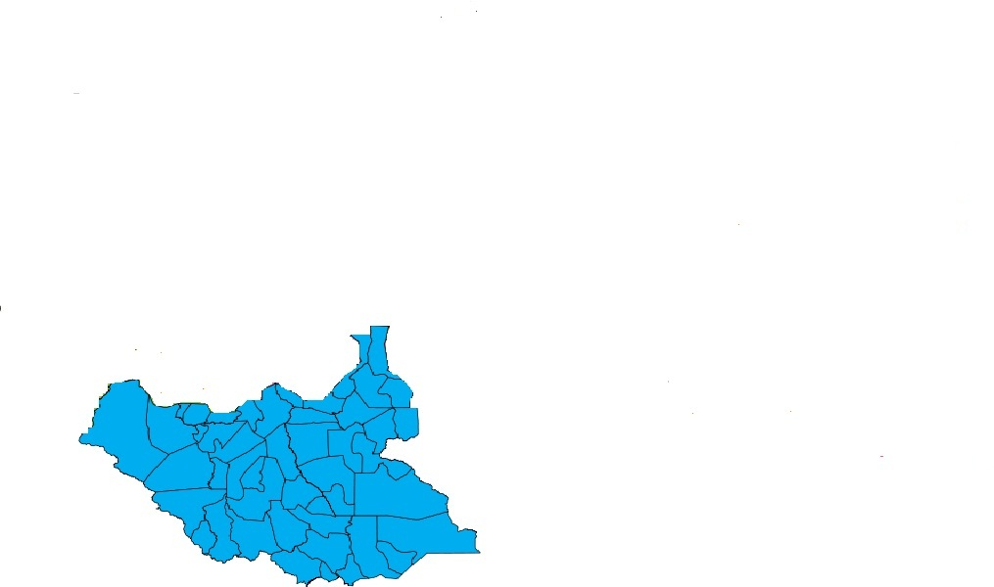
7:2 The South Sudan Map:

THE SOUTH SUDAN MAP

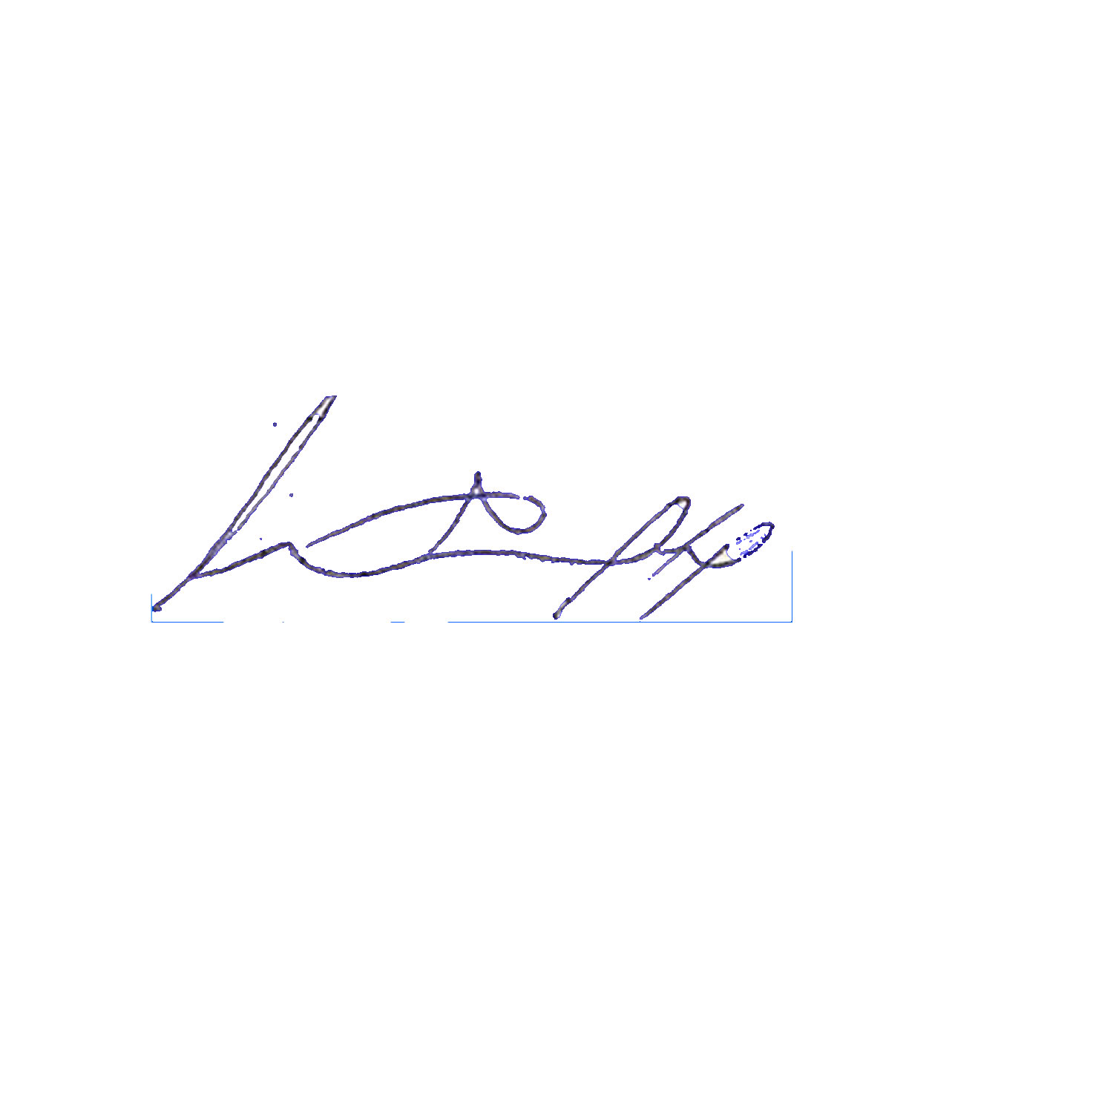

Signed by:
Lt. Gen. George Athor Deng
The Chairman of South Sudan Democratic Movement (S.S.D.M) &
The Commander in Chief of South Sudan Defense Army (S.S.D.A).

Date: May, 23, 2011.

Long Live the movement & the Army
Long Live the Liberation for Democracy, Equality & Freedoms
SSDM & SSDA shall win
SSDM-A up, up, up SSDM-A up, up, up SSDM-A up, up, up

