**Link: http://www2.irrawaddy.com/article.php?art_id=22390**

**DKBA Brigade 5 Reaches Ceasefire with Naypyidaw**

By SAW YAN NAING Friday, November 4, 2011

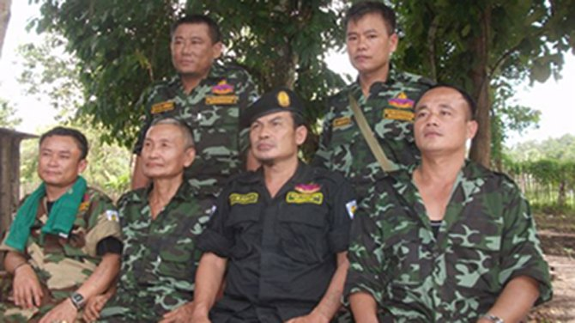

DKBA Brigade 5 leaders, including Brig-Gen Saw Lah Pwe (black shirt), pose for a photograph at a base in eastern Burma. (Photo: The Irrawaddy)

|  |
| --- |
| [[http://www2.irrawaddy.com/images/view_comments.gif](http://www2.irrawaddy.com/article.php?art_id=22390#comment)COMMENTS (16)](http://www2.irrawaddy.com/article.php?art_id=22390#comment) |
| http://www2.irrawaddy.com/images/RECOMMEND.gif[RECOMMEND (291)](http://www2.irrawaddy.com/article.php?art_id=22390&Submit=Submit) |
|  |
| http://www2.irrawaddy.com/images/facebook.gif[FACEBOOK](javascript:void(0);) |
| http://www2.irrawaddy.com/images/twitter.gif[TWITTER](javascript:void(0);) |
| PLUSONE |
|  |
| http://www2.irrawaddy.com/images/share.gif[MORE](javascript:void(0);) |
| [[http://www2.irrawaddy.com/images/email_to_friends.gif](http://www2.irrawaddy.com/article.php?art_id=22390)E-MAIL](http://www2.irrawaddy.com/article.php?art_id=22390) |
| [[http://www2.irrawaddy.com/images/print_article.gif](http://www2.irrawaddy.com/print_article.php?art_id=22390)PRINT](http://www2.irrawaddy.com/print_article.php?art_id=22390) |
| [http://www2.irrawaddy.com/web_images/plus1.gifhttp://www2.irrawaddy.com/web_images/minus1.gif](http://www2.irrawaddy.com/article.php?art_id=22390)  [TEXT SIZE](http://www2.irrawaddy.com/article.php?art_id=22390) |

The Democratic Karen Buddhist Army’s (DKBA) Brigade 5 reached a ceasefire agreement with a Burmese government delegation on Thursday, said the DKBA Brigade 5 leader, Brig-Gen Saw Lah Pwe.

Saw Lah Pwe told *The Irrawaddy* on Friday that he signed a ceasefire agreement with a Burmese delegation on Thursday. He said that fighting had stopped and some government troops that previously were deployed on the frontlines had begun to withdraw from areas controlled by DKBA Brigade 5.

“I think they really want to make a ceasefire with us at this moment. Some of the representatives are Burmese officials from Naypyidaw,” said Saw Lah Pwe.

He said that the official statement about the ceasefire agreement with the Burmese authorities will be announced on Nov. 6 and DKBA Brigade 5 will reopen its headquarters in Sone Seen Myaing, Myawaddy Township.

DKBA Brigade 5, which has an estimated 1,500 troops, split with the DKBA, which has an estimated 6,000 troops, and restarted armed conflict with government troops in 2010 when the Burmese military attempted to force the DKBA to join its Border Guard Force. Then on Nov 7, 2010, DKBA Brigade 5 temporarily took control of several government buildings in the town of Myawaddy on the Thai border and the fighting that followed forced over 20,000 people to flee to Thailand.

The renewed hostilities between DKBA Brigade 5 and government troops broke a 15-year-old ceasefire agreement between the DKBA and Burma’s previous military regime, which was signed in 1995.

The DKBA, with the exception of Brigade 5, previously agreed to join the BGF. However, despite the ceasefire, Brigade 5 is no longer being asked to join.

The ceasefire agreement between DKBA Brigade 5 and the Naypyidaw delegation was reached after several previous meetings failed to produce an agreement.

Meanwhile, other government delegations have separately approached other ethnic armed groups such as the Karen National Union, Shan State Army – South and New Mon State Party for peace talks. Some of them have met with the government delegations, but no agreements have been reached thus far.