Link: <http://www.satp.org/satporgtp/countries/india/states/nagaland/terrorist_outfits/NSCN_K.HTM>

**ational Socialist Council of Nagaland - Khaplang**

http://www.satp.org/satporgtp/Templates/images/back1_2_1.jpg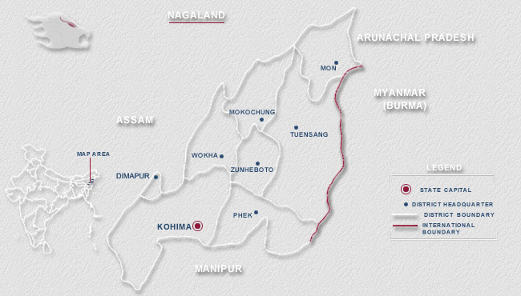

http://www.satp.org/satporgtp/Templates/images/back1_2_1.jpg

**Incidents and Statements involving NSCN-K:** [**2015**](http://www.satp.org/satporgtp/countries/india/states/nagaland/terrorist_outfits/NSCN_K_2015.htm)**,** [**2014**](http://www.satp.org/satporgtp/countries/india/states/nagaland/terrorist_outfits/NSCN_K_2014.htm)**,** [**2013**](http://www.satp.org/satporgtp/countries/india/states/nagaland/terrorist_outfits/NSCN_K_2013.htm)**,** [**1988-2012**](http://www.satp.org/satporgtp/countries/india/states/nagaland/terrorist_outfits/NSCN_K_tl.htm)

**Formation**

The National Socialist Council of Nagaland – Khaplang (NSCN-K) was formed on April 30, 1988, consequent to an assassination attempt on the General Secretary of what emerged as the rival outfit – [NSCN (IM)](http://www.satp.org/satporgtp/countries/india/states/nagaland/terrorist_outfits/NSCN_IM.HTM) – Thuingaleng Muivah. Clannish divisions among the Nagas (Konyaks and Tangkhuls) were the primary reason behind the split of the NSCN in 1988. The Konyaks formed the NSCN-K (Khaplang) under the leadership of Khole Konyak and S S Khaplang. The Tangkhul faction, the NSCN-IM (Isak-Muivah), was led by Isak Chisi Swu and T. Muivah.

**Leadership**

S S Khaplang is the Chairman of the outfit. N Kitovi Zhimomi acts as the General Secretary and Akaho Asumi is the Publicity Secretary.

**Objectives**

The primary objective of the NSCN-K is the establishment of a ‘[greater Nagaland](http://www.satp.org/satporgtp/countries/india/states/nagaland/backgrounder/Nagalim.htm)’ comprising of the Naga dominated areas of the neighbouring States within India, and contiguous areas in Myanmar.

**Area of Operation and Structure**

The outfit is active in the eastern parts of Nagaland, as well as in the Tirap and Changlang districts of neighbouring Arunachal Pradesh.

It has a cadre strength of approximately 2,000, with a following among the Konyaks of both India and Myanmar, the Pangmeis of Myanmar, the Aos of Mokokchung district, the Phoms and Yimchungers of Tuensang district, the Angamis, the Semas and the Lothas. It commands influence in parts of Nagaland, Tirap and Changlang districts of Arunachal Pradesh, as well as the Hemei and Pangmei settlements in Myanmar.

The NSCN-K runs a government-in-exile called the Government of the People's Republic of Nagaland, NSCN-K. The General Head Quarters (GHQ) of the GPRN/NSCN-K is located in Eastern Nagaland (Myanmar). Kitovi Zhimomi is the self-styled "Prime minister of the Government of the People's Republic of Nagaland".

For generation of finance, the group reportedly indulges in kidnapping, extortion and other terrorist activities. The NSCN-K accounted for 62 civilian and 26 security forces’ fatalities during the period 1992 to 2000, and lost 245 of its men over this period.

**Linkages**

The group is reported to have training camps and its headquarters in Myanmar.

**Incidents and Statements involving NSCN-K:** [**2014**](http://www.satp.org/satporgtp/countries/india/states/nagaland/terrorist_outfits/NSCN_K_2014.htm)**,** [**2013**](http://www.satp.org/satporgtp/countries/india/states/nagaland/terrorist_outfits/NSCN_K_2013.htm)**,** [**2014**](http://www.satp.org/satporgtp/countries/india/states/nagaland/terrorist_outfits/NSCN_K_2014.htm)**,** [**1988-2012**](http://www.satp.org/satporgtp/countries/india/states/nagaland/terrorist_outfits/NSCN_K_tl.htm)