**Link: https://www.dabangasudan.org/en/all-news/article/sudan-revolutionary-front-formed**

**Sudan Revolutionary Front formed**

November 13 - 2011 KHARTOUM

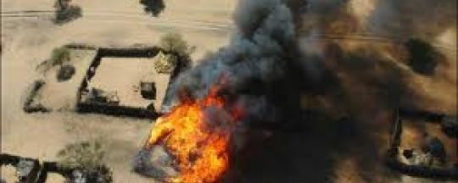

T**he opposition alliance formed by four armed opposition groups says it will use all available means to bring about change in Khartoum**

Leaders of the four opposition parties formed the Sudan Revolutionary Front (SRF) on Friday and declared that they would overthrow the regime of the National Congress Party (NCP) “using all available means.”

The parties participating in the second meeting of the SRF were the Sudan People’s Liberation Movement-North (SPLM-N), Justice and Equality Movement (JEM), Sudan Liberation Army-Abdel Wahid (SLA-AW), Sudan Liberation Army-Minni Minnawi (SLA-MM).

In a statement, the SRF stressed on the need to converge civil political action and the armed struggle. They also announced the formation of high-level committees, political as well as military, to undertake the day-to-day work of the SRF. This is a step towards formalizing the Kauda collation/alliance formed by the four participating parties.

“The NCP regime, in spite of its continuous attacks and daily atrocities against the daughters and sons of our people through unending violations of human rights, including war crimes and ethnic cleansing, is presently at its weakest - economically, politically and militarily,” the statement said.

It added, “The SRF is calling upon all Sudanese political forces to reject the path of partial political settlement with the NCP regime and adopt a holistic approach for changing the regime's seat of power in Khartoum.”

The SRF also called upon the international community to take a clear stand on the NCP’s use of food as a weapon of war.

**‘Welcome change’**

Nimr Abdel Rahman, spokesperson of the SLA-AW told Radio Dabanga, “The coming days will witness completion of the structures of the front and start work in all parts of Sudan to change the system.”

Meanwhile, the JEM also stressed on the importance of the formalization of the Kauda alliance. Spokesperson Jibril Adam Bilal said, “The coalition alliance is a step in the right direction towards overthrowing the regime in Khartoum. All marginalized forces should join in.”

**Hostile act: Sudanese government**

The Sudanese government reacted strongly to the SRF by calling it a hostile act. El Obeid Ahmed Marawah spokesperson of the Sudanese foreign ministry told Radio Dabanga in an interview that the coalition was ‘no good.’

“We saw the work of the National Rally in 1993 which aimed to overthrow the regime through military action and failed,” he said.

He added that the government is still committed to a peaceful approach in which power can be transferred and others can share seats in the government. “In this context, if the SRF wants to go back in time and cause more bloodshed then the state is definitely responsible for the security and protection of citizens,” he said.