**Link: http://www.sudantribune.com/spip.php?mot319**

**Sudanese Communist Party (SCP) | Communist Party of Sudan (CPS)**

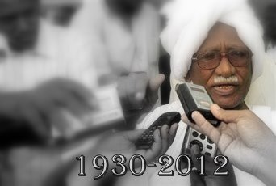

**Leader of the Sudanese Communist Party Mohamed Ibrahim Nugud (Reuters)**

**Name:** Sudanese Communist Party (SCP) or Communist Party of Sudan (CPS)

**Headquarters:** Khartoum, Sudan

**Ideology**: Communism, Marxism-Leninism

**Aligned Newspapers:** [*Al-Midan*](http://www.sudantribune.com/+-Al-Midan,491-+)

**Official Website:** [Arabic](http://www.midan.net/) / [English](http://www.midan.net/?page_id=475)

**Leaders:** Abdel-Khalek Mahjoub, -1971; [Mohamed Ibrahim Nugud](http://www.sudantribune.com/+-Mohamed-Ibrahim-Nugud,1090-+), 1971-2012.

**Timeline**

1946 - Sudanese Communist Party (SCP) is founded.

1971 - SCP leader Abdel-Khalek Mahjoub executed by ex-president Ga’afar Nimeiri in the aftermath of the brief SCP-backed coup in 1971 along with a large number of the party’s leadership. Succeeded by [Mohamed Ibrahim Nugud](http://www.sudantribune.com/+-Mohamed-Ibrahim-Nugud,1090-+) who goes into hiding. Analysts say that the party was never able to regain its prominence as the strongest communist party in the region after losing its top leadership in 1971.

1985 - Uprising against Nimeiri leads Nugud to reemerges to the political scene after 14 years in hiding

1989 - Military coup led by Brigadier Omer Hassan al-Bashir brings the Islamist National Islamic Front to power. All political parties are banned and Nugud goes back into hiding.

1991 - The collapse of the Soviet Union. The SCP struggles to retain its popularity after this watershed and the diminishing popularity of communist ideology around the world.

2005 - Nugud’s hiding place is uncovered by the National Intelligence and Security Services (NISS) but the Comprehensive Peace Agreement between the SPLM and NIF/NCP sees Sudan moved into a a system of government that was more tolerant of opposition.

2009 - SCP holds its first general convention in decades. Nugud is reelected to the party’s top post but his views appear more moderate with some in the party privately attributing it to old age and deteriorating health. At one point there were discussions within the SCP on whether its name should be changed to reflect the new realities.

2010 April - Nugud only receives 26,442 votes (0.26%) in his bid to become president at elections in April. The SCP chief iss no longer the charismatic eloquent figure he used to be.

2012 March - Nugud dies in London aged 82 from brain cancer.