Elijah Andrushenko

09/18/2018

Parallel Computing

CPTS 411

Homework 1

1.

i) **Speedup = (n lg n) / ((n/p) lg n + lg p)** Amdahl’s Law states Speed up is the ratio of Serial / Parallel.

ii) The Speedup is sublinear. In the table below we plugged in the speedup equation making n = 64 and p = 1, 2, 4, 8, and 16. The speedup is sublinear since for each process the speedup is less than the number of processes.

|  |  |  |  |  |  |
| --- | --- | --- | --- | --- | --- |
|  | 1 | 2 | 4 | 8 | 16 |
| Speedup | 1 | 1.99 | 3.92 | 7.52 | 13.714 |
| Linear | 1 | 2 | 4 | 8 | 16 |

iii) **Efficiency = (n lg n) / (p * ((n/p) lg n + lg p))** Efficiency equation is Serial / p * Parallel, p being the number of processors.

iv) **Overhead = ((n/p) lg n + lg p) – (n lg n)** as stated in the homework and in Gustafson’s Law overhead is Parallel – Serial.

2.

a)

Parallel Runtime –> T(n ,p)

|  |  |  |  |  |  |  |
| --- | --- | --- | --- | --- | --- | --- |
| n | 1 | 2 | 4 | 8 | 16 | 32 |
| **64** | **1000** | **582** | **310** | **200** | **156** | **102** |
| **128** | **2078** | **1010** | **689** | **412** | **255** | **175** |
| **256** | **5100** | **2600** | **1420** | **780** | **420** | **250** |
| **512** | **11029** | **5900** | **2900** | **1580** | **780** | **390** |

See graph below, there are PNGs saved in the zip file for a better look at the graphs

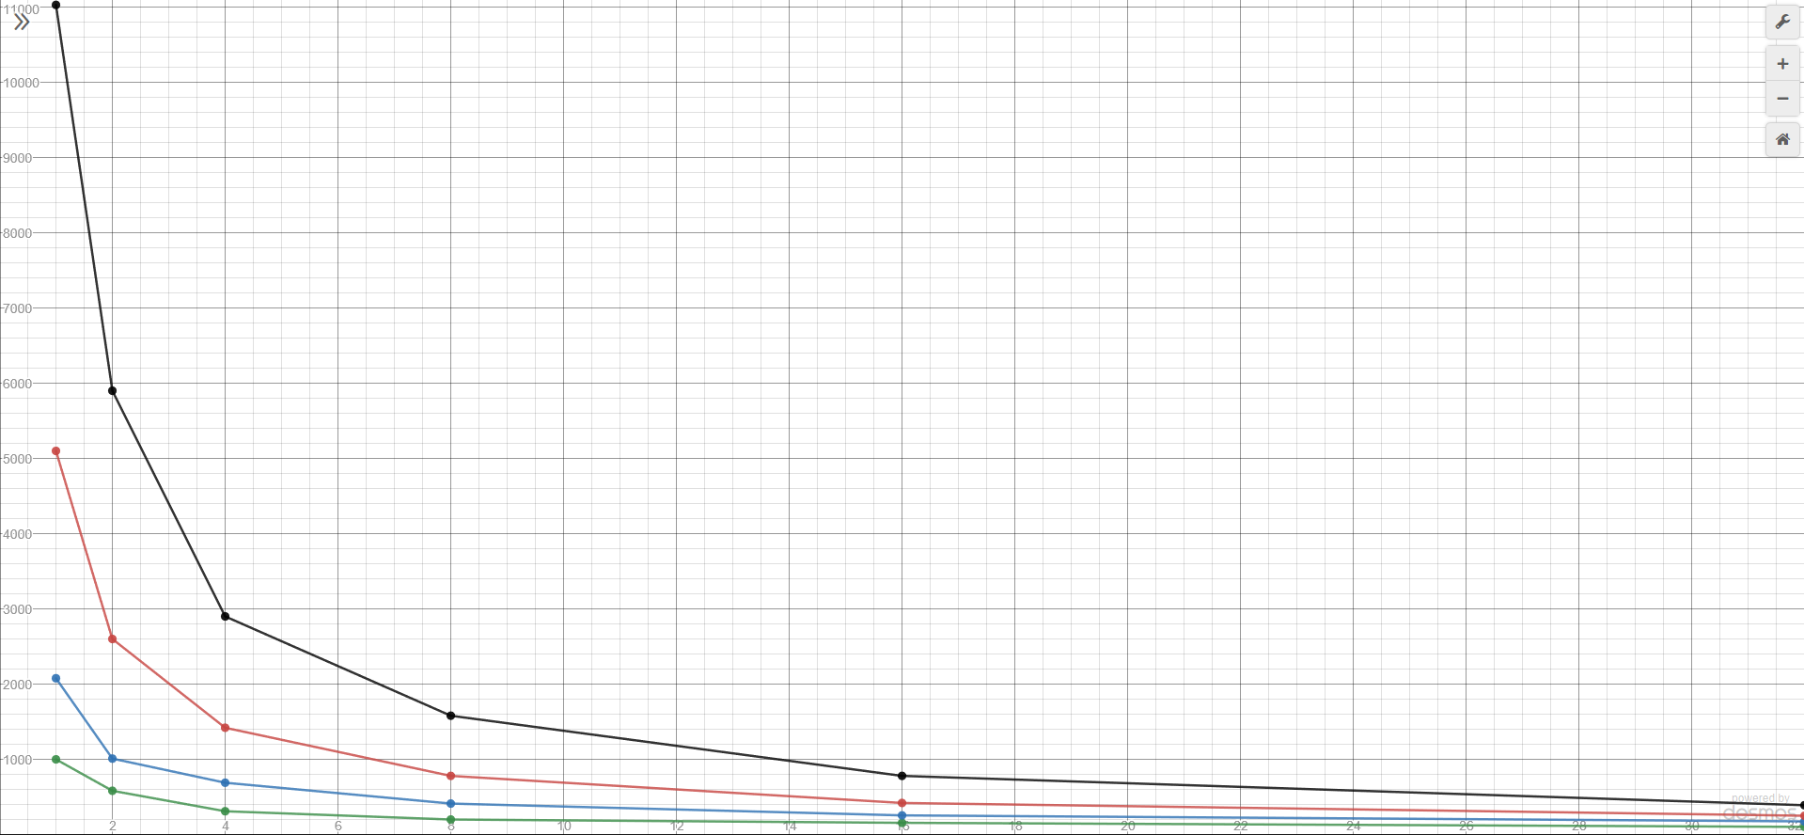

b)

Speedup -> S(n, P) = T(n, 1) / T(n , p)

|  |  |  |  |  |  |  |
| --- | --- | --- | --- | --- | --- | --- |
| n | 1 | 2 | 4 | 8 | 16 | 32 |
| **64** | **1** | **1.72** | **3.23** | **5** | **6.41** | **9.80** |
| **128** | **1** | **2.06** | **3.02** | **5.04** | **8.15** | **11.87** |
| **256** | **1** | **1.96** | **3.59** | **6.54** | **12.14** | **20.4** |
| **512** | **1** | **1.87** | **3.80** | **6.98** | **14.14** | **28.27** |

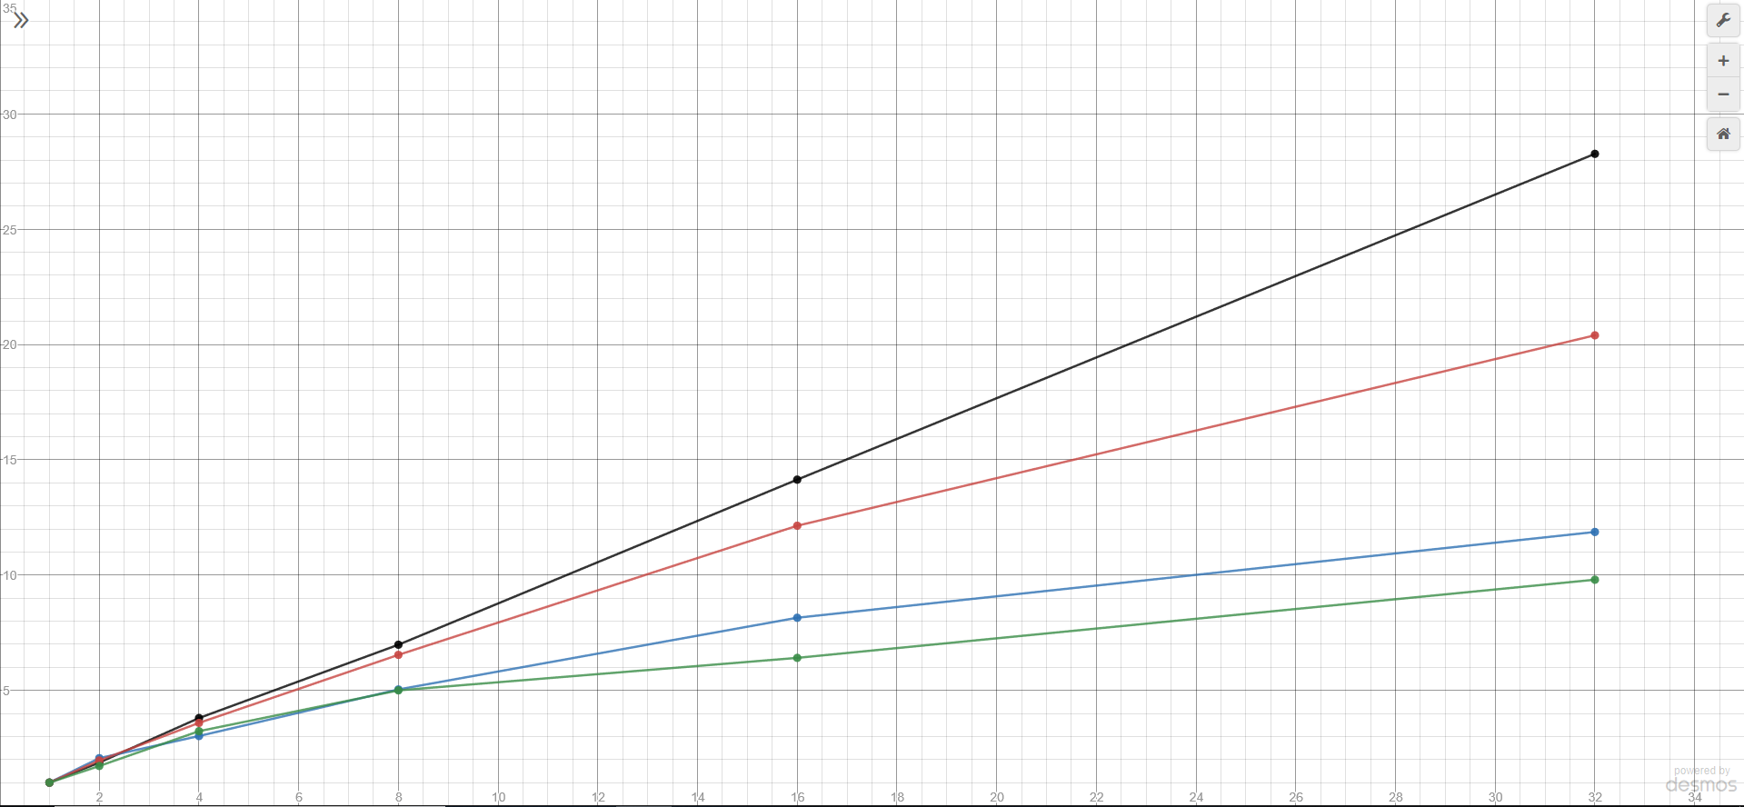

c)

Efficiency –> E(n,p) = T(n ,1) / (p * T(n,p))

|  |  |  |  |  |  |  |
| --- | --- | --- | --- | --- | --- | --- |
| n | 1 | 2 | 4 | 8 | 16 | 32 |
| **64** | **1** | **0.86** | **0.81** | **0.63** | **0.40** | **0.31** |
| **128** | **1** | **1.02** | **0.75** | **0.63** | **0.51** | **0.37** |
| **256** | **1** | **0.98** | **0.90** | **0.82** | **0.76** | **0.64** |
| **512** | **1** | **0.93** | **0.95** | **0.87** | **0.88** | **0.88** |

