Elijah Andrushenko

CPTS 411

09/25/2018

Intro to Parallel Computing

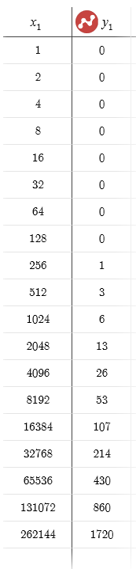Project #2

MPI Send – X: Size (Bytes) Y: Time (Milliseconds)

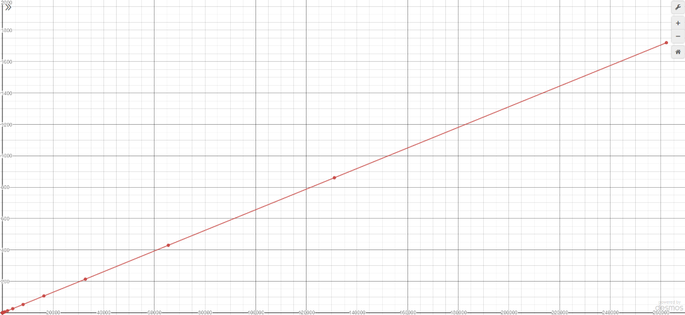

Bandwidth = 151 Bytes per Millisecond

Latency = 0.00000152 Milliseconds

Network Buffer Size = 2

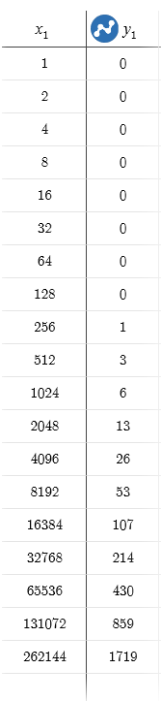MPI Recv – X: Size (Bytes) Y: Time (Milliseconds)

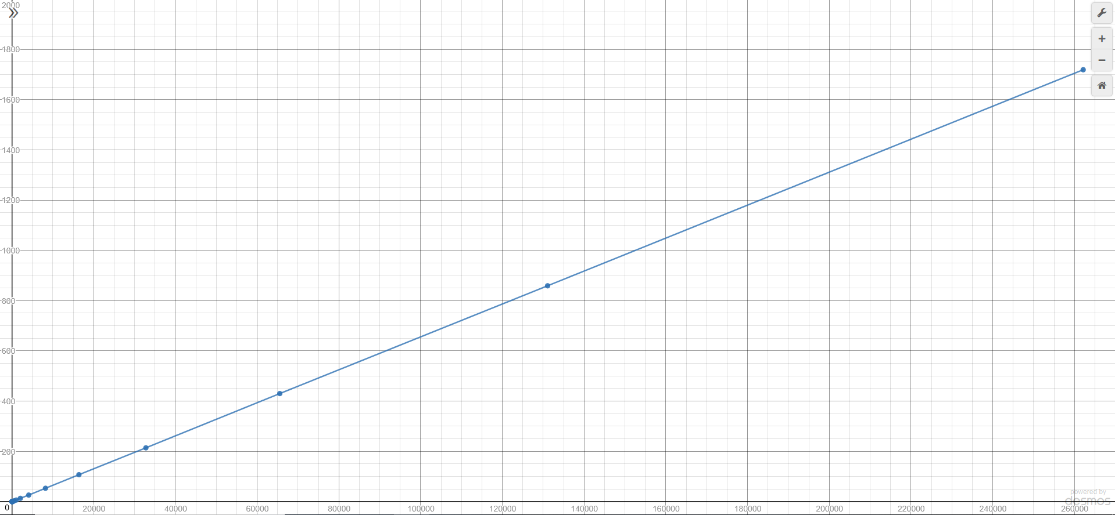

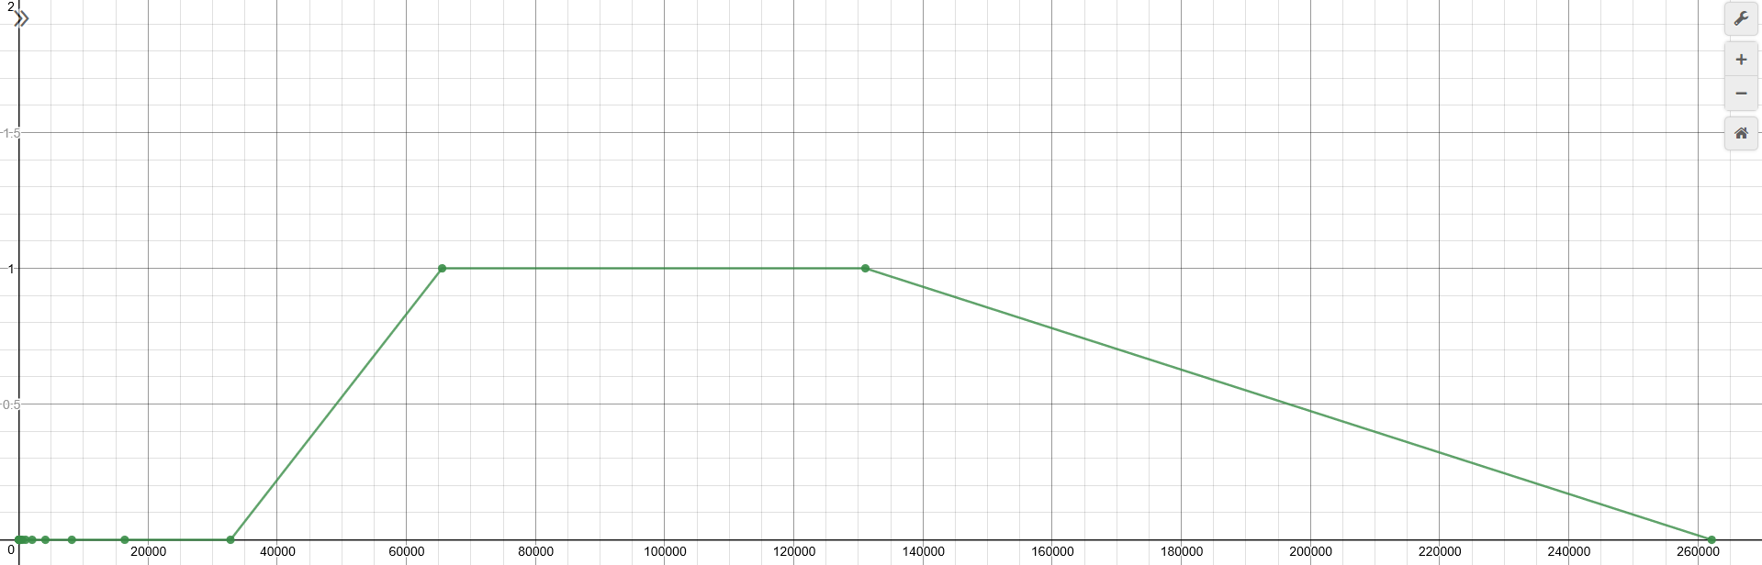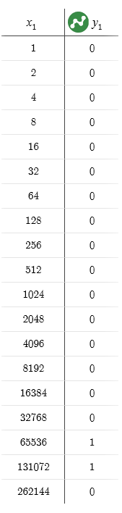Communication – X: Size (Bytes) Y: Time (Milliseconds)