Elijah Andrushenko

CPTS 434

Neural Network Design & Applications

09-24-2019

Homework #2

KNN Classifier

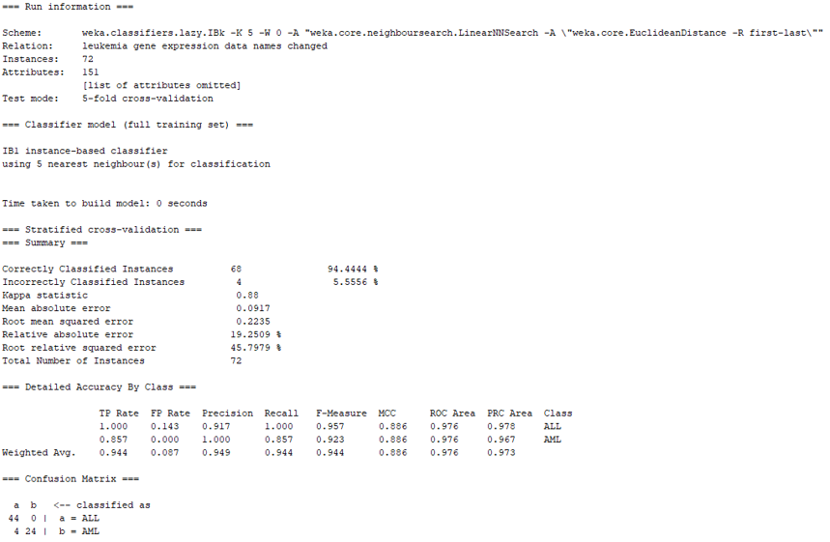

=== Confusion Matrix ===

a b <-- classified as

24 4 | b = AML

0 44 | a = ALL

TP rate = 24/28 = **0.857%**

FP rate = 0/44 = **0.000%**

This matches the calculated accuracy provided by WEKA.

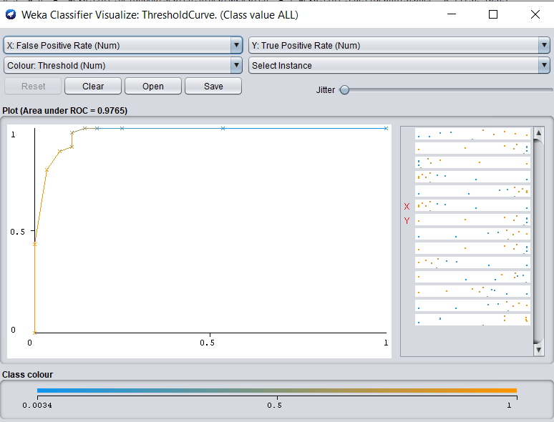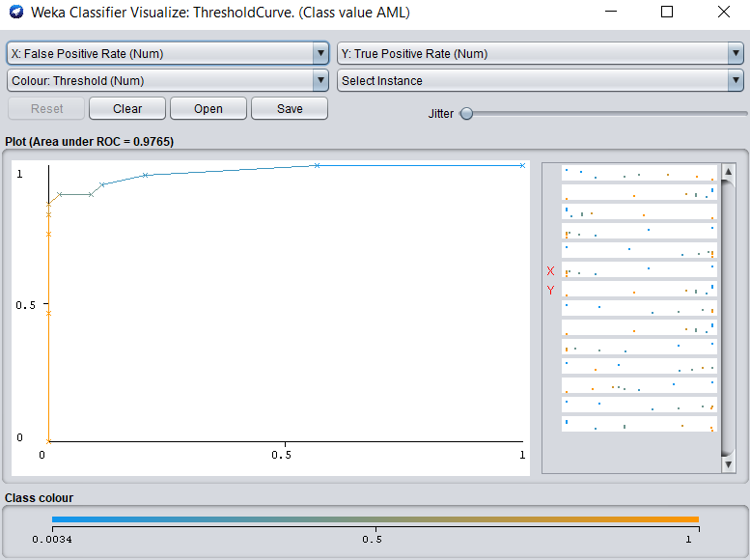

ZeroR Classifier

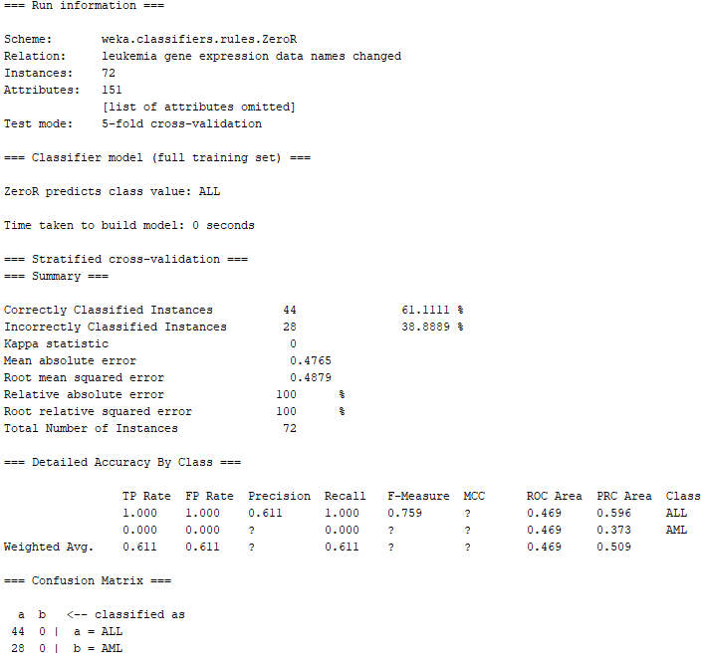

=== Confusion Matrix ===

a b <-- classified as

44 0 | b = AML

28 0 | a = ALL

TP rate = 0/28 = **0.000%**

FP rate = 0/44 = **0.000%**

This matches the calculated accuracy provided by WEKA.

