Elijah Andrushenko

CPTS 434

Neural Network Design & Applications

10-1-2019

Homework #3

Naïve Bayes Classifier

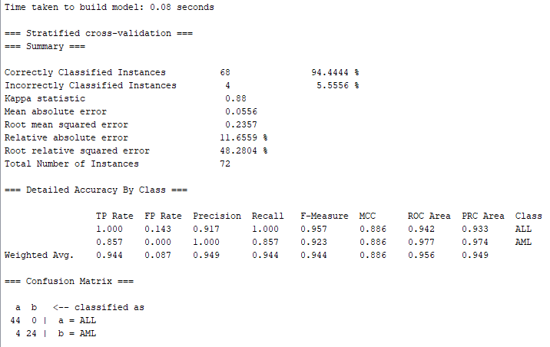

=== Confusion Matrix ===

a b 🡨 classified as

24 4 | b = AML

0 44 | a = ALL

TP rate = 24/28 = **0.857%**

FP rate = 0/44 = **0.000%**

This matches the score calculated by WEKA.

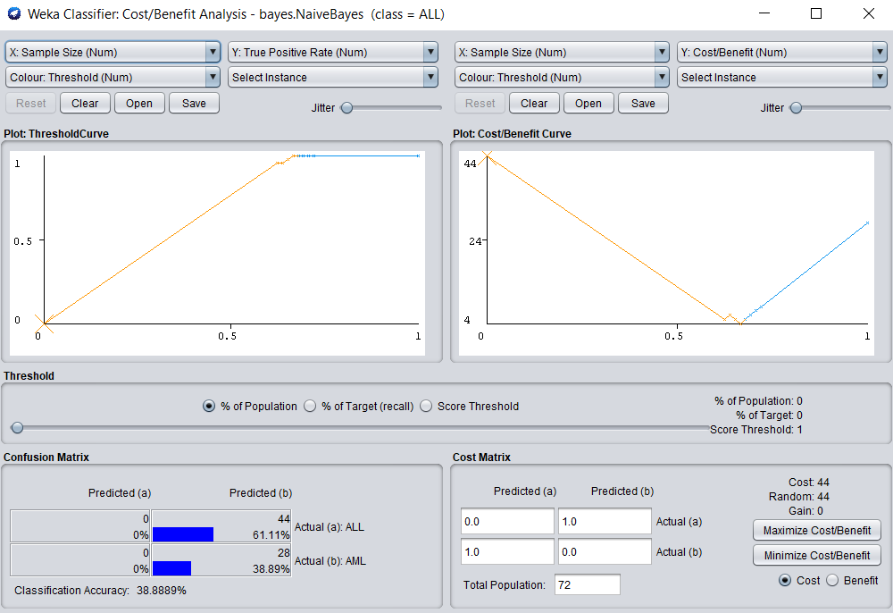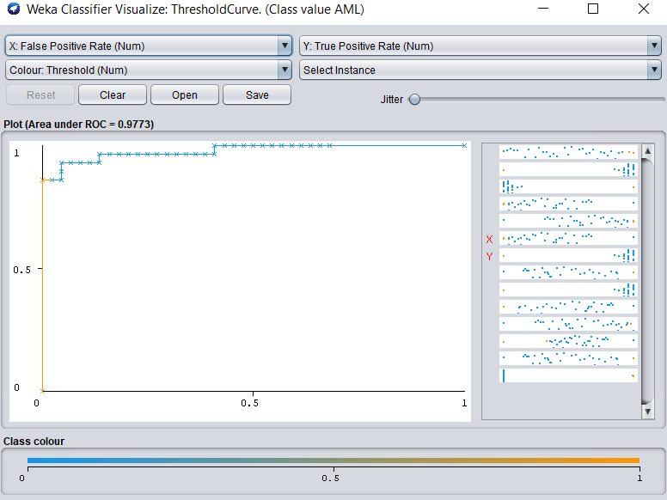

Based on the results from homework 2, Naïve Bayes is much more similar to KNN then it is to ZeroR.

Since both have the same Kappa statistic, correctly classified instances, incorrectly classified instances, identical confusion matrices, identical precision, F-measures, MCC. Their ROC and PRC areas are similar relative to ZeroR.

Based on this knowledge is why I conclude that Naïve Bayes results yield similar to the KNN classifier and dissimilar to the ZeroR classifier.