Elijah Andrushenko

CPTS 434

Introduction to Neural Network Design & Applications

10-15-2019

Homework #5

**Part 1**

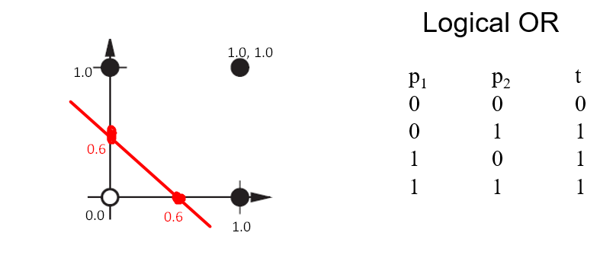1.

Bias

$$w^{T}p+b=0$$

$$-b= w^{T}p$$

$$-b= \begin{matrix}[1 & 1]\end{matrix}\left[\begin{matrix}0 \\ 0.6\end{matrix}\right]$$

$$b=-0.6$$

Decision Boundary

$$w^{T}p+b=0$$

$$\left[\begin{matrix}1 & 1\end{matrix}\right]\left[\begin{matrix}x \\ y\end{matrix}\right]-0.6=0$$

$$x+y=0.6$$

2.

Open-Circles Margin

$$d=\frac{|g\left(0,0\right)|}{|\left|w\right||}$$

$$d= \frac{|\left[\begin{matrix}1 & 1\end{matrix}\right]\left[\begin{matrix}0 \\ 0\end{matrix}\right]-0.6|}{\sqrt{1^{2}+1^{2}}}=0.42$$

Closed-Circles Margin

$$d=\frac{|g\left(0,0\right)|}{|\left|w\right||}$$

$d= \frac{|\left[\begin{matrix}1 & 1\end{matrix}\right]\left[\begin{matrix}0 \\ 1\end{matrix}\right]-0.6|}{\sqrt{1^{2}+1^{2}}}=0.28$

**Part 2**

1.

Step 1

$$a=hardlim(w^{T}p_{1}+b)$$

$$a=hardlim(\left[\begin{matrix}0.5 & -1 & -0.5\end{matrix}\right]\left[\begin{matrix}-1 \\ 1 \\ -1\end{matrix}\right]+0.5)$$

$$a=hardlim(-0.5)$$

$$a=0$$

$$t_{1}=1 and a=0, t_{1}≠a, therefore weights need to be adjusted$$

$$w_{new}=w_{old}+ep_{1}, we need to find e$$

$$e=t_{1}-a$$

$$e=1-0$$

$$e=1$$

$$w_{new}=\left[\begin{matrix}0.5 \\ -1 \\ -0.5\end{matrix}\right]+\left[\begin{matrix}-1 \\ 1 \\ -1\end{matrix}\right]$$

$$w_{new}=\left[\begin{matrix}-0.5 \\ 0 \\ -1.5\end{matrix}\right]$$

$$b_{new}=b_{old}+e$$

$$b_{new}=0.5+1$$

$$b_{new}=1.5$$

Step 2

$$a=hardlim(w^{T}p_{2}+b)$$

$$a=hardlim(\left[-\begin{matrix}0.5 & 0 & -1.5\end{matrix}\right]\left[\begin{matrix}1 \\ 1 \\ -1\end{matrix}\right]+1.5)$$

$$a=hardlim(2.5)$$

$$a=1$$

$$t_{2}=0 and a=1, t_{2}≠a, therefore weights need to be adjusted$$

$$w_{new}=w_{old}+ep_{2}, we need to find e$$

$$e=t_{2}-a$$

$$e=0-1$$

$$e=-1$$

$$w_{new}=\left[\begin{matrix}-0.5 \\ 0 \\ -1.5\end{matrix}\right]+\left[\begin{matrix}1 \\ 1 \\ -1\end{matrix}\right]$$

$$w_{new}=\left[\begin{matrix}-1.5 \\ -1 \\ -0.5\end{matrix}\right]$$

$$b_{new}=b_{old}+e$$

$$b_{new}=1.5-1$$

$$b_{new}=0.5$$

Step 3

$$a=hardlim(w^{T}p_{1}+b)$$

$$a=hardlim(\left[-\begin{matrix}1.5 & -1 & -0.5\end{matrix}\right]\left[\begin{matrix}-1 \\ 1 \\ -1\end{matrix}\right]+0.5)$$

$$a=hardlim(1.5)$$

$$a=1$$

$$t_{1}=1 and a=1, t_{1}=a, therefore weights don^{'}t need to be adjusted$$

Step 4

$$a=hardlim(w^{T}p_{2}+b)$$

$$a=hardlim(\left[-\begin{matrix}1.5 & -1 & -0.5\end{matrix}\right]\left[\begin{matrix}1 \\ 1 \\ -1\end{matrix}\right]+0.5)$$

$$a=hardlim(-1.5)$$

$$a=0$$

$$t_{2}=0 and a=0, t_{2}=a, therefore weights don^{'}t need to be adjusted$$

Step 5

$$No Adjustments were made for p_{1} or p_{2} therefore we are done$$

Results

$$w^{T}=[\begin{matrix}-1.5 & -1 & -0.5\end{matrix}]$$

$$b=0.5$$

Decision Boundary

$$w^{T}p+b=0$$

$$\left[\begin{matrix}-1.5 & -1 & -0.5\end{matrix}\right]\left[\begin{matrix}x \\ y \\ z\end{matrix}\right]+0.5=0$$

$$-1.5x-y-0.5z+0.5=0$$

2.

$$Distance Calculation for p_{1}$$

$$d_{1}= \frac{|g\left(p_{1}\right)|}{|\left|w\right||}$$

$$d_{1}= \frac{|\left[\begin{matrix}-1.5 & -1 & -0.5\end{matrix}\right]\left[\begin{matrix}-1 \\ 1 \\ -1\end{matrix}\right]+0.5|}{\sqrt{{1.5}^{2}+{-1}^{2}+{-0.5}^{2}}}$$

$$d_{1}=0.80$$

$$Distance Calculation for p_{2}$$

$$d_{2}= \frac{|g\left(p_{2}\right)|}{|\left|w\right||}$$

$$d_{2}= \frac{|\left[\begin{matrix}-1.5 & -1 & -0.5\end{matrix}\right]\left[\begin{matrix}1 \\ 1 \\ -1\end{matrix}\right]+0.5|}{\sqrt{{1.5}^{2}+{-1}^{2}+{-0.5}^{2}}}$$

$$d_{2}=0.80$$