Elijah Andrushenko

CPTS 471

1/22/2018

Computational Genomics

Homework #1

1.

Reverse Compliment of accgtagccggatatac

Compliment -> tggcatcggcctatatg

Reverse Compliment -> **gtatatccggctacggt**

2.

There are 24 chromosomes in the human genome. 1-22 plus the X and Y chromosomes. A single person has 23 chromosome pairs 1-22 plus XX pair or XY pair depending on gender.

3.

Gene Associated with Breast Cancer

Name: **BRCA1** DNA repair associated **Breast Cancer 1**

Chromosome: **17**

Coordinates: **43,044,295 - 43,125,483** Band: **17q21.31**

Length (bp): **81,188**

Main protein product length: **50** amino acids

**7** cysteine residues

**1** histidine residue

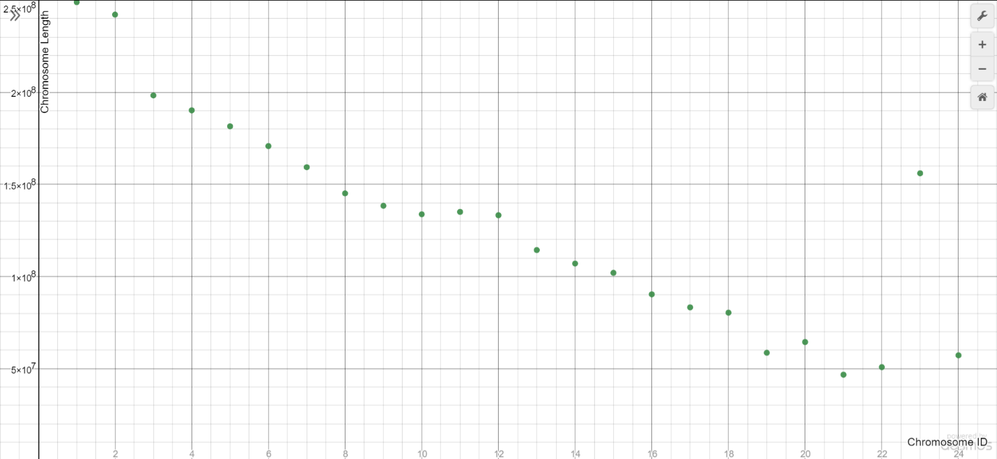

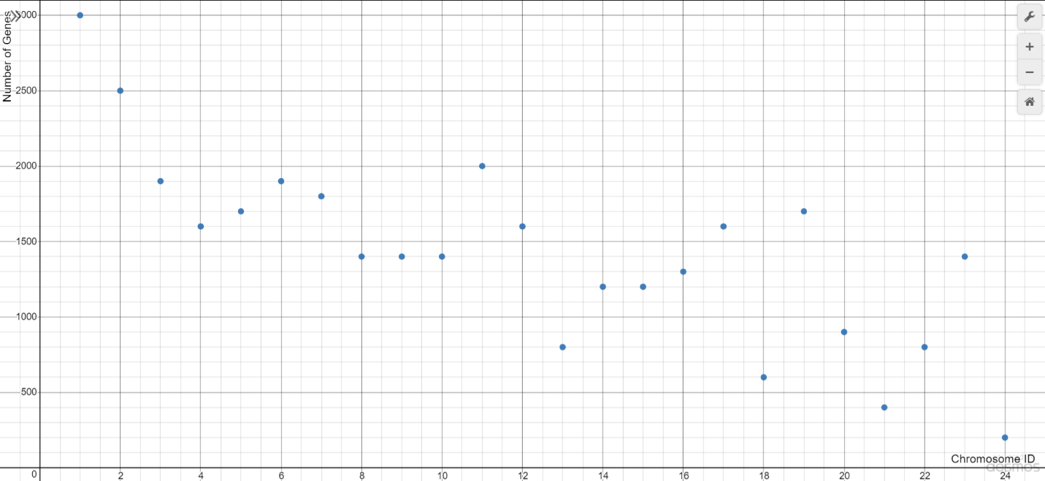

|  |  |  |
| --- | --- | --- |
| **Chromosome ID** | **Chromosome Length (BP)** | **Number of Genes(Approx.)** |
| Chromosome 1 | 248,956,422 | 3000 |
| Chromosome 2 | 242,193,529 | 2500 |
| Chromosome 3 | 198,295,559 | 1900 |
| Chromosome 4 | 190,214,555 | 1600 |
| Chromosome 5 | 181,538,259 | 1700 |
| Chromosome 6 | 170,805,979 | 1900 |
| Chromosome 7 | 159,345,973 | 1800 |
| Chromosome 8 | 145,138,636 | 1400 |
| Chromosome 9 | 138,394,717 | 1400 |
| Chromosome 10 | 133,797,422 | 1400 |
| Chromosome 11 | 135,086,622 | 2000 |
| Chromosome 12 | 133,275,309 | 1600 |
| Chromosome 13 | 114,364,328 | 800 |
| Chromosome 14 | 107,043,718 | 1200 |
| Chromosome 15 | 101,991,189 | 1200 |
| Chromosome 16 | 90,338,345 | 1300 |
| Chromosome 17 | 83,257,441 | 1600 |
| Chromosome 18 | 80,373,285 | 600 |
| Chromosome 19 | 58,617,616 | 1700 |
| Chromosome 20 | 64,444,167 | 900 |
| Chromosome 21 | 46,709,983 | 400 |
| Chromosome 22 | 50,818,468 | 800 |
| Chromosome X | 156,040,895 | 1400 |
| Chromosome Y | 57,227,415 | 200 |
| **Full Genome (Total)** | 3,088,269,832 | 34300 |