Elijah Andrushenko

2/26/2019

Introduction to Database Systems

CPTS 451

Homework #3

1.

R1 = σ Student.major = 'CptS' and Student.trackcode = 'SYS' (Enroll ⨝ Student ⨝ Course)

R2 = π Enroll.courseNo R1 ⨝ π Course.credits R1

τ Enroll.courseNo R2

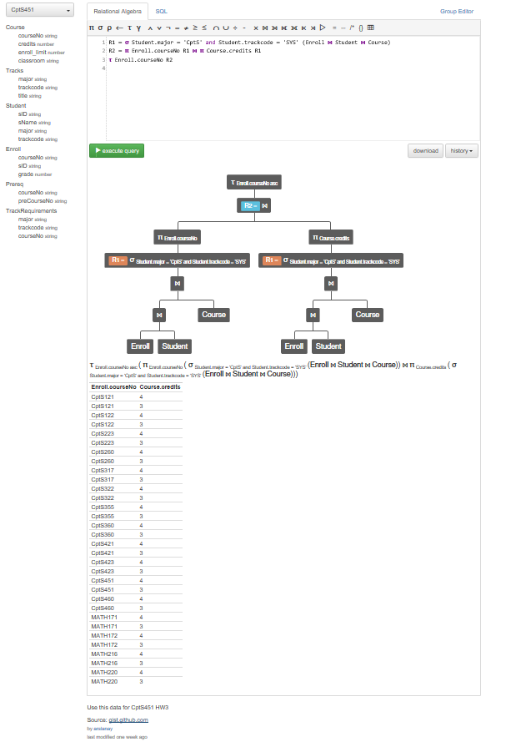

2.

π Student.sName, Student.sID, Student.major, Student.trackcode, totalcredits (τ Student.sName (Student ⨝ σ totalcredits > 18 ((γ sName, major, sID; sum(credits)->totalcredits (Student ⨝ Course ⨝ Enroll)))))

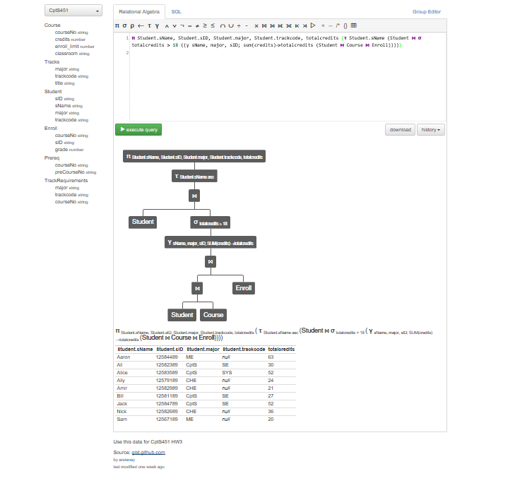

3.

π Enroll.courseNo σ Student.major = 'CptS' and Student.trackcode = 'SE' (Enroll ⨝ Student) ▷ π Enroll.courseNo σ Student.major ≠ 'CptS' or Student.trackcode ≠ 'SE' (Enroll ⨝ Student)

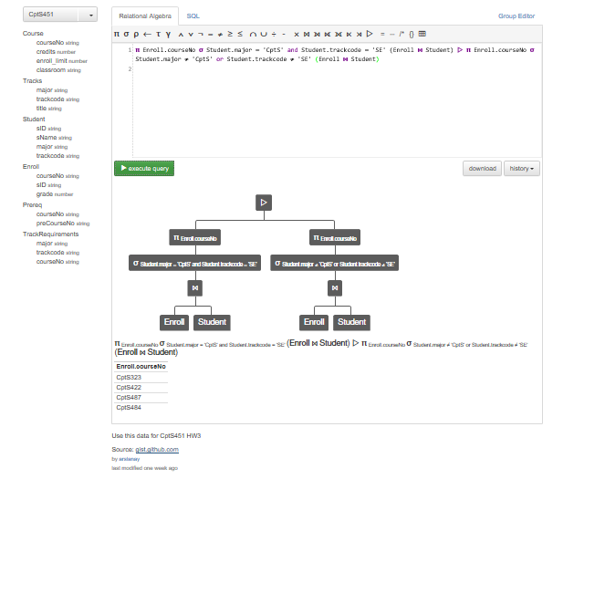

4.

R1 = σ Student.major = 'CptS' (Student ⨝ Enroll)

R2 = σ Student.major = 'CptS' (Student)

R3 = π Student.sName, Student.sID R1

R4 = π Student.sName, Student.sID R2

R4 - R3

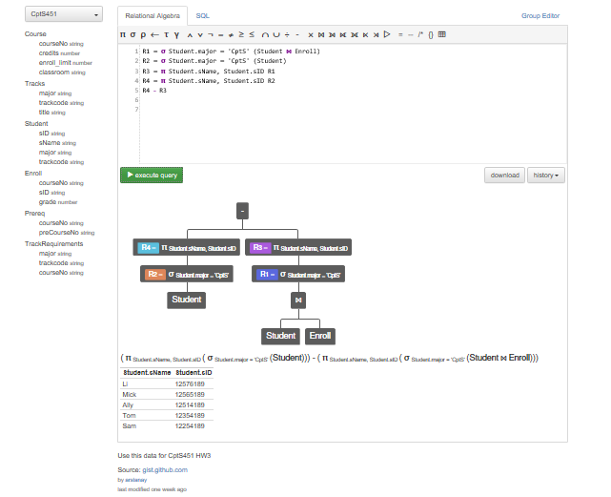

5.

R1 = σ Student.sName = 'Diane' (Student ⨝ Enroll)

R2 = ρ sID2←Student.sID, sName2←Student.sName, major2←Student.major, trackcode2←Student.trackcode, courseNo2←Enroll.courseNo, grade2←Enroll.grade ( R1 )

R3 = σ (Enroll.courseNo2 = Enroll.courseNo) and (Enroll.grade2 = Enroll.grade) and (Student.sName ≠ 'Diane') (R2 ⨝ Student ⨝ Enroll)

π Student.sName, Student.sID, Student.major, Enroll.courseNo, Enroll.grade (R3)

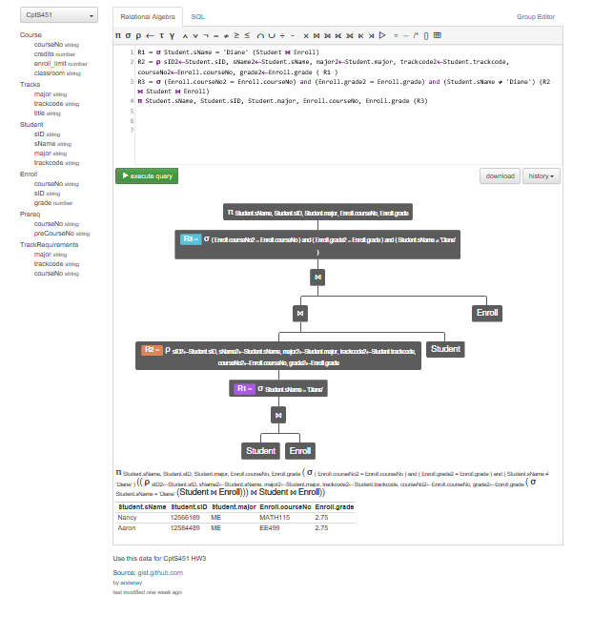

6.

π Course.courseNo, Course.enroll_limit, numEnrolled σ Course.enroll_limit < numEnrolled ∧ Course.classroom like 'Sloan%' (Course ⨝ (γ Enroll.courseNo; count(Enroll.sID)->numEnrolled (Enroll)))

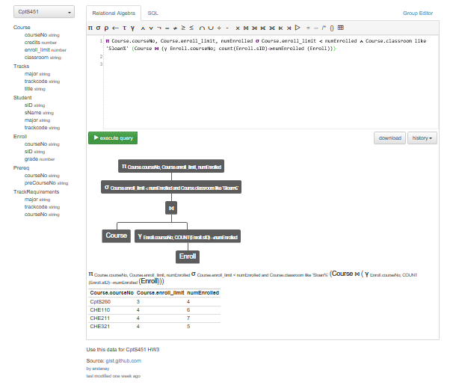

7.

R1 = (Student ⨝ Enroll)

R2 = σ Enroll.grade < 2 R1

R3 = ρ FailedCourse←Enroll.courseNo R2

R4 = π Student.sID, Student.sName, Enroll.FailedCourse R3

R5 = R4 ⨝ Enroll ⨝ Prereq

R6 = σ Enroll.FailedCourse = Prereq.preCourseNo R5

π Student.sName, Student.sID, Enroll.courseNo R6

