**GRDE2015 Game Design Introduction**

**Game Asset (40%)**

**Tutor: Dr Glen Spoors**

**Student Name:   
Student #:**

**Game and asset conceptualisation (10%)**

Have you clearly and engagingly summarised your game concept and the asset? How practical and original is the game concept and asset? Does the asset represent and extend the concept in a meaningful way?

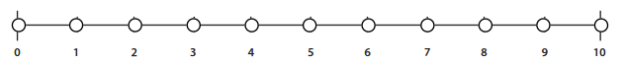Unoriginal/vague concepts Clear, novel concept Highly polished and original concept

11

**Aesthetic design (specific to your medium) (10%)**

Does your asset reflect an understanding of the aesthetics of the medium in which you are working (e.g. character design, story design, level design, 3D modelling)? Does it cohere as an aesthetic object in a manner that integrates its elements in a consistent manner? Does it have a clear, defining style?

Ill-considered, poor design Logical, sound design Striking, holistic design

**Polish (10%)**

How well presented and executed is your design: have you presented the work well, shown clear refinement of your idea, and performed polished editing of your work?

Draft execution Well presented and developed Professional refinement and polish

**Reflection (10%)**

Do you clearly discuss the design process and your design decisions and evaluate the final product, and what was learned from the design and development process? Is there thoughtful integration of theories or concepts from the unit and your design practice.

No reflection on the process, General reflection on the process, Detailed reflection on specifics of your  
lessons or outcome lessons and/or outcome design process, lessons & outcomes

**Assessor’s Comments Assessment submitted: Deduction of:**

**Assessment 3 : Total:**

Details on Curtin University's late assessment policy can be found here: http://humanities.curtin.edu.au/current_students/late_assessment.cfm