

IT342-Section SYSTEMS INTEGRATION AND

ARCHITECTURE 1

FUNCTIONAL REQUIREMENTS SPECIFICATION (FRS)

Project Title: WealthWise
Prepared By: Earion Icer O. Bramwell Date of Submission: 02/06/2026 Version: 1

Table of Contents
- Introduction 3
  - Purpose 3
  - Scope 3
  - Definitions, Acronyms, and Abbreviations 3
- Overall Description 3
  - System Perspective 3
  - User Classes and Characteristics 3
  - Operating Environment 4
  - Assumptions and Dependencies 4
- System Features and Functional Requirements 4
  - Feature 1: 4
  - Feature 2: 4
- Non-Functional Requirements 5
- System Models (Diagrams) 6
  - ERD 6
  - Use Case Diagram 7
  - Activity Diagram 8
  - Class Diagram 9
  - Sequence Diagram 10
- Appendices 11

Introduction

Purpose
The purpose of WealthWise is to provide students, individuals and freelancers with a simple yet effective platform to track income, expenses, savings, and overall financial health.

Scope
WealthWise will allow users to register, log in, and manage their personal finance data through a secure dashboard. Users can record transactions, categorize expenses, set budgets, and view analytics. The system boundaries include:
    - In-scope: User authentication, transaction management, dashboards, reporting.
    - Out-of-scope: Complex financial forecasting, integration with external banking APIs (future enhancement).

Definitions, Acronyms, and Abbreviations

    - CRUD: Create, Read, Update, Delete operations.

    - UI: User Interface.

    - API: Application Programming Interface.

    - Transaction: A financial record of income or expense.

    - Dashboard: A summary view of financial data and analytics.

Overall Description

System Perspective
WealthWise is a personal finance management web and mobile application. It interacts with a relational database for persistent storage.

User Classes and Characteristics

Guest User: Can register and log in.

Authenticated User: Can view profile, dashboard, and manage transactions.

Operating Environment
    - Backend: Spring Boot (Java)
    - Frontend: ReactJS
    - Mobile: Android Kotlin
    - Database: PostgreSQL
    - Version Control: Git and GitHub
    - Deployment: Cloud hosting

Assumptions and Dependencies

Users have stable internet connection.

Passwords are securely stored using hashing algorithms. System depends on database availability and uptime.

System Features and Functional Requirements
  - Feature 1: Expense & Income Logging with Categories
Description: Allows users to record financial transactions like income or expenses and categorize them for better tracking.
Functional Requirements:
-User can add a transaction with fields: amount, category, type (income/expense), date, and notes.
-System must validate that amount is numeric and category is valid.
-User can edit or delete existing transactions.
-Transactions are linked to the authenticated user’s account.
-Dashboard updates automatically when new transactions are added.

  - Feature 2: Budget Planning
Description: Enables users to set monthly spending limits and receive alerts when nearing or exceeding those limits.
Functional Requirements:
- User can define a monthly budget per category (e.g. food, rent, utilities).
- System tracks total expenses versus the set budget.
-Alerts are triggered when expenses reach 80% of the budget.

-Alerts are triggered again when the budget is exceeded.
-Dashboard displays budget utilization percentage per category.
  - Feature 3: Transactional Function (Payments & Bills)
Description: Allows users to record payments and mark bills as paid, ensuring accurate tracking of obligations.
Functional Requirements:
-User can log bill payments with details (amount, due date, status).
-System must allow marking bills as “Paid” or “Unpaid.”
-Paid bills are excluded from pending obligations in the dashboard.
-Transaction history must reflect payment status changes.
-User can filter transactions by status (paid/unpaid).
  - Feature 3: Analytical Dashboard
Description: Provides users with visual insights into their financial health through charts and summaries.
Functional Requirements:
-Dashboard displays income vs. expenses in graphical format (pie chart).
-System must calculate monthly savings (income – expenses).
-Dashboard shows spending trends over time (daily, weekly, monthly).
-User can filter analytics by category or date range.
-Charts must update dynamically when new transactions are added.

Non-Functional Requirements

Security: Passwords must be hashed. Sessions are managed with tokens. Protected pages cannot be accessed without authentication.

Usability: Intuitive UI with clear navigation; responsive design for mobile and desktop. Reliability: System uptime of 99%. Database backups are performed daily.
Scalability: Architecture will allow for future integration with external APIs like banking.

Maintainability: The codebase will be modularly designed for easy updates.

System Models (Diagrams)

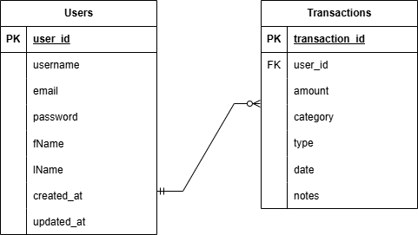
ERD

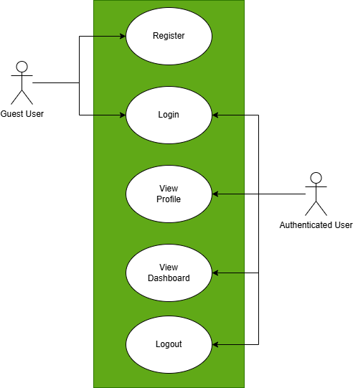
Use Case Diagram

Activity Diagram
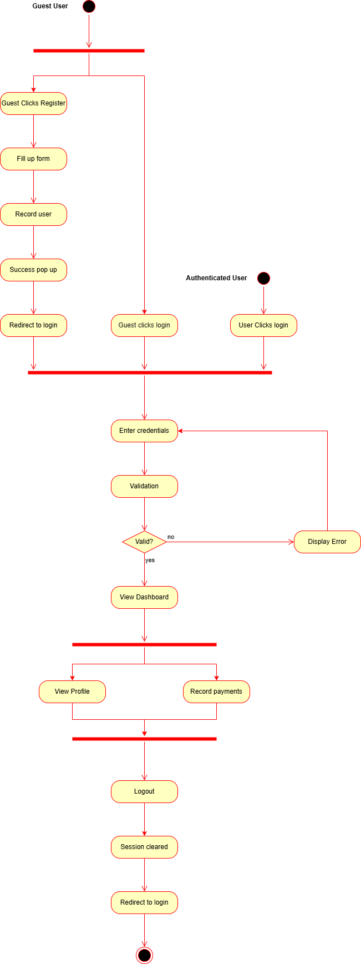

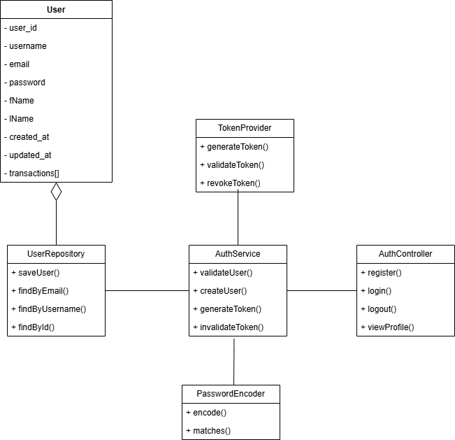
Class Diagram

Sequence Diagram
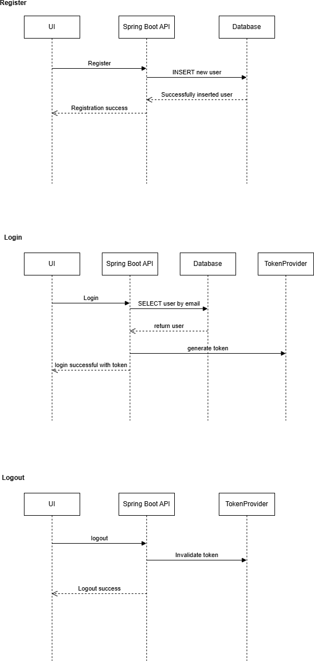

Appendices

Sample API Endpoints:
- POST /register → Create new user.
- POST /login → Authenticate user and return token.
- GET /dashboard → Return summary of transactions.
- POST /transaction → Add new transaction.
- PUT /transaction/:id → Update transaction.
- DELETE /transaction/:id → Delete transaction.
- POST /logout → Invalidate session token.

