STOCK TRANSFER REQUEST
Company Name: Lumiere Corporation
Company Address: Natalio B. Bacalso Ave, Bulacao Pardo, Cebu City, 6000 Cebu
Contact Number: 09705157399
Email Address: earljustinesierra@gmail.com
TRANSFER DETAILS
Transfer No. | Date Requested | Required Transfer Date | Transfer Status
TR-2026-0005 | 2026-05-19 | 2026-05-19 | Transfer Signed
REQUESTING WAREHOUSE INFORMATION
Warehouse Name | Warehouse B
Warehouse Address | N. Bacalso Avenue, Cebu City, Cebu
Warehouse Manager | Jan Andrie Bansag
Contact Number | janandrie@gmail.com
REQUESTED WAREHOUSE INFORMATION
Warehouse Name | Warehouse A
Warehouse Address | Pope John Paul II Avenue, Cebu City, Cebu
Warehouse Manager | Lumiere Manager
Contact Number | admin@lumiere.com
TRANSFER ITEM DETAILS
Item No. | Item Code / SKU | Description of Item | Quantity | Unit | Remarks
1 | NEO-ANM-TJ | Anime LED Neon Sign - Tanjiro Kamado | 10 | unit | Transfer to Warehouse B
TRANSFER SUMMARY
Total Items | 1
Total Quantity | 10
DELIVERY / TRANSFER INFORMATION
Pickup Location: Warehouse A - Pope John Paul II Avenue, Cebu City, Cebu
Delivery Location: Warehouse B - N. Bacalso Avenue, Cebu City, Cebu
Transfer Instructions:
- Ensure all transferred items match the approved stock transfer request.
- Items must be properly packed and labeled before release.
- Both warehouse managers must verify the transferred stock before signing.
TERMS AND CONDITIONS
- Only approved items listed in this document may be transferred.
- Any shortage, damage, or discrepancy must be reported immediately.
- The requesting warehouse becomes responsible for the items once received and verified.
- This document must be signed by both warehouse managers for validation.
SIGNATORIES

Requesting Warehouse Manager | Requested Warehouse Manager
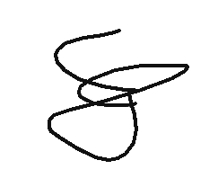  _____________________________  Jan Andrie Bansag  Date Signed: 2026-05-19 | 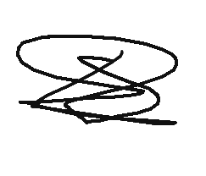  _____________________________  Lumiere Manager  Date Signed: 2026-05-19
Releasing / Receiving Confirmation
Note: The company information is fixed and should not be edited. Only placeholder values enclosed in {{ }} should be filled by the website/system.

