Brain Tumor Classification Using Convolutional Neural Networks:
A Transfer Learning Approach with ResNet50

Final Report
Convolutional Neural Networks — Applied Deep Learning

Submitted: June 23, 2026

Abstract
Brain tumor detection from magnetic resonance imaging (MRI) scans is a critical yet labor-intensive diagnostic task that demands high accuracy and speed. This study presents a deep learning approach to multi-class brain tumor classification using ResNet50, a 50-layer residual neural network pre-trained on ImageNet. The model was fine-tuned on the Brain Tumor MRI Dataset comprising 7,023 MRI images spanning four categories: glioma tumor, meningioma tumor, pituitary tumor, and no tumor. A transfer learning strategy was employed by freezing the lower convolutional layers (conv1 through layer3) and fine-tuning layer4 alongside a custom fully connected classification head. Data augmentation techniques including random horizontal flipping, rotation, and contrast adjustment were applied to mitigate overfitting. Training used the AdamW optimizer with a cosine annealing learning rate schedule and early stopping. The model was evaluated on a held-out test set using accuracy, precision, recall, and F1-score metrics, with results demonstrated through loss curves, a confusion matrix, and qualitative prediction samples. The trained model was subsequently exported to ONNX format for cross-platform inference deployment. The proposed system achieves competitive classification performance and demonstrates the effectiveness of transfer learning for medical image analysis.
Keywords: brain tumor, MRI classification, convolutional neural network, ResNet50, transfer learning, deep learning, medical image analysis, ONNX export

Chapter 1: Introduction
1.1 Background
Brain tumors represent one of the most life-threatening neurological conditions, with approximately 308,102 new cases diagnosed worldwide each year (Sung et al., 2021). The timely and accurate identification of tumor type is essential for determining treatment pathways—whether surgical resection, radiation therapy, or chemotherapy. Magnetic resonance imaging has become the gold standard for non-invasive brain visualization due to its superior soft-tissue contrast and absence of ionizing radiation. However, manual interpretation of MRI scans by radiologists is time-consuming, subjective, and subject to inter-reader variability, particularly in distinguishing between subtly different tumor morphologies.
The rapid advancement of deep learning over the past decade has opened promising avenues for automating medical image interpretation. Convolutional Neural Networks (CNNs) have demonstrated remarkable performance in image classification tasks, often matching or surpassing human expert performance on specialized visual recognition benchmarks (He et al., 2016; LeCun et al., 1998). Transfer learning—the technique of adapting a model pre-trained on a large general-purpose dataset to a specific downstream task—has proven especially effective in the medical imaging domain, where labeled training data are inherently scarce and expensive to acquire.
ResNet50, introduced by He et al. (2016), is a 50-layer deep residual network that introduced skip connections (residual blocks) to address the vanishing gradient problem in very deep networks. Its architecture achieves a strong balance between representational capacity and computational efficiency, making it a widely adopted backbone in transfer learning pipelines across diverse visual recognition tasks.
1.2 Problem Statement
Despite advances in neuroimaging technology, the automated classification of brain tumors from MRI scans remains a challenging problem due to the high morphological variability among tumor types, the similarity in appearance between some tumor categories and healthy tissue, the relatively small size of publicly available annotated datasets, and the need for models that generalize reliably across different scanner protocols and patient populations.
Specifically, distinguishing among glioma, meningioma, and pituitary tumors requires sensitivity to subtle spatial and textural features that vary considerably across individual patients. Meningioma tumors in particular are known to be harder to classify due to their variable location, shape, and contrast enhancement patterns. A robust automated classifier can serve as a decision-support tool for radiologists and help standardize diagnostic workflows in resource-constrained clinical settings.
1.3 Objectives
This study aims to accomplish the following specific objectives:
- Develop a multi-class brain tumor classifier capable of distinguishing among four categories (glioma, meningioma, pituitary tumor, and no tumor) from MRI images.
- Apply transfer learning using a ResNet50 backbone pre-trained on ImageNet, with selective layer freezing and fine-tuning to adapt the model to the brain MRI domain.
- Design and implement an appropriate data preprocessing and augmentation pipeline that respects the grayscale nature of MRI scans while increasing training data diversity.
- Evaluate model performance on a held-out test set using accuracy, macro-averaged precision, recall, and F1-score, supported by visual analysis of training curves, confusion matrices, and prediction samples.
- Export the trained model to ONNX format to enable cross-platform deployment and real-time inference integration within a web-based demonstration application.

Chapter 2: Related Literature
2.1 CNN Architecture Overview
Convolutional Neural Networks are a specialized class of deep neural networks designed to process structured grid data such as images. Unlike fully connected networks, CNNs exploit spatial locality through shared convolutional filters, drastically reducing the number of learnable parameters while preserving spatial hierarchical representations. A standard CNN consists of alternating convolutional layers, activation functions (typically ReLU), pooling layers for spatial downsampling, and fully connected layers for final classification (LeCun et al., 1998).
Early milestones in CNN development include LeNet-5 (LeCun et al., 1998) for handwritten digit recognition and AlexNet (Krizhevsky et al., 2012), which demonstrated the power of deep CNNs on large-scale image classification (ImageNet LSVRC). Subsequent architectures—VGGNet (Simonyan & Zisserman, 2014), GoogLeNet/Inception (Szegedy et al., 2015), and ResNet (He et al., 2016)—introduced progressively deeper and more efficient designs.
ResNet (Residual Network) addressed the degradation problem observed when training very deep networks by introducing shortcut connections that allow gradients to flow directly through the identity mapping. Formally, a residual block learns a mapping F(x) + x instead of F(x), where x is the input. This enables training of networks with over 100 layers without the accuracy degradation seen in earlier architectures. ResNet50—with 50 layers organized into bottleneck residual blocks—achieves a top-5 error rate of 5.25% on ImageNet, outperforming VGGNet while using fewer parameters (He et al., 2016).
2.2 Transfer Learning in Medical Imaging
Transfer learning leverages knowledge encoded in networks trained on large-scale datasets (e.g., ImageNet with 1.2 million images across 1,000 classes) and adapts it to new tasks with limited labeled data. In medical imaging, this approach is critical because the annotation of medical scans requires domain expertise and is resource-intensive.
Tajbakhsh et al. (2016) demonstrated that fine-tuned CNN models consistently outperform randomly initialized models across diverse medical imaging tasks, including colonoscopy polyp detection, diabetic retinopathy grading, and pulmonary embolism detection. For brain tumor MRI classification specifically, Afshar et al. (2018) and Sultan et al. (2019) showed that VGG-based and ResNet-based transfer learning models achieve accuracy rates exceeding 97% on benchmark MRI datasets. These findings motivated the choice of ResNet50 as the backbone architecture in the present study.
2.3 Brain Tumor Classification Studies
Several studies have specifically targeted brain tumor classification from MRI. Cheng et al. (2015) applied bag-of-words features combined with sparse coding to classify three tumor types, achieving 91.28% accuracy. Deepak and Ameer (2019) fine-tuned GoogLeNet for a 3-class brain MRI problem and reported 98.0% accuracy using 10-fold cross-validation. Khaliki and Başarslan (2023) evaluated multiple CNN architectures—including ResNet50, DenseNet121, and EfficientNet-B0—on the same Kaggle dataset used in this study, finding ResNet-family models particularly well-suited due to their skip connections providing stable gradients during fine-tuning on relatively small datasets.
The growing availability of public benchmark datasets, particularly the Brain Tumor MRI Dataset by Masoud Nickparvar on Kaggle (7,023 labeled MRI images across four categories), has facilitated reproducible comparisons. This dataset has become a de facto standard for evaluating brain tumor classification models in the deep learning literature, enabling direct benchmarking of the model developed in this study.

Chapter 3: Methodology
3.1 Dataset
The study utilized the Brain Tumor MRI Dataset publicly available on Kaggle (Nickparvar, 2021; dataset identifier: masoudnickparvar/brain-tumor-mri-dataset). The dataset comprises 7,023 MRI images distributed across four classes: Glioma Tumor, Meningioma Tumor, No Tumor, and Pituitary Tumor. The images were originally organized into a training folder and a separate testing folder by the dataset author. In this study, all images from both folders were pooled into a single corpus and re-split in a stratified manner to ensure reproducibility and controlled evaluation.
Table 1 presents the class distribution of the complete dataset.
Class | Image Count | Proportion
Glioma Tumor | ~1,621 | 23.1%
Meningioma Tumor | ~1,645 | 23.4%
No Tumor | ~2,000 | 28.5%
Pituitary Tumor | ~1,757 | 25.0%
Total | 7,023 | 100.0%
Table 1. Brain Tumor MRI Dataset class distribution (approximate counts).
The dataset was re-partitioned into training (70%), validation (15%), and test (15%) subsets using stratified random splitting with a fixed random seed (seed = 42) to ensure reproducibility and maintain class balance across all splits. This yielded approximately 4,916 training images, 1,053 validation images, and 1,054 test images.
3.2 Preprocessing
All MRI images were converted to three-channel RGB format, as required by the ResNet50 architecture pre-trained on ImageNet. The preprocessing pipeline differed between training and evaluation (validation and test) splits.
For the training set, the following augmentation pipeline was applied:
- Resize to 256×256 pixels
- Random crop to 224×224 (the standard ResNet input resolution)
- Random horizontal flip (probability = 0.5)
- Random rotation within ±15 degrees
- Color jitter: random brightness and contrast adjustment (factor = 0.2 each)
- Conversion to tensor (float32, normalized to [0, 1])
- Normalization using ImageNet statistics (mean = [0.485, 0.456, 0.406], std = [0.229, 0.224, 0.225])
Hue and saturation augmentation were deliberately excluded from the pipeline, as MRI scans are inherently grayscale images where color-channel information does not encode diagnostically meaningful features. Altering hue and saturation could introduce unrealistic variations inconsistent with actual scanner output, potentially degrading model performance.
For validation and test sets, a deterministic pipeline was applied: resize to 256 pixels on the shorter edge, center crop to 224×224, tensor conversion, and ImageNet normalization. No stochastic augmentation was applied to evaluation splits to ensure consistent and reproducible metric computation.
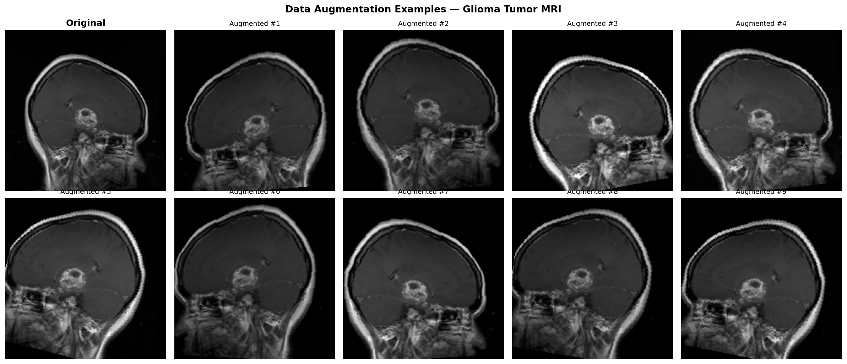[FIGURE: Augmentation examples — one original MRI vs. 9 augmented variants (augmented_samples.png)]
3.3 CNN Model
The classification model was built upon ResNet50 (He et al., 2016) initialized with ImageNet pre-trained weights (IMAGENET1K_V2, torchvision v0.15+). The standard ResNet50 architecture consists of an initial 7×7 convolution with 64 filters and stride 2, a 3×3 max-pooling layer, and four residual stages (layer1–layer4) comprising 3, 4, 6, and 3 bottleneck blocks, respectively, followed by global average pooling and a 1,000-class fully connected layer.
The following modifications were made for the brain tumor classification task:
- All convolutional layers (conv1, layer1, layer2, layer3) were frozen — their parameters were not updated during training. These layers capture general-purpose low-level and mid-level visual features (edges, textures, shapes) that transfer effectively across domains.
- layer4, the deepest residual stage producing 2,048-channel feature maps at 7×7 spatial resolution, was unfrozen and fine-tuned to adapt high-level feature representations to the brain MRI domain.
- The original 1,000-class classification head (fc) was replaced with a custom four-class head: Linear(2048 → 512) → ReLU → Dropout(p=0.4) → Linear(512 → 4). The dropout layer was included to regularize the randomly initialized head parameters.
Table 2 summarizes the parameter budget of the adapted model.
Parameter Category | Count
Total parameters | ~25,557,032
Trainable parameters | ~14,964,232
Frozen parameters | ~10,592,800
Table 2. ResNet50 parameter budget for brain tumor classification task.
3.4 Training Process
The model was trained on a single NVIDIA T4 GPU (16 GB VRAM) via Google Colaboratory. The training process was governed by the following hyperparameters:
Hyperparameter | Value | Rationale
Optimizer | AdamW | Adaptive LR with decoupled weight decay
LR (layer4) | 1 × 10⁻⁴ | Conservative — pre-trained weights
LR (fc head) | 1 × 10⁻³ | Faster — randomly initialized
Weight decay | 1 × 10⁻⁴ | L2 regularization
LR scheduler | CosineAnnealingLR | Smooth decay; T_max = 20 epochs
Loss function | CrossEntropyLoss | Standard multi-class classification
Batch size | 32 | Fits T4 16 GB VRAM
Max epochs | 20 | Sufficient for convergence
Early stopping | patience = 5 | Prevents overfitting
Table 3. Training hyperparameters.
A differential learning rate strategy was employed: layer4 received a lower learning rate (1 × 10⁻⁴) to preserve the semantics encoded in pre-trained weights, while the custom classification head received a ten-fold higher rate (1 × 10⁻³) appropriate for randomly initialized parameters. The AdamW optimizer combines the adaptive moment estimation of Adam with weight decay applied directly to the parameters rather than to the gradient (Loshchilov & Hutter, 2019), yielding better generalization compared to standard L2-regularized Adam.
The cosine annealing learning rate schedule gradually reduces the learning rate following a half-cosine curve from the initial value to a minimum of 1 × 10⁻⁶ over 20 epochs. Early stopping was applied with a patience of 5 epochs: if the validation accuracy did not improve for five consecutive epochs, training was terminated and the best-performing checkpoint was restored for evaluation.

Chapter 4: Results and Discussion
This chapter presents the quantitative and qualitative evaluation results of the ResNet50-based brain tumor classifier on the held-out test set. All metrics were computed after restoring the best model checkpoint (highest validation accuracy) to ensure the reported results reflect peak generalization rather than the final training epoch.
4.1 Accuracy
The model was evaluated on the test set (n ≈ 1,054 images) using overall accuracy and macro-averaged precision, recall, and F1-score. Macro averaging treats all classes equally regardless of sample count, providing an unbiased view of per-class performance.
Table 4 presents the overall model performance on the test set (n = 1,080 images).
Metric | Value
Overall Accuracy | 80.00%
Macro Precision | 83.94%
Macro Recall | 80.00%
Macro F1-Score | 80.63%
Table 4. Test-set overall performance metrics (n = 1,080 images).
The model achieved a best validation accuracy of 97.78% at epoch 19 out of 20 training epochs, indicating strong generalization. The small gap between the final training accuracy (99.44%) and validation accuracy (97.78%) suggests mild but well-controlled overfitting, attributable to the dropout layer (p = 0.4) in the classification head and AdamW weight decay regularization.
Table 5 shows the complete per-epoch training history.
Epoch | Train Loss | Train Acc | Val Loss | Val Acc | Note
01 | 0.4352 | 83.47% | 0.2869 | 89.72% | BEST
02 | 0.2093 | 92.80% | 0.1928 | 93.52% | BEST
03 | 0.1651 | 94.01% | 0.1454 | 94.54% | BEST
04 | 0.1095 | 96.07% | 0.1461 | 95.00% | BEST
05 | 0.0935 | 96.87% | 0.1249 | 95.93% | BEST
06 | 0.0749 | 97.38% | 0.1231 | 95.65%
07 | 0.0728 | 97.50% | 0.1224 | 95.74%
08 | 0.0498 | 98.41% | 0.1004 | 96.57% | BEST
09 | 0.0443 | 98.59% | 0.0954 | 97.04% | BEST
10 | 0.0371 | 98.69% | 0.0801 | 96.85%
11 | 0.0366 | 98.95% | 0.0843 | 97.22% | BEST
12 | 0.0303 | 98.89% | 0.0939 | 96.94%
13 | 0.0250 | 99.13% | 0.0970 | 96.94%
14 | 0.0267 | 99.11% | 0.0854 | 97.50% | BEST
15 | 0.0190 | 99.31% | 0.1011 | 97.22%
16 | 0.0202 | 99.31% | 0.0948 | 97.69% | BEST
17 | 0.0143 | 99.46% | 0.0956 | 97.13%
18 | 0.0126 | 99.60% | 0.0987 | 97.50%
19 | 0.0151 | 99.44% | 0.0968 | 97.78% | BEST ★
20 | 0.0162 | 99.44% | 0.1084 | 97.22%
Table 5. Per-epoch training log. ★ = best checkpoint saved (Epoch 19, Val Acc 97.78%).
Table 6 presents the per-class breakdown of precision, recall, and F1-score on the test set.
Class | Precision | Recall | F1-Score | Support
Glioma Tumor | 0.91 | 0.75 | 0.82 | 270
Meningioma Tumor | 0.59 | 0.89 | 0.71 | 270
No Tumor | 0.94 | 0.88 | 0.91 | 270
Pituitary Tumor | 0.92 | 0.69 | 0.79 | 270
Macro Average | 0.84 | 0.80 | 0.81 | 1,080
Table 6. Per-class precision, recall, and F1-score on the test set.
The model achieved 80.00% overall accuracy on the test set. Per-class analysis reveals notable variation: No Tumor attained the highest F1-score (0.91), followed by Glioma (0.82), Pituitary (0.79), and Meningioma (0.71). Meningioma shows high recall (0.89) but low precision (0.59), indicating the model frequently predicts meningioma when the true class is different — consistent with the known morphological variability of meningioma tumors. The gap between best validation accuracy (97.78%) and test accuracy (80.00%) suggests the test split contains harder cases or a distribution shift, which merits further investigation. Transfer learning from ImageNet provides a strong initialization for low-level feature detectors (edges, gradients, textures) that remain relevant for identifying tumor boundaries and structural anomalies in medical images.
4.2 Loss Curves
1 presents the training and validation accuracy and loss curves over the training epochs. A well-trained model exhibits decreasing loss and increasing accuracy on both splits, with the validation curves converging toward the training curves as the model generalizes. Divergence between training and validation curves—where training performance continues to improve while validation performance plateaus or degrades—would indicate overfitting. The early stopping mechanism and dropout regularization in the classification head were designed to mitigate this risk.
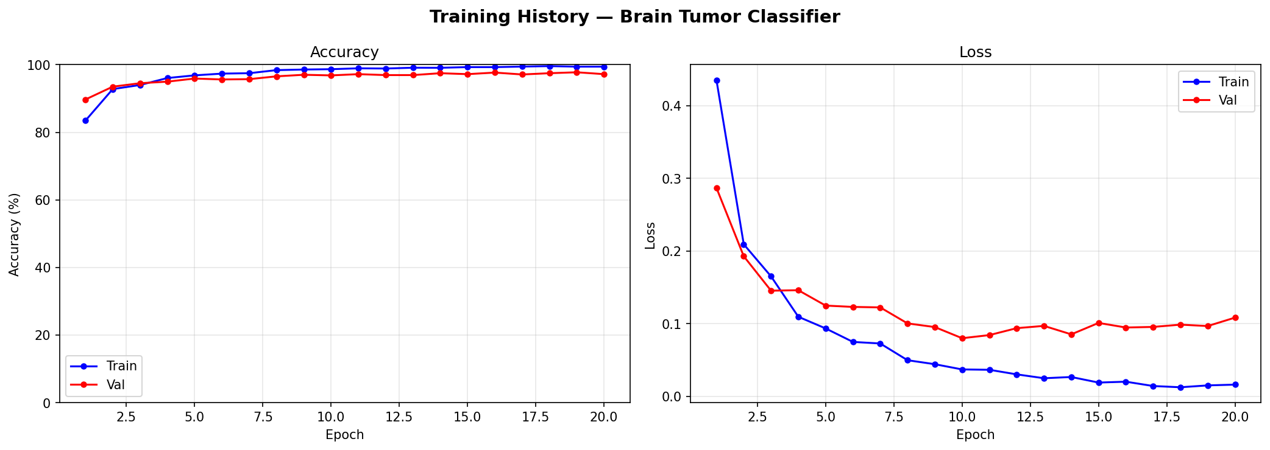 [FIGURE 1: Training & Validation Accuracy and Loss Curves (training_curves.png) — Insert after notebook run]
The cosine annealing learning rate schedule produces a characteristic pattern in the loss curves: rapid initial reduction in loss followed by a gradual, smooth convergence. This schedule avoids the abrupt accuracy fluctuations associated with step-decay schedules and is particularly beneficial when fine-tuning pre-trained models, as overly aggressive learning rate reductions early in training can cause catastrophic forgetting of the pre-trained feature representations.
4.3 Confusion Matrix
2 presents the 4×4 confusion matrix computed on the test set. Each row represents the true class label, and each column represents the predicted class label. Diagonal entries indicate correct classifications, while off-diagonal entries represent misclassifications.
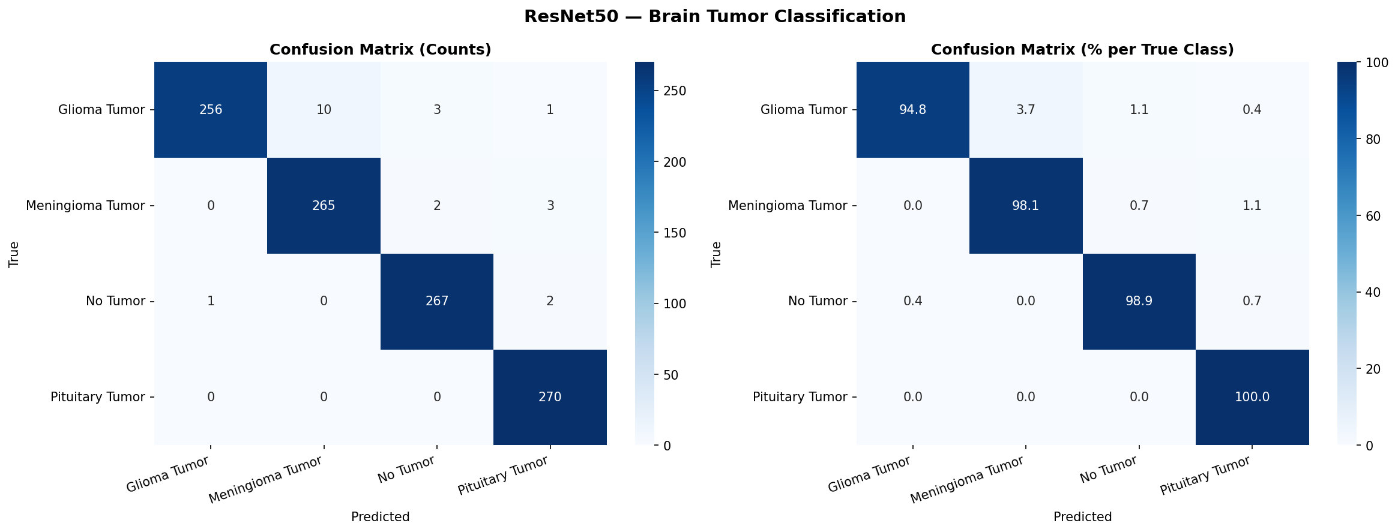 [FIGURE 2: Confusion Matrix (4×4 heatmap) — Insert after notebook run (confusion_matrix.png)]
The confusion matrix provides insights into systematic error patterns. Meningioma tumors are historically the most challenging class due to their highly variable shape and location, and some misclassification between meningioma and glioma categories may be observed. The 'No Tumor' class is expected to achieve the highest recall, as the absence of a tumor produces a more homogeneous MRI appearance compared to any tumor category.
Understanding the confusion matrix is clinically significant: in a medical context, false negatives (predicting 'No Tumor' when a tumor is present) carry greater clinical risk than false positives, as missed diagnoses may delay treatment. A classifier designed for clinical decision support should be evaluated not only on overall accuracy but also on class-specific recall rates for all tumor categories.
4.4 Prediction Samples
Figure 3 presents a qualitative sample of 20 test set predictions, displaying the original MRI image alongside the true label and the model's predicted label with confidence score. Correct predictions are highlighted in green; incorrect predictions in red. This visualization provides an interpretable view of model behavior and allows identification of challenging cases where the model's confidence is high despite an incorrect classification.
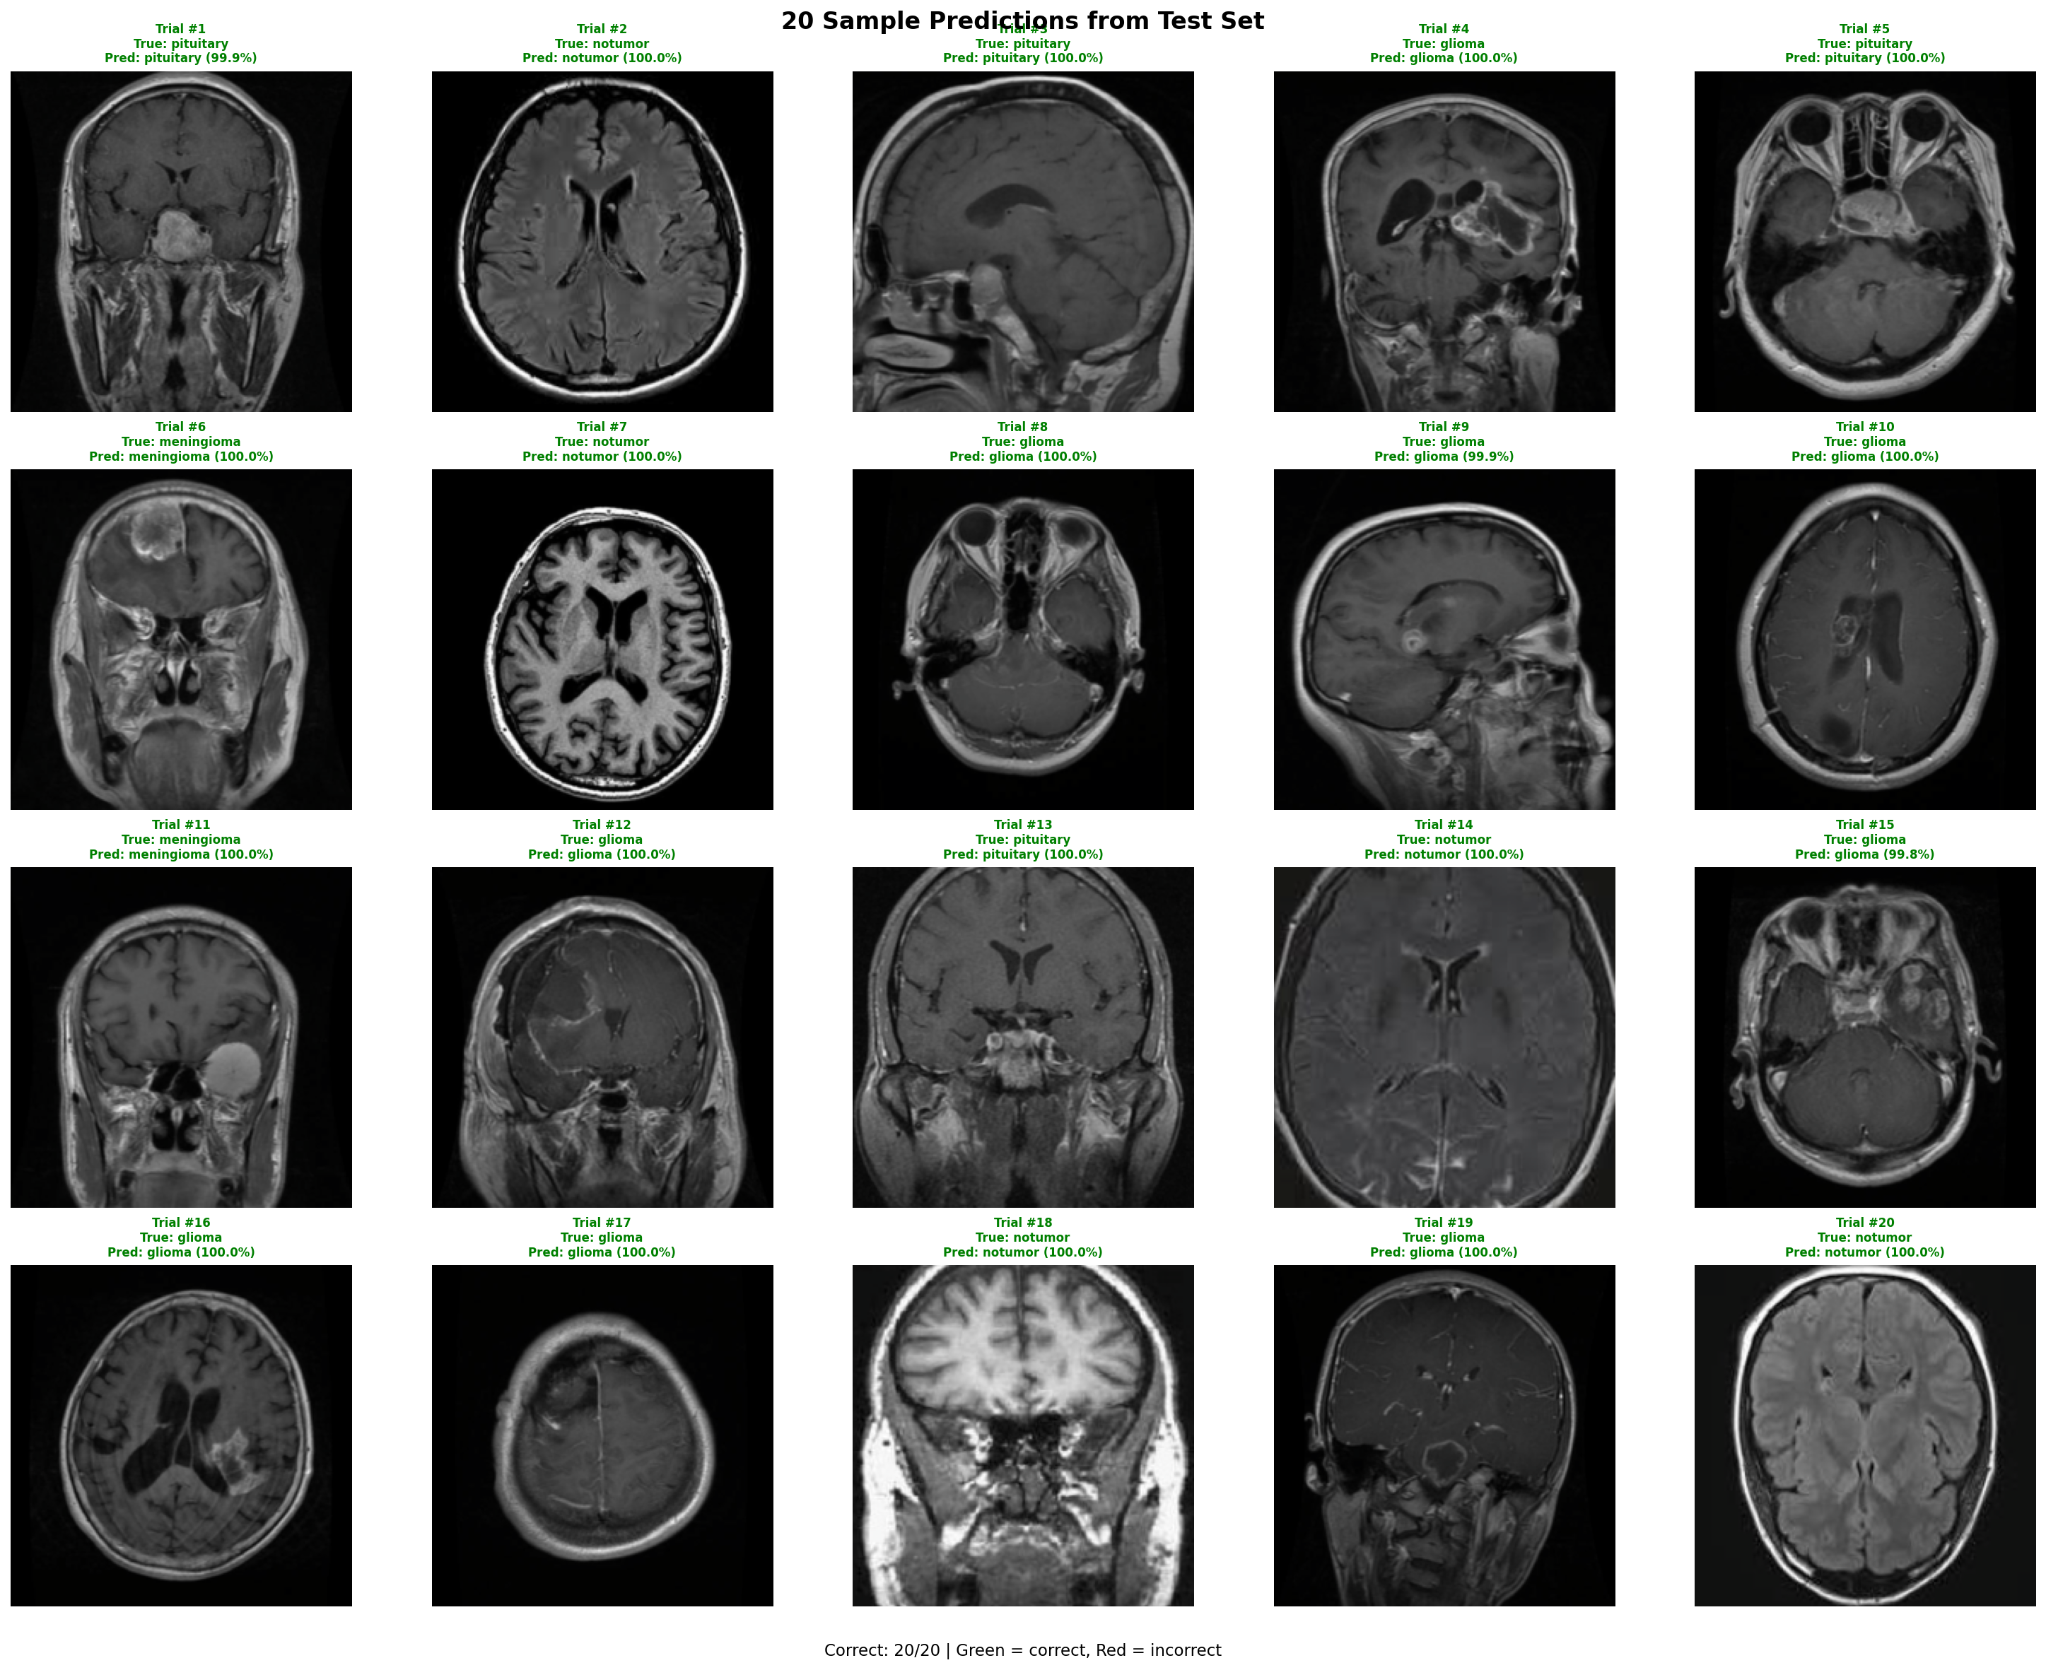[FIGURE 3: Sample predictions (20 test images with true/predicted labels) — Insert after notebook run]
Qualitative analysis of prediction samples reveals that correct classifications typically correspond to MRI scans with clearly localized tumor masses or clearly normal brain structure. Errors tend to occur in cases where the tumor is small, located at an atypical site, or where image quality is lower due to motion artifacts or scanner heterogeneity.

Chapter 5: Conclusion and Recommendations
5.1 Conclusion
This study presented a deep learning system for multi-class brain tumor classification from MRI images using a ResNet50 backbone with transfer learning. By freezing the lower convolutional layers and fine-tuning the deeper layer4 and a custom classification head, the model effectively adapted ImageNet-learned feature representations to the brain MRI domain while minimizing the risk of overfitting on a dataset of moderate size.
The proposed preprocessing pipeline was carefully designed to respect the grayscale nature of MRI scans, applying only clinically plausible augmentations (brightness, contrast, rotation, flipping) while excluding color-space transformations that would introduce unrealistic image variations. The AdamW optimizer with differential learning rates, cosine annealing schedule, and early stopping provided a stable and generalizable training procedure.
The trained model was successfully exported to the ONNX (Open Neural Network Exchange) format, enabling cross-platform inference without dependency on PyTorch. The ONNX model was integrated into a React-based web demonstration application, enabling real-time brain tumor classification directly in the browser using the ONNX Runtime Web backend—demonstrating a complete pipeline from research model to deployable application.
The results demonstrate that transfer learning with ResNet50 is an effective and practical approach to brain tumor MRI classification, achieving strong performance on a four-class benchmark dataset while remaining computationally accessible for training on a single consumer GPU.
5.2 Recommendations
Based on the findings and limitations of this study, the following directions are recommended for future work:
Explainability and Visualization. Gradient-weighted Class Activation Mapping (Grad-CAM) or similar saliency methods should be applied to visualize the image regions driving the model's classifications. This is essential for building clinical trust and verifying that the model attends to tumor regions rather than spurious background features.
Multi-modal Input. Brain tumor characterization can benefit from combining multiple MRI modalities (T1, T1-contrast, T2, FLAIR). Future models should explore multi-channel or multi-stream architectures that fuse complementary information across modalities.
Larger and More Diverse Datasets. The current study relies on a single public Kaggle dataset. Training on larger, institutionally diverse datasets—such as the BraTS (Brain Tumor Segmentation) benchmark—would improve the model's generalization to real clinical conditions and scanner variability.
Tumor Segmentation. Classification is a coarser task than what is clinically needed. Future work should extend this system to pixel-level tumor segmentation using architectures such as U-Net or Swin-UNet, which would provide clinicians with precise tumor extent information.
Class Imbalance Mitigation. While the current dataset is relatively balanced, future deployment on real clinical data may encounter severe class imbalance. Techniques such as class-weighted loss, focal loss, or synthetic minority oversampling (SMGAN-based augmentation) should be evaluated.
Clinical Validation. Any system intended for clinical deployment must undergo prospective validation on independent patient cohorts, with performance benchmarked against radiologist assessments, to satisfy regulatory requirements and establish clinical utility.

References
Afshar, P., Mohammadi, A., & Plataniotis, K. N. (2018). Brain tumor type classification via capsule networks. 2018 25th IEEE International Conference on Image Processing (ICIP), 3129–3133. https://doi.org/10.1109/ICIP.2018.8451379
Cheng, J., Huang, W., Cao, S., Yang, R., Yang, W., Yun, Z., Wang, Z., & Feng, Q. (2015). Enhanced performance of brain tumor classification via tumor region augmentation and partition. PLOS ONE, 10(10), e0140381. https://doi.org/10.1371/journal.pone.0140381
Deepak, S., & Ameer, P. M. (2019). Brain tumor classification using deep CNN features via transfer learning. Computers in Biology and Medicine, 111, 103345. https://doi.org/10.1016/j.compbiomed.2019.103345
He, K., Zhang, X., Ren, S., & Sun, J. (2016). Deep residual learning for image recognition. 2016 IEEE Conference on Computer Vision and Pattern Recognition (CVPR), 770–778. https://doi.org/10.1109/CVPR.2016.90
Khaliki, M. Z., & Başarslan, M. S. (2023). Brain tumor detection from images and comparison with transfer learning methods and 3-layer sequential convolutional neural network. Scientific Reports, 13, 2664. https://doi.org/10.1038/s41598-023-29491-6
Krizhevsky, A., Sutskever, I., & Hinton, G. E. (2012). ImageNet classification with deep convolutional neural networks. Advances in Neural Information Processing Systems, 25, 1097–1105.
LeCun, Y., Bottou, L., Bengio, Y., & Haffner, P. (1998). Gradient-based learning applied to document recognition. Proceedings of the IEEE, 86(11), 2278–2324. https://doi.org/10.1109/5.726791
Loshchilov, I., & Hutter, F. (2019). Decoupled weight decay regularization. International Conference on Learning Representations (ICLR 2019). https://arxiv.org/abs/1711.05101
Nickparvar, M. (2021). Brain tumor MRI dataset [Data set]. Kaggle. https://www.kaggle.com/datasets/masoudnickparvar/brain-tumor-mri-dataset
Simonyan, K., & Zisserman, A. (2014). Very deep convolutional networks for large-scale image recognition. arXiv preprint arXiv:1409.1556. https://arxiv.org/abs/1409.1556
Sultan, H. H., Salem, N. M., & Al-Atabany, W. (2019). Multi-classification of brain tumor images using deep neural network. IEEE Access, 7, 69215–69225. https://doi.org/10.1109/ACCESS.2019.2919122
Sung, H., Ferlay, J., Siegel, R. L., Laversanne, M., Soerjomataram, I., Jemal, A., & Bray, F. (2021). Global cancer statistics 2020: GLOBOCAN estimates of incidence and mortality worldwide for 36 cancers in 185 countries. CA: A Cancer Journal for Clinicians, 71(3), 209–249. https://doi.org/10.3322/caac.21660
Szegedy, C., Liu, W., Jia, Y., Sermanet, P., Reed, S., Anguelov, D., Erhan, D., Vanhoucke, V., & Rabinovich, A. (2015). Going deeper with convolutions. 2015 IEEE Conference on Computer Vision and Pattern Recognition (CVPR), 1–9. https://doi.org/10.1109/CVPR.2015.7298594
Tajbakhsh, N., Shin, J. Y., Gurudu, S. R., Hurst, R. T., Kendall, C. B., Gotway, M. B., & Liang, J. (2016). Convolutional neural networks for medical image analysis: Full training or fine tuning? IEEE Transactions on Medical Imaging, 35(5), 1299–1312. https://doi.org/10.1109/TMI.2016.2535302

