efg, 2024-07-30

Contents

1 KORA Request 2

2 KORA Reply 4

2.1 Email 4

2.2 Attachments 5

2.2.1 2004 Agreement between KS Dept. of Revenue and Secretary of State 5

2.2.2 2006 Memorandum/Contract between KS Dept. of Revenue and Secretary of State 5

2.2.3 2012 Memorandum of Understanding between Kansas Secretary of State and KS Dept. of Revenue 6

2.2.4 2004 Agreement between KS Dept. of Revenue and Social Security Administration 6

# KORA Request

Kansas Open Records Act Request

|  |  |
| --- | --- |
| **Subject:** | Kansas Open Records Act (KORA) Request |
| **Date:** | Tue, 30 Apr 2024 15:58:42 -0500 |
| **From:** | Earl Glynn |
| **To:** | Ted Smith |

Ted Smith  
General Counsel, Kansas Department of Revenue

Dear Mr. Smith:

**Background Information**

1.      The Social Security Administration (SSA) maintains a website “Help America Vote Verification (HAVV) Transactions by State,” <https://www.ssa.gov/open/havv/>

2.      This site shows transactions by week by state (but for some reason weeks after March 30, 2024 have not been appearing). The most recent week is here:   
<https://www.ssa.gov/open/havv/havv-weekly-2024-03-30.html>

From file HAVV-running-list.xlsx downloaded from this SSA site on April 30, 2024 here is an example of the most recent Kansas data:

Kansas data from worksheet 033024

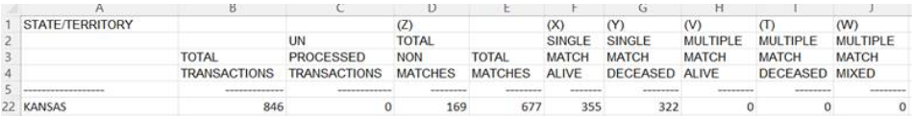

Kansas data from worksheet “January 2011-to-date”

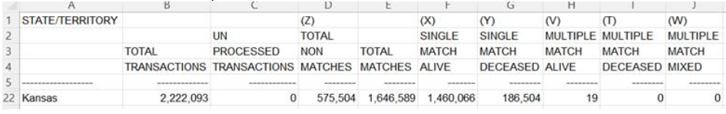

3.      “The Help America Vote Act of 2002, P.L. 107-252 (HAVA) requires States to verify the information of newly registered voters for Federal elections. Each State must establish a computerized State-wide voter registration list and verify new voter information with the State’s Motor Vehicle Administration (MVA).” <https://www.ssa.gov/open/havv/>

**KORA Request**

1.      Copy of any active “memorandum of understanding,” or similar documents with agreements, **between the Kansas Department of Revenue and the Social Security Administration** about the administration of the Help America Vote Verification (HAVV) data.

2.      Copy of any active “memorandum of understanding,” or similar documents with agreements, **between the Kansas Department of Revenue and the Kansas Secretary of State’s office** about the administration of the Help America Vote Verification (HAVV) data and transfer of data to ELVIS (Election Voter Information System).

3.      Any reports from 2023 through current April 2024 (preferable in a csv or Excel file) showing a breakdown of the statewide numbers shown on the national HAVV site (<https://www.ssa.gov/open/havv/>), such as shown in Section 2 of Background Information above, but by individual Kansas drivers license location.

Thank you.

--   
efg | Earl F Glynn …

# KORA Reply

## Email

|  |  |
| --- | --- |
| **Subject:** | **KORA Request** |
| **Date:** | Fri, 21 Jun 2024 15:56:20 +0000 |
| **From:** | David S. French [KDOR] |
| **To:** | Earl Glynn |
| **CC:** | Adam King [KDOR] |

Good morning,

Here are the documents responsive to your KORA request.

Thanks,

 David French

Records Custodian | Office of Policy and Research

**Kansas Department of Revenue**109 SW 9th Street | Topeka, KS  66601-3506  
Phone: 785-291-3570 | Fax: 785-296-7928  
[David.french@ks.gov](mailto:David.french@ks.gov) | ksrevenue.gov

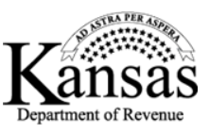  
  
CONFIDENTIALITY STATEMENT:   
This message and its contents are privileged and confidential and it is solely for the use of the intended recipient. Should you not be the intended recipient, be aware that any review, disclosure, copying, distribution or use of the contents of this message is strictly prohibited. If you have received this message in error, please destroy it immediately and notify the sender.

## Attachments

### 2004 Agreement between KS Dept. of Revenue and Secretary of State

|  |  |  |
| --- | --- | --- |
| **File** | **Date** | **Pages** |
| **Agreement with Office of the Secretary of State 07.24.04.pdf**  Signed by Ron Thornburgh, SOS and Joan Wagnon, KDOR | 7/22/2004 | 5 |
| **Agreement with Office of the Secretary of State.pdf**   * p. 1 matches p. 1 of above document, but this copy has no handwriting or date stamp * p. 2 matches p. 3 of above document, but is unsigned * p. 3 matches p. 5 of above document |  | 3 |

1. The DEPARTMENT will verify all drivers license records with the Social Security Administration. The Department will coordinate an initial batch verification process and subsequent interactive on-line verification. Once the Kansas Drivers License record is verified with the Social Security Administration, the Kansas Drivers License record maintained within the Kansas Drivers License Database will indicate the record as verified.
2. Once the DEPARTMENT has verified the initial listing of drivers license records, the DEPARTMENT will receive the Central Voter Registration file from the OFFICE OF THE SECRETARY OF STATE to compare with the verified listing of drivers license records. (see attachment A for file format)

### 2006 Memorandum/Contract between KS Dept. of Revenue and Secretary of State

|  |  |  |
| --- | --- | --- |
| **File** | **Date** | **Pages** |
| **Memorandum, Contract between KDOR & SOS.pdf**  [unsigned but names listed: Ron Thornburg, SOS; Joan Wagnon, KDOR] | 1/27/2006 | 3 |

*WHEREAS, the parties desire to enter into a contract for purposes of complying with Section 303 of the Help America Vote Act (MAYA);*

*…*

*SOS will interface with DMV using Power Profile EE/Agency Central to validate information as*

*required by HAVA. Voter registration* ***applicants will provide either a driver's license number or the last***

***four digits of the social security number****, which shall be validated by DMV using a live connection (i.e.,*

*real time). DMV shall be responsible for implementing custom search logic as a secure web service,*

*which shall be accessible by Agency Central via the intemet.*

***If DMV is unable to validate the information*** *using the driver's license database, DMV shall validate the*

*last four digits of the social security number,* ***when provided,*** *with the Social Security Administration*

*using the verification process established through the American Association of Motor Vehicle*

*Administrators (AAMVA).*

*SOS agrees to pay one-half of DMV's costs to participate in the first year of the AAMVA verification*

*process, which costs shall not exceed $11,860. "First year" as used in this section shall mean the*

*calendar year of January 1,2006 to December 31, 2006.*

Exhibit “A” is missing.

### 2012 Memorandum of Understanding between Kansas Secretary of State and KS Dept. of Revenue

|  |  |  |
| --- | --- | --- |
| **File** | **Date** | **Pages** |
| **Memorandum of Understanding (2).pdf** Between **Kansas Secretary of State** and **Kansas Dept of Revenue**  *Signed by Secretary of Revenue and Secretary of State* | 6/5/2012 | 5 |

* + 5-digit zip is not considered “personal information”
  + Both agencies have “contact” person
  + “Limit access only to those individuals directly responsible”
  + Silent about reports except for quarterly reports for non-driver IDs
  + **“Nothing in this MOU shall prohibit the SOS from disclosing aggregate information derived from such records as long as protected, personal information is not disclosed.”**

### 2004 Agreement between KS Dept. of Revenue and Social Security Administration

|  |  |  |
| --- | --- | --- |
| **File** | **Date** | **Pages** |
| **Memorandum of Agreement - Model, MVA using AAMVANE Inc.pdf**  Agreement received from Social Security Administration on March 25, 2004 by DMV. | 3/22/2004 | 7 |

The purpose of this Agreement is to establish the conditions under which the Social Security Administration (SSA) will provide Social Security Number (SSN) verification services to the Kansas Department of Revenue.

…

The American Association of Motor Vehicle Administrators' (AAMVA) subsidiary

AAMVAnet, Inc. is hereafter deemed the "agent" for the Kansas Department of Revenue for

billing purposes and will serve as the conduit to transmit information to and receive information

from SSA, consistent with the terms of this Agreement. AAMVAnet, Inc. will transmit

information to and receive information from SSA on behalf of the Kansas Department of

Revenue.

SSA agrees to provide the Kansas Department of Revenue with SSN online verification service for its existing, renewal and new drivers' license (DL), and identification card (ID) records via direct terminal access through AAMVAnet, Inc.