<https://datacentral.ksde.org/>

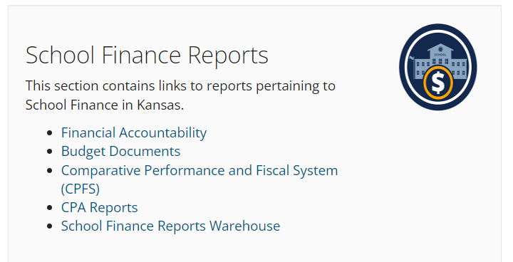

<https://datacentral.ksde.org/cpfs.aspx>

Kansas Department of Education  
Comparative Performance and Fiscal System (CPFS) - Data Central

All Unified School Districts / General / USD Budget Summary – Cash Balance

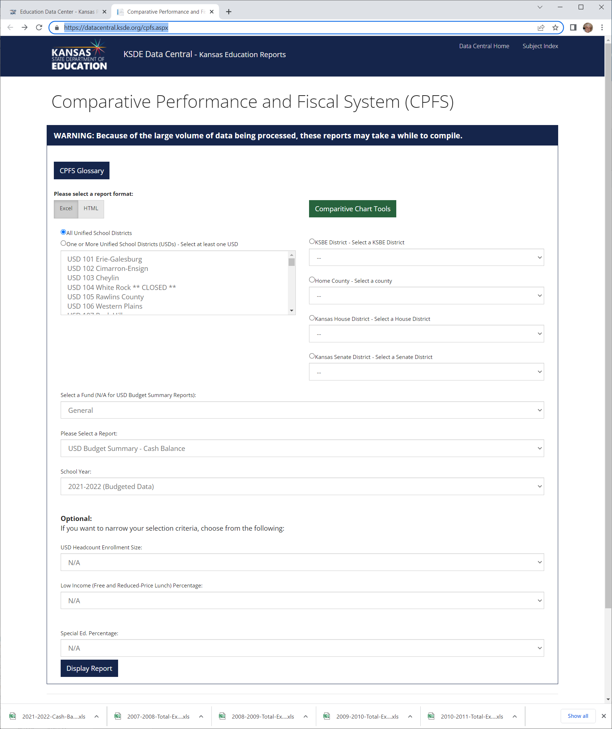

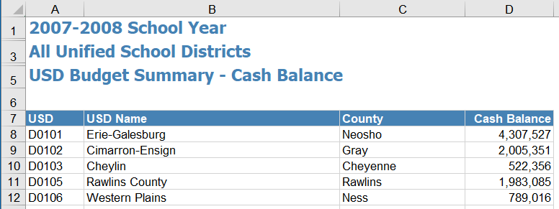

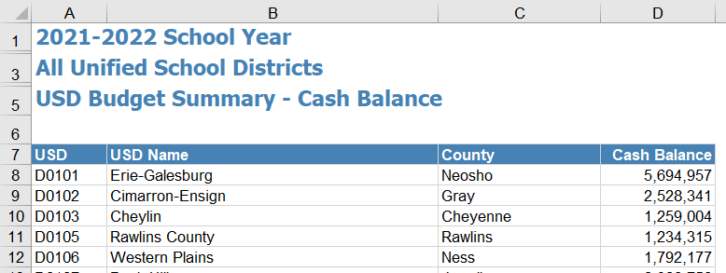

<https://datacentral.ksde.org/>



<https://datacentral.ksde.org/school_finance_reports.aspx>

Cash Balances

