efg, 2024-07-09

Contents

1 Kansas Population Pyramid 2

2 data.census.gov 5

3 www.census.gov 8

# Kansas Population Pyramid

<https://data.census.gov/profile/Kansas?g=040XX00US20#populations-and-people>

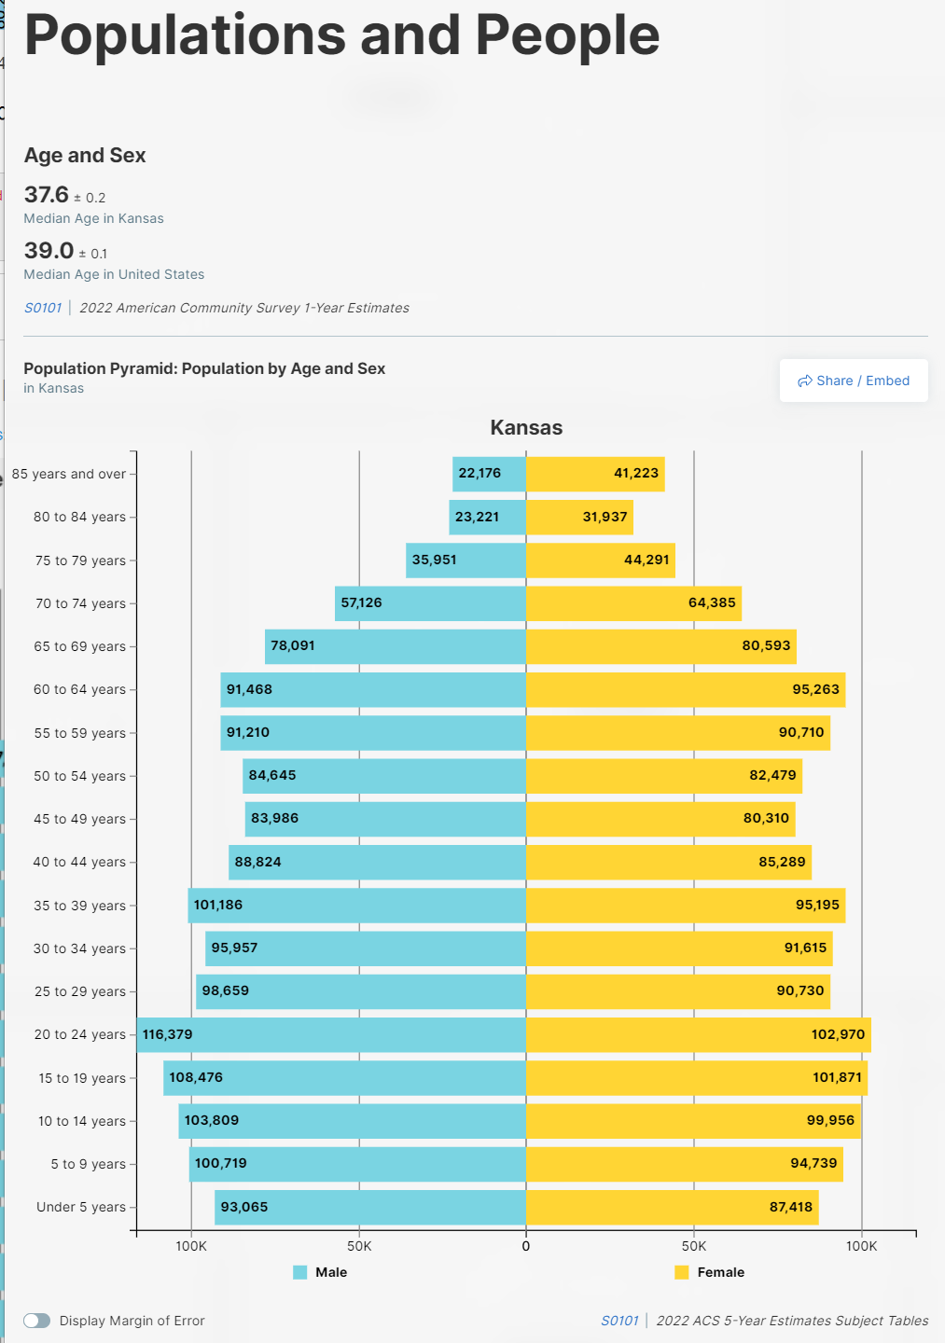

S0101 | 2022 ACS 5-year Estimates Subject Tables

Link goes here:

https://data.census.gov/table/ACSST5Y2022.S0101?g=040XX00US20&tid=ACSST5Y2022.S0101

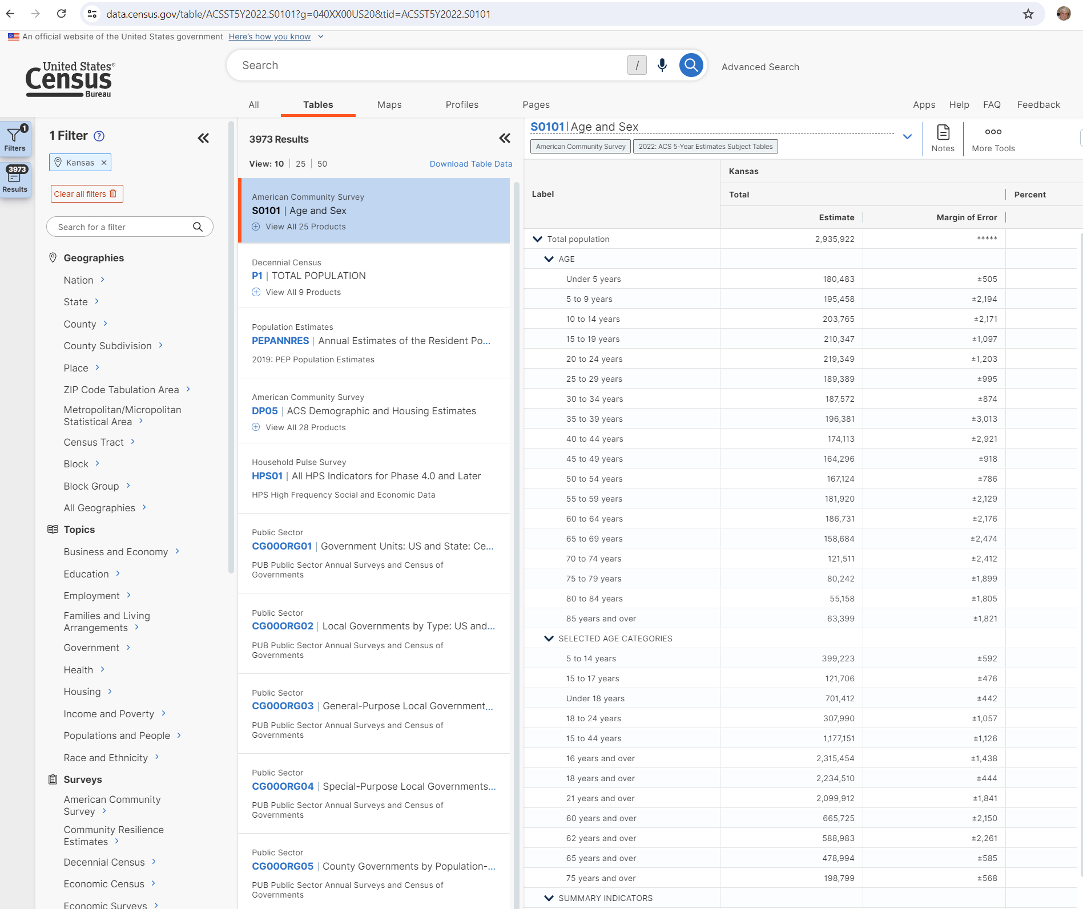

Years

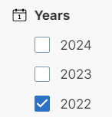

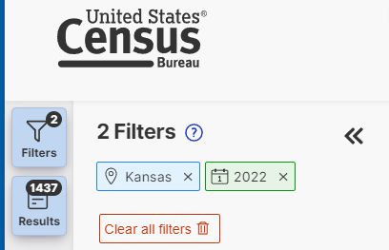

Download Table Data

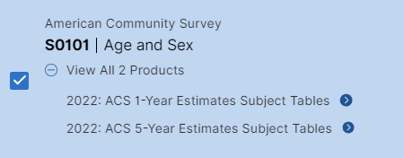



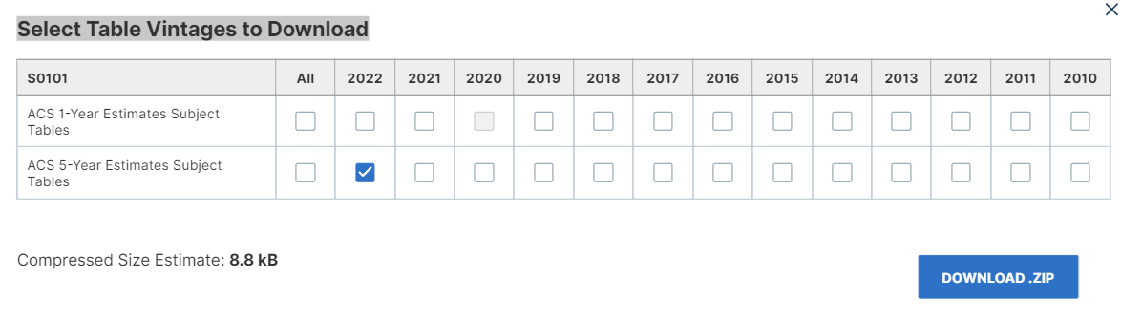

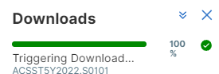

ACSST5Y2022.S0101_2024-07-09T013427.zip

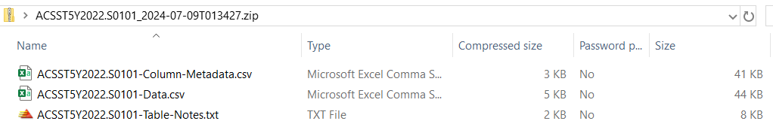

# data.census.gov

<http://data.census.gov>

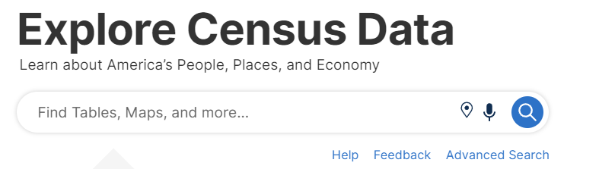

Geographies

* State: Kansas
* County: All Counties within Kansas

Surveys

* American Community Survey  
  5-Year Estimates

Year

* 2022

Search: S0101

* Age & Sex

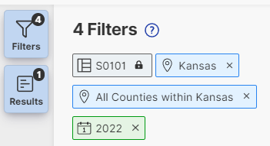

Tables

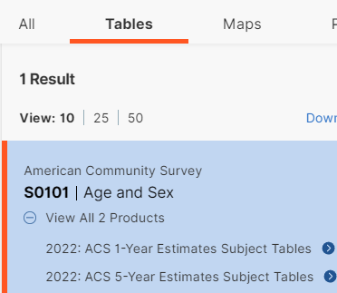

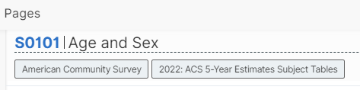

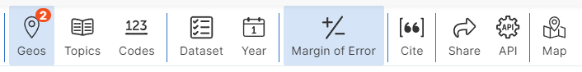

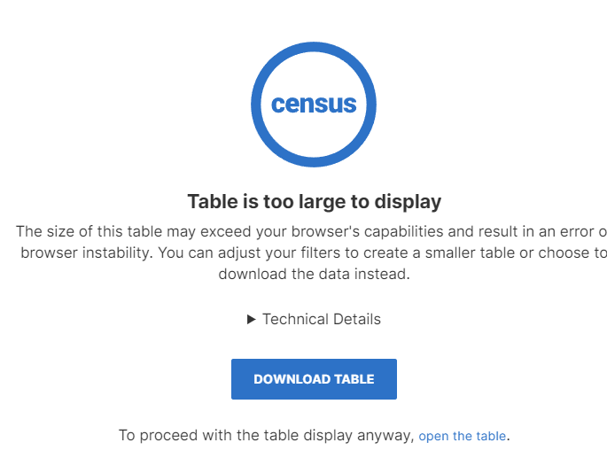

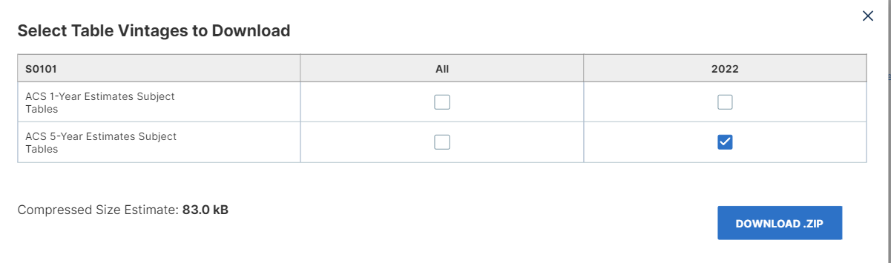

ACSST5Y2022.S0101_2024-07-09T015212.zip

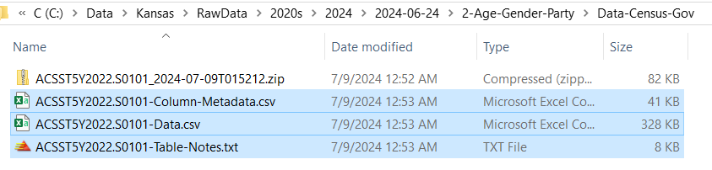

One row for State and each County

Many columns

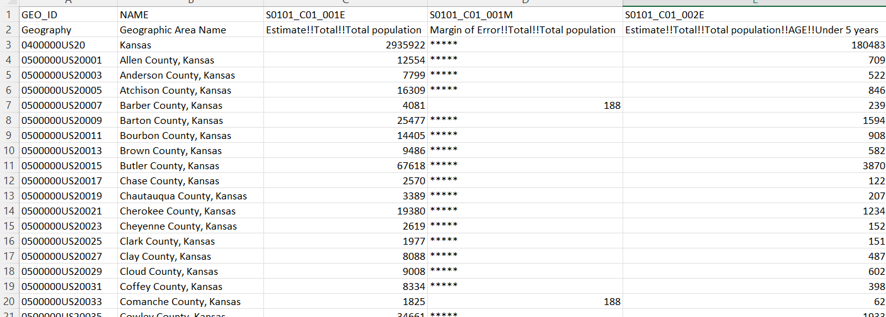

# [www.census.gov](http://www.census.gov)

<https://www.census.gov/>



<https://www.census.gov/data.html>



https://data.census.gov/table/ACSDP1Y2017.DP05?q=United%20States&table=DP05&g=010XX00US&lastDisplayedRow=29&vintage=2017&layer=state&cid=DP05_0001E&tid=ACSDP1Y2017.DP05

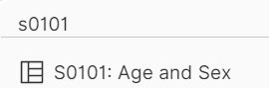



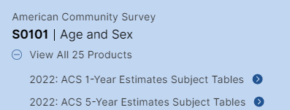

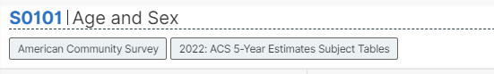

https://data.census.gov/table/ACSST5Y2022.S0101?q=s0101&g=010XX00US







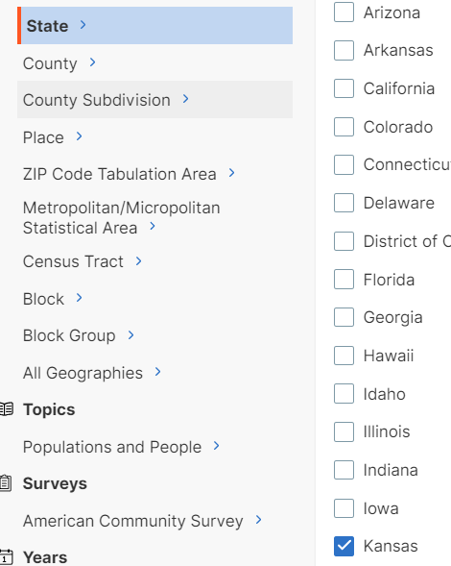

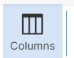

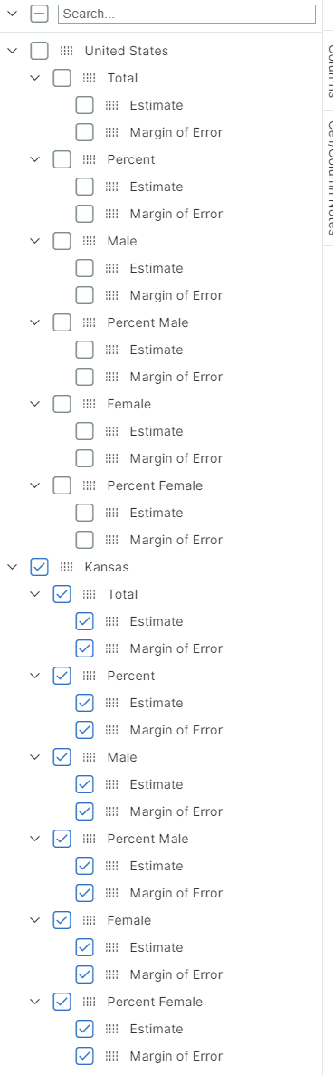

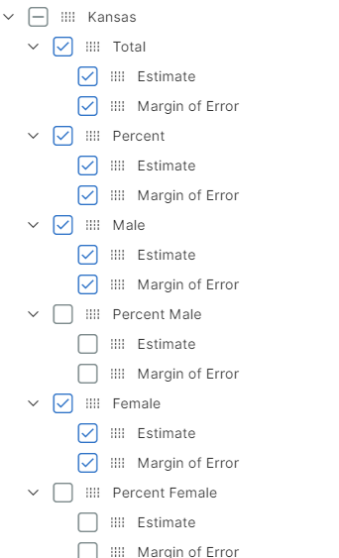

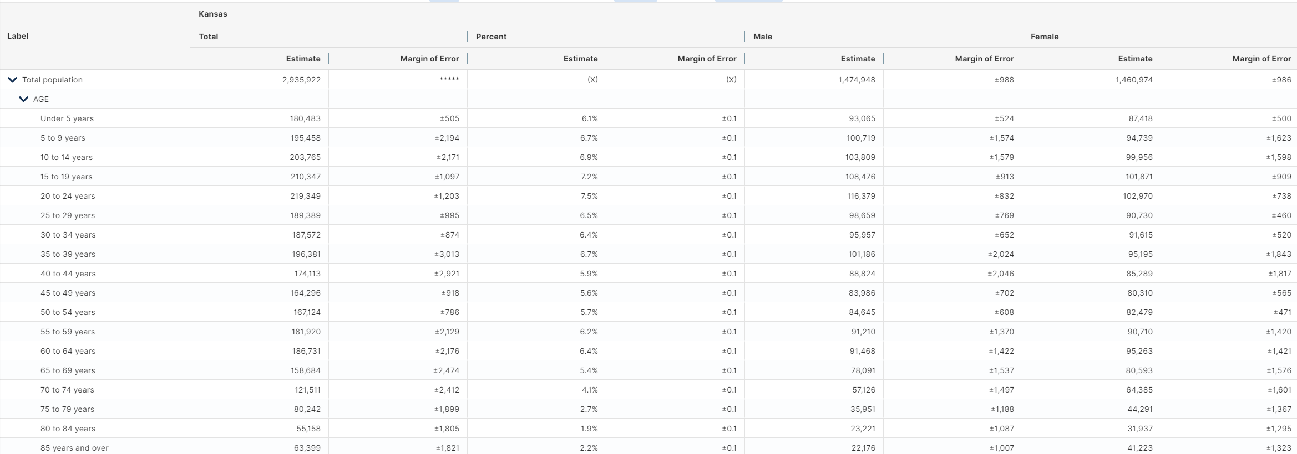



ACSST5Y2022.S0101-2024-07-08T231013.xlsx





