Follow instructions here to get started with MIMIC-III:   
<https://mimic.physionet.org/gettingstarted/access/>

**Requesting Access**

You’ll need to complete these online training sessions before you can request access to MIMIC-III data:

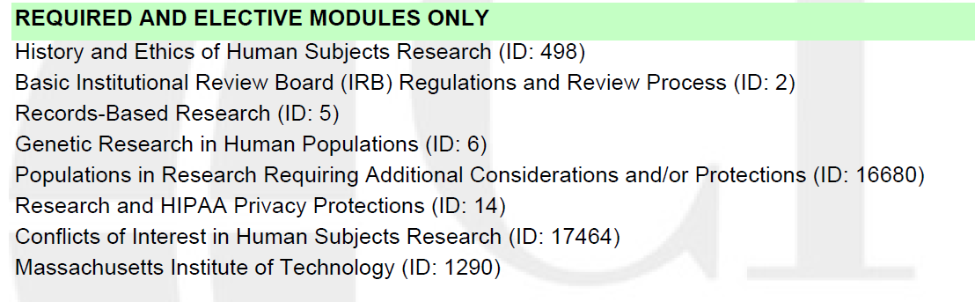

Next request access to the MIMIC-III data.

Once you’ve been granted access, follow these instructions:

<https://mimic.physionet.org/gettingstarted/dbsetup/>

The **DownloadMIMIC-III.nb.html** notebook shows how to download the files, unzip them, and compute md5sums.