Let’s do a few more quality checks before loading the data.

The notebook, **MIMIC-III-Will-Files-Parse.nb.html**, looks at parsing the files before loading them into the Postgres database.

This script summarizes some metadata about the files:

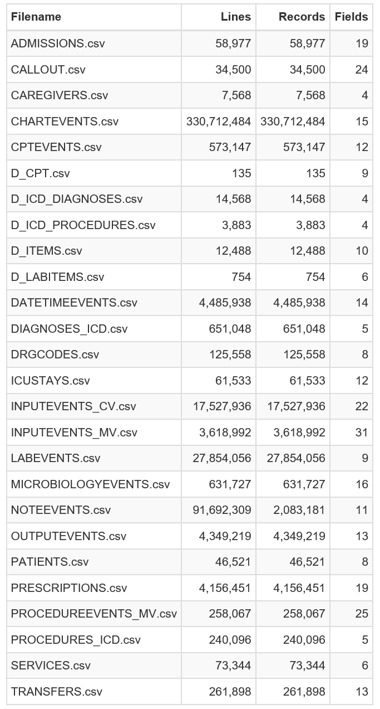

Except for NOTEEVENTS.csv, the number of lines in the files matches the number of data records, each with the given number of fields. These files should be easy to parse.

The fields in NOTEEVENTS.csv for a single record often span several dozen lines. The notebook shows how some fields are enclosed in opening and closing quotes (“) that can span several lines. As long as software supports reading multi-line fields enclosed in quotes, all the logical records of NOTEEVENTS.csv have exactly 11 fields.