**Installing-PostgreSQL-on-Windows-for-MIMIC-III.docx**

Download and use BigSQL graphical installer to install Postgres on Windows in directory D:\PostgreSQL.

To use the odbc R package below, be sure to install the Windows Postgres ODBC Driver discussed in Section 4.

**Loading-MIMIC-III-into-PostgreSQL.docx**

Run psql shell to …

* create mimic database,
* load tables with data,
* build indexes for faster access,
* test the build.

The final section shows a link to online MIMIC-III database schema documentation.

**MIMIC-Install-on-Postgres.html**

Additional details about running SQL command in psql from previous step.

**MIMIC-III-First-Look** using several database packages

First look at accessing MIMIC-III database tables using RStudio notebooks and R database packages. I very much wanted RPostgres to be the package of choice, but it currently has some problems with time stamps (2018-12-23).

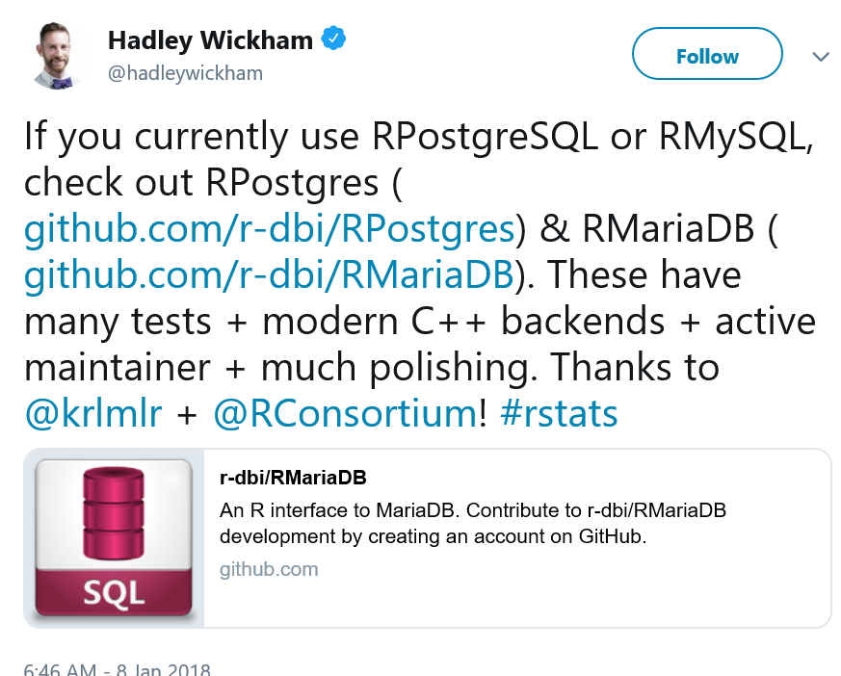

* [RPostgreSQL](https://cran.r-project.org/web/packages/RPostgreSQL/index.html): **MIMIC-III-First-Look-RPostgreSQL.html**  
  Database interface and 'PostgreSQL' driver for 'R'. This package provides a Database Interface 'DBI' compliant driver for 'R' to access 'PostgreSQL' database systems.  
    
  Summary: RPostgreSQL CORRECTLY shows dates back to 1800, but DOES NOT ALLOW execution of Postgres SQL chunks in RStudio.
* [RPostgres](https://cran.r-project.org/web/packages/RPostgres/index.html): **MIMIC-III-First-Look-RPostgres.html**  
  Fully 'DBI'-compliant 'Rcpp'-backed interface to 'PostgreSQL.  
    
  Summary: RPostgres DOES NOT correctly show dates back to 1800 (only to 1969), but ALLOWS execution of SQL chunks. How to resolve no timezone specified with original data with current timezone?
* [odbc](https://cran.r-project.org/web/packages/odbc/index.html): **MIMIC-III-First-Look-odbc.html**  
  Connect to ODBC Compatible Databases (using the DBI Interface).

Summary: odbc CORRECTLY shows dates back to 1800, but DOES NOT ALLOW execution of Postgres SQL chunks in RStudio.