This online article about MIMIC shows three Jupyter notebooks with tutorial information:

Alistair E.W. Johnson, et al, [MIMIC-III, a freely accessible critical care database](https://www.ncbi.nlm.nih.gov/pubmed/27219127), Scientific Data, 2016-05-24 online.

<https://github.com/MIT-LCP/mimic-iii-paper/tree/master/notebooks>   
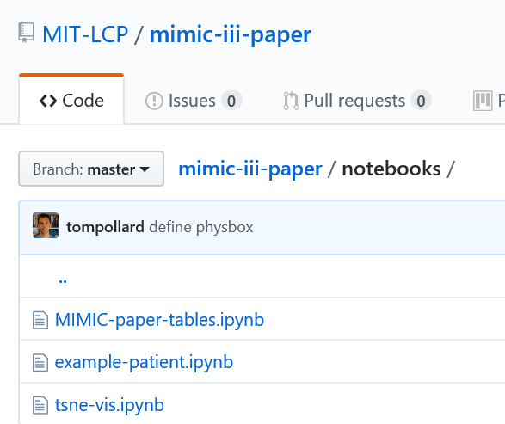

I can only get the **example-patient.ipynb** notebook to work with my installation of MIMIC and current version of Anaconda **Python 3** at this time.

I see this problem with **MIMIC-paper-tables.ipynb**:

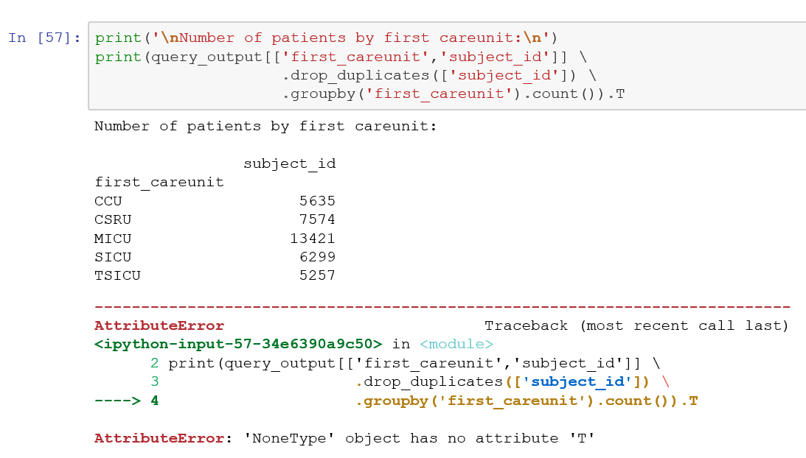

I see this problem with **tsne-vis.ipynb**:

