<http://mcdc.missouri.edu/>



<http://mcdc.missouri.edu/data/georef/zcta_master.Metadata.html>

This metadata pertains to the data set [**zcta_master**](http://mcdc2.missouri.edu/cgi-bin/broker?_PROGRAM=websas.uex2dex.sas&_SERVICE=appdev9&path=/pub/data/georef&dset=zcta_master&view=0) dataset within the **/pub/data/georef** data directory of the MCDC data archive.

Metadata for dataset /pub/data/georef/zcta_master

This dataset was created as a concatentation of the 51 state datasets stored in the **zctamstr** subdirectory of this (/pub/data/georef) data directory. It completely replaces the previous version done in early September, 2012.

zcta_master link above is to

<http://mcdc2.missouri.edu/cgi-bin/broker?_PROGRAM=websas.uex2dex.sas&_SERVICE=appdev9&path=/pub/data/georef&dset=zcta_master&view=0>

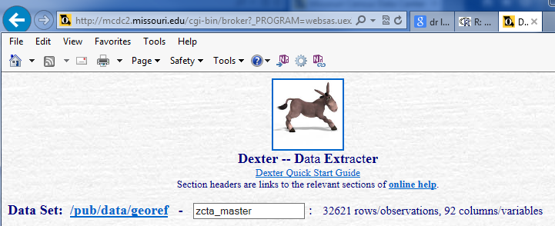

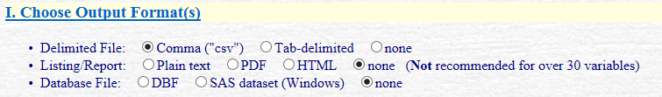



No selection

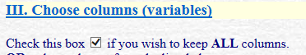



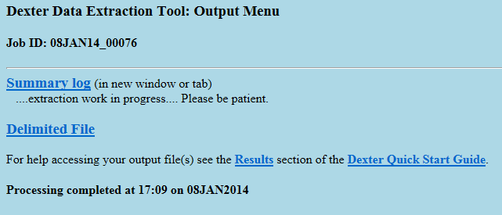

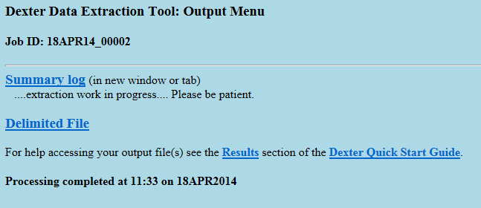

Selected: Delimited File



C:\Data\US-Government\Census-Bureau\Missouri-Census-Data-Center>md5sum x*.csv

fa0523dd6339a5c116940e2549b5d200 *xtract-2014-01-08.csv

fa0523dd6339a5c116940e2549b5d200 *xtract-2014-04-18.csv

Summary Log:

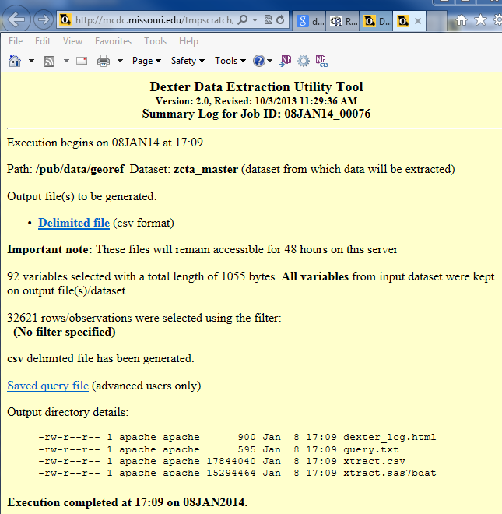

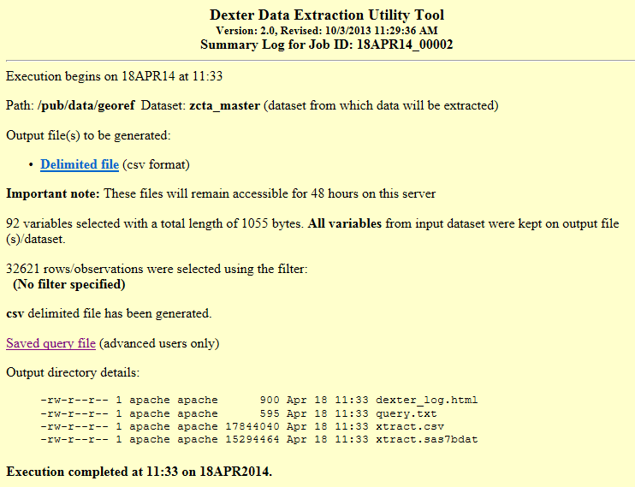

Saved query file

*----dexter saved query file----*;

%let path=/pub/data/georef;

%let sasdset=zcta_master;

%let view=0;

%let nomenu=0;

%let dlm=csv;

%let lst=none;

%let dbfile=none;

%let _aggby=;

%let _agglvl=1;

%let _grand=NO;

%let _dropvars=_lvl_ _nag_;

%let _means=;

%let _mweights=;

%let _nodupagg=0;

%let where =;

%let _labelopt=;

%let rept_byvars=;

%let rept_idvars=;

%let odsstyle=sasweb;

%let orient=portrait;

%let fmtstmt=;

%let renamestmt=;

%let labelstmt=;

%let keepvars2=_all_;

%let keepvars1=&keepvars2;

%let morexyvars= ;

%let maxobs=;

%let title2=;

%let sortby=;

%let subtitle= ;

%let footnote= ;

<http://mcdc.missouri.edu/data/georef/zcta_master.Metadata.html>

**zcta5**   
ZIP Census Tabulation Area (5-digit). We sometimes like to think of this as the "same thing" as a ZIP code but it really is not. Close enough for many (most?) applications though. These are **proxies for residential ZIP codes as defined on Jan. 1, 2010 and "rounded" off to census blocks**.

**zipname**   
A name assigned to the ZIP code associated with the ZCTA. This name comes from the Snow directory file where it is the "City name" suggested by the USPS. This is the name that can be used as the last line of an address to get mail delivered to the ZIP. However, we think that name is not always the best. For example: ZIP code 63119 comes with a "city name" of "Saint Louis", which is close. This ZIP code is actually just east of the city of St. Louis and is almost entirely within the suburb city of Webster Groves. Since we know what place (city) the ZIP (ZCTA) intersects with we are able to "improve" on the original name by assigning one based on the city (if any) with which it intersects. So you will find that the value of this variable for the 63119 observation is "Webster Groves, MO". If the ZCTA lies all or mostly outside any unincorporated area (with no CDP assigned) then the original post-office city name is retained.

**stab**   
State postal abbreviation. For example, "MO". Values are in upper case. Corresponds to the State variable.

**county**   
The county in which the ZCTA is all or mostly contained. Over 90% of ZCTAs fall entirely within a single county.

**county2**   
The "secondary" county for the ZCTA, i.e. the county with which it has the 2nd largest intersection. Over 90% of the time this value will be blank.

**ZCTA Data from the American Community Survey**

**medianage**   
Median age in years

**pctunder18**   
% Under 18 years of Age

**pctover65**   
% 65 years and over

**pctwhite1**   
% White alone

**pctblack1**   
% Black or African American

**pctasian1**   
% Asian

**pcthispanicpop**   
% Hispanic or Latino of any race

**tothhs**   
Total households

**medianhhinc**   
Median household income

**famhhs**   
Family Households

**medianfaminc**   
Median family income

**povuniverse**   
Persons for whom poverty status is determined

**pctpoor**   
% Persons Below Poverty

**pctgrpquarters**   
% Living in Group Quarters

**pctincollege**   
% In College or graduate school

**pctbachelorsormore**   
% Bachelor degree or higher

**pctforeignborn**   
% Foreign born

**tothus**   
Total housing units

**occhus**   
Occupied housing units

**pctrenterocc**   
% Renter-occupied units

**medianhvalue**   
Median Home Value

**mediangrossrent**   
Median Rent