# <http://www.whitehouse.gov/briefing-room/disclosures/visitor-records>

# 

To download data released from 2009-2010 in its raw format, [click here](http://www.whitehouse.gov/files/disclosures/visitors/WhiteHouse-WAVES-Released-1210.zip%20). (.zip of a .csv, 20MB)

To download Part 1 of the data released in 2011 in its raw format, [click here](http://www.whitehouse.gov/files/disclosures/visitors/WhiteHouse-WAVES-Released-0711b.zip). (.zip of a .csv, 7.4MB)

To download Part 2 of the data released in 2011 in its raw format, [click here](http://www.whitehouse.gov/files/disclosures/visitors/WhiteHouse-WAVES-Released-through-December-2011.zip). (.zip of a .csv, 15.2MB)

To download the data released in 2012 in its raw format, [click here](http://www.whitehouse.gov/sites/default/files/disclosures/whitehouse-waves-2012.csv_.zip). (zip of a .csv, 28.4MB)

To download the data released in 2013 in its raw format, [click here](http://www.whitehouse.gov/sites/default/files/disclosures/whitehouse-waves-2013.csv__0.zip). (zip of a .csv, 16.06MB)

To download the data released in 2014 in its raw format, [click here](http://www.whitehouse.gov/sites/default/files/disclosures/whitehouse-waves-2014_09.csv_.zip). (zip of a .csv, 11.75MB)

To download an explanation of the column headers contained in the raw data file, [click here](http://www.whitehouse.gov/files/disclosures/visitors/WhiteHouse-WAVES-Key-1209.txt). (.txt, 1.3KB)

Request White House Visitor Access

As detailed in our [Voluntary Disclosure Policy on Visitor Access Records](http://www.whitehouse.gov/VoluntaryDisclosure), for records between January 20 and September 15, 2009, White House Counsel will voluntarily respond to individual requests that are reasonable, narrow, and specific (e.g. requests that list possible visitors).  To request such visitor records, [click here](http://www.whitehouse.gov/requestvisitorrecords).

.

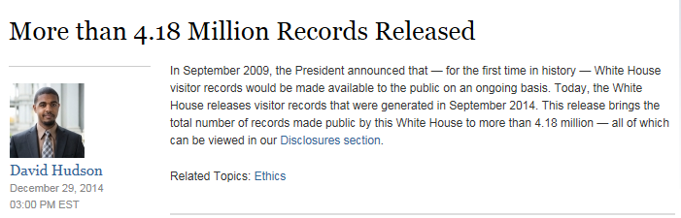

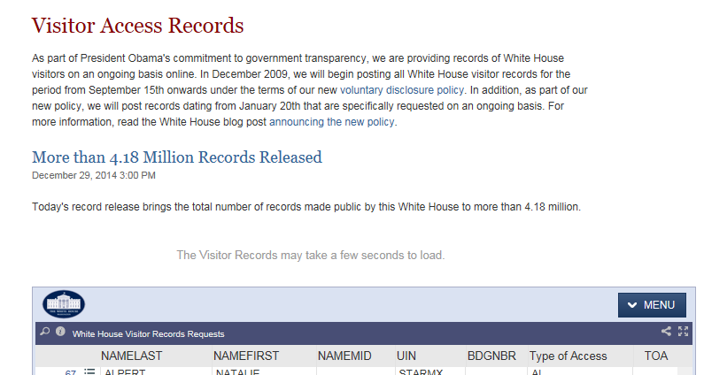

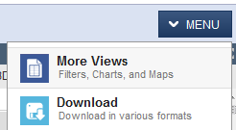

Download

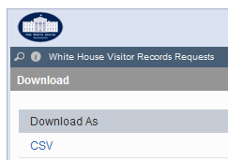



**→stored in F:\WhiteHouse\2014-08-29\White_House_Visitor_Records_Requests.csv**

3,891,622 records (August 29, 2014, 719 MB)

3,616,357 records (Apr 25, 2014, 607 MB)

3,577,137 records (Mar 28, 2014, 601 MB)

3,481,591 records (Feb 28, 2014, 585 MB)

3,443,065 records (Jan 31, 2014, 579 MB)

3,427,531 records (Dec 27, 2013, 576 MB)

3,408,503 records (Nov 29, 2013, 573 MB)

3,393,018 records (Nov 8, 2013, 570 MB)

3,367,184 records (Sept 27, 2013, 566MB)

3,345,244 records (Aug 30, 2013, 562 MB)

3,325,453 records (July 26, 2013, 559 MB)

3,298,736 records (June 28, 2013, 554 MB)

3,246,487 records (May 31, 2013, 546 MB)

3,190,660 records (Apr 26, 2013, 537 MB)

3,141,037 records (Mar 29, 2013, 528 MB)

3,030,412 records (Feb 22, 2013, 510 MB)

3,599,501 records (Jan 25, 2013, 602 MB)

3,527,467 records (Dec 28, 2012, 590 MB)

2,834,619 records (Nov 30, 2012, 477 MB)

2,751,457 records (Oct 26, 2012, 464 MB)

2,661,174 records (Sept 28, 2012, 449 MB)

2,560,232 records (Aug 31, 2012, 432 MB)

2,477,299 records (July 27, 2012, 417 MB)

2,367,783 records (June 29, 2012, 398 MB)

2,248,018 records (April 27, 2012, 377 MB)

2,097,152 records (Feb. 24, 2012, 351 MB)

Always verify no tabs in file since tab-delimited format is used for cleaned-up file.

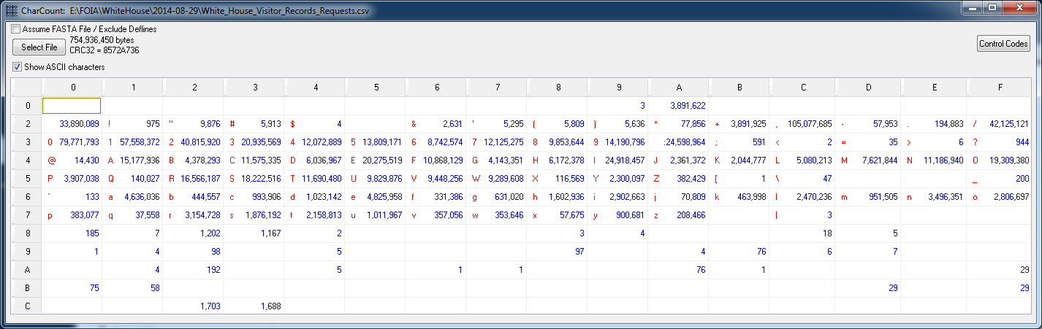

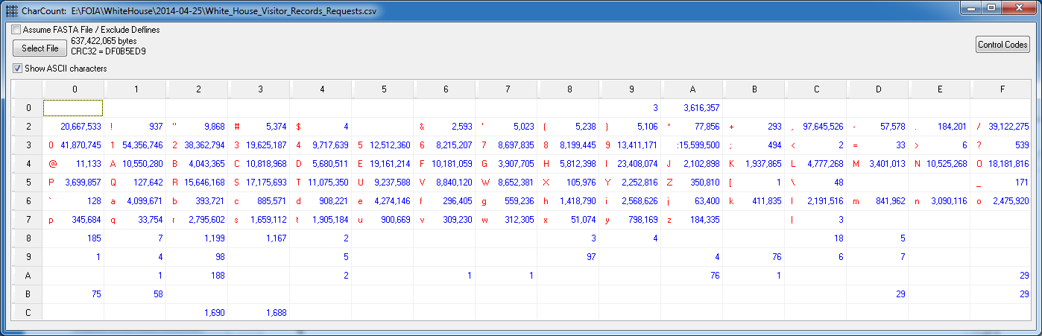

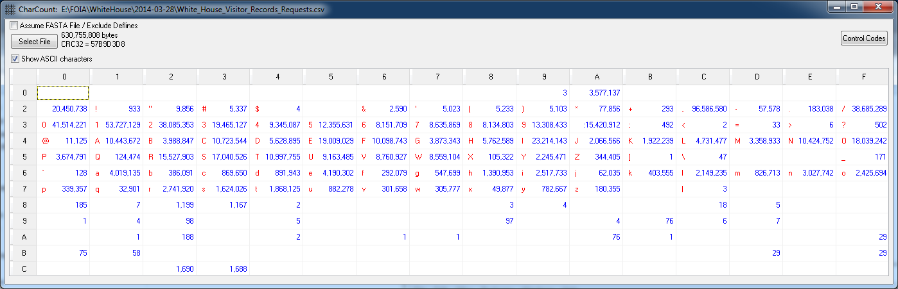

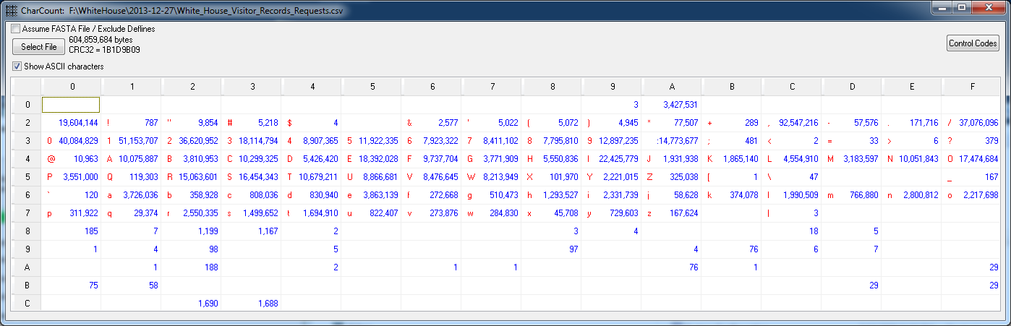

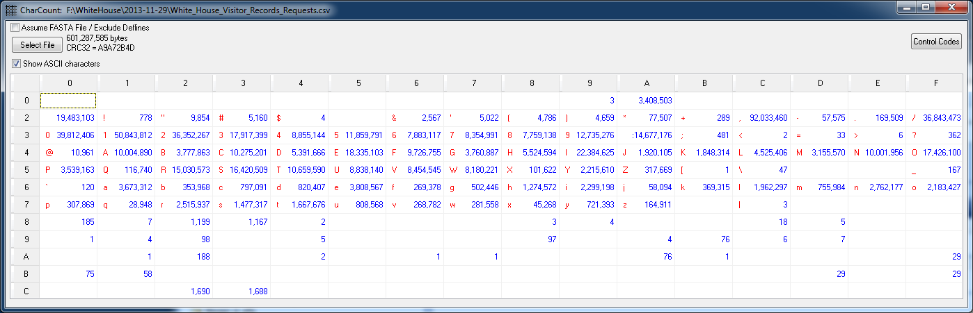

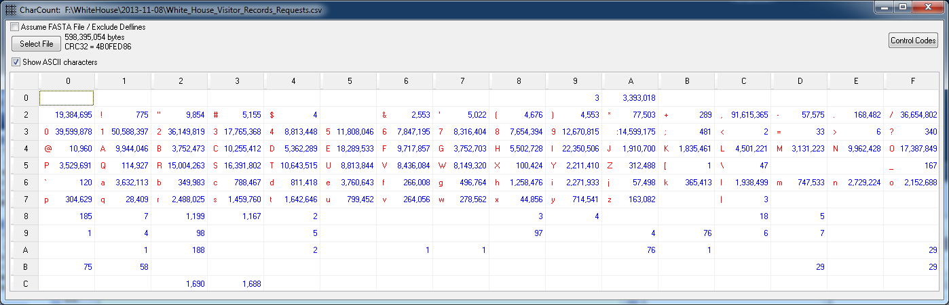

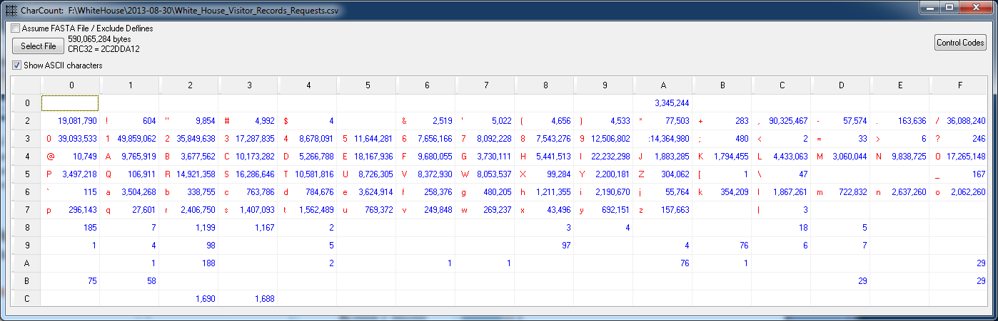

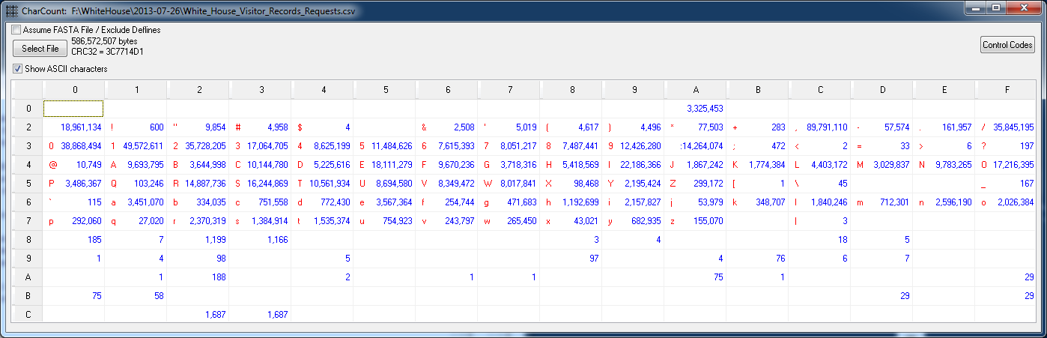

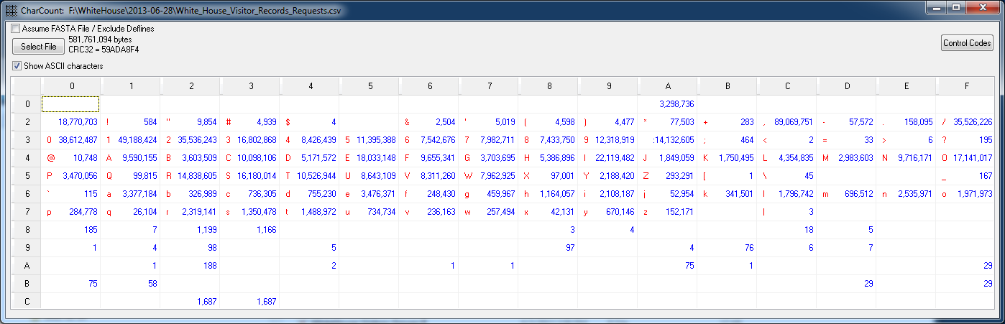

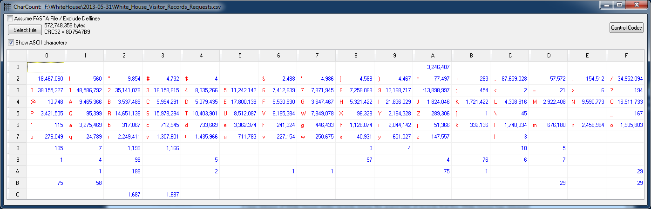

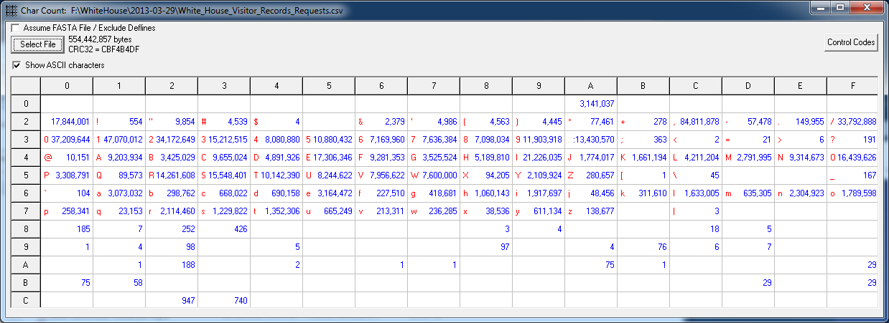

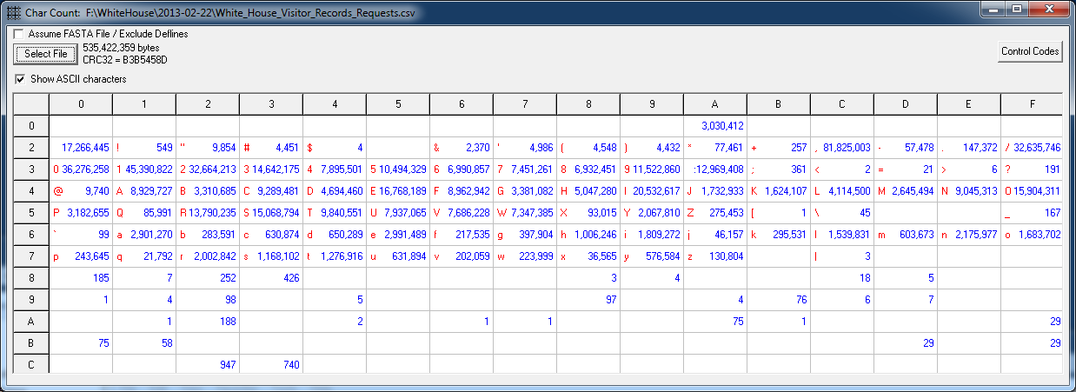

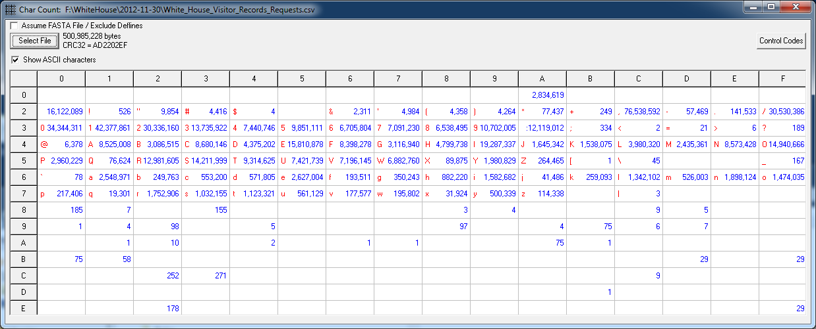

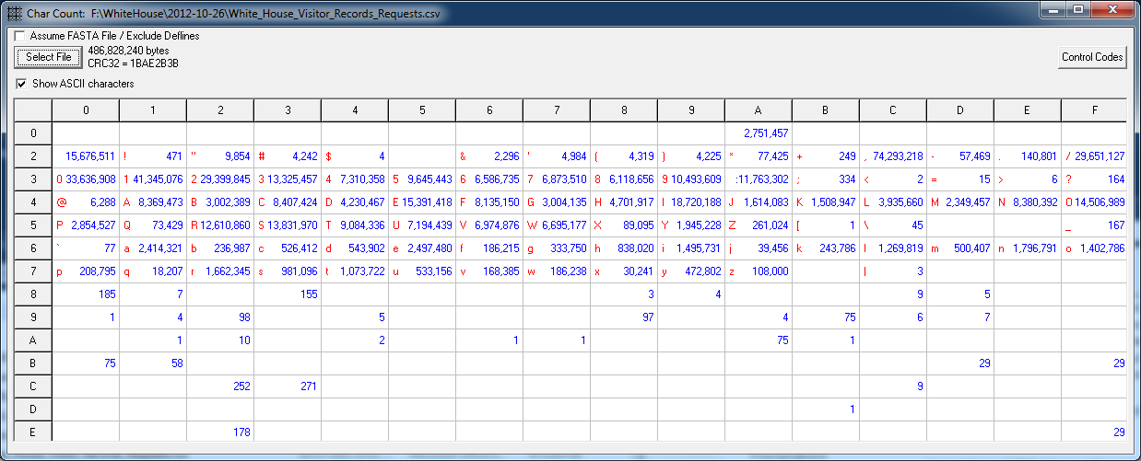

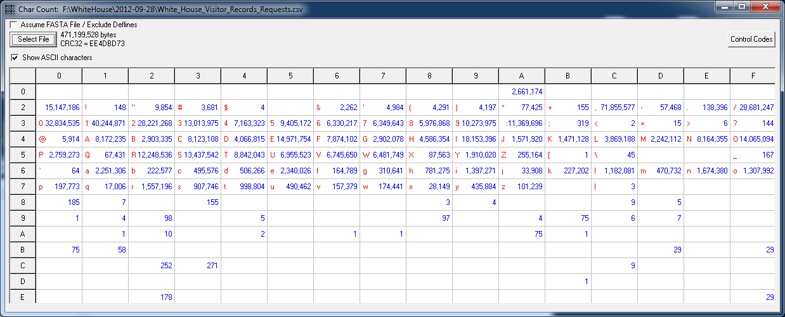

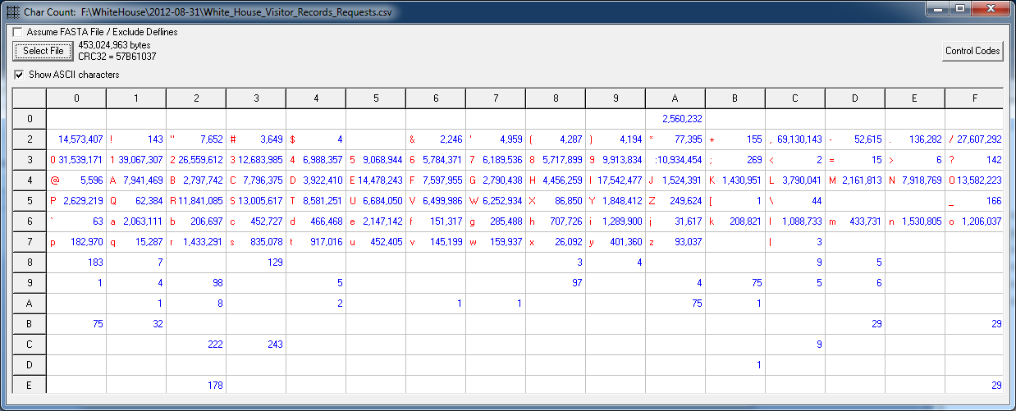

OLD:

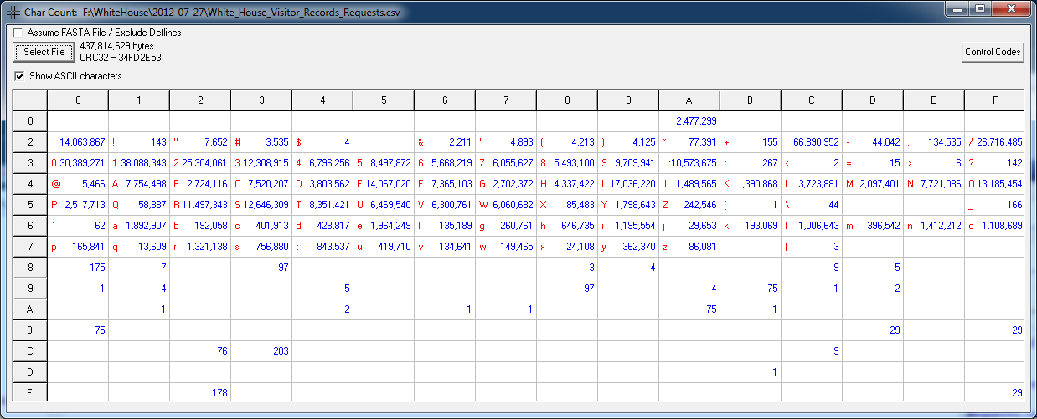

Unusual characters in White House Visitors Log

4 "$" (June 2012)

Hdru,Abraham,,U58962,,VA,,,,,11/15/2011 0:00,11/20/2011 13:30,11/20/2011 23:59,,4,ST,WIN,11/15/2011 12:07,ST,Pierret,Charles,WH,WEST WING,THOMAS,SHARON,, ,02/24/2012

Muskin,Carol,L,U58962,0,VA,11/20/2011 13:29,B0402,,,11/15/2011 0:00,11/20/2011 13:30,11/20/2011 23:59,,4,ST,WIN,11/15/2011 12:07,ST,Pierret,Charles,WH,WEST WING,THOMAS,SHARON,,WEST WING TOUR CONFIRMED for $,02/24/2012

MuskinPierret,Daniel,J,U58962,0,VA,11/20/2011 13:30,B0402,,,11/15/2011 0:00,11/20/2011 13:30,11/20/2011 23:59,,4,ST,WIN,11/15/2011 12:07,ST,Pierret,Charles,WH,WEST WING,THOMAS,SHARON,,WEST WING TOUR CONFIRMED for $,02/24/2012

MuskinPierret,Leah,M,U58962,0,VA,11/20/2011 13:30,B0402,,,11/15/2011 0:00,11/20/2011 13:30,11/20/2011 23:59,,4,ST,WIN,11/15/2011 12:07,ST,Pierret,Charles,WH,WEST WING,THOMAS,SHARON,,WEST WING TOUR CONFIRMED for $,02/24/2012

F:\WhiteHouse\2012-11-30\WAVES\**WhiteHouse-WAVES.R**

Expand all ZIPs in WAVES directory.

Modify WhiteHouse-WAVES.R as appropriate for any changes

Unclear why there are more released names than in the raw data:

* Raw-Names-Not-in-Release.txt
* Release-Names-Not-in-Raw.txt