<https://www.whitehouse.gov/briefing-room/disclosures/visitor-records>

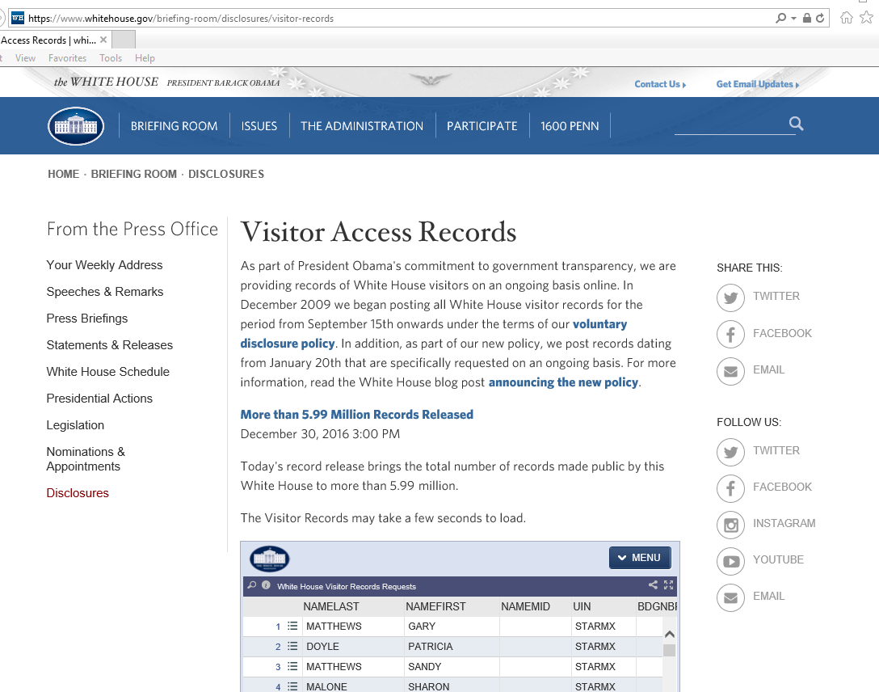

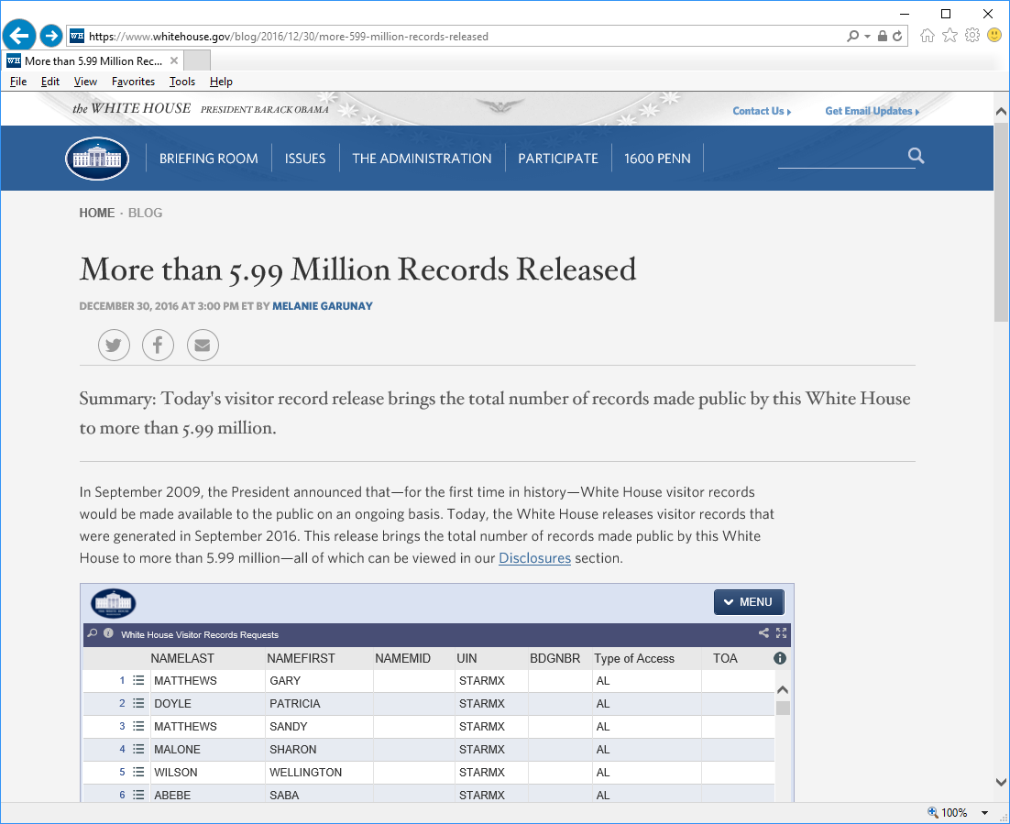

# More than 5.99 Million Records Released

December 30, 2016 at 3:00 PM ET by [Melanie Garunay](https://www.whitehouse.gov/blog/author/melanie-garunay)

[Twitter](http://twitter.com/intent/tweet?url=https%3A%2F%2Fwww.whitehouse.gov%2Fblog%2F2016%2F12%2F30%2Fmore-599-million-records-released&text=More%20than%205.99%20Million%20Records%20Released) [Facebook](http://facebook.com/sharer.php?u=https%3A%2F%2Fwww.whitehouse.gov%2Fblog%2F2016%2F12%2F30%2Fmore-599-million-records-released) [Email](mailto:?to=&subject=&body=Today%27s%20visitor%20record%20release%20brings%20the%20total%20number%20of%20records%20made%20public%20by%20this%20White%20House%20to%20more%20than%205.99%20million.%0Ahttps%3A%2F%2Fwww.whitehouse.gov%2Fblog%2F2016%2F12%2F30%2Fmore-599-million-records-released)

Summary:

Today's visitor record release brings the total number of records made public by this White House to more than 5.99 million.

In September 2009, the President announced that—for the first time in history—White House visitor records would be made available to the public on an ongoing basis. Today, the White House releases visitor records that were generated in September 2016. This release brings the total number of records made public by this White House to more than 5.99 million—all of which can be viewed in our [Disclosures](https://www.whitehouse.gov/briefing-room/disclosures/visitor-records) section.

.