<https://web.archive.org/web/20141222175449/http://watchdoglabs.org/blog/2012/12/12/white-house-worker-and-visitor-entry-system-data-fields>

<https://web.archive.org/web/20140209163904/http://watchdoglabs.org/blog/2012/12/>



## [White House Worker and Visitor Entry System Data Fields](https://web.archive.org/web/20141222175449/http:/watchdoglabs.org/blog/2012/12/12/white-house-worker-and-visitor-entry-system-data-fields/)

[*efg*](https://web.archive.org/web/20141222175449/http:/watchdoglabs.org/blog/author/efg/)[*December 12, 2012 at 11:39 pm*](https://web.archive.org/web/20141222175449/http:/watchdoglabs.org/blog/2012/12/)

By Earl F Glynn | Franklin Center

This is the third technical article in a series about analyzing White House visitor data. This article describes the data fields in the White House Worker and Visitor and Entry System (WAVES), including known limitations.

[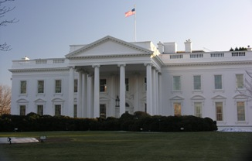](https://web.archive.org/web/20141222175449/http:/watchdoglabs.org/blog/wp-content/uploads/2012/12/White-House.jpg)

Analysis of the White House visitor data requires understanding the various data fields, but there is little public information about WAVES.

The intent of this article is to collect information about each WAVES data field on a single page and update this page as additional limitations are discovered about each data field.

Feedback from the public is welcome to enhance the information on this page.

**Data fields**

Information about WAVES data collection and processing is in the earlier article, [Background information on White House visitor data](https://web.archive.org/web/20141222175449/http:/watchdoglabs.org/blog/2012/12/10/background-information-on-white-house-visitor-data/).

The White House [Visitor Access Records page](https://web.archive.org/web/20141222175449/http:/www.whitehouse.gov/briefing-room/disclosures/visitor-records) provides a brief [description of the data items in the raw WAVES files](https://web.archive.org/web/20141222175449/http:/www.whitehouse.gov/files/disclosures/visitors/WhiteHouse-WAVES-Key-1209.txt).

Table 1  below is derived from that file,[information released about WAVES records in response to Freedom of Information Act requests](https://web.archive.org/web/20141222175449/http:/www.whitehouse.gov/blog/Opening-up-the-peoples-house) from the years of the Bush administration shown in Table 2, and various legal briefs in the battle over the disclosure of this information via FOIA.

**Table 1.  White House Worker and Visitor Entry System (WAVES) Data Fields**

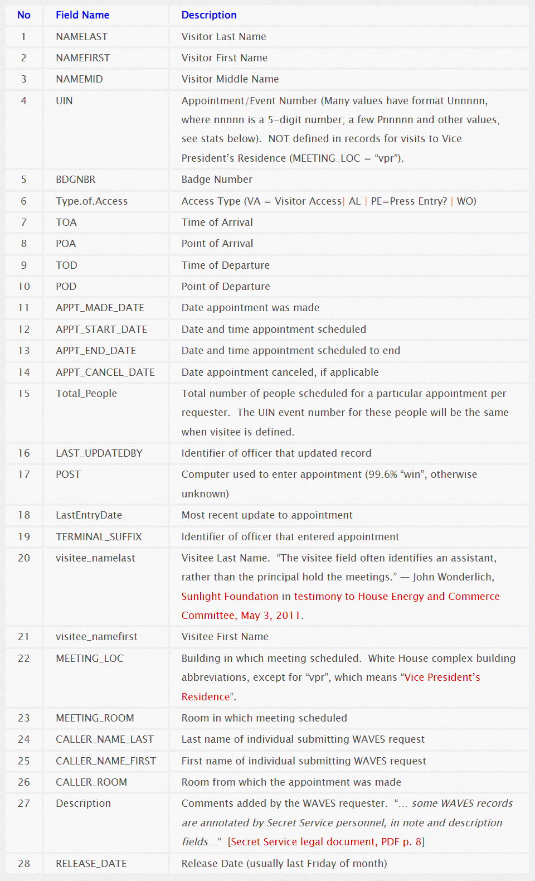

**Notes:**[Information gleaned about each data field from all sources will be added to the table above with details shown below.]

[**MEETING_LOC**](https://web.archive.org/web/20141222175449/http:/watchdoglabs.org/data/WhiteHouse/2012-11-30/Counts-ALL/22-MEETING_LOC.csv) (percentages from Nov. 2012 data)

* wh (81.9%) = White House
* oeob (14.5%) = [Old Executive Office Building](https://web.archive.org/web/20141222175449/http:/en.wikipedia.org/wiki/Old_Executive_Office_Building) (same as eeob below)
* neob (2.82%) = [New Executive Office Building](https://web.archive.org/web/20141222175449/http:/en.wikipedia.org/wiki/New_Executive_Office_Building)
* vpr (0.38%) = [Vice President’s Residence](https://web.archive.org/web/20141222175449/http:/www.whitehouse.gov/about/vp-residence) (code defined in legal documents)
* visitors (0.38%) = ?
* all (0.02%) = ?
* eeob (0.005%) = [Eisenhower Executive Office Building](https://web.archive.org/web/20141222175449/http:/en.wikipedia.org/wiki/Eisenhower_Executive_Office_Building) (same as oeob but new name not used much)
* 1800 (0.005%) = ?

**Table 2.  Sample Redacted Released WAVES Record**

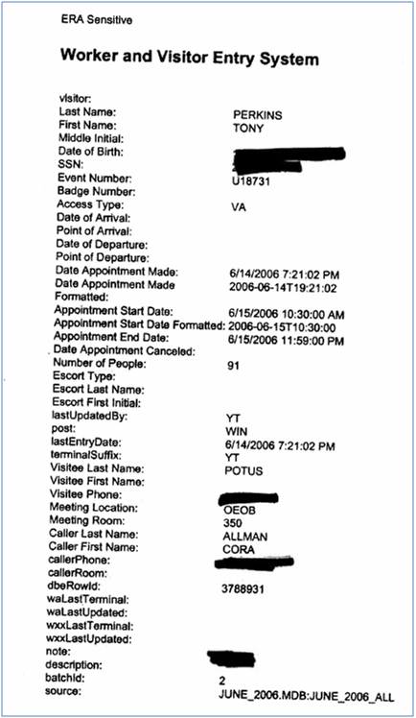

*Redacted “WAVES” (Worker and Visitor Entry System) record released on September 4, 2009 for Tony Perkins’ White House visit in July 2006 originally sought by CREW lawsuit. Perkins visited “POTUS”, President of the United States, who was George W. Bush at that time.*

**Redacted WAVES Information**

**Records redacted in released data**

The [White House Voluntary Disclosure Policy](https://web.archive.org/web/20141222175449/http:/www.whitehouse.gov/VoluntaryDisclosure) lists four exceptions for data that would not be released:

1. Data fields that “implicate personal privacy or law enforcement concerns” would not be released. The redacted fields above in the WAVES example shows most of the fields that are not released.
2. Records related “to purely personal guest of the first and second families” would not be released.
3. Records “related to a small group of particularly sensitive meetings.”
4. Because of incompatible systems, information released about visitors to the Vice President’s residence would not be identical to information released about visitors to the White House complex.

Other records have been redacted, or are missing, for unknown reasons (quotes below are from John Wonderlich, Sunlight Foundation in [testimony to House Energy and Commerce Committee, May 3, 2011](https://web.archive.org/web/20141222175449/http:/sunlightfoundation.com/policy/documents/john-wonderlich-testimony-house-energy-and-commerc/)):

* “Some visitors are clearly missing from the data, despite their being at the White House.”
* “There have been numerous reports of Administration officials scheduling meetings in the White House Conference Center (a space apparently not covered by the WAVES system), or holding meetings with lobbyists in coffee shops and restaurants near the White House.”

**Fields redacted in released data** (based on comparison to released redacted WAVE records that show all data field names, such as the one shown in Table 2):

* Visitor Date of Birth
* Visitor Social Security Number
* Visitee Phone Number
* Escort Type
* Escort Last Name
* Escort First Initial
* CALLER Phone Number
* note. “… some WAVES records are annotated by Secret Service personnel, in note and description fields…“  [[Secret Service legal document, PDF p. 8](https://web.archive.org/web/20141222175449/http:/www.judicialwatch.org/files/documents/2010/jw-v-usss-def-cm4sjopp2sj-04212010.pdf)]
* batchid
* source

**Additional Redacted Data**

Based on a review of a number of legal documents in the FOIA battle over the release of White House visitor data,  the following information is contained in WAVES but not released:

* **Sensitive Record Indicator**.  “In order to account properly for the exceptions to the voluntary disclosure policy, the ability to designate sensitive records was added to the WAVES system. For all post-September 15 [2009] appointments, White House Complex staff submitting an access request can designate whether the public release of the visitor record would implicate national security concerns.”  [[Secret Service legal document, PDF p. 12](https://web.archive.org/web/20141222175449/http:/www.judicialwatch.org/files/documents/2010/jw-v-usss-def-cm4sjopp2sj-04212010.pdf)]
* **Reason for Sensitive Record**.  “If a WAVES user designates an appointment as highly sensitive, s/he is also required to select whether the particular sensitivity of the meeting is derived from national security or non-national security matters. … Since the voluntary disclosure policy took effect in mid-September [2009] to date [April 19, 2010], no visitor records have been withheld due to non-national security sensitivity.”  [[Secret Service legal document, PDF p. 77](https://web.archive.org/web/20141222175449/http:/www.judicialwatch.org/files/documents/2010/jw-v-usss-def-cm4sjopp2sj-04212010.pdf)]
* **Color Code**.  “After review by the visitee, or pertinent person, WAVES records are color coded, and records designated for public disclosure are reviewed for a third time by the Director for Counterintelligence and the Senior Director for Administration, before they are released.” [[Secret Service legal document, PDF p. 45](https://web.archive.org/web/20141222175449/http:/www.judicialwatch.org/files/documents/2010/jw-v-usss-def-cm4sjopp2sj-04212010.pdf)]

**Metadata**(data about data)

To understand which data fields have which values, including missing values, Table 3 was created using an R program described in the article Cleaning and standardizing White House visitor data.

The stats shown below in Table 3 are not for the raw WAVES data, but rather the cleaned up version.

**Table 3.  Descriptive statistics on WAVES data fields [Nov. 30, 2012 release]**

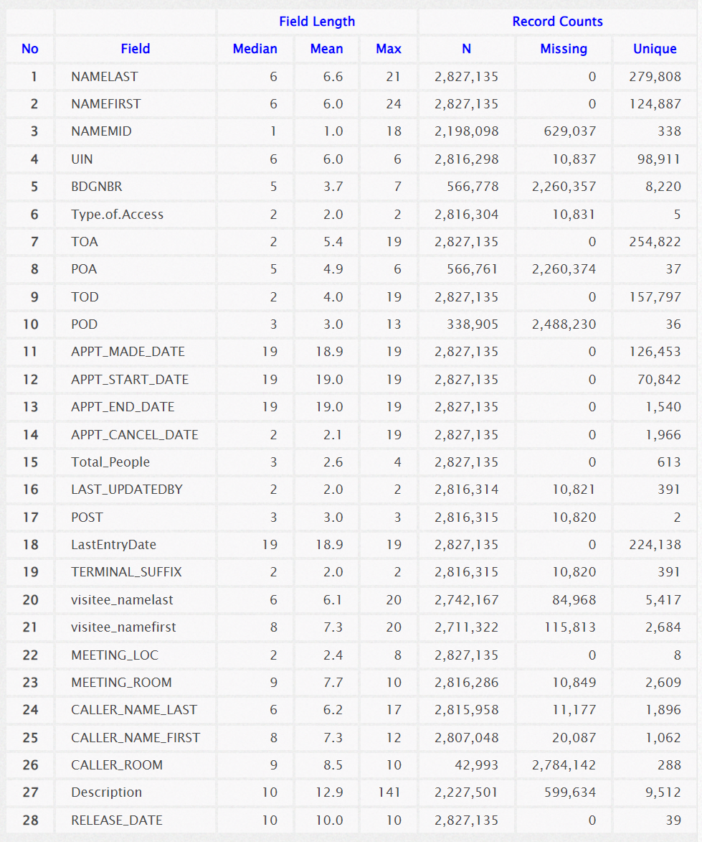

CSV files with the frequency counts of each observed value by data field can be [found in this data directory](https://web.archive.org/web/20141222175449/http:/watchdoglabs.org/data/WhiteHouse/2012-11-30/Counts-ALL/).  Download the CSV files and view in Excel.

**Series about analyzing White House visitor data**

* [Background information on White House visitor data](https://web.archive.org/web/20141222175449/http:/watchdoglabs.org/blog/2012/12/10/background-information-on-white-house-visitor-data/), WatchdogLabs.org, Dec. 10, 2012.
* [Discrepancies between “raw format” and final release versions of White House visitor records](https://web.archive.org/web/20141222175449/http:/watchdoglabs.org/blog/2012/12/11/discrepancies-between-raw-format-and-final-release-versions-of-white-house-visitor-records/), WatchdogLabs.org, Dec. 11, 2012.
* **White House Worker and Visitor Entry System Data Fields, WatchdogLabs.org, Dec. 12, 2012.**
* [Cleaning and standardizing White House visitor data](https://web.archive.org/web/20141222175449/http:/watchdoglabs.org/blog/2012/12/14/cleaning-and-standardizing-white-house-visitor-data/), WatchdogLabs.org, Dec. 14, 2012.
* Dividing White House visitor data into categories:  POTUS, staff, tourists, WatchdogLabs.org, Dec. 14, 2012.
* …

**Updates to this article**

* Descriptions in Table 1 were added to clarify how records from the Vice President’s Residence are treated.  Specifically, these records are missing visitee and UIN information when MEETING_LOC is “vpr”.  Dec. 21, 2012.