<http://www.7-zip.org/download.html>

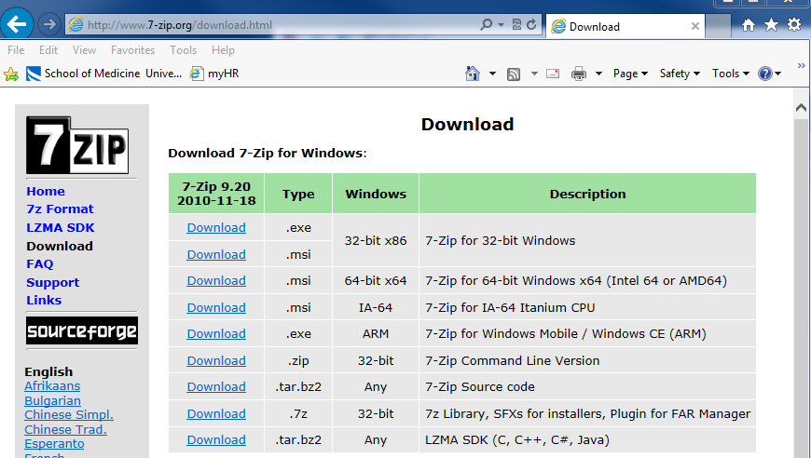



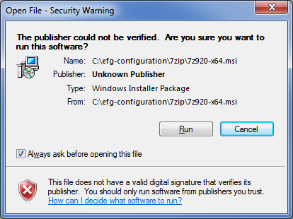

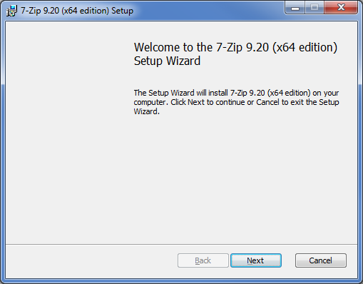

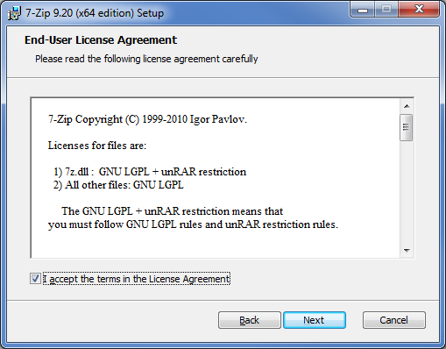

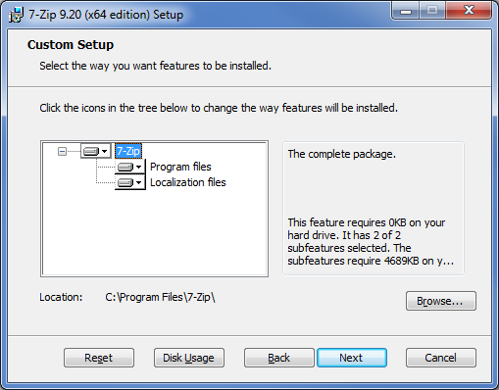

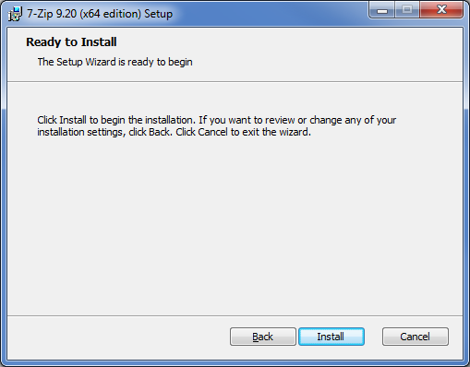

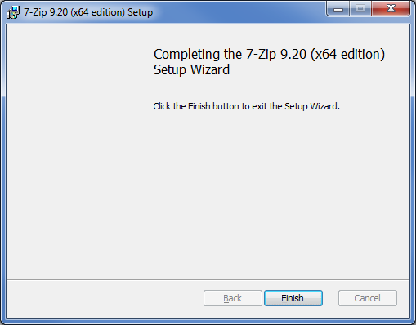



CentOS

7ZIP: **sudo yum install p7zip**

[284 efg localhost 2015-01-15 11:33:34 /home/efg]

7za

7-Zip (A) [64] 9.20 Copyright (c) 1999-2010 Igor Pavlov 2010-11-18

p7zip Version 9.20 (locale=en_US.UTF-8,Utf16=on,HugeFiles=on,1 CPU)

Usage: 7za <command> [<switches>...] <archive_name> [<file_names>...]

[<@listfiles...>]

<Commands>

a: Add files to archive

b: Benchmark

d: Delete files from archive

e: Extract files from archive (without using directory names)

l: List contents of archive

t: Test integrity of archive

u: Update files to archive

x: eXtract files with full paths

<Switches>

-ai[r[-|0]]{@listfile|!wildcard}: Include archives

-ax[r[-|0]]{@listfile|!wildcard}: eXclude archives

-bd: Disable percentage indicator

-i[r[-|0]]{@listfile|!wildcard}: Include filenames

-m{Parameters}: set compression Method

-o{Directory}: set Output directory

-p{Password}: set Password

-r[-|0]: Recurse subdirectories

-scs{UTF-8 | WIN | DOS}: set charset for list files

-sfx[{name}]: Create SFX archive

-si[{name}]: read data from stdin

-slt: show technical information for l (List) command

-so: write data to stdout

-ssc[-]: set sensitive case mode

-t{Type}: Set type of archive

-u[-][p#][q#][r#][x#][y#][z#][!newArchiveName]: Update options

-v{Size}[b|k|m|g]: Create volumes

-w[{path}]: assign Work directory. Empty path means a temporary directory

-x[r[-|0]]]{@listfile|!wildcard}: eXclude filenames

-y: assume Yes on all queries