**Installing and Configuring**

**MySQL on Windows 7**

**by  
Earl F Glynn**

**UMKC Center for Health Insights**

11 April 2014

Contents

Purpose 3

Introduction 3

Why not use Excel and Access? 3

MySQL Server and Clients 3

How to Use These Notes 4

MySQL Installation Requirements 4

Hardware 4

Software 4

Download MySQL Installer 4

MySQL Installation 7

Setup Type 9

Custom Installation 10

Configuration 14

MySQL Workbench 19

Preferences 21

Remove Default 1000 Record Limit 21

Increase DBMS Connection Times 21

Options File 22

Directory datadir 22

Test Databases 23

User without password for use in scripts 23

Controlling the MySQL Service 23

Running MySQL from a Windows Command Line 24

Windows 7 Start Menu Options 25

MySQL Removal 26

# Purpose

The purpose of these notes is to provide step-by-step instructions to install and configure a MySQL server and the MySQL Workbench client on a Windows 7 platform. The goal is to **make MySQL a desktop database** for use with a variety of other desktop software tools, including Excel, Access, and R. The hope is that large databases can be built and data analyzed on a single computer without the need for an IT support staff.

These notes are intended for data analysts and others to get started using the free [MySQL Community Server](http://www.mysql.com/products/community/) for data analysis projects. Most of the installation steps require little prior computer experience.

While MySQL can be used on various computer platforms, including [Mac OS X](http://dev.mysql.com/doc/refman/5.0/en/macosx-installation.html) and [Linux](http://dev.mysql.com/downloads/os-linux.html), these notes focus on working with Windows 7.

# Introduction

## Why not use Excel and Access?

As “data” become “[big data](http://en.wikipedia.org/wiki/Big_data)” Excel and Access quickly run out of power. [Excel can only handle one million rows](http://office.microsoft.com/en-us/excel-help/excel-specifications-and-limits-HA103980614.aspx) (1,048,576 = 1024*1024 to be exact). Access 2013 still is limited to 2 GB files some eighteen years after Microsoft introduced Access 95, which was limited to 1 GB files. The size of data files has greatly increased over the years but Microsoft has not extended Access much to work with larger files.

MySQL is limited only by available disk space and memory of a computer, so it can be used with much larger datasets. MySQL brings some additional complexity in setup and use, but did I say it was free?

## MySQL Server and Clients

The Access “desktop database” is a program that you can start when you work with data, and close when no longer needed. Access only needs to be running as you work with your data.

MySQL works in a different way. MySQL requires installing a “server” – a program that will always be running on your computer but “sleeps” when not needed. Often “servers” are installed on separate computers, but in this discussion the server will be installed on your desktop computer.

“Client” programs communicate with a server to perform various database operations, like loading or querying data. In this discussion, both the MySQL client and MySQL server will be on the same computer.

The installation described below will install “MySQL Workbench,” which is a client database program for communicating with the MySQL server. SQL queries can be entered and executed directly in MySQL Workbench.

Many client programs can access the MySQL server in addition to MySQL Workbench. Other clients can include applications written in languages like R or Python that use “connectors” to access the database.

Access and Excel can be clients to a MySQL server. Access can be used as a “front end” database to the backend MySQL server.

## How to Use These Notes

After discussion of installation requirements, these notes give step-by-step instructions for downloading and installing MySQL server and MySQL Workstation on your Windows 7 computer.

After installation, changes to certain default preferences and options are discussed. Without making these changes, you may run into problems when working with some large databases.

# MySQL Installation Requirements

## Hardware

For the best performance of your MySQL box, use a PC with the most processing power (e.g., 4 or 8 cores), the most memory (perhaps 8 to 16 GB), and the most disk space (1 to 2 TB or more) that you can afford.

## Software

The notes below describe installation on a PC with a Windows 7 operating system, but most of the steps also apply to Windows 8.

The installation process described below may tell you certain other software must be installed first depending on your PC and the selected installation options.

You might save some time by installing certain prerequisite software before starting the process below:

|  |  |
| --- | --- |
| **To install product:** | **You may be required to install this first:** |
| MySQL Workbench CE 6.0.6 | * [Microsoft Visual C++ 2010 32-bit runtime](http://www.microsoft.com/en-us/download/details.aspx?id=5555) * [Microsoft .NET Framework 4 Client Profile](http://www.microsoft.com/en-us/download/details.aspx?id=17113) |
| MySQL for Excel | * Microsoft Excel 2007 or later * [Visual Studio Tools for Office 2010 Runtime](http://msdn.microsoft.com/en-us/library/ms178739.aspx) * [Microsoft NET Framework 4 Client Profile](http://www.microsoft.com/en-us/download/details.aspx?id=17113) |
| Connector for Python | Python 2.7 or 3.3 |

If you know you need to install some of the requirements shown above, do it now.

Otherwise, the MySQL installer will inform you of installation conflicts. Return to the links above as the installer identifies requirements before it can proceed.

# Download MySQL Installer

Oracle simplified the installation of MySQL Server and MySQL Workstation. Only a single installation program is now needed.

Start here: <http://dev.mysql.com/downloads/>

Look for the free **MySQL Community Server** download area:

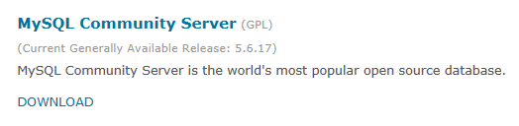

Select: **MySQL Community Server** or **Download.**

<http://dev.mysql.com/downloads/mysql/>

Scroll down the page to see:

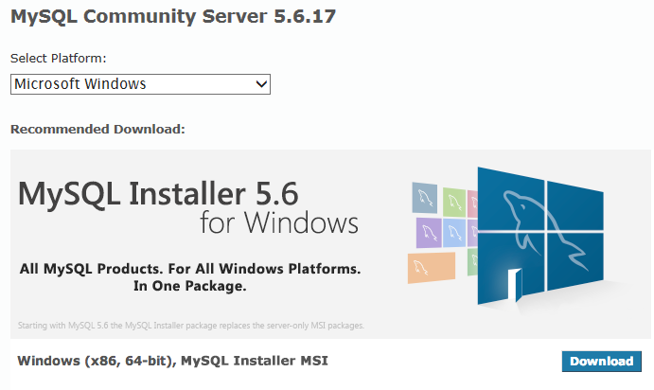

Select:

* Microsoft Windows
* Download

If you do not have a 64-bit CPU, look for the link for a 32-bit installation.

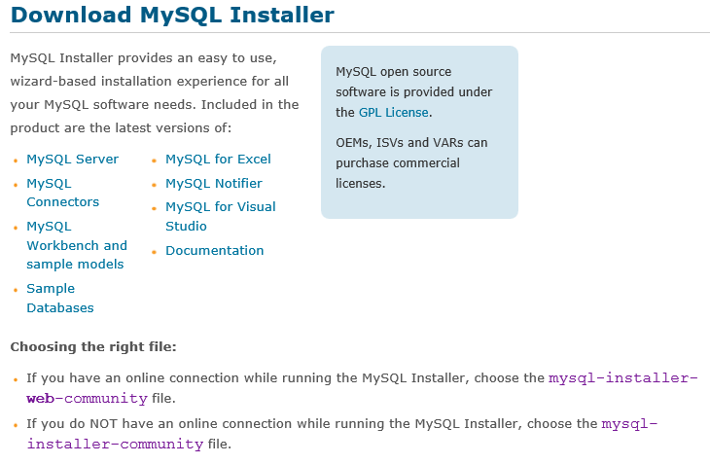

I normally use the larger **myssql-installer-community** installer. I save a copy of exactly what I install in case I want to replicate the same installation on another machine. You may want to select the other download option.

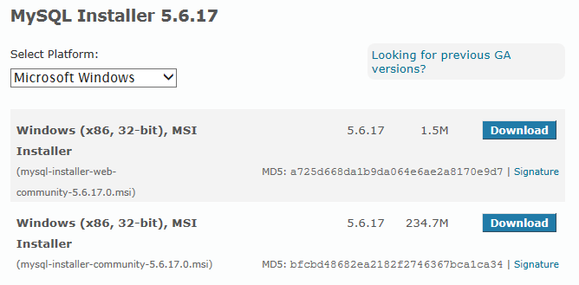

Apparently the MySQL Installer is a 32-bit version regardless of whether you’re installing 32-bit or 64-bit programs.

To start the download, login to your Oracle account, or simply select this link at the bottom left:



I normally save the file for future use, but you may wish to simply select “Run” at this point.

Rename the file to have an .msi extension.

# MySQL Installation

Double click on .**msi** file to start installation

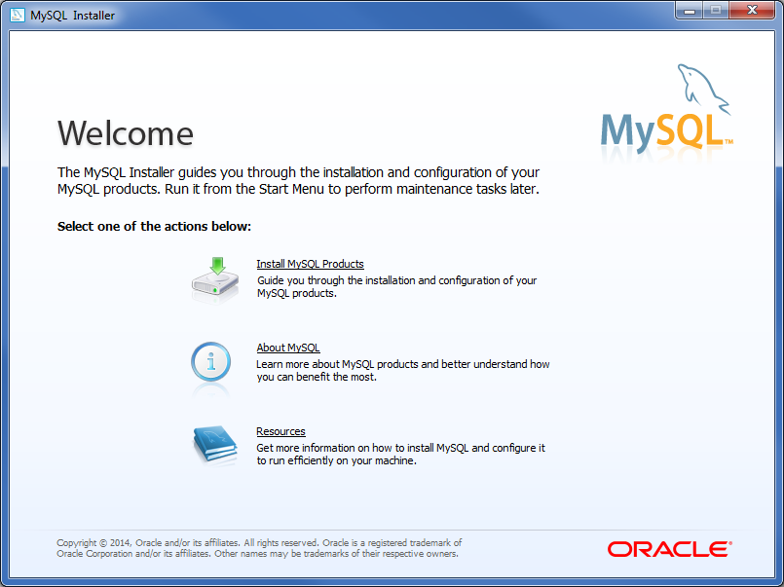

Select:

* Install MySQL Products
* Next

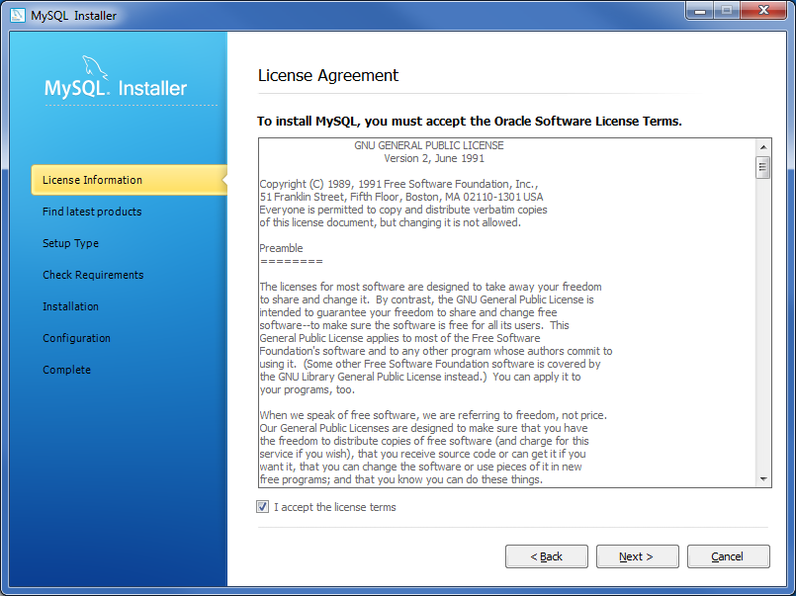

“I accept the license terms”  
Next

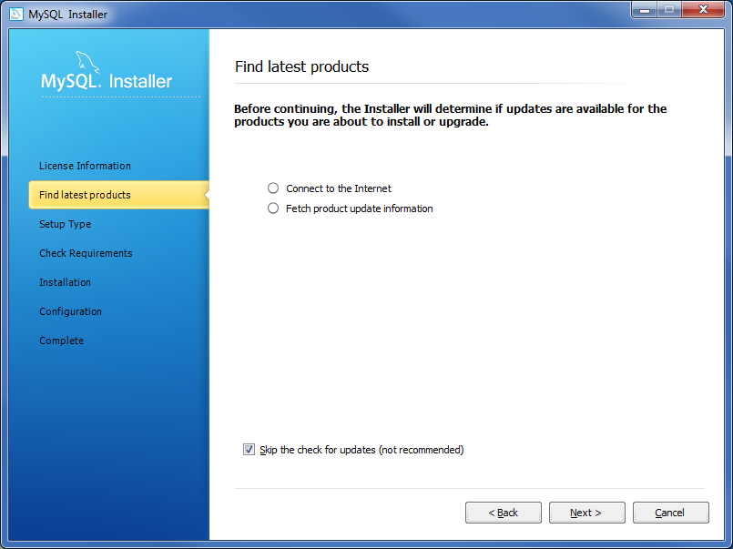

Select connection option. I’m skipping the updates for now.  
Execute or Next

## Setup Type

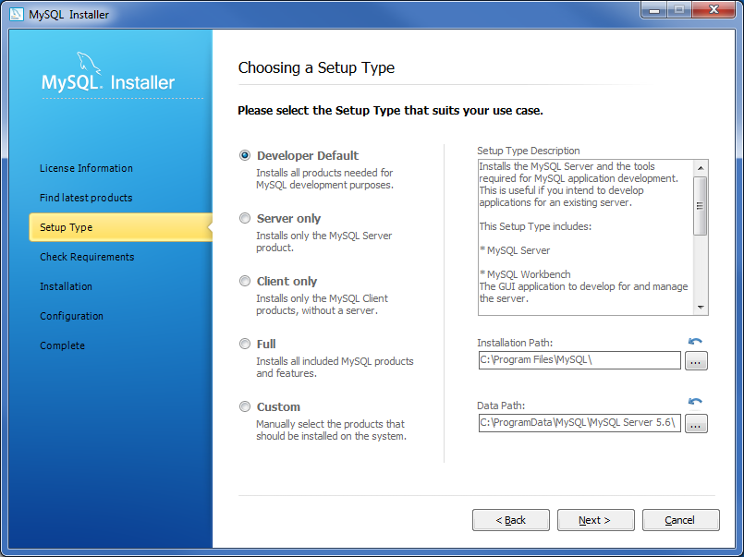

This installation process is simpler than in earlier versions.

The “Developer Default” installs the most-used features and may be adequate for most. This selection includes:

* MySQL Server
* MySQL Workbench
* MySQL Visual Studio Plugin
* MySQL Connectors
* Examples and tutorials
* Documentation

I’m selecting “Custom” to review installation options:

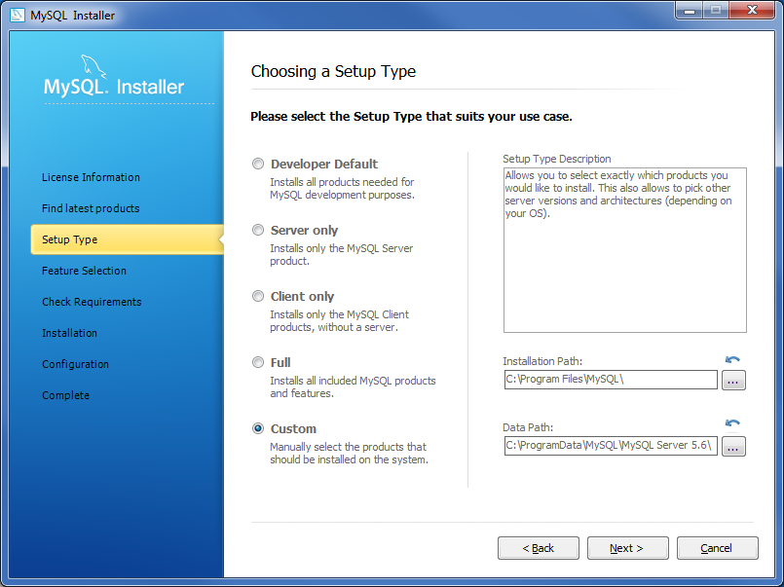

Next

## Custom Installation

Review features

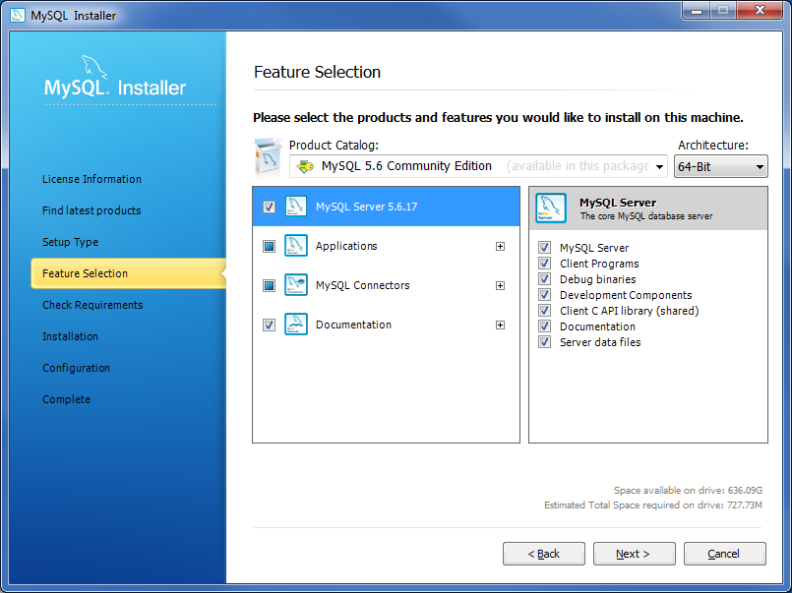

Next

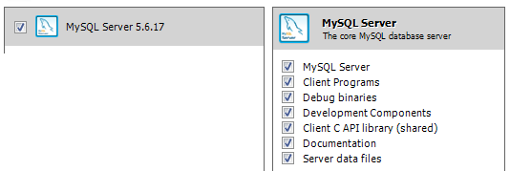

You most likely want to install all the MySQL Server options.

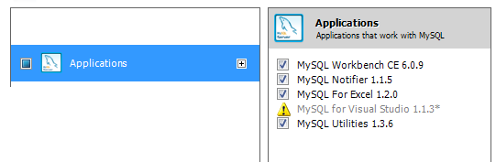

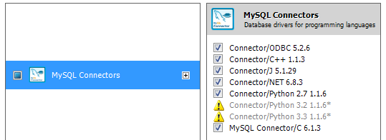

I plan to use the **Connector/ODBC** for connecting to MySQL from R and Access. I may want to use the Python connectors at a later date. For now I’m neutral on the C++, J and NET connectors but install them anyway.

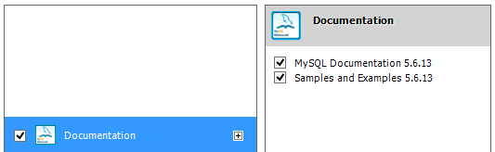

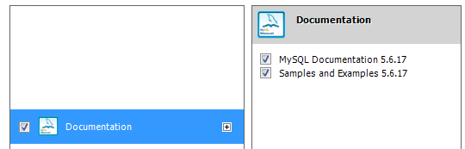

Having local documentation can be helpful.

Next

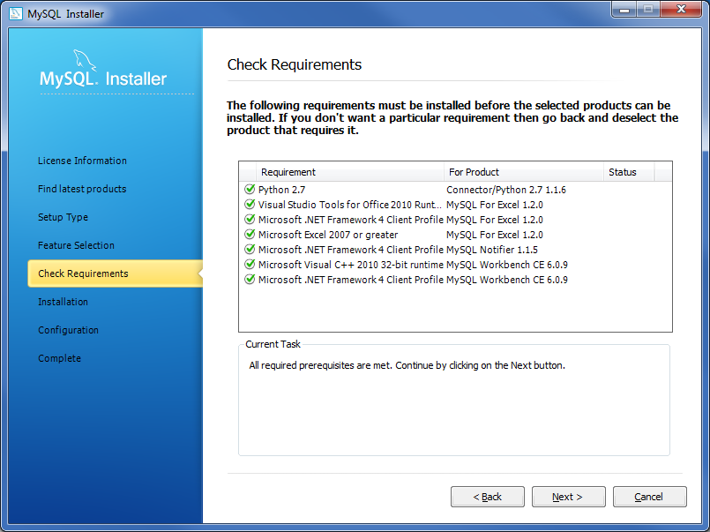

The checkboxes above indicate I have the needed prerequisite software already installed. At this point, depending on the options you selected, you may need to cancel and install prerequisite software.

Next

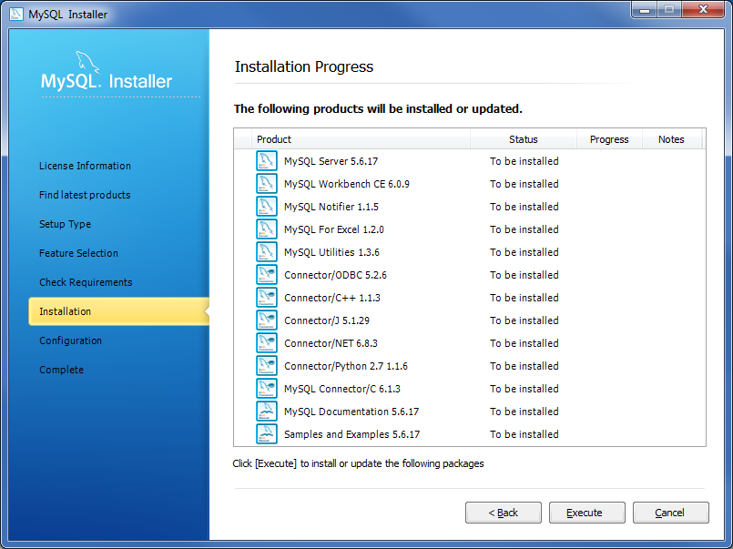

Execute

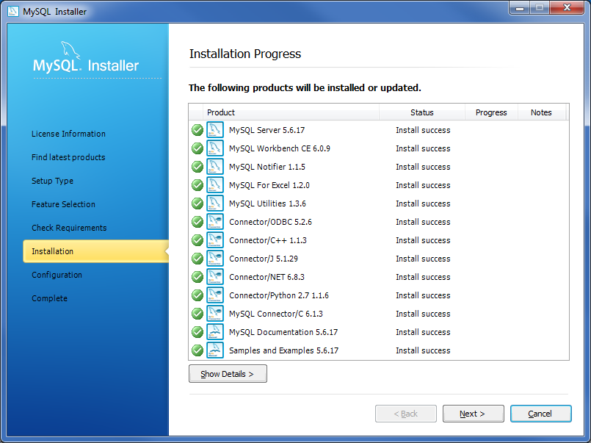

Next

## Configuration

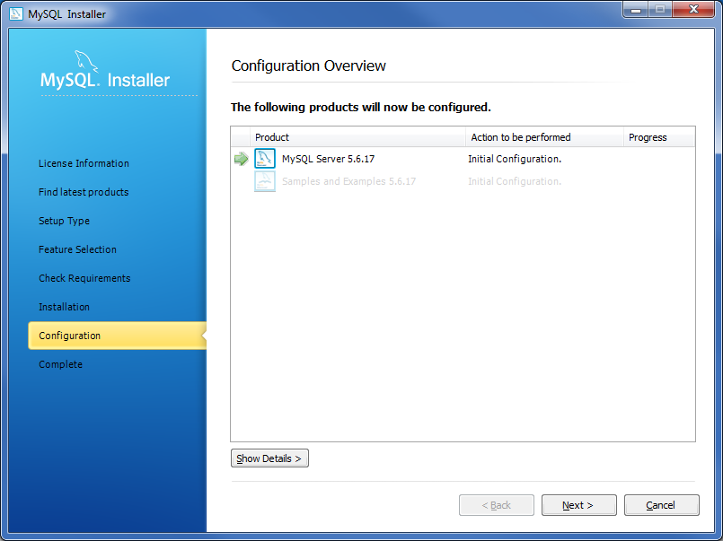

Next

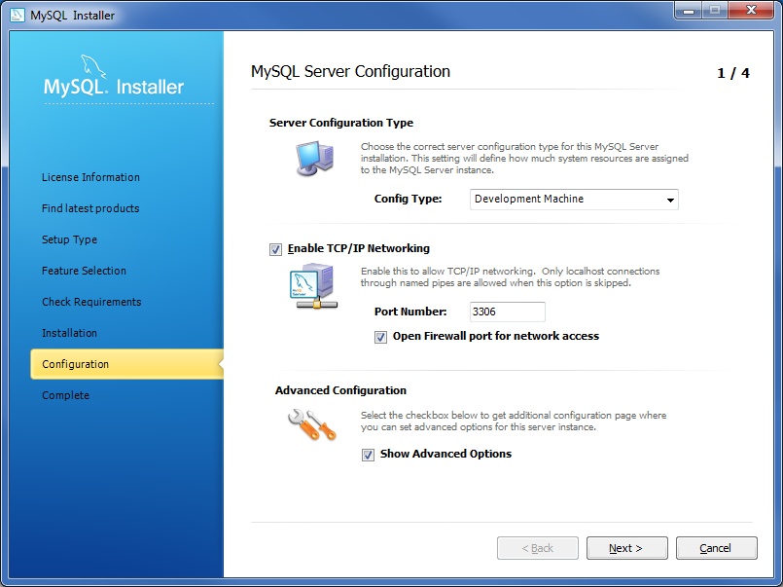

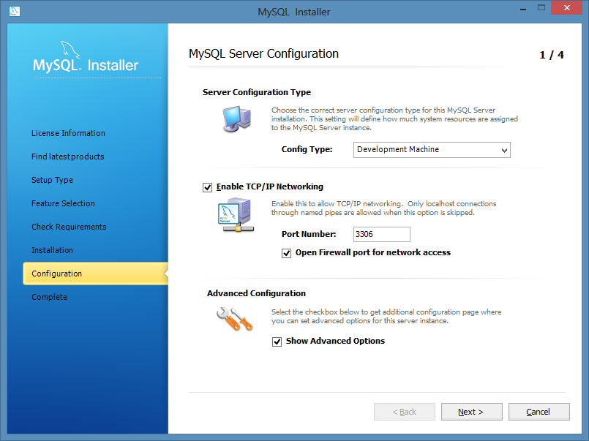

To be extra conservative, you might want to uncheck the “Open Firewall port for network access” option. Opening the firewall could introduce some new security concerns. As a “desktop database” we do not need network access but if TCP/IP Networking is enabled, you could in theory access your database over your network.

Next

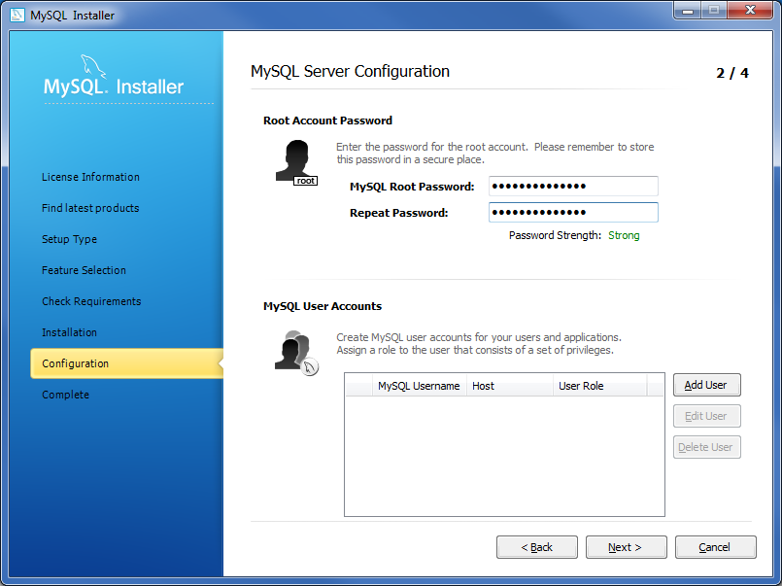

Select a strong password for your MySQL “root” user. Next.

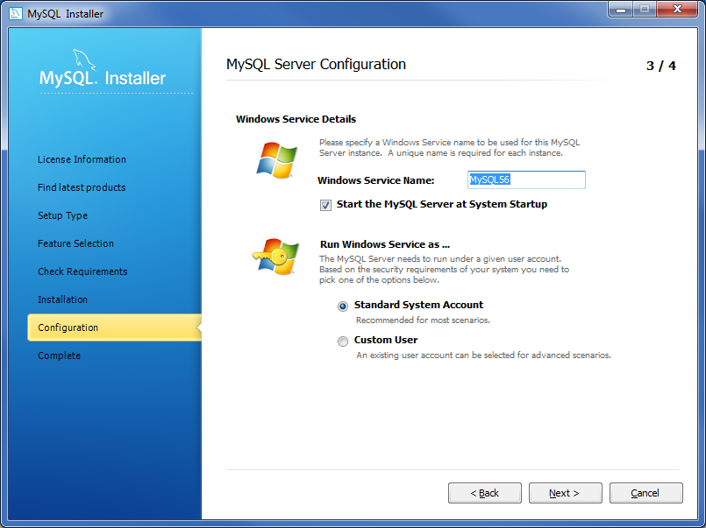

Next

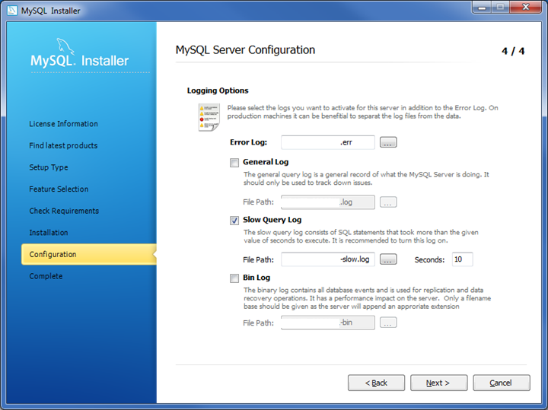

Next

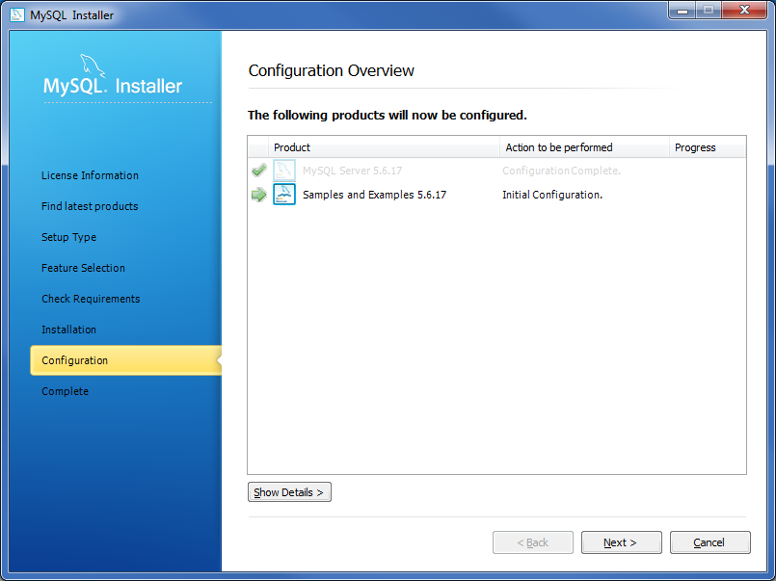

Next

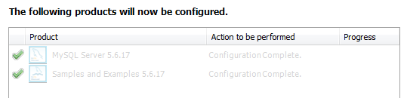

Next

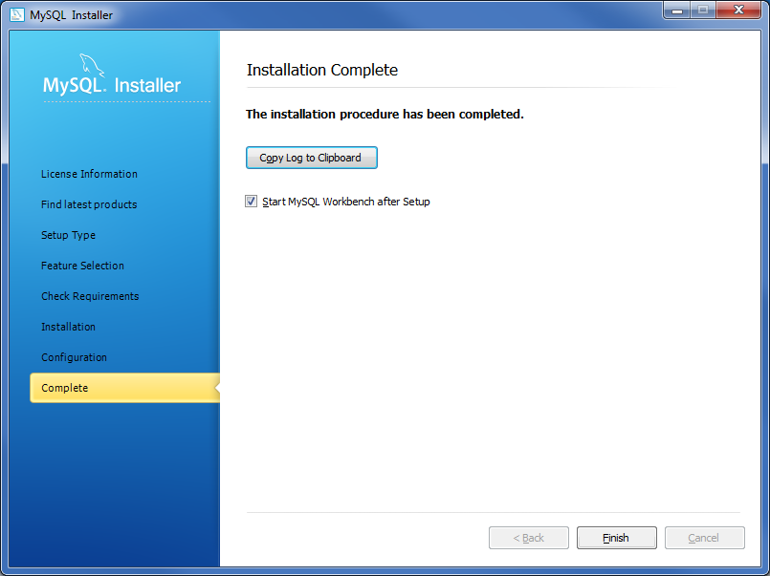

Finish

After the MySQL server is installed and started, MySQL Workbench starts.

Remember MySQL Workbench is the client program that will “talk” to the MySQL server.

# MySQL Workbench

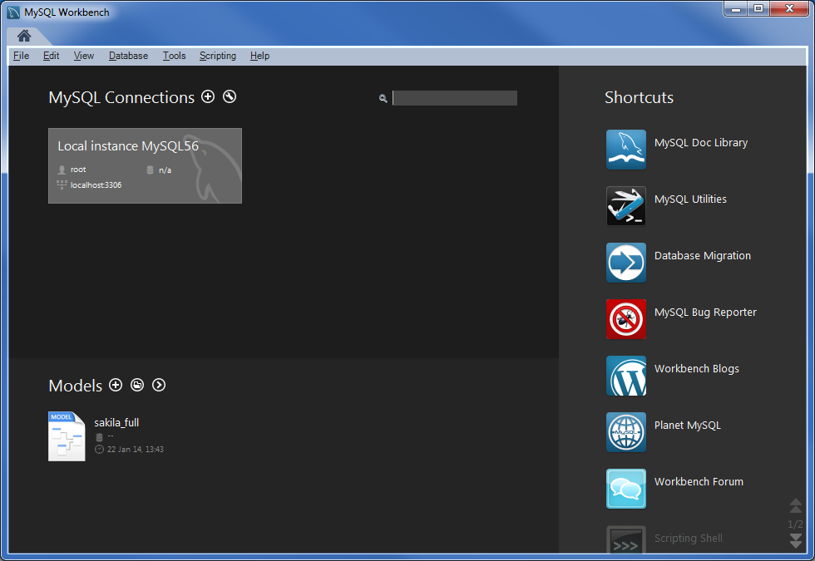

Double click on "Local instance MySQL56"

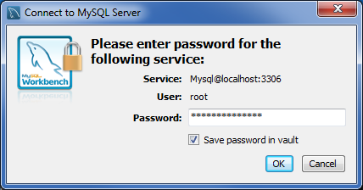

Check “Save password in vault” so you never need to enter this password again using MySQL as a desktop database.

OK

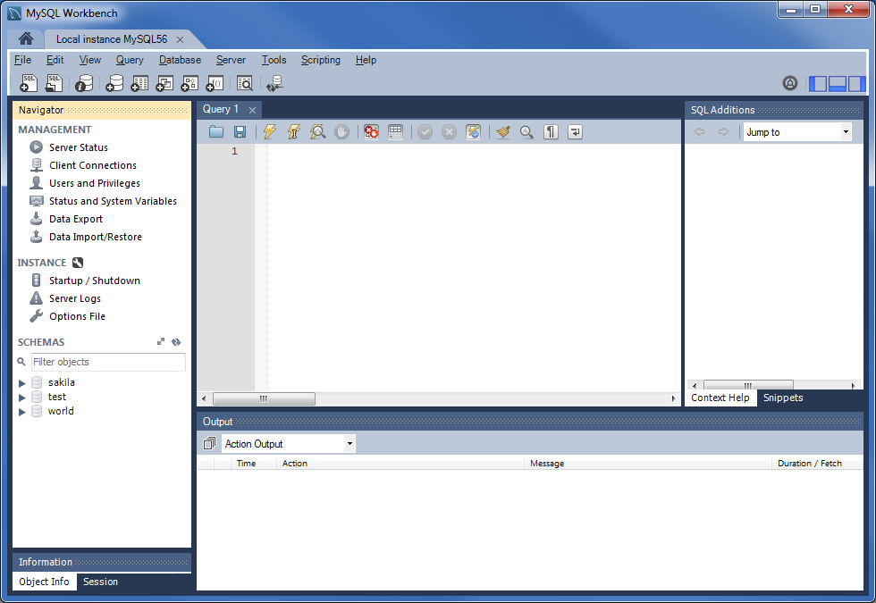

## Preferences

### Remove Default 1000 Record Limit

My default, MySQL Workstation automatically limits resultsets to 1000 records or fewer. Be careful, but I’d suggest removing this limit:

Edit, Preferences, SQL Queries Tab, Query Results section

Uncheck “Limit Rows”:

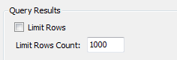

OK

### Increase DBMS Connection Times

Sometimes when working with long queries, a client program like MySQL Workbench loses its connection to the MySQL server. To avoid “Error Code: 2013. Lost connection to MySQL server during query” during long queries, increase the default from 600 seconds to higher value. I picked 7200 seconds (2 hours).

Edit, Preferences, SQL Editor, General



OK

Restart MySQL Workbench to use the longer DBMS connection time.

## Options File

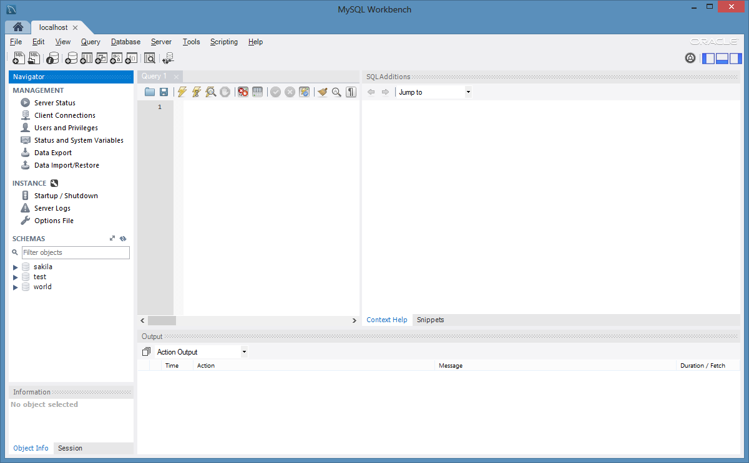

Select Options File and scroll down to the middle of the selections

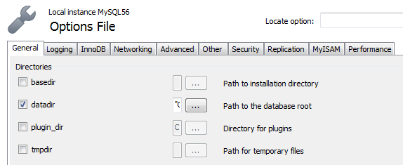

### Directory datadir

The location of the database files can be changed by specifying **datadir** above.

By default, the MySQL server files are written to your C disk. If you have an auxiliary disk at a different driver letter, you can change the location of your MySQL files by changing **datadir**.

To change locations, stop the *mysql* server (stop the service), change **datadir** (perhaps copying all files from old location to new location), and then restart server.

## Test Databases

Under Schema at the left in the Navigator, notice the test databases that were installed:

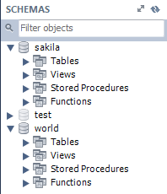

These test databases can use used to “play” with MySQL.

## User without password for use in scripts

To avoid entering password in R scripts, I create a user that corresponds to my Windows login and grant it all privileges:

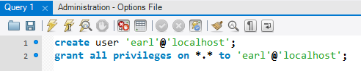

Use Ctrl-Enter after each line to run the command.

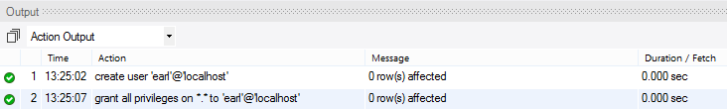

Related:

* [How to setup mysqldump without password in cronjob](http://www.techiecorner.com/1619/how-to-setup-mysqldump-without-password-in-cronjob/), Techie Corner

# Controlling the MySQL Service

To start or stop the mysql Windows service, select Startup/Shutdown under "Instance" in MySQL Workstation:



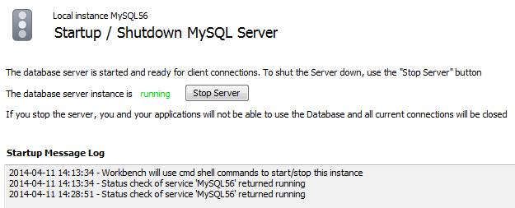

This can also be done by starting the **Task Manager** (right click on task bar on desktop), and selecting Services

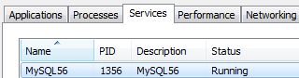

Right click on the service to see options: Start, Stop, Restart

# Running MySQL from a Windows Command Line

MySQL can be run in batch mode by invoking mysql.exe from a .bat script.

Somehow during installation I missed the option to add the location of the mysql.exe to the Path. Let’s add the workbench directory to the path:

Control Panel | System | Advanced system settings | Advanced tab | Environment variables

System variables | Path | Edit

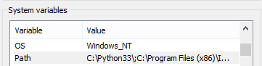

Add to path manually: **C:\Program Files (x86)\MySQL\MySQL Workbench CE 6.0.9**

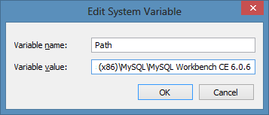

At a Windows command line enter “mysql –help” to see options:

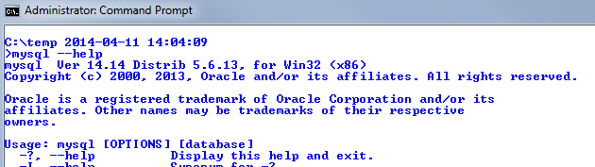

…

# Windows 7 Start Menu Options

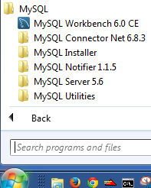

# MySQL Removal

If for some reason you want to remove MySQL from your PC, the following is a rough outline of the steps needed:

Control Panel

Programs and Features

Uninstall the following:

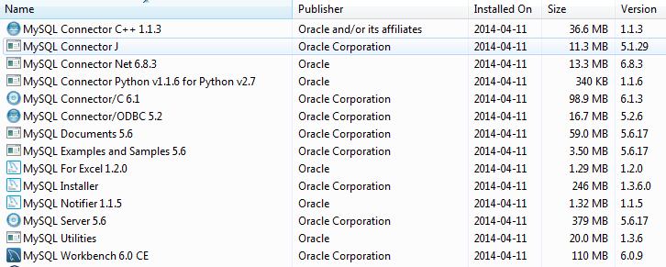

Remove files in C:\ProgramData\MySQL and possibly other locations