<http://mingw-w64.sourceforge.net/download.php#mingw-builds>

**Mingw-builds**

[Mingw-builds](https://sourceforge.net/projects/mingwbuilds/files/host-windows/releases/) provides native toolchains for Windows. Builds are based on trunk version of the mingw-w64 runtime. It has an online [installer](http://sourceforge.net/projects/mingwbuilds/files/mingw-builds-install/mingw-builds-install.exe/download).

|  |  |  |  |
| --- | --- | --- | --- |
| **Languages** | **Installer** | **C++ Exceptions** | **GCC Threading Model** |
| C, C++, Fortran | Yes | DWARF, SJLJ, SEH | Win32, Posix |

|  |  |  |  |  |
| --- | --- | --- | --- | --- |
| **Host** | **Exception** | **Target** | **GCC** | **Homepage** |
| Windows 32 | DWARF | i686 | 4.6.2 - 4.8.1 | [Sourceforge.net](https://sourceforge.net/projects/mingwbuilds) |
| SJLJ | i686, x86_64 |
| Windows 64 | SEH | x86_64 |
| SJLJ | x86_64, i686 |

**Additional Software**: GDB, Python, zlib, libiconv.

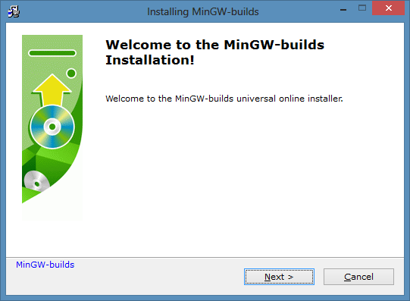

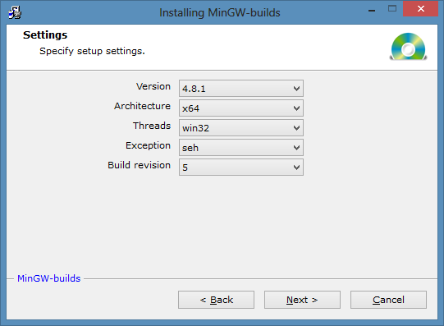

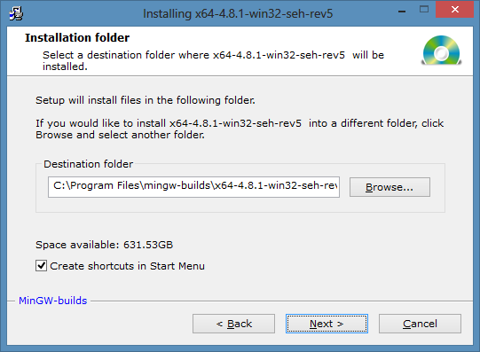

Add to path:

C:\Program Files\mingw-builds\x64-4.8.1-win32-seh-rev5\mingw64\bin

Control Panel

System

Advanced System Settings

Environment Variables

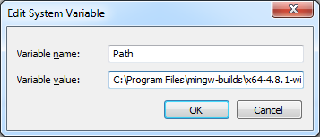

In command prompt window:

