Uninstall old Anaconda version first

<http://continuum.io/downloads>

#### Windows installers

#### 

#### stored in C:\efg-configuration\Packages\Anaconda

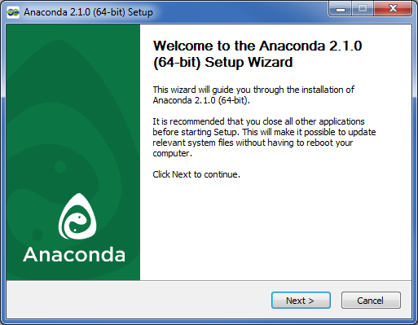

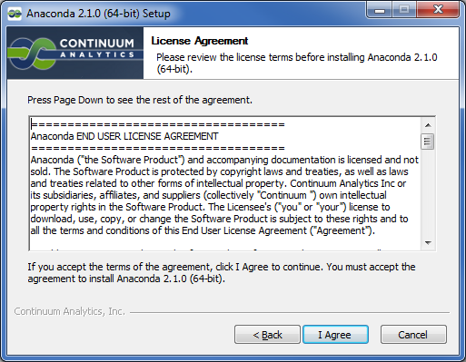

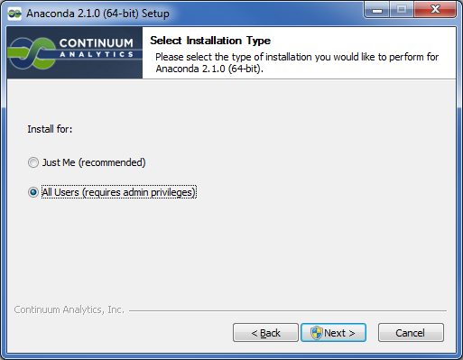

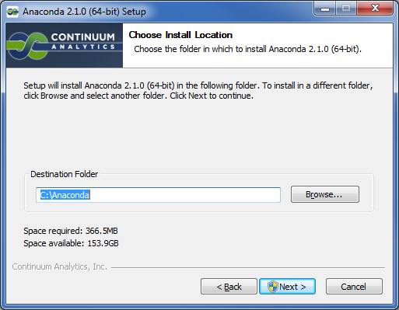

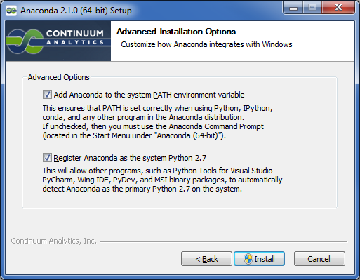

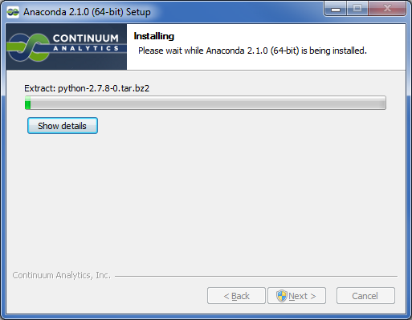

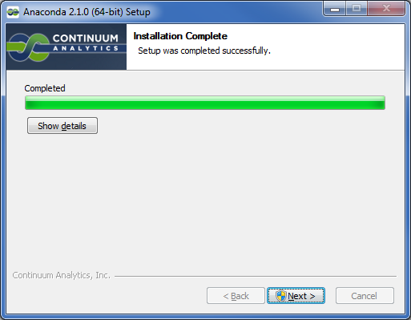

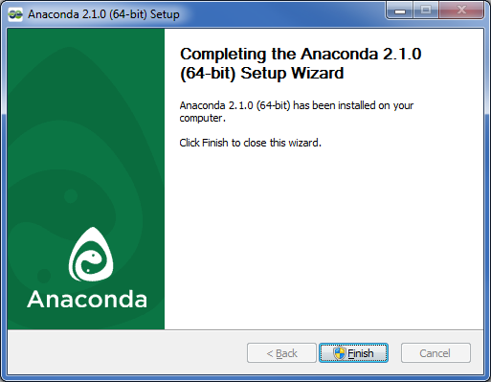

Start Menu

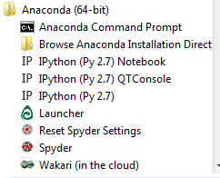

To avoid conflicts with other versions of python, add to beginning of path:

C:\Anaconda and C:\Anaconda\Scripts

Advanced system settings in Control Panel

>conda list

# packages in environment at C:\Anaconda:

#

_license 1.1 py27_0

anaconda 2.1.0 np19py27_0

argcomplete 0.8.1 py27_0

astropy 0.4.2 np19py27_0

atom 0.3.9 py27_0

backports.ssl-match-hostname 3.4.0.2 <pip>

beautiful-soup 4.3.2 py27_0

beautifulsoup4 4.3.2 <pip>

binstar 0.7.1 py27_0

bitarray 0.8.1 py27_1

blaze 0.6.3 np19py27_0

blz 0.6.2 np19py27_0

bokeh 0.6.1 np19py27_0

boto 2.32.1 py27_0

casuarius 1.1 py27_0

cdecimal 2.3 py27_1

cffi 0.8.6 py27_0

chaco 4.4.1 np19py27_0

colorama 0.3.1 py27_0

conda 3.7.0 py27_0

conda-build 1.8.2 py27_0

configobj 5.0.6 py27_0

cryptography 0.5.4 py27_0

cython 0.21 py27_0

cytoolz 0.7.0 py27_0

datashape 0.3.0 np19py27_1

dateutil 2.1 py27_2

decorator 3.4.0 py27_0

docutils 0.12 py27_0

dynd-python 0.6.5 np19py27_0

enable 4.3.0 np19py27_2

enaml 0.9.8 py27_0

flask 0.10.1 py27_1

future 0.13.1 py27_0

futures 2.1.6 py27_0

gevent 1.0.1 py27_0

gevent-websocket 0.9.3 py27_0

greenlet 0.4.4 py27_0

grin 1.2.1 py27_2

h5py 2.3.1 np19py27_0

ipython 2.2.0 py27_0

ipython-notebook 2.2.0 py27_0

ipython-qtconsole 2.2.0 py27_0

itsdangerous 0.24 py27_0

jdcal 1.0 py27_0

jinja2 2.7.3 py27_1

kiwisolver 0.1.3 py27_0

launcher 1.0.0 1

libpython 1.0 py27_1

llvmpy 0.12.7 py27_0

lxml 3.4.0 py27_0

markupsafe 0.23 py27_0

matplotlib 1.4.0 np19py27_0

menuinst 1.0.4 py27_0

mingw 4.7 1

mock 1.0.1 py27_0

multipledispatch 0.4.7 py27_0

networkx 1.9.1 py27_0

nltk 3.0.0 np19py27_0

node-webkit 0.10.1 0

nose 1.3.4 py27_0

numba 0.14.0 np19py27_0

numexpr 2.3.1 np19py27_0

numpy 1.9.0 py27_0

openpyxl 1.8.5 py27_0

pandas 0.14.1 np19py27_0

patsy 0.3.0 np19py27_0

pep8 1.5.7 py27_0

pil 1.1.7 py27_0

pip 1.5.6 py27_0

ply 3.4 py27_0

psutil 2.1.1 py27_0

py 1.4.25 py27_0

pycosat 0.6.1 py27_0

pycparser 2.10 py27_0

pycrypto 2.6.1 py27_2

pyface 4.4.0 py27_0

pyflakes 0.8.1 py27_0

pygments 1.6 py27_0

pyopenssl 0.14 py27_0

pyparsing 2.0.1 py27_0

pyqt 4.10.4 py27_0

pyreadline 2.0 py27_0

pytables 3.1.1 np19py27_1

pytest 2.6.3 py27_0

python 2.7.8 0

python-dateutil 1.5 <pip>

pytz 2014.7 py27_0

pywin32 219 py27_0

pyyaml 3.11 py27_0

pyzmq 14.3.1 py27_0

requests 2.4.1 py27_0

rope 0.9.4 py27_1

runipy 0.1.1 py27_0

scikit-image 0.10.1 np19py27_0

scikit-learn 0.15.2 np19py27_0

scipy 0.14.0 np19py27_0

setuptools 5.8 py27_0

six 1.8.0 py27_0

sockjs-tornado 1.0.1 py27_0

sphinx 1.2.3 py27_0

spyder 2.3.1 py27_0

spyder-app 2.3.1 py27_0

sqlalchemy 0.9.7 py27_0

ssl_match_hostname 3.4.0.2 py27_0

statsmodels 0.5.0 np19py27_2

sympy 0.7.5 py27_0

tables 3.1.1 <pip>

toolz 0.7.0 py27_0

tornado 4.0.2 py27_0

traits 4.4.0 py27_0

traitsui 4.4.0 py27_0

ujson 1.33 py27_0

unicodecsv 0.9.4 py27_0

werkzeug 0.9.6 py27_1

wsgiref 0.1.2 <pip>

xlrd 0.9.3 py27_0

xlsxwriter 0.5.7 py27_0

xlwings 0.2.2 py27_0

xlwt 0.7.5 py27_0

>python

Python 2.7.8 |Anaconda 2.1.0 (64-bit)| (default, Jul 2 2014, 15:12:11) [MSC v.1500 64 bit (AMD64)] on win32

Type "help", "copyright", "credits" or "license" for more information.

Anaconda is brought to you by Continuum Analytics.

Please check out: http://continuum.io/thanks and https://binstar.org

>>> import numpy

>>> numpy.__version__

'1.9.0'

>>> import scipy

>>> scipy.__version__

'0.14.0'

**IDLE shortcut**

>C:\Anaconda\python C:\Anaconda\Lib\idlelib\idle.py

Right click | New Shortcut

C:\Anaconda\python C:\Anaconda\Lib\idlelib\idle.py

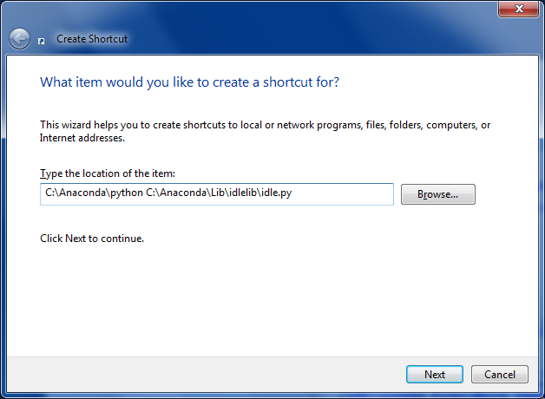

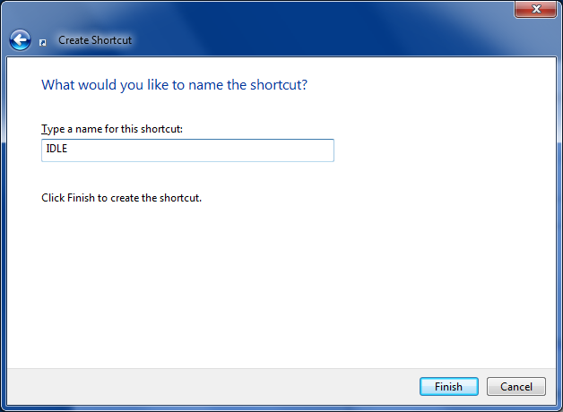

<http://sourceforge.net/projects/opencvlibrary/files/opencv-win/>







stored in C:\efg-configuration\Packages\opencv

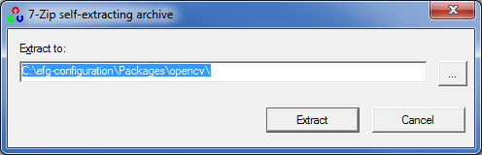

Copy **C:\efg-configuration\Packages\opencv\opencv\build\python\2.7\x64\cv2.py** to **C:\Anaconda\DLLs**

Check version:

>python

Python 2.7.8 |Anaconda 2.1.0 (64-bit)| (default, Jul 2 2014, 15:12:11) [MSC v.1500 64 bit (AMD64)] on win32

Type "help", "copyright", "credits" or "license" for more information.

Anaconda is brought to you by Continuum Analytics.

Please check out: http://continuum.io/thanks and https://binstar.org

>>> import cv2

>>> cv2.__version__

'2.4.10'

**Using conda**

[**http://www.continuum.io/blog/conda**](http://www.continuum.io/blog/conda)

>conda info

Current conda install:

platform : win-64

conda version : 3.7.0

conda-build version : 1.8.2

python version : 2.7.8.final.0

requests version : 2.4.1

root environment : C:\Anaconda (writable)

default environment : C:\Anaconda

envs directories : C:\Anaconda\envs

package cache : C:\Anaconda\pkgs

channel URLs : http://repo.continuum.io/pkgs/free/win-64/

http://repo.continuum.io/pkgs/pro/win-64/

config file : None

is foreign system : False

conda update conda

conda install pip

pip install wget

pip install argparse

pip install Pillow # Python Imaging Library