Uninstall old version first

<http://continuum.io/downloads>

#### Windows installers



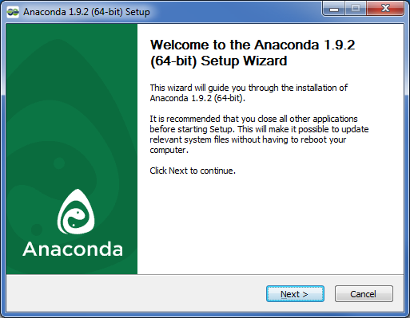

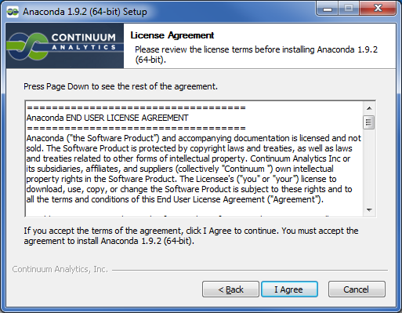

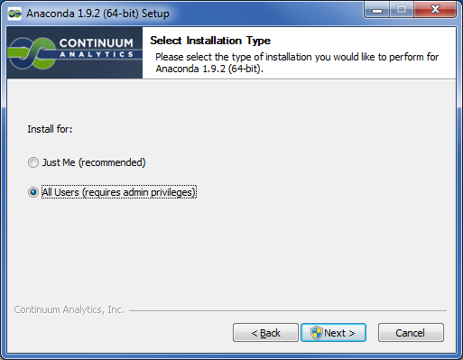

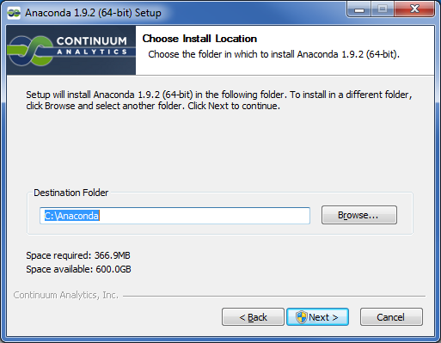

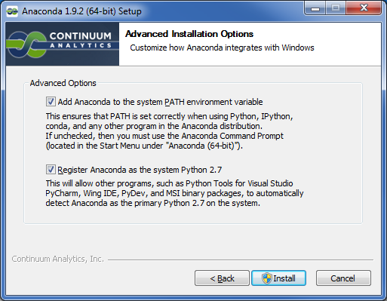

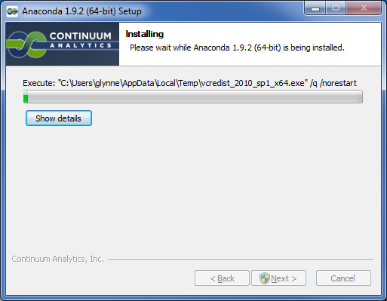

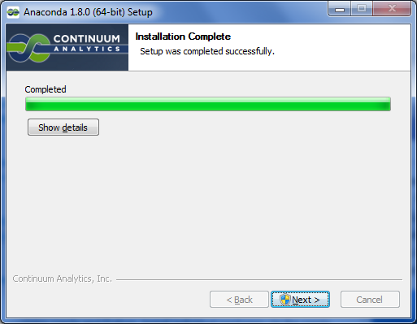

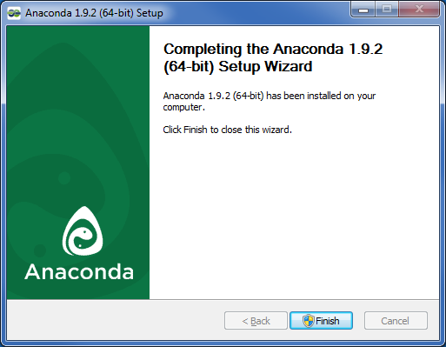

Added C:\Anaconda and C:\Anaconda\Scripts to PATH.

C:\Anaconda>python

Python 2.7.6 |Anaconda 1.9.2 (64-bit)| (default, Nov 11 2013, 10:49:15) [MSC v.

500 64 bit (AMD64)] on win32

Type "help", "copyright", "credits" or "license" for more information.

>>> import numpy

>>> numpy.__version__

**'1.8.0'**

>>> import scipy

>>> scipy.__version__

**'0.13.3'**

>>>

**IDLE**

>C:\Anaconda\python C:\Anaconda\Lib\idlelib\idle.py

Right click | New Shortcut

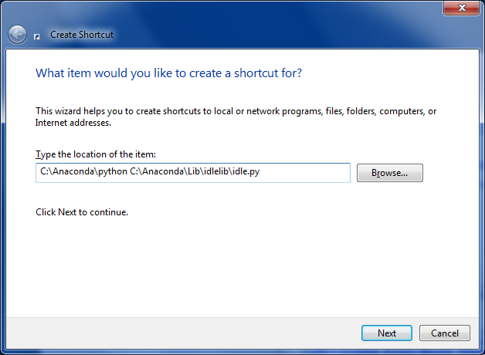

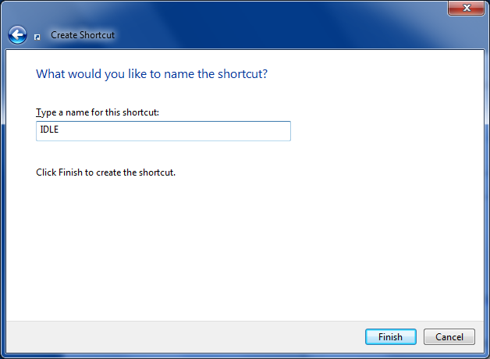

<http://sourceforge.net/projects/opencvlibrary/files/opencv-win/>







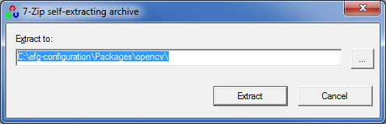

Copy **C:\efg-configuration\Packages\opencv\opencv\build\python\2.7\x64\cv2.py** to **C:\Anaconda\DLLs**

Check version:

Python 2.7.6 |Anaconda 1.9.2 (64-bit)| (default, Nov 11 2013, 10:49:15) [MSC v.1500 64 bit (AMD64)] on win32

Type "copyright", "credits" or "license()" for more information.

>>> import cv2

>>> cv2.__version__

**'2.4.9'**

**Using conda**

[**http://www.continuum.io/blog/conda**](http://www.continuum.io/blog/conda)

>conda info

Current conda install:

platform : win-64

conda version : 3.4.1

python version : 2.7.6.final.0

root environment : C:\Anaconda (writable)

default environment : C:\Anaconda

envs directories : C:\Anaconda\envs

package cache : C:\Anaconda\pkgs

channel URLs : http://repo.continuum.io/pkgs/free/win-64/

http://repo.continuum.io/pkgs/pro/win-64/

config file : None

is foreign system : False

>conda update conda

>conda install pip

Fetching package metadata: ..

Solving package specifications: .

Package plan for installation in environment C:\Anaconda:

The following packages will be downloaded:

package | build

---------------------------|-----------------

pip-1.5.6 | py27_0 1.3 MB

setuptools-3.6 | py27_0 775 KB

------------------------------------------------------------

Total: 2.1 MB

The following packages will be UN-linked:

package | build

---------------------------|-----------------

pip-1.5.2 | py27_0

setuptools-2.2 | py27_0

The following packages will be linked:

package | build

---------------------------|-----------------

pip-1.5.6 | py27_0 hard-link

setuptools-3.6 | py27_0 hard-link

Proceed ([y]/n)?

Fetching packages ...

pip-1.5.6-py27 100% |###############################| Time: 0:00:01 1.31 MB/s

setuptools-3.6 100% |###############################| Time: 0:00:00 844.20 kB/s

Extracting packages ...

[ COMPLETE ] |#################################################| 100%

Unlinking packages ...

[ COMPLETE ] |#################################################| 100%

Linking packages ...

[ COMPLETE ] |#################################################| 100%

>pip install wget

Downloading/unpacking wget

Downloading wget-2.2.tar.gz

Running setup.py (path:c:\users\glynne\appdata\local\temp\pip_build_glynne\wget\setup.py) egg_info

Installing collected packages: wget

Running setup.py install for wget

Successfully installed wget

Cleaning up...