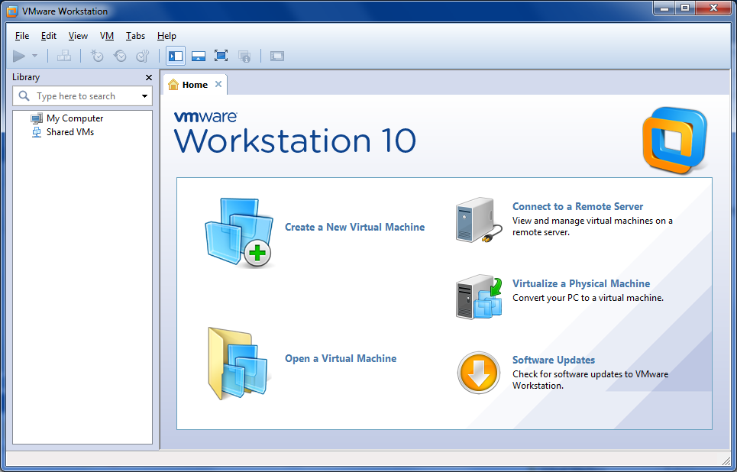

File | New Virtual Machine

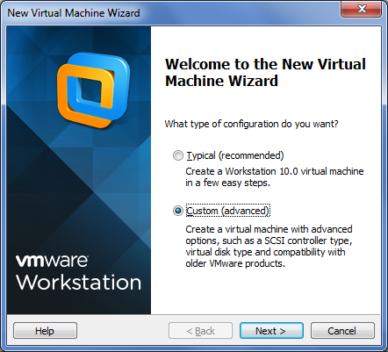

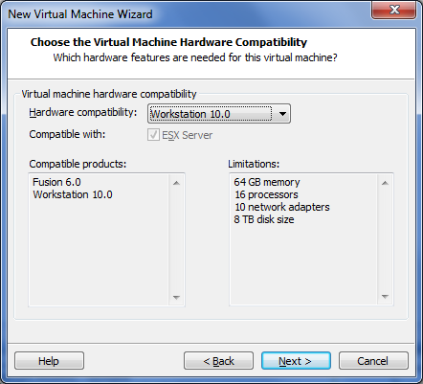

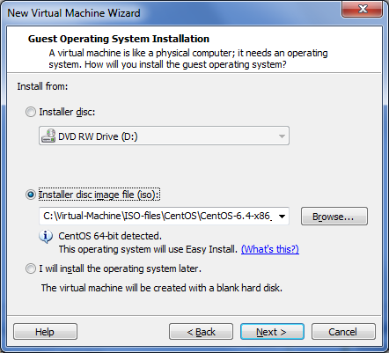

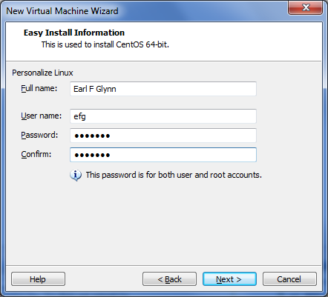

syzygy5

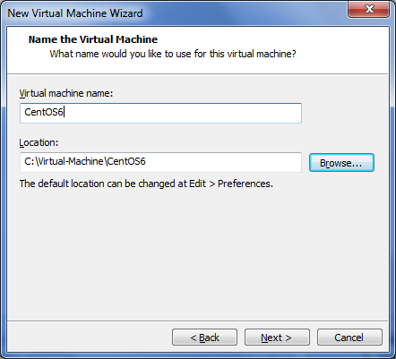

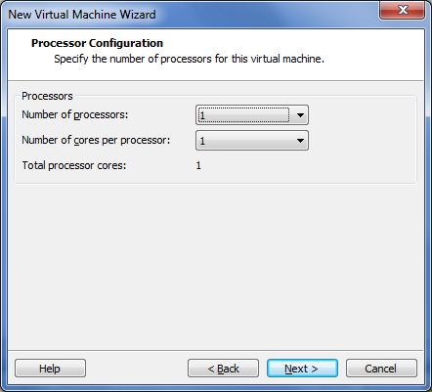

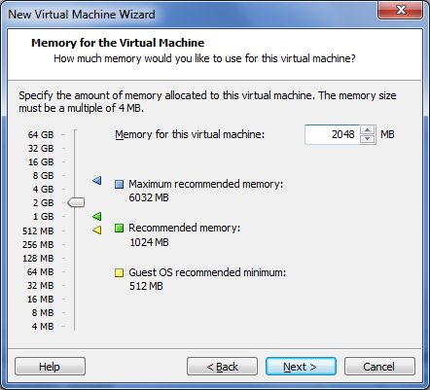

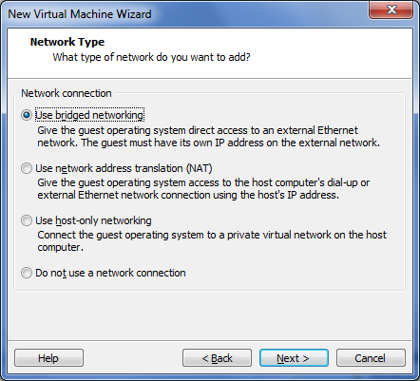

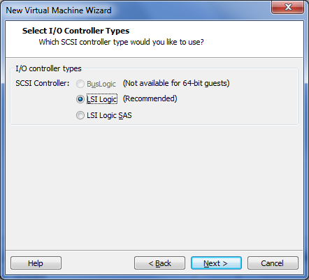

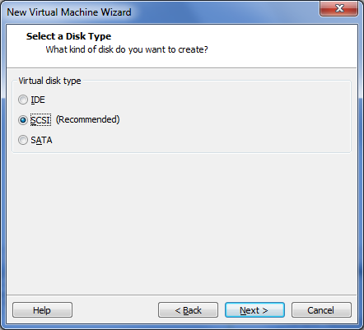

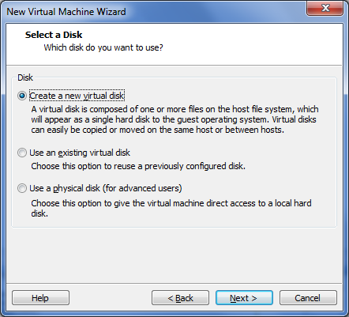

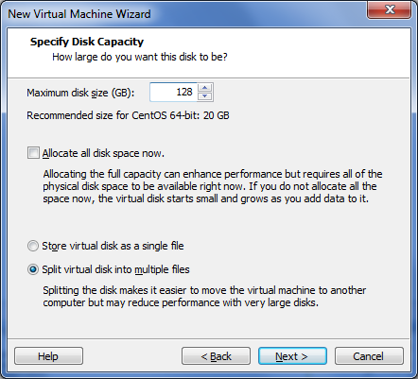

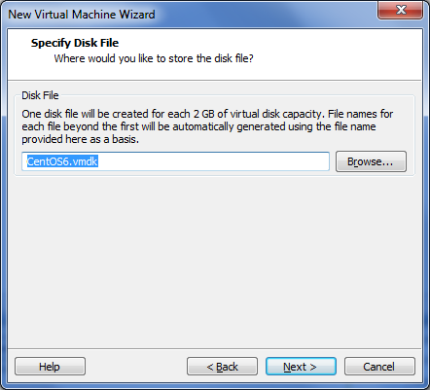

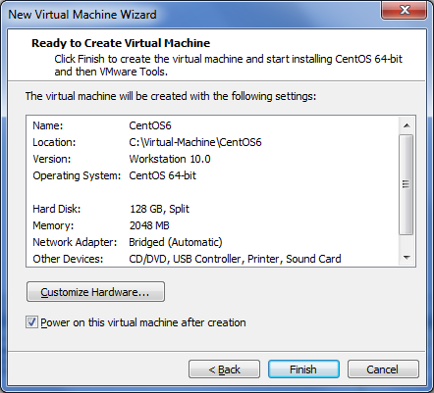

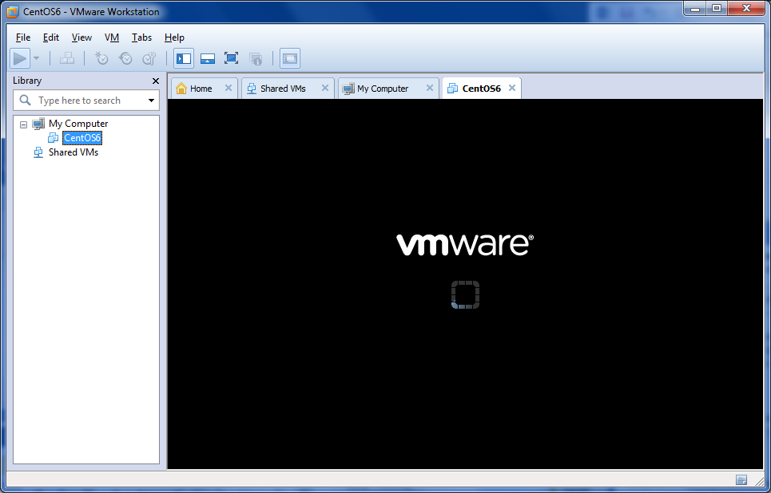

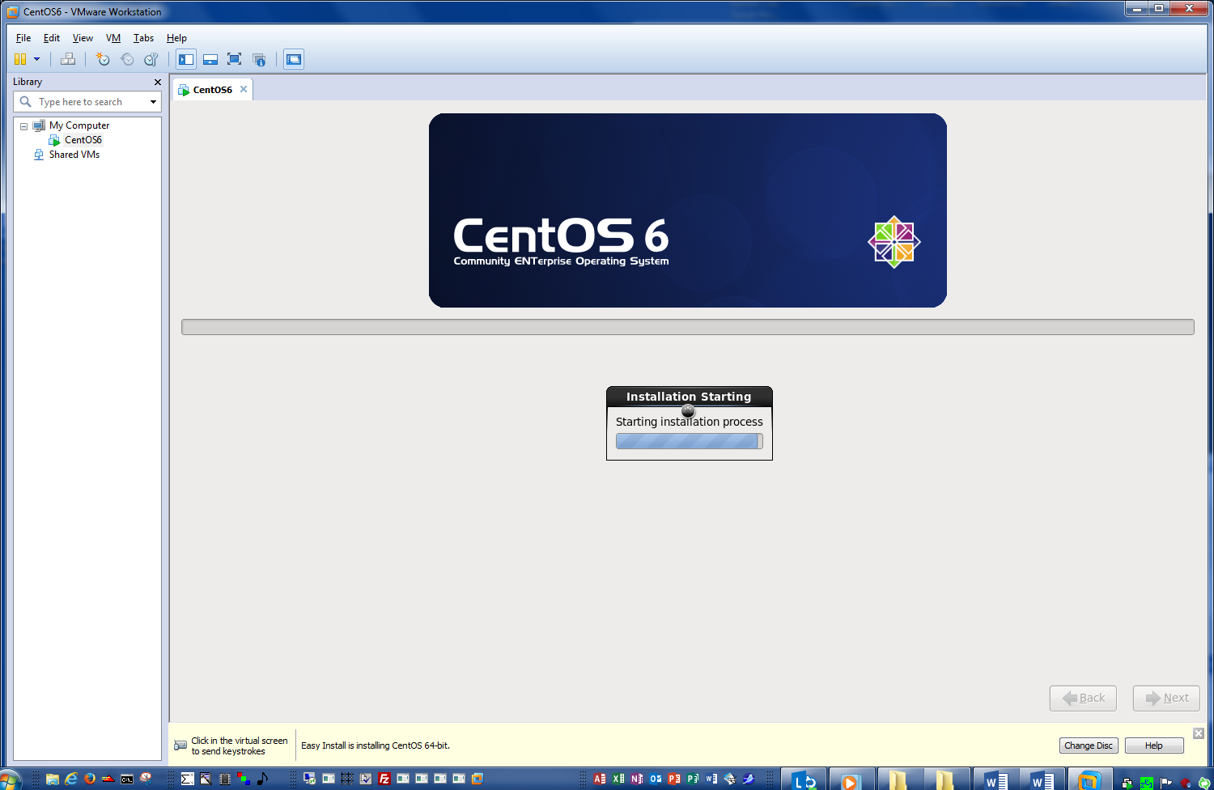



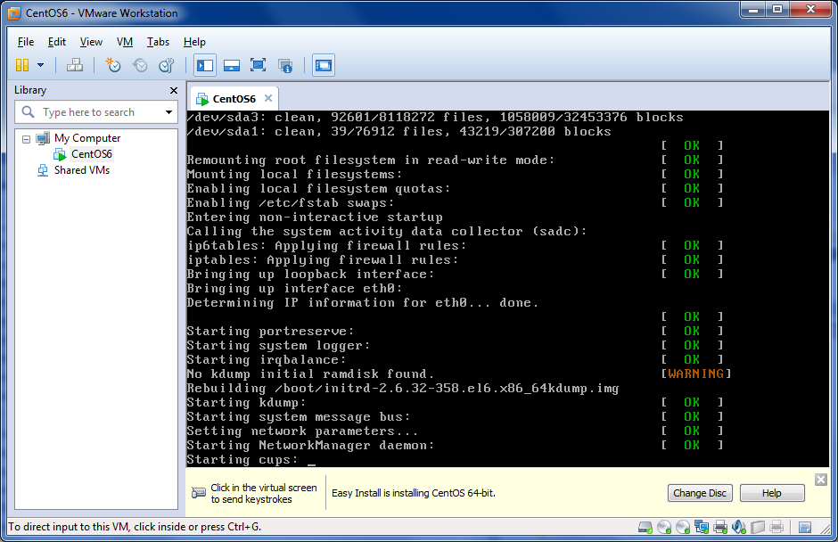

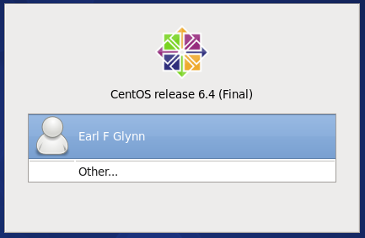

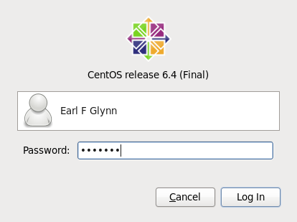

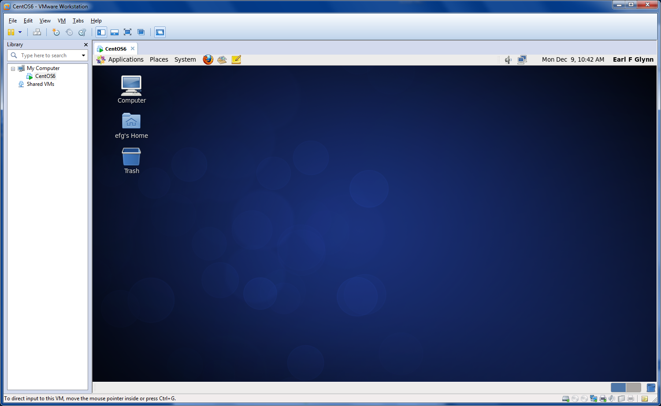

Applications | Accessories | gedit Text Editor | Add this launcher to panel



Applications | System Tools | File Browser | Add this launcher to panel

Applications | System Tools | System Monitor | Add this launcher to panel

Applications | System Tools | Terminal | Add this launcher to panel



Right click on desktop | Change Desktop Background

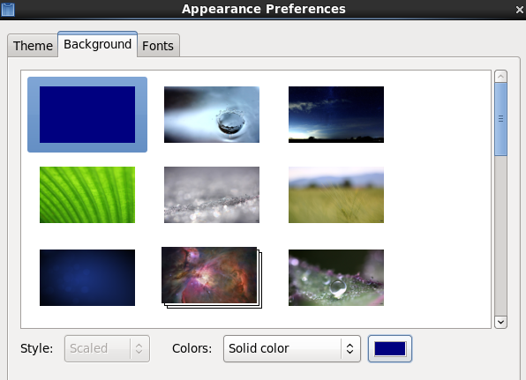

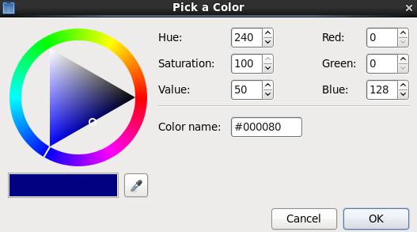

**Update CentOS**

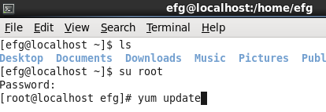

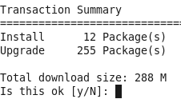

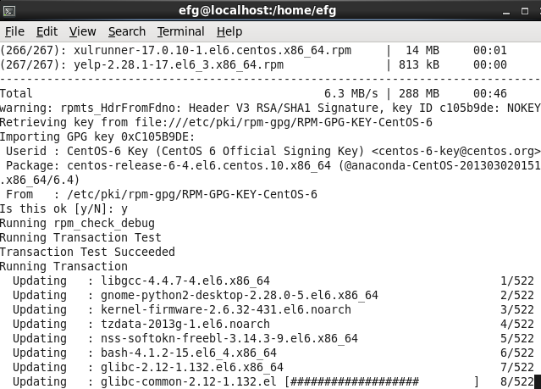

yum search : yum list all

yum grouplist

yum groupinstall “Development Tools”

yum and package info:  
<http://www.cyberciti.biz/faq/rhel-centos-fedora-linux-yum-command-howto/>

<http://mirror.centos.org/centos/6/os/x86_64/Packages/>

**Modify .bashrc**

[29 efg localhost 2013-12-09 13:38:20 /home/efg]

cat .bashrc

# .bashrc

# Source global definitions

if [ -f /etc/bashrc ]; then

. /etc/bashrc

fi

# User specific aliases and functions

alias filemanager='nautilus --no-desktop --browser /home/efg'

alias systemmonitor=gnome-system-monitor

alias xterm=gnome-terminal

case $TERM in

xterm*)

PROMPT_COMMAND='echo -ne "\033]0;${USER} ${HOSTNAME}\007"'

;;

*)

;;

esac

BLUETEXT="\[\e[34;1m\]"

RESETTEXT="\[\e[0m\]"

PS1="\n$BLUETEXT[\! \u \h \$(date '+%Y-%m-%d %T') \$( pwd )]$RESETTEXT\n"

yum grouplist

Loaded plugins: fastestmirror, refresh-packagekit, security

Setting up Group Process

Loading mirror speeds from cached hostfile

* base: mirror.anl.gov

* extras: mirror.steadfast.net

* updates: mirror-centos.hostingswift.com

Installed Groups:

Additional Development

Base

Desktop

Dial-up Networking Support

Directory Client

E-mail server

Fonts

General Purpose Desktop

Graphical Administration Tools

Hardware monitoring utilities

Internet Browser

Legacy UNIX compatibility

Legacy X Window System compatibility

Network Infrastructure Server

Networking Tools

Performance Tools

Perl Support

Print Server

Printing client

SNMP Support

Security Tools

Web Server

X Window System

Installed Language Groups:

Arabic Support [ar]

…

Venda Support [ve]

Available Groups:

Backup Client

Backup Server

CIFS file server

Client management tools

Compatibility libraries

Console internet tools

Debugging Tools

Desktop Debugging and Performance Tools

Desktop Platform

Desktop Platform Development

Development tools

Directory Server

Eclipse

Emacs

FCoE Storage Client

FTP server

Graphics Creation Tools

High Availability

High Availability Management

Identity Management Server

Infiniband Support

Input Methods

Internet Applications

Java Platform

KDE Desktop

Large Systems Performance

Load Balancer

Mainframe Access

Messaging Client Support

**MySQL Database client**

**MySQL Database server**

NFS file server

Network Storage Server

Network file system client

Office Suite and Productivity

PHP Support

PostgreSQL Database client

PostgreSQL Database server

Remote Desktop Clients

Resilient Storage

Ruby Support

Scalable Filesystems

Scientific support

Server Platform

Server Platform Development

Smart card support

Storage Availability Tools

System Management

System administration tools

TeX support

Technical Writing

TurboGears application framework

Virtualization

Virtualization Client

Virtualization Platform

Virtualization Tools

Web Servlet Engine

Web-Based Enterprise Management

iSCSI Storage Client

Available Language Groups:

Afrikaans Support [af]

…

Zulu Support [zu]

Done

System | Administration | Add / Remove Software

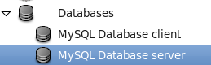

Client

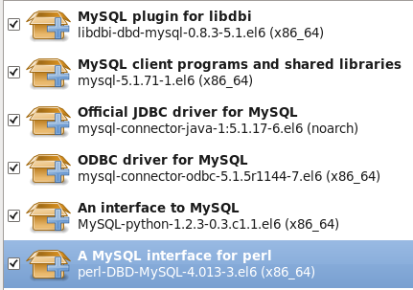

Server

