Download CentOS 6.5 ISO files from Argonne National Laboratory Public Software Mirror: <http://mirror.anl.gov/>

<http://mirror.anl.gov/pub/centos/6.5/isos/x86_64/>

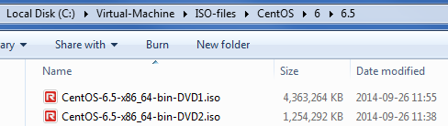

Start VMware

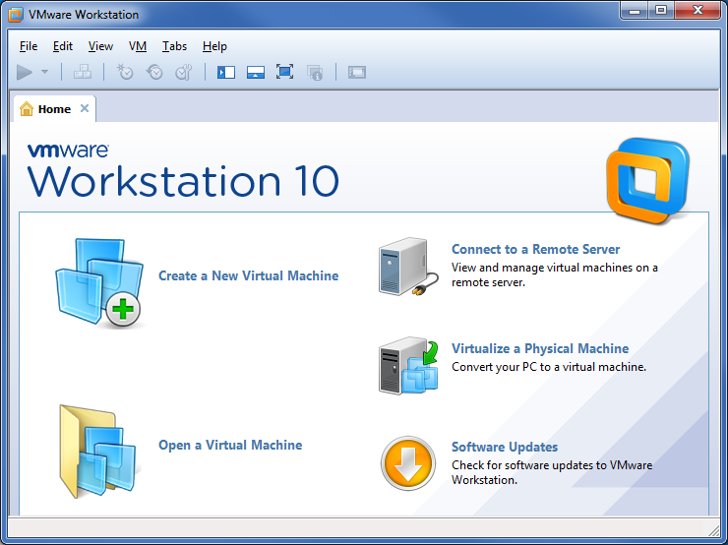

File | New Virtual Machine



Next

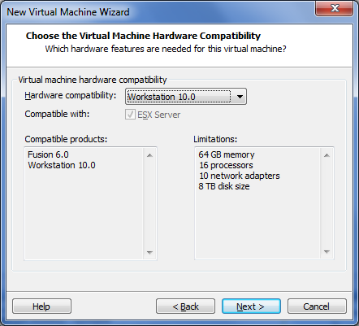

Next

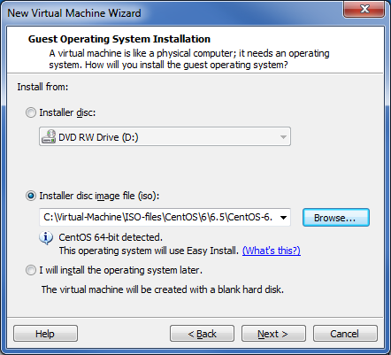

C:\Virtual-Machine\ISO-files\CentOS\6\6.5\CentOS-6.5-x86_64-bin-DVD1.iso  
Next

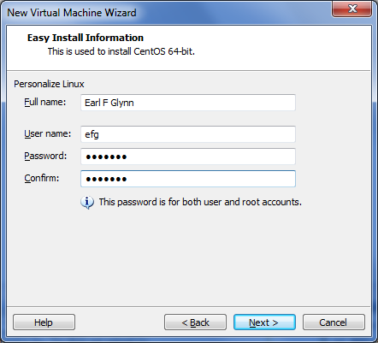

Next

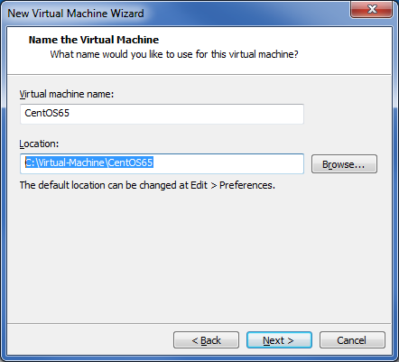

Override defaults: CentOS65, C:\Virtual-Machine\CentOS65, Next

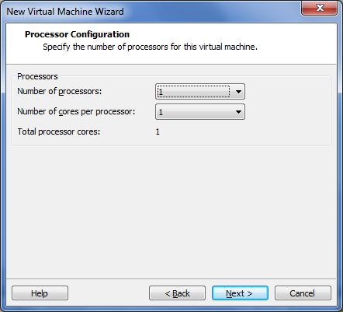

Next



2048, Next

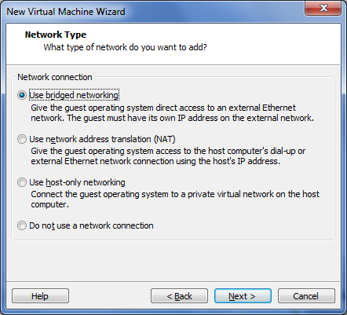

Use bridged networking, Next

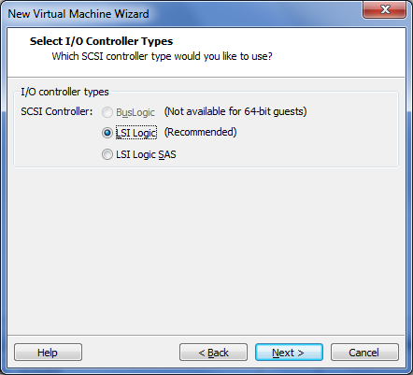

Next

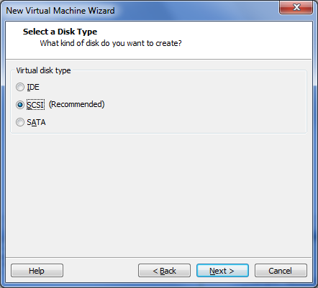

Next

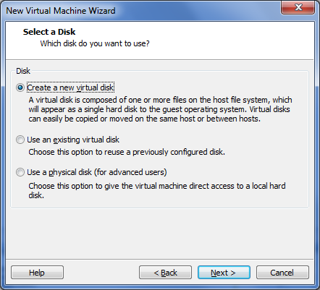

Next

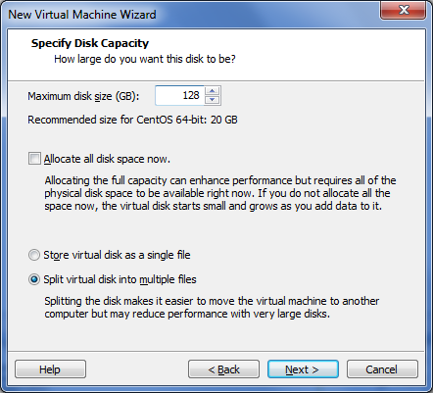

128, Next

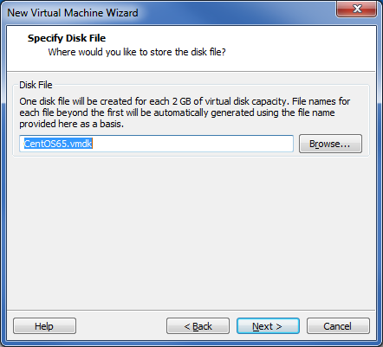

Next

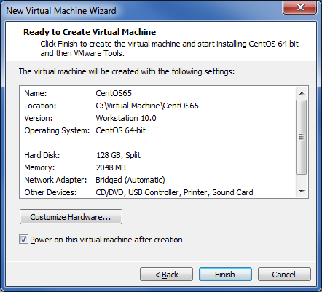

Finish

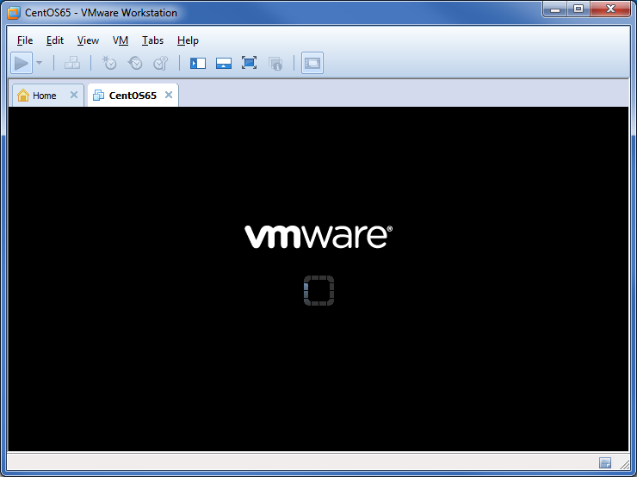

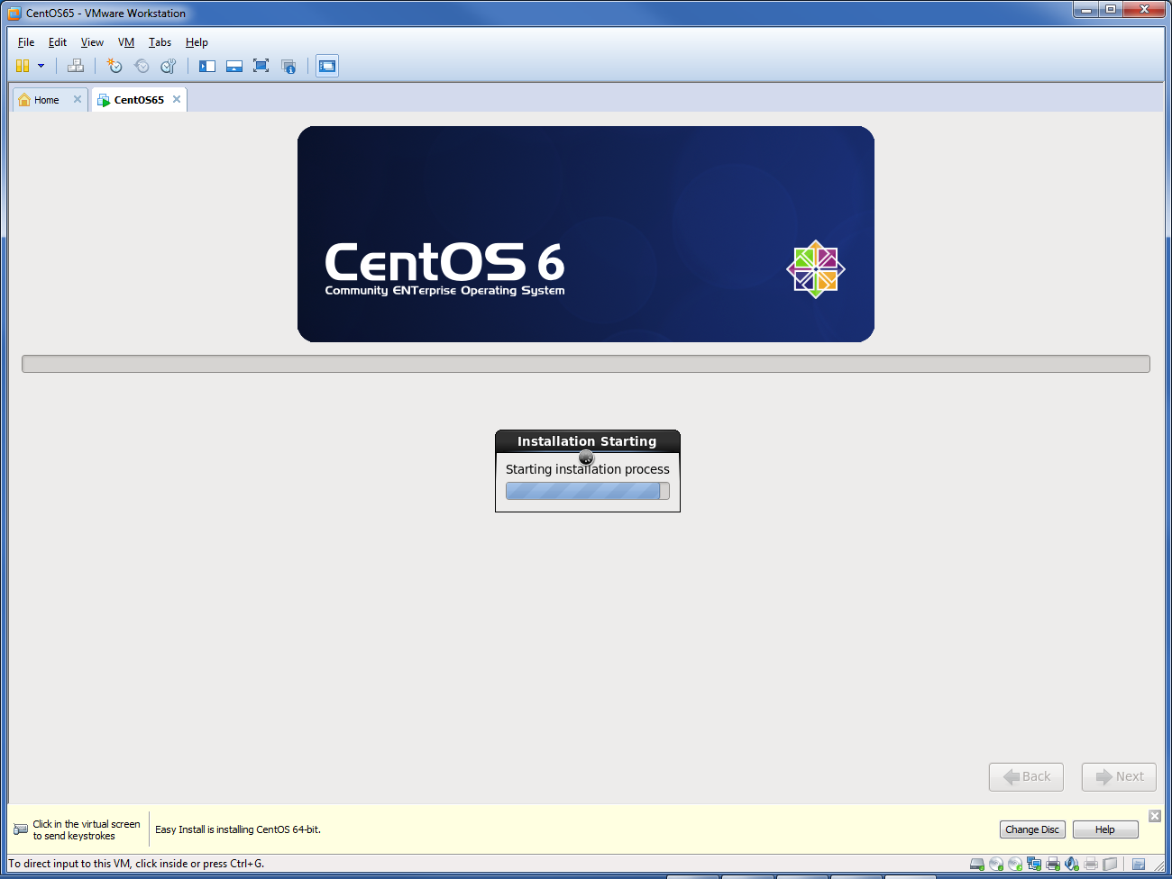

. . .



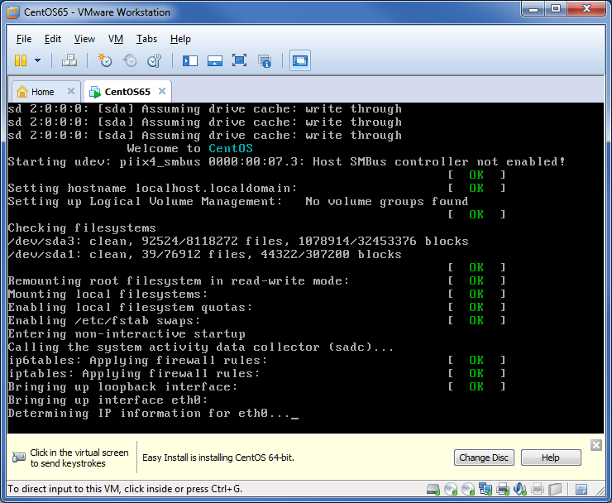

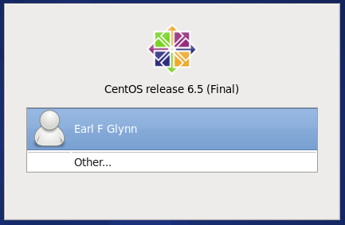

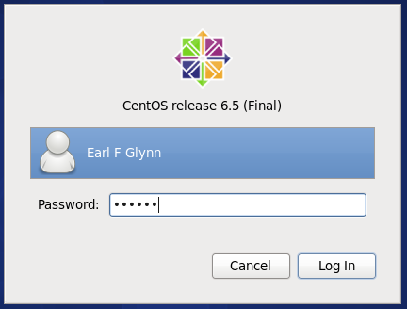

Log In

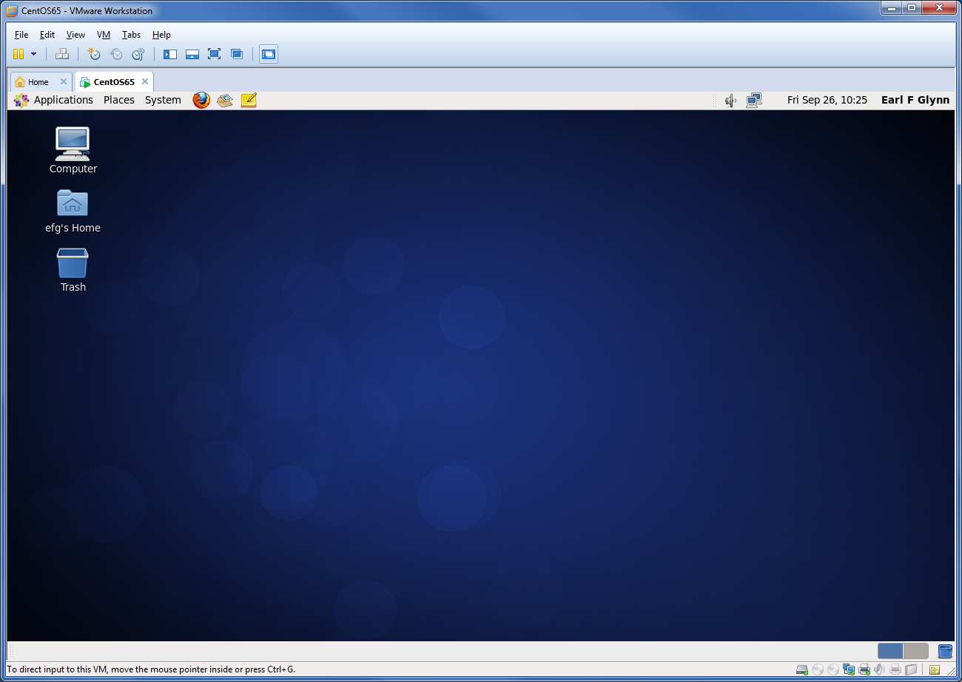

Applications | Accessories | right click on gedit Text Editor | Add this launcher to panel

Applications | System Tools | right click on File Browser | Add this launcher to panel

Applications | System Tools | right click on System Monitor | Add this launcher to panel

Applications | System Tools | right click on Terminal | Add this launcher to panel



Start Terminal window



su root

yum update

. . .

Transaction Summary

================================================================================

Install 3 Package(s)

Upgrade 131 Package(s)

Total download size: 204 M

Is this ok [y/N]: y



. . .

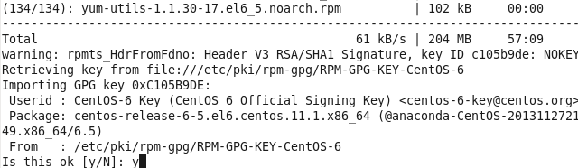

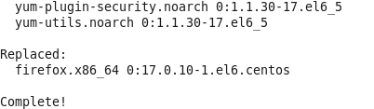

*Shutdown and Restart, and repeat* yum update *until there's nothing to update*

**Add efg and root to sudoers**

<http://wpguru.co.uk/2014/06/centos-sudoers/>

su root

echo "root ALL=(ALL) NOPASSWD: ALL" >> /etc/sudoers

echo "efg ALL=(ALL) NOPASSWD: ALL" >> /etc/sudoers

**Add EPEL Repo**

**Install RHEL (Red Hat Enterprise Linux) Extra Packages Repo**

[32 efg localhost 2014-11-13 07:04:38 /home/efg]

yum repolist

Loaded plugins: fastestmirror, refresh-packagekit, security

Determining fastest mirrors

* base: mirror.team-cymru.org

* extras: mirror.team-cymru.org

* updates: mirror.team-cymru.org

base | 3.7 kB 00:00

extras | 3.4 kB 00:00

updates | 3.4 kB 00:00

updates/primary_db | 852 kB 00:00

repo id repo name status

base CentOS-6 - Base 6,518

extras CentOS-6 - Extras 35

updates CentOS-6 - Updates 315

repolist: 6,868

[33 efg localhost 2014-11-13 07:05:59 /home/efg]

wget http://mirror-fpt-telecom.fpt.net/fedora/epel/6/i386/epel-release-6-8.noarch.rpm

--2014-11-13 07:09:22-- http://mirror-fpt-telecom.fpt.net/fedora/epel/6/i386/epel-release-6-8.noarch.rpm

Resolving mirror-fpt-telecom.fpt.net... 118.69.250.132

Connecting to mirror-fpt-telecom.fpt.net|118.69.250.132|:80... connected.

HTTP request sent, awaiting response... 200 OK

Length: 14540 (14K) [application/x-redhat-package-manager]

Saving to: “epel-release-6-8.noarch.rpm”

…

2014-11-13 07:09:27 (59.4 KB/s) - “epel-release-6-8.noarch.rpm” saved [14540/14540]

[34 efg localhost 2014-11-13 07:09:27 /home/efg]

sudo rpm -ivh epel-release-6-8.noarch.rpm

warning: epel-release-6-8.noarch.rpm: Header V3 RSA/SHA256 Signature, key ID 0608b895: NOKEY

Preparing... ########################################### [100%]

1:epel-release ########################################### [100%]

[35 efg localhost 2014-11-13 07:09:49 /home/efg]

yum repolist

Loaded plugins: fastestmirror, refresh-packagekit, security

Loading mirror speeds from cached hostfile

epel/metalink | 13 kB 00:00

* base: mirror.team-cymru.org

* epel: kdeforge2.unl.edu

* extras: mirror.team-cymru.org

* updates: mirror.team-cymru.org

**epel | 4.4 kB 00:00**

**epel/primary_db | 6.4 MB 00:00**

repo id repo name status

base CentOS-6 - Base 6,518

**epel Extra Packages for Enterprise Linux 6 - x86_64 11,211**

extras CentOS-6 - Extras 35

updates CentOS-6 - Updates 315

repolist: 18,079

**Additional packages to install:**

**sudo yum groupinstall “Development Tools”**

root@localhost efg]# yum groupinstall "Development Tools"

Loaded plugins: fastestmirror, refresh-packagekit, security

Loading mirror speeds from cached hostfile

* base: mirror.steadfast.net

* extras: mirror.steadfast.net

* updates: mirror.steadfast.net

Setting up Group Process

Checking for new repos for mirrors

Package gcc-4.4.7-4.el6.x86_64 already installed and latest version

Package 1:make-3.81-20.el6.x86_64 already installed and latest version

. . .

Installed:

autoconf.noarch 0:2.63-5.1.el6 automake.noarch 0:1.11.1-4.el6

bison.x86_64 0:2.4.1-5.el6 byacc.x86_64 0:1.9.20070509-7.el6

cscope.x86_64 0:15.6-6.el6 ctags.x86_64 0:5.8-2.el6

cvs.x86_64 0:1.11.23-16.el6 diffstat.x86_64 0:1.51-2.el6

doxygen.x86_64 1:1.6.1-6.el6 flex.x86_64 0:2.5.35-8.el6

gcc-c++.x86_64 0:4.4.7-4.el6 gcc-gfortran.x86_64 0:4.4.7-4.el6

gettext.x86_64 0:0.17-16.el6 git.x86_64 0:1.7.1-3.el6_4.1

indent.x86_64 0:2.2.10-7.el6 intltool.noarch 0:0.41.0-1.1.el6

libtool.x86_64 0:2.2.6-15.5.el6 patchutils.x86_64 0:0.3.1-3.1.el6

rcs.x86_64 0:5.7-37.el6 redhat-rpm-config.noarch 0:9.0.3-42.el6.centos

rpm-build.x86_64 0:4.8.0-37.el6 subversion.x86_64 0:1.6.11-10.el6_5

swig.x86_64 0:1.3.40-6.el6 systemtap.x86_64 0:2.3-4.el6_5

Dependency Installed:

gdb.x86_64 0:7.2-64.el6_5.2 gettext-devel.x86_64 0:0.17-16.el6

gettext-libs.x86_64 0:0.17-16.el6 libgcj.x86_64 0:4.4.7-4.el6

libgfortran.x86_64 0:4.4.7-4.el6 libstdc++-devel.x86_64 0:4.4.7-4.el6

perl-Compress-Raw-Zlib.x86_64 1:2.021-136.el6 perl-Compress-Zlib.x86_64 0:2.021-136.el6

perl-Error.noarch 1:0.17015-4.el6 perl-Git.noarch 0:1.7.1-3.el6_4.1

perl-HTML-Parser.x86_64 0:3.64-2.el6 perl-HTML-Tagset.noarch 0:3.20-4.el6

perl-IO-Compress-Base.x86_64 0:2.021-136.el6 perl-IO-Compress-Zlib.x86_64 0:2.021-136.el6

perl-URI.noarch 0:1.40-2.el6 perl-XML-Parser.x86_64 0:2.36-7.el6

perl-libwww-perl.noarch 0:5.833-2.el6 systemtap-client.x86_64 0:2.3-4.el6_5

systemtap-devel.x86_64 0:2.3-4.el6_5

Complete!

sudo yum install filezilla

filezilla&

File | Site Manager | New Site

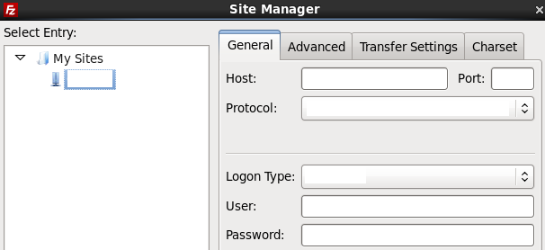

*yum and package info:*<http://www.cyberciti.biz/faq/rhel-centos-fedora-linux-yum-command-howto/>   
<http://mirror.centos.org/centos/6/os/x86_64/Packages/>

yum grouplist

**Change Background**

Right click on desktop | Change Desktop Background

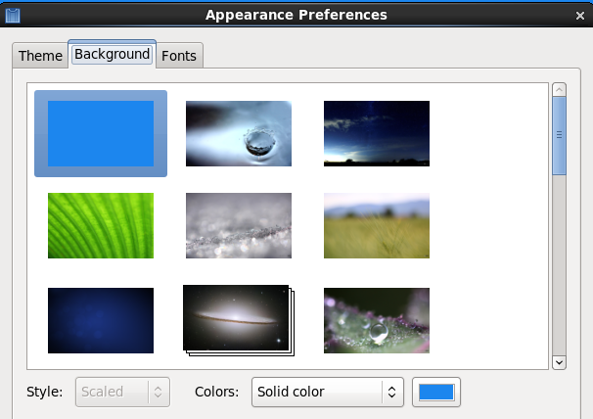

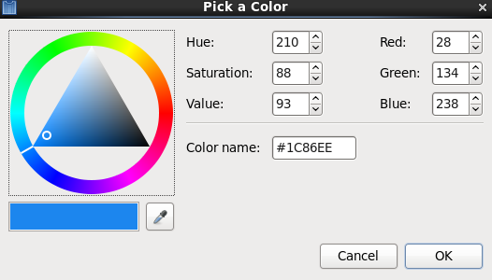



**Modify .bashrc**

[efg@localhost ~]$ cd

[efg@localhost ~]$ gedit .bashrc

*copy and paste*

# .bashrc

# Source global definitions

if [ -f /etc/bashrc ]; then

. /etc/bashrc

fi

# User specific aliases and functions

alias filemanager='nautilus --no-desktop --browser /home/efg'

alias systemmonitor=gnome-system-monitor

alias xterm=gnome-terminal

case $TERM in

xterm*)

PROMPT_COMMAND='echo -ne "\033]0;${USER} ${HOSTNAME}\007"'

;;

*)

;;

esac

BLUETEXT="\[\e[34;1m\]"

RESETTEXT="\[\e[0m\]"

PS1="\n$BLUETEXT[\! \u \h \$(date '+%Y-%m-%d %T') \$( pwd )]$RESETTEXT\n"

**Display Preferences**

System | Preferences | Display



or



(or higher if possible on other monitors)

**Power Management**

System | Preferences | Power Management

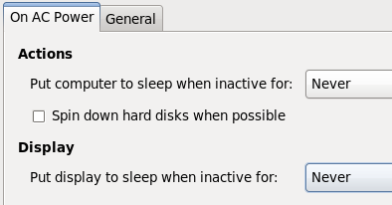

**Screen Saver**

System | Preferences |Screen Saver



**Virtual Environments**

sudo yum install python-pip

sudo pip install virtualenv

sudo pip install virtualenvwrapper

cd /opt

sudo mkdir virtualenv

sudo chown efg virtualenv

source `which virtualenvwrapper.sh`

WORKON_HOME=/opt/virtualenv

mkvirtualenv TestEnv

[53 efg localhost 2014-11-13 11:22:10 /opt]

mkvirtualenv TestEnv

New python executable in TestEnv/bin/python

Installing setuptools, pip...done.

(TestEnv)

[56 efg localhost 2014-11-13 11:23:48 /home/efg]

python --version

Python 2.6.6

Add to .bashrc:

[1003 efg localhost 2014-11-12 15:04:08 /home/efg]

tail -4 .bashrc

**# virtualenvwrapper**

**export WORKON_HOME=/opt/virtualenv**

**source `which virtualenvwrapper.sh`**

This enables "workon" to display possible environments from any terminal window, and then enable a new environment.

[40 efg localhost 2014-11-13 11:27:50 /home/efg]

workon

TestEnv

[41 efg localhost 2014-11-13 11:27:55 /home/efg]

workon TestEnv

(TestEnv)

[42 efg localhost 2014-11-13 11:28:00 /home/efg]

**Latest Python 2.7 version for work environment**

<https://www.digitalocean.com/community/tutorials/how-to-set-up-python-2-7-6-and-3-3-3-on-centos-6-4>

sudo yum -y update

sudo yum groupinstall -y development

sudo yum install -y zlib-devel openssl-devel sqlite-devel bzip2-devel

Let's put all python compiled versions in subdirectories here:

**/opt/python**

specifically:

/opt/python/python278  
/opt/python/python342

Let's create a /opt/python/bin directory that will have links to the individual python executables, like python27 and python 33. More on this later.

For now:

[72 efg localhost 2014-11-13 11:40:56 **/opt**]

sudo mkdir -p python/python278

chown –R efg python

Let's compile Python version 2.7.8 (in future check for later 2.X version):

[78 efg localhost 2014-11-13 11:33:51 **/home/efg/build**]

wget http://www.python.org/ftp/python/2.7.8/Python-2.7.8.tar.xz

xz -d Python-2.7.8.tar.xz

[79 efg localhost 2014-11-13 11:34:18 /home/efg/build]

ll

total 10280

-rw-rw-r--. 1 efg efg 10525244 Jun 29 19:41 Python-2.7.8.tar.xz

[80 efg localhost 2014-11-13 11:35:02 /home/efg/build]

xz -d Python-2.7.8.tar.xz

[81 efg localhost 2014-11-13 11:36:12 /home/efg/build]

ll

total 64712

-rw-rw-r--. 1 efg efg 66263040 Jun 29 19:41 Python-2.7.8.tar

tar -xvf Python-2.7.8.tar

cd Python-2.7.8

./configure --prefix=/opt/python/python278

make

make altinstall

Be sure to use **altinstall** above to not change the system version of Python.

Verify executable built correctly:

[89 efg localhost 2014-11-13 11:52:55 /opt/python/python278/bin]

/opt/python/python278/bin/python2.7 --version

Python 2.7.8

[93 efg localhost 2014-11-13 11:55:28 /opt/virtualenv]

virtualenv --python=/opt/python/python278/bin/python2.7 Python278

Running virtualenv with interpreter /opt/python/python278/bin/python2.7

New python executable in Python278/bin/python2.7

Also creating executable in Python278/bin/python

Installing setuptools, pip...done.

[94 efg localhost 2014-11-13 11:57:45 /opt/virtualenv]

workon

Python278

TestEnv

[95 efg localhost 2014-11-13 11:58:03 /opt/virtualenv]

workon Python278

(Python278)

[96 efg localhost 2014-11-13 11:59:08 /opt/virtualenv]

python --version

Python 2.7.8

**Latest Python 3.4 version for work environment**

[121 efg localhost 2014-11-13 12:16:59 /opt]

mkdir -p python/python342

Let's compile Python version 3.4.2 (in future check for later 3.X version):

[122 efg localhost 2014-11-13 12:19:47 /home/efg/build]

wget <http://www.python.org/ftp/python/3.4.2/Python-3.4.2.tar.xz>

xz -d Python-3.4.2.tar.xz

tar -xvf Python-3.4.2.tar

cd Python-3.4.2

./configure --prefix=/opt/python/python342

make

make altinstall

Be sure to use **altinstall** above to not change the system version of Python.

Verify executable built correctly:

[128 efg localhost 2014-11-13 12:28:48 /opt/python/python342/bin]

/opt/python/python342/bin/python3.4 --version

Python 3.4.2

[133 efg localhost 2014-11-13 12:30:55 /opt/virtualenv]

virtualenv --python=/opt/python/python342/bin/python3.4 Python342

Running virtualenv with interpreter /opt/python/python342/bin/python3.4

Using base prefix '/opt/python/python342'

New python executable in Python342/bin/python3.4

Also creating executable in Python342/bin/python

Installing setuptools, pip...done.

[134 efg localhost 2014-11-13 12:31:38 /opt/virtualenv]

workon

Python278

Python342

TestEnv

[135 efg localhost 2014-11-13 12:31:49 /opt/virtualenv]

workon Python342

(Python342)

[136 efg localhost 2014-11-13 12:31:56 /opt/virtualenv]

python --version

Python 3.4.2

For convenience:

[127 efg localhost 2014-11-13 12:33:50 /opt/python/bin]

ln -s ../python278/bin/python2.7 .

[128 efg localhost 2014-11-13 12:34:50 /opt/python/bin]

ln -s ../python342/bin/python3.4 .

[129 efg localhost 2014-11-13 12:35:05 /opt/python/bin]

ll

total 0

lrwxrwxrwx. 1 efg efg 26 Nov 13 12:34 python2.7 -> ../python278/bin/python2.7

lrwxrwxrwx. 1 efg efg 26 Nov 13 12:35 python3.4 -> ../python342/bin/python3.4

Might consider modifying path, but not now:

export PATH="/opt/python/bin:$PATH"