The following notes were collected while creating a new 1 TB virtual disk for a CentOS virtual machine.

**Initial state4 of virtual machine**

**[435 efg localhost 2015-01-26 15:18:43 /home/efg]**

df

Filesystem 1K-blocks Used Available Use% Mounted on

/dev/sda3 127644396 12852892 108300832 11% /

tmpfs 957356 80 957276 1% /dev/shm

/dev/sda1 289293 63538 210395 24% /boot

**[435 efg localhost 2015-01-26 15:19:11 /home/efg]**

runlevel

N 5

[442 efg localhost 2015-01-26 15:34:57 /sys/class/scsi_host]

ll

total 0

lrwxrwxrwx. 1 root root 0 Jan 26 15:17 host0 -> ../../devices/pci0000:00/0000:00:07.1/host0/scsi_host/host0/

lrwxrwxrwx. 1 root root 0 Jan 26 15:17 host1 -> ../../devices/pci0000:00/0000:00:07.1/host1/scsi_host/host1/

lrwxrwxrwx. 1 root root 0 Jan 26 15:17 host2 -> ../../devices/pci0000:00/0000:00:10.0/host2/scsi_host/host2/

<http://www.thegeekstuff.com/2010/09/linux-fdisk/>   
Linux fdisk Command Examples to Manage Hard Disk Partition

**[443 efg localhost 2015-01-26 15:37:25 /sys/class/scsi_host]**

sudo fdisk -l

Disk /dev/sda: 137.4 GB, 137438953472 bytes

255 heads, 63 sectors/track, 16709 cylinders

Units = cylinders of 16065 * 512 = 8225280 bytes

Sector size (logical/physical): 512 bytes / 512 bytes

I/O size (minimum/optimal): 512 bytes / 512 bytes

Disk identifier: 0x0007f1ee

Device Boot Start End Blocks Id System

/dev/sda1 * 1 39 307200 83 Linux

Partition 1 does not end on cylinder boundary.

/dev/sda2 39 549 4096000 82 Linux swap / Solaris

Partition 2 does not end on cylinder boundary.

/dev/sda3 549 16710 129813504 83 Linux

**Shutdown**

**Add new virtual disk**

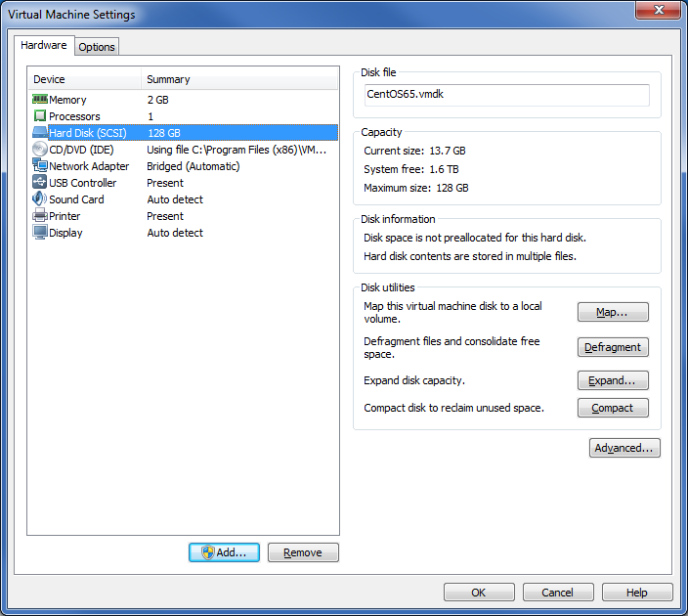



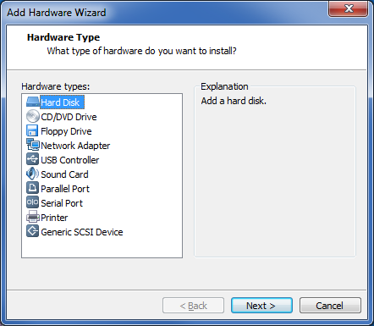

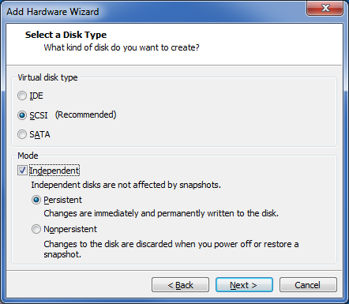

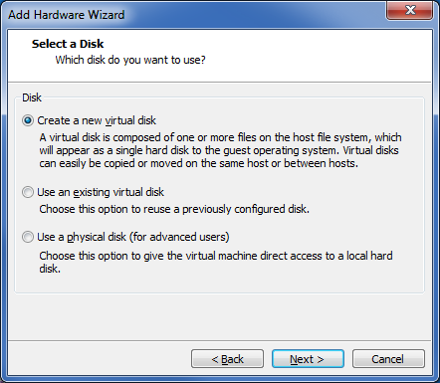

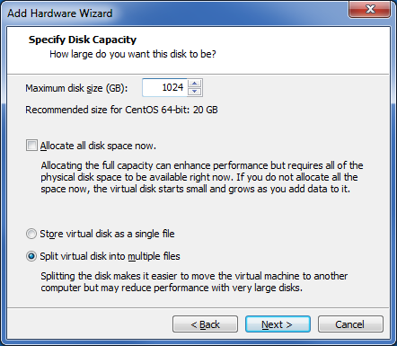

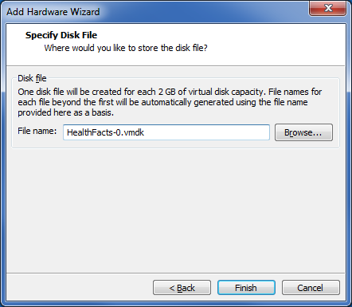

**Start virtual machine**

**[446 efg localhost 2015-01-26 16:23:05 /home/efg]**

sudo fdisk -l

Disk /dev/sda: 137.4 GB, 137438953472 bytes

255 heads, 63 sectors/track, 16709 cylinders

Units = cylinders of 16065 * 512 = 8225280 bytes

Sector size (logical/physical): 512 bytes / 512 bytes

I/O size (minimum/optimal): 512 bytes / 512 bytes

Disk identifier: 0x0007f1ee

Device Boot Start End Blocks Id System

/dev/sda1 * 1 39 307200 83 Linux

Partition 1 does not end on cylinder boundary.

/dev/sda2 39 549 4096000 82 Linux swap / Solaris

Partition 2 does not end on cylinder boundary.

/dev/sda3 549 16710 129813504 83 Linux

Disk /dev/sdb: 1099.5 GB, 1099511627776 bytes

255 heads, 63 sectors/track, 133674 cylinders

Units = cylinders of 16065 * 512 = 8225280 bytes

Sector size (logical/physical): 512 bytes / 512 bytes

I/O size (minimum/optimal): 512 bytes / 512 bytes

Disk identifier: 0x00000000

Create new partition

From <http://www.thegeekstuff.com/2010/09/linux-fdisk/>

<http://askubuntu.com/questions/154180/how-to-mount-a-new-drive-on-startup>

<http://www.thegeekstuff.com/2011/05/ext2-ext3-ext4/>

[455 efg localhost 2015-01-26 16:54:38 /home/efg]

sudo fdisk /dev/sdb

WARNING: DOS-compatible mode is deprecated. It's strongly recommended to

switch off the mode (command 'c') and change display units to

sectors (command 'u').

Command (m for help): o

Building a new DOS disklabel with disk identifier 0xcf9c88b4.

Changes will remain in memory only, until you decide to write them.

After that, of course, the previous content won't be recoverable.

Warning: invalid flag 0x0000 of partition table 4 will be corrected by w(rite)

WARNING: DOS-compatible mode is deprecated. It's strongly recommended to

switch off the mode (command 'c') and change display units to

sectors (command 'u').

Command (m for help): n

Command action

e extended

p primary partition (1-4)

p

Partition number (1-4): 1

First cylinder (1-133674, default 1):

Using default value 1

Last cylinder, +cylinders or +size{K,M,G} (1-133674, default 133674):

Using default value 133674

Command (m for help): w

The partition table has been altered!

Calling ioctl() to re-read partition table.

Syncing disks.

**[458 efg localhost 2015-01-26 17:02:49 /home/efg]**

sudo mkfs.ext4 /dev/sdb1

mke2fs 1.41.12 (17-May-2010)

Filesystem label=

OS type: Linux

Block size=4096 (log=2)

Fragment size=4096 (log=2)

Stride=0 blocks, Stripe width=0 blocks

67108864 inodes, 268434093 blocks

13421704 blocks (5.00%) reserved for the super user

First data block=0

Maximum filesystem blocks=4294967296

8192 block groups

32768 blocks per group, 32768 fragments per group

8192 inodes per group

Superblock backups stored on blocks:

32768, 98304, 163840, 229376, 294912, 819200, 884736, 1605632, 2654208,

4096000, 7962624, 11239424, 20480000, 23887872, 71663616, 78675968,

102400000, 214990848

Writing inode tables: done

Creating journal (32768 blocks): done

Writing superblocks and filesystem accounting information: done

This filesystem will be automatically checked every 29 mounts or

180 days, whichever comes first. Use tune2fs -c or -i to override.

[459 efg localhost 2015-01-26 17:05:10 /home/efg]

sudo fdisk /dev/sdb1

Device contains neither a valid DOS partition table, nor Sun, SGI or OSF disklabel

Building a new DOS disklabel with disk identifier 0x77aa5014.

Changes will remain in memory only, until you decide to write them.

After that, of course, the previous content won't be recoverable.

Warning: invalid flag 0x0000 of partition table 4 will be corrected by w(rite)

WARNING: DOS-compatible mode is deprecated. It's strongly recommended to

switch off the mode (command 'c') and change display units to

sectors (command 'u').

Command (m for help): x

Expert command (m for help): i

New disk identifier (current 0x77aa5014):

Expert command (m for help): w

The partition table has been altered!

Calling ioctl() to re-read partition table.

WARNING: Re-reading the partition table failed with error 22: Invalid argument.

The kernel still uses the old table. The new table will be used at

the next reboot or after you run partprobe(8) or kpartx(8)

Syncing disks.

Add line to /etc/fstab to automatically mount drive a boot time.

[464 efg localhost 2015-01-26 17:11:07 /home/efg]

cat /etc/fstab

#

# /etc/fstab

# Created by anaconda on Mon Dec 22 02:31:32 2014

#

# Accessible filesystems, by reference, are maintained under '/dev/disk'

# See man pages fstab(5), findfs(8), mount(8) and/or blkid(8) for more info

#

UUID=083da226-2ca1-4678-86c4-1c5ac746c6ce / ext4 defaults 1 1

UUID=849faf00-ee9f-4a93-acf2-d77299f3f601 /boot ext4 defaults 1 2

UUID=47ced98d-fc75-4a77-b84f-4ba667de733e swap swap defaults 0 0

tmpfs /dev/shm tmpfs defaults 0 0

devpts /dev/pts devpts gid=5,mode=620 0 0

sysfs /sys sysfs defaults 0 0

proc /proc proc defaults 0 0

/dev/sdb1 /healthfacts ext4 defaults 0 0

[469 efg localhost 2015-01-26 17:15:39 /]

sudo mkdir healthfacts



After reboot

[475 efg localhost 2015-01-26 17:18:22 /home/efg]

df

Filesystem 1K-blocks Used Available Use% Mounted on

/dev/sda3 127644396 12911104 108242620 11% /

tmpfs 957356 148 957208 1% /dev/shm

/dev/sda1 289293 63538 210395 24% /boot

/dev/sdb1 1056757608 72984 1002997808 1% /healthfacts