**Earl F Glynn**UMKC Center for Health Insights  
2014-07-07

Contents

Starting Point 3

Additional Prerequisites 3

Visual C++ 2012 Redistributable 3

Third Party Software Required for REDCap 3

Wampserver: Apache, MySQL, PHP 5

WampServer Testing/Configuration 11

localhost 11

MySQL 13

phpMyAdmin 14

www directory 15

PHP in Path 16

Reboot 16

PEAR 17

pear Auth-1.6.2 21

pear DB-1.7.14RC1 21

REDCap Installation 22

Download files 22

Run index.php in browser 23

Create redcap database user in phpMyAdmin 24

Modify data.php 28

Customize values for server and installation 30

Create REDCap database tables 32

Configuration Check 33

REDCap Configuration 37

How to change from "None (Public)" to "Table-based" authentication 37

Create New User 38

Designate Super User 39

Remove site_admin as superuser 41

Forgot to setup superuser before enabling table-based authentication 42

Add New Users: superCHI and normalCHI 42

REDCap Fixes 43

ERROR: Cron job not running! 43

Your web server does NOT have the PHP library cURL installed 44

MySQL Tweak 45

PHP Tweaks 46

Missing UTF-8 fonts for PDF export 47

Validation Types 47

Not using SSL 48

REDCap is not able to send emails - CRITICAL 48

Directory that stores user-uploaded documents is exposed to the web 49

# Purpose

These instructions show how to extend a Windows 7 VMware virtual machine to provide a REDCap environment for development and test purposes.

# Starting Point

The starting point for building the REDCap virtual machine is a Windows 7 Virtual Machine in this folder:   
**C:\Virtual-Machine\Windows7-1Minimal-Tools\.**

The folder contains ~270 files and takes about 26 GB of space.

The build process for this virtual machine may be found in the document:  
**C:\Virtual-Machine\Windows7-1Minimal-Tools\VMware-Build-Notes-Windows-7.docx**

Copy **C:\Virtual-Machine\Windows7-1Minimal-Tools** to **C:\Virtual-Machine\REDCapVM64**

# Additional Prerequisites

## Visual C++ 2012 Redistributable

Visual C++ Redistributable for Visual Studio 2012 Update 4  
<http://www.microsoft.com/en-us/download/details.aspx?id=30679>

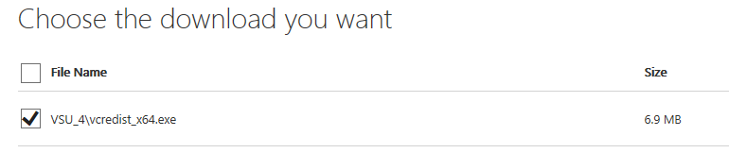

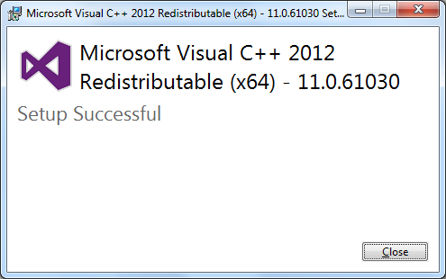

Install 64 bit version of Visual C++ 2012 Redistributable for WampServer (described below).

## Third Party Software Required for REDCap

**REDCap Wiki**

<https://iwg.devguard.com/trac/redcap>

<https://iwg.devguard.com/trac/redcap/wiki/3rdPartySoftware>

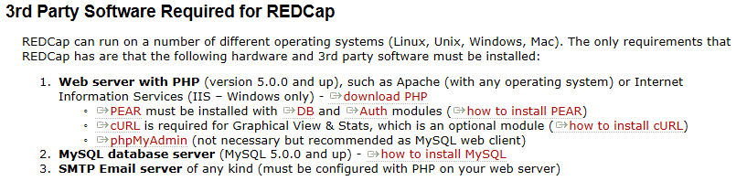

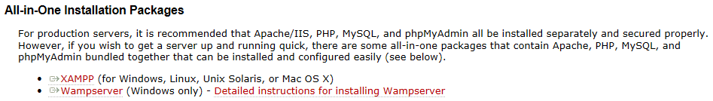

Online notes say XAMPP is perhaps 10 years old. It does work on multiple platforms but some online comments suggest Wampserver may be a better "black box" approach. So, we will try Wampserver first.

## Wampserver: Apache, MySQL, PHP

<http://www.wampserver.com/en/>

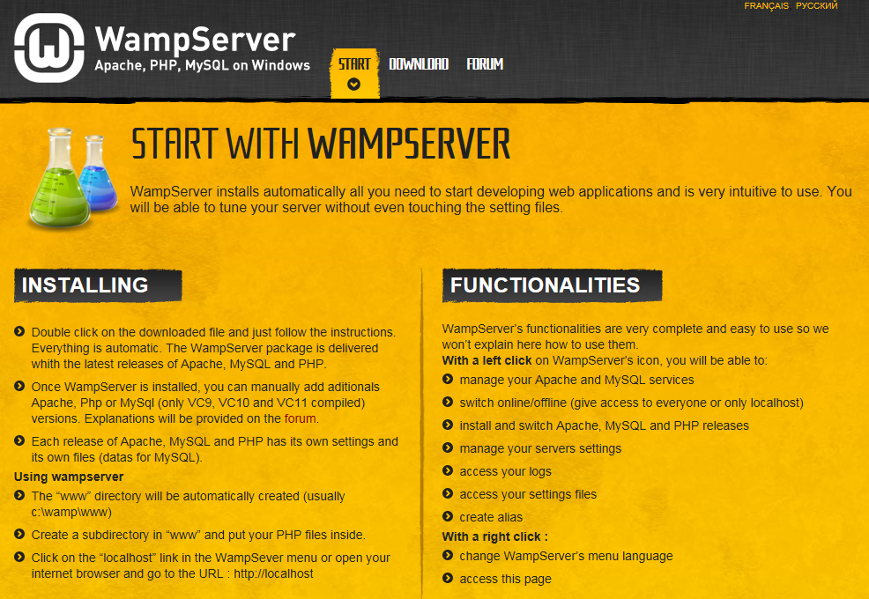

Older versions at SourceForge:

<http://sourceforge.net/projects/wampserver/files/>

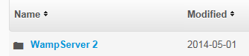

**Recent Version WampServer: 2.4**

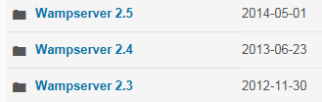

<http://sourceforge.net/projects/wampserver/files/WampServer%202/Wampserver%202.4/>

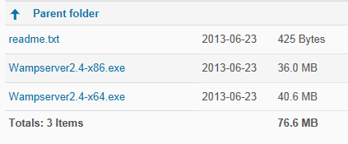

<http://iweb.dl.sourceforge.net/project/wampserver/WampServer%202/Wampserver%202.4/readme.txt>

WampServer 2.4 - Windows 64 Bits

Apache : 2.4.4

MySQL : 5.6.12

PHP : 5.4.12

PHPMyAdmin : 4.0.4

SqlBuddy : 1.3.3

XDebug : 2.2.3

64 Bits Version tested on Windows Seven and 8

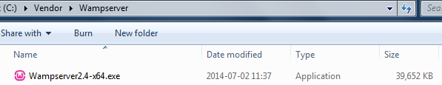

**Go with Wampserver 2.4 to get to an older version of PHP, which is being used with the current UMKC**

**production REDCap server.**

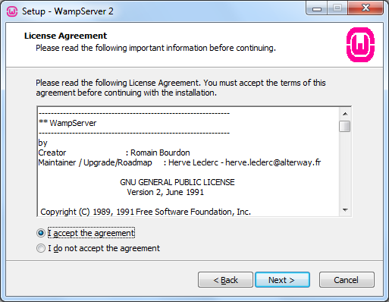

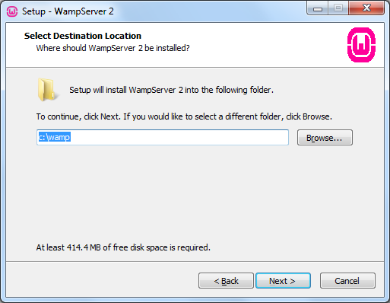

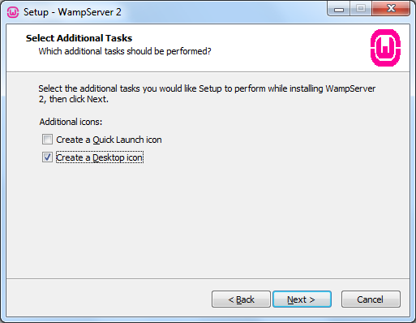

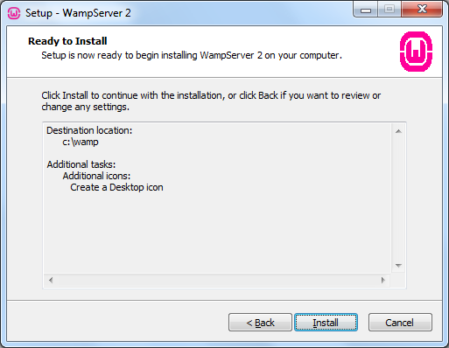

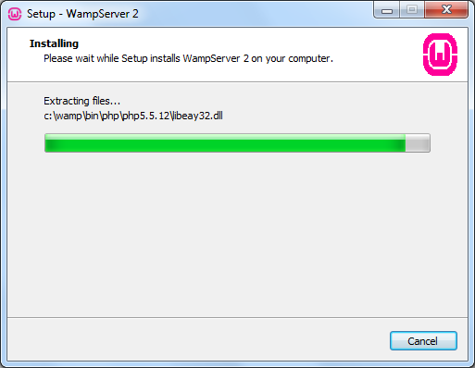

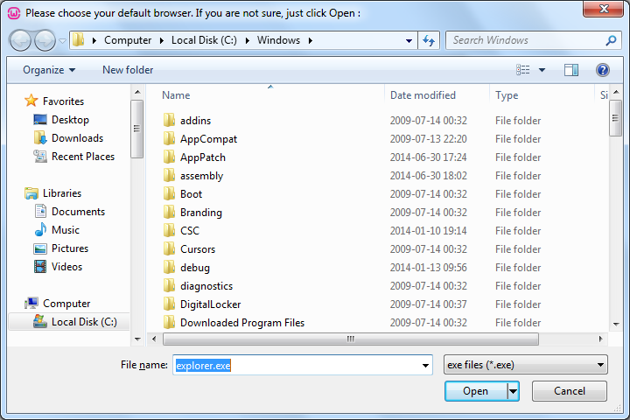

Open

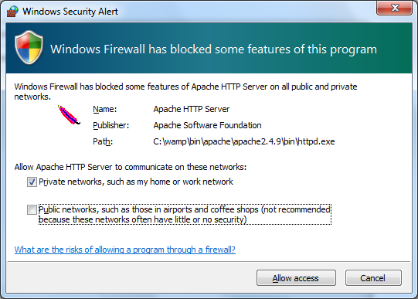

Allow Access

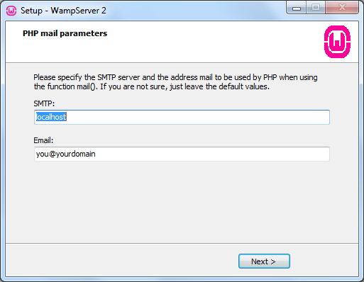

May need to get mail server working at some point? Perhaps use Gmail here?

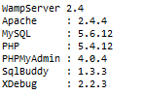





## WampServer Testing/Configuration

### localhost

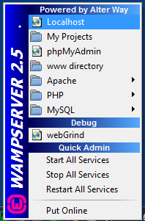

Localhost

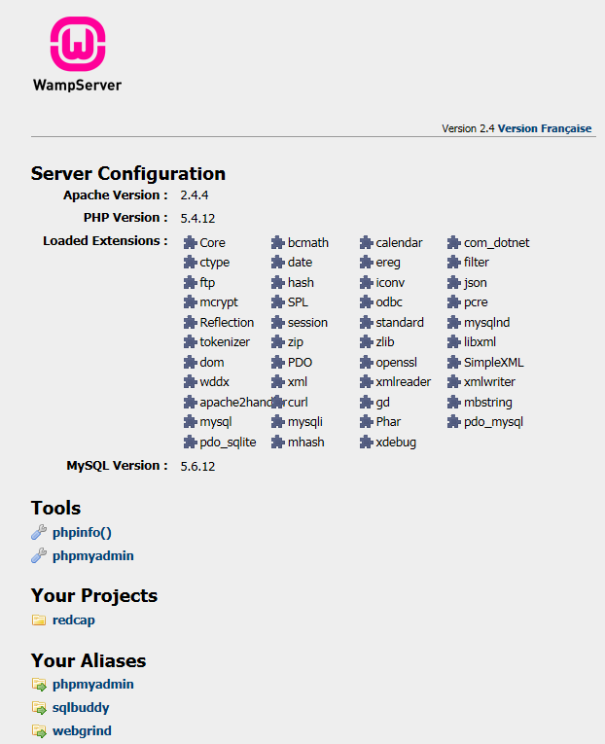

Turn on Intranet settings

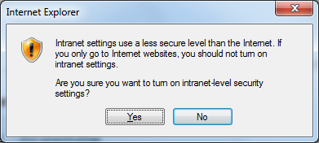

Yes

### MySQL

Try to run this test:

<http://localhost/testmysql.php>

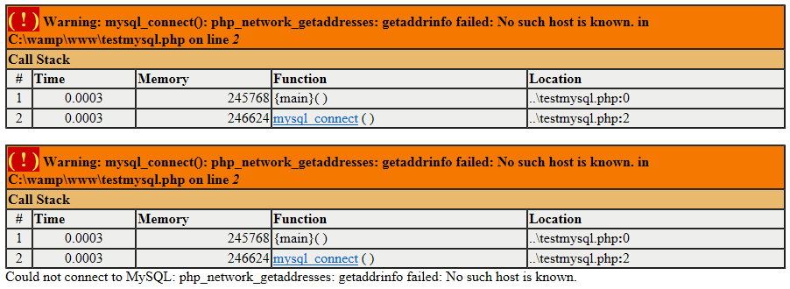

Modify file **testmysql.php** stored in directory **c:\wamp\www**.

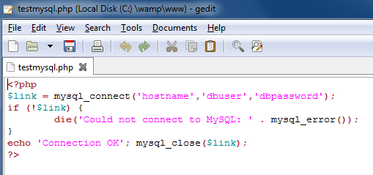

The hostname, dbuser and dbpassword are not correct.

By default, the user "root" has a blank password.

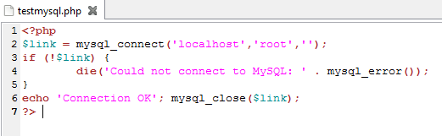

Rerun the test:

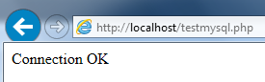

### phpMyAdmin

Run phpMyAdmin:

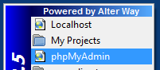

By default, the Username "root" has a blank password.

Go

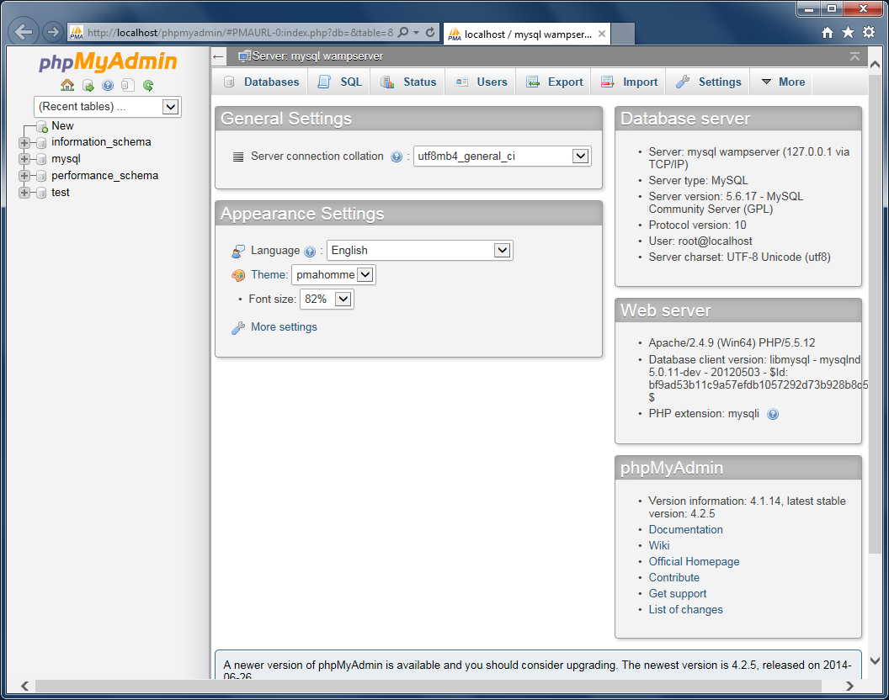

### www directory

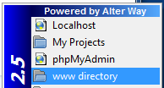

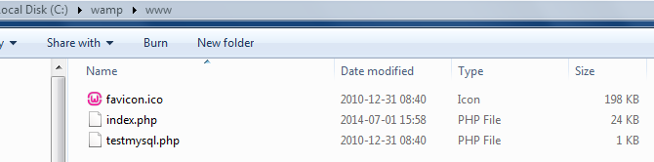

### PHP in Path

Add PHP to path so php will run from command line:

>echo %Path%

C:\Windows\system32;C:\Windows;C:\Windows\System32\Wbem;C:\Windows\System32\WindowsPowerShell\v1.0\;C:\Anaconda;C:\Anaconda\Scripts;**C:\wamp\bin\php\php5.4.12**

>php --version

PHP 5.4.12 (cli) (built: Feb 25 2013 00:29:22)

Copyright (c) 1997-2013 The PHP Group

Zend Engine v2.4.0, Copyright (c) 1998-2013 Zend Technologies

### Reboot

After reboot, all services can be started by double clicking the WampServer icon:

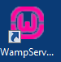

The tray icon starts out red, goes yellow briefly, and ends up green:



## PEAR

The REDCap wiki describes installation of PEAR:

<https://iwg.devguard.com/trac/redcap/wiki/3rdPartySoftware>

* To install PEAR module in PHP:
  1. go to pear.php.net/go-pear
  2. download go-pear.php and save it to the root directory
  3. go to the page localhost\go-pear.php and run the installation.

Various problems were observed in installing PEAR:

<http://pear.php.net/go-pear>

Save to desktop: **go-pear.txt**

Rename to **go-pear.php** and save to **C:\wamp\www**

In command window:

# Command-line installation (for advanced users):

# 1) Download this file and save it as go-pear.php

# 2) Open a terminal/command prompt and type: php -q go-pear.php

C:\wamp\www 2014-07-02 16:13:05

>php -q go-pear.php

∩╗┐Sorry! Your PHP version is too new (5.4.12) for this go-pear.

Instead use http://pear.php.net/go-pear.phar for a more stable and current

version of go-pear, more suited to your PHP version.

Thank you for your coopertion and sorry for the inconvenience!

Alternatives to installing PEAR did not work:

<http://pear.php.net/manual/en/installation.php>

For older versions:

<http://pear.php.net/package/PEAR/download/1.9.4/>

Problems were described here:

<http://comfycode.wordpress.com/2012/02/16/installing-pear-on-wamp-revisited/>

Advice on this page was useful to solve the problem:

<http://stackoverflow.com/questions/7471603/how-to-install-pear-with-easyphp-5-3-8>

*the script go-pear.php doesn't work on some new php version. My solution :  
dowload in php folder the file from* [*http://pear.php.net/go-pear.phar*](http://pear.php.net/go-pear.phar) *(use the windows console in mode admin) and from php folder type : php go-pear.phar*

>php go-pear.phar

Are you installing a system-wide PEAR or a local copy?

(system|local) [system] :

Below is a suggested file layout for your new PEAR installation. To

change individual locations, type the number in front of the

directory. Type 'all' to change all of them or simply press Enter to

accept these locations.

1. Installation base ($prefix) : C:\wamp\bin\php\php5.4.12

2. Temporary directory for processing : C:\wamp\bin\php\php5.4.12\tmp

3. Temporary directory for downloads : C:\wamp\bin\php\php5.4.12\tmp

4. Binaries directory : C:\wamp\bin\php\php5.4.12

5. PHP code directory ($php_dir) : C:\wamp\bin\php\php5.4.12\pear

6. Documentation directory : C:\wamp\bin\php\php5.4.12\docs

7. Data directory : C:\wamp\bin\php\php5.4.12\data

8. User-modifiable configuration files directory : C:\wamp\bin\php\php5.4.12\cfg

9. Public Web Files directory : C:\wamp\bin\php\php5.4.12\www

10. Tests directory : C:\wamp\bin\php\php5.4.12\tests

11. Name of configuration file : C:\Windows\pear.ini

12. Path to CLI php.exe : C:\wamp\bin\php\php5.4.12

1-12, 'all' or Enter to continue:

Beginning install...

PHP Warning: date(): It is not safe to rely on the system's timezone settings. You are *required* to use

one setting or the date_default_timezone_set() function. In case you used any of those methods and you are

this warning, you most likely misspelled the timezone identifier. We selected the timezone 'UTC' for now,

t date.timezone to select your timezone. in phar://C:/wamp/bin/php/php5.4.12/go-pear.phar/PEAR/Registry.ph

PHP Warning: date(): It is not safe to rely on the system's timezone settings. You are *required* to use

one setting or the date_default_timezone_set() function. In case you used any of those methods and you are

this warning, you most likely misspelled the timezone identifier. We selected the timezone 'UTC' for now,

t date.timezone to select your timezone. in phar://C:/wamp/bin/php/php5.4.12/go-pear.phar/PEAR/Registry.ph

PHP Warning: date(): It is not safe to rely on the system's timezone settings. You are *required* to use

one setting or the date_default_timezone_set() function. In case you used any of those methods and you are

this warning, you most likely misspelled the timezone identifier. We selected the timezone 'UTC' for now,

t date.timezone to select your timezone. in phar://C:/wamp/bin/php/php5.4.12/go-pear.phar/PEAR/Registry.ph

PHP Warning: date(): It is not safe to rely on the system's timezone settings. You are *required* to use

one setting or the date_default_timezone_set() function. In case you used any of those methods and you are

this warning, you most likely misspelled the timezone identifier. We selected the timezone 'UTC' for now,

t date.timezone to select your timezone. in phar://C:/wamp/bin/php/php5.4.12/go-pear.phar/PEAR/Registry.ph

Configuration written to C:\Windows\pear.ini...

Initialized registry...

Preparing to install...

installing phar://C:/wamp/bin/php/php5.4.12/go-pear.phar/PEAR/go-pear-tarballs/Archive_Tar-1.3.11.tar...

installing phar://C:/wamp/bin/php/php5.4.12/go-pear.phar/PEAR/go-pear-tarballs/Console_Getopt-1.3.1.tar...

installing phar://C:/wamp/bin/php/php5.4.12/go-pear.phar/PEAR/go-pear-tarballs/PEAR-1.9.4.tar...

installing phar://C:/wamp/bin/php/php5.4.12/go-pear.phar/PEAR/go-pear-tarballs/Structures_Graph-1.0.4.tar.

installing phar://C:/wamp/bin/php/php5.4.12/go-pear.phar/PEAR/go-pear-tarballs/XML_Util-1.2.1.tar...

install ok: channel://pear.php.net/Archive_Tar-1.3.11

install ok: channel://pear.php.net/Console_Getopt-1.3.1

install ok: channel://pear.php.net/Structures_Graph-1.0.4

install ok: channel://pear.php.net/XML_Util-1.2.1

install ok: channel://pear.php.net/PEAR-1.9.4

PEAR: Optional feature webinstaller available (PEAR's web-based installer)

PEAR: Optional feature gtkinstaller available (PEAR's PHP-GTK-based installer)

PEAR: Optional feature gtk2installer available (PEAR's PHP-GTK2-based installer)

PEAR: To install optional features use "pear install pear/PEAR#featurename"

******************************************************************************

WARNING! The include_path defined in the currently used php.ini does not

contain the PEAR PHP directory you just specified:

<C:\wamp\bin\php\php5.4.12\pear>

If the specified directory is also not in the include_path used by

your scripts, you will have problems getting any PEAR packages working.

Would you like to alter php.ini <C:\wamp\bin\php\php5.4.12\php.ini>? [Y/n] : Y

php.ini <C:\wamp\bin\php\php5.4.12\php.ini> include_path updated.

Current include path : .;C:\php\pear

Configured directory : C:\wamp\bin\php\php5.4.12\pear

Currently used php.ini (guess) : C:\wamp\bin\php\php5.4.12\php.ini

Press Enter to continue:

** WARNING! Old version found at C:\wamp\bin\php\php5.4.12, please remove it or be sure to use the new c:\

hp5.4.12\pear.bat command

The 'pear' command is now at your service at c:\wamp\bin\php\php5.4.12\pear.bat

* WINDOWS ENVIRONMENT VARIABLES *

For convenience, a REG file is available under C:\wamp\bin\php\php5.4.12PEAR_ENV.reg .

This file creates ENV variables for the current user.

Double-click this file to add it to the current user registry.

C:\Windows\pear.ini

#PEAR_Config 0.9

a:12:{s:15:"preferred_state";s:6:"stable";s:8:"temp_dir";s:29:"C:\wamp\bin\php\php5.4.12\tmp";s:12:"download_dir";s:29:"C:\wamp\bin\php\php5.4.12\tmp";s:7:"bin_dir";s:25:"C:\wamp\bin\php\php5.4.12";s:7:"php_dir";s:30:"C:\wamp\bin\php\php5.4.12\pear";s:7:"doc_dir";s:30:"C:\wamp\bin\php\php5.4.12\docs";s:8:"data_dir";s:30:"C:\wamp\bin\php\php5.4.12\data";s:7:"cfg_dir";s:29:"C:\wamp\bin\php\php5.4.12\cfg";s:7:"www_dir";s:29:"C:\wamp\bin\php\php5.4.12\www";s:8:"test_dir";s:31:"C:\wamp\bin\php\php5.4.12\tests";s:7:"php_bin";s:33:"C:\wamp\bin\php\php5.4.12\php.exe";s:10:"__channels";a:3:{s:5:"__uri";a:0:{}s:11:"doc.php.net";a:0:{}s:12:"pecl.php.net";a:0:{}}}

C:\wamp\bin\php\php5.4.12

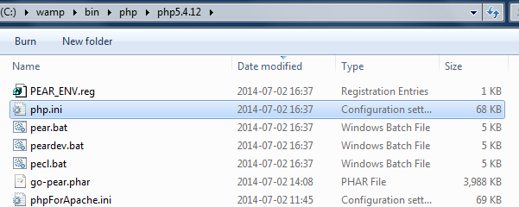

Double click on PEAR_ENV.reg to add to registry:

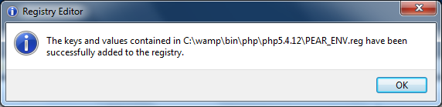

Multiple php.ini files are confusing:

<http://forum.wampserver.com/read.php?2,45057,45079>

Verifications:

<http://pear.php.net/manual/en/installation.checking.php#installation.checking.cli.modifyingphpini>

>pear version

PEAR Version: 1.9.4

PHP Version: 5.4.12

Zend Engine Version: 2.4.0

Running on: Windows NT WIN-M0Q9TTFRU53 6.1 build 7601 (Windows 7 Enterprise Edition Service Pack 1) AMD64

C:\Users\Windows7 2014-07-02 17:00:32

>pear config-get php_dir

C:\wamp\bin\php\php5.4.12\pear

<https://iwg.devguard.com/trac/redcap/wiki/3rdPartySoftware>

* To install PEAR Auth and PEAR Db in Windows:
  1. run command and go to php directory
  2. type: pear install Auth-1.6.2
  3. after the Auth is installed, install PEAR Db by typing: pear install DB-1.7.14RC1

### pear Auth-1.6.2

C:\wamp\bin\php\php5.4.12 2014-07-02 17:10:50

>pear install Auth-1.6.2

WARNING: "pear/DB" is deprecated in favor of "pear/MDB2"

WARNING: "pear/MDB" is deprecated in favor of "pear/MDB2"

WARNING: "pear/HTTP_Client" is deprecated in favor of "pear/HTTP_Request2"

Did not download optional dependencies: pear/Log, pear/File_Passwd, pear/Net_POP3, pear/DB, pear/MDB, pear/MDB2, pear/Au

th_RADIUS, pear/Crypt_CHAP, pear/File_SMBPasswd, pear/HTTP_Client, pear/SOAP, pear/Net_Vpopmaild, pecl/vpopmail, pecl/ka

dm5, use --alldeps to download automatically

pear/Auth can optionally use package "pear/Log" (version >= 1.9.10)

pear/Auth can optionally use package "pear/File_Passwd" (version >= 1.1.0)

pear/Auth can optionally use package "pear/Net_POP3" (version >= 1.3.0)

pear/Auth can optionally use package "pear/DB" (version >= 1.6.0)

pear/Auth can optionally use package "pear/MDB"

pear/Auth can optionally use package "pear/MDB2" (version >= 2.0.0RC1)

pear/Auth can optionally use package "pear/Auth_RADIUS"

pear/Auth can optionally use package "pear/Crypt_CHAP" (version >= 1.0.0)

pear/Auth can optionally use package "pear/File_SMBPasswd" (version >= 1.0.0)

pear/Auth can optionally use package "pear/HTTP_Client" (version >= 1.1.0)

pear/Auth can optionally use package "pear/SOAP" (version >= 0.9.0)

pear/Auth can optionally use package "pear/Net_Vpopmaild" (version >= 0.1.0)

pear/Auth can optionally use package "pecl/vpopmail" (version >= 0.2)

pear/Auth can optionally use package "pecl/kadm5" (version >= 0.2.3)

pear/Auth can optionally use PHP extension "imap"

pear/Auth can optionally use PHP extension "saprfc"

pear/Auth can optionally use PHP extension "soap"

downloading Auth-1.6.2.tgz ...

Starting to download Auth-1.6.2.tgz (56,036 bytes)

.............done: 56,036 bytes

install ok: channel://pear.php.net/Auth-1.6.2

### pear DB-1.7.14RC1

>pear install DB-1.7.14RC1

WARNING: "pear/DB" is deprecated in favor of "pear/MDB2"

downloading DB-1.7.14RC1.tgz ...

Starting to download DB-1.7.14RC1.tgz (132,604 bytes)

.....................done: 132,604 bytes

install ok: channel://pear.php.net/DB-1.7.14RC1

# REDCap Installation

From REDCap Wiki:

<https://iwg.devguard.com/trac/redcap>

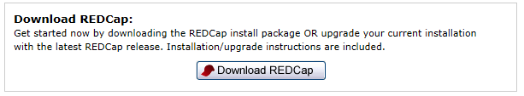

## Download files

<https://iwg.devguard.com/trac/redcap/wiki/RedcapDownloadArea>

Go with REDCap version currently on production UMKC server:







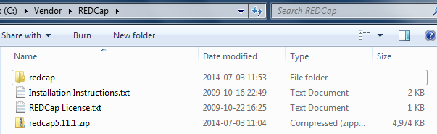

**Installation Instructions.txt**

== INSTRUCTIONS FOR INSTALLING REDCAP ==

NOTE: These instructions assume that you already have a MySQL database server and a web server with PHP

up and running. You will need to use a MySQL client (we recommend phpMyAdmin) to interface with the

MySQL server. If one or more of these components are not installed, visit the following address for more

information about obtaining and installing them: https://iwg.devguard.com/trac/redcap/wiki/3rdPartySoftware

1.) In the installation package ZIP file, unzip its contents and copy the "redcap" folder from the

ZIP file onto your web server at the file location that you wish to serve it from over the web.

2.) Now that the "redcap" folder is on your web server, try to access its Install Module from a web

browser by pointing your browser to the "install.php" page inside the "redcap" folder

(e.g. https://www.mc.vanderbilt.edu/apps/redcap/install.php). Once you load the REDCap installation

module in your web browser, it will provide you with the rest of the instructions you will need for

completing the installation of REDCap.

ENJOY!

**Move to c:\wamp\www**

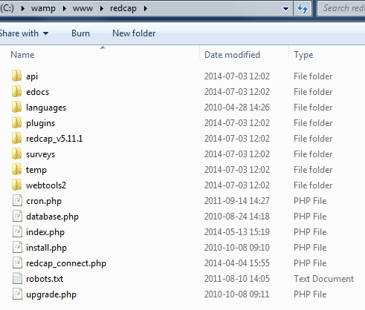

## Run index.php in browser

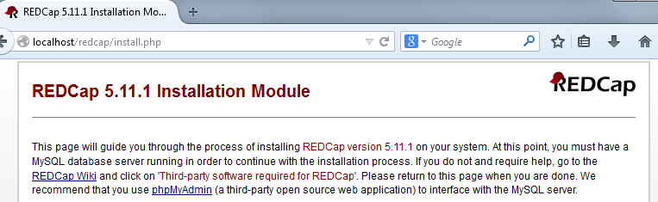

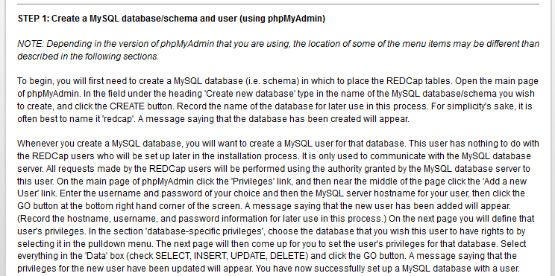

## Create redcap database user in phpMyAdmin

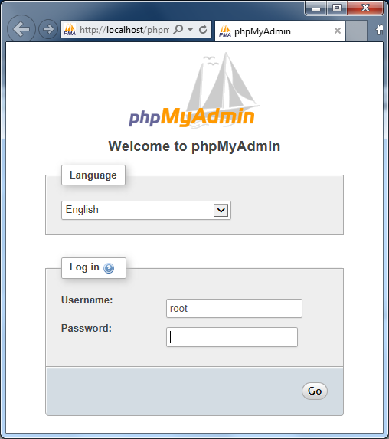

USERID = root  
PASSWORD = <blank>

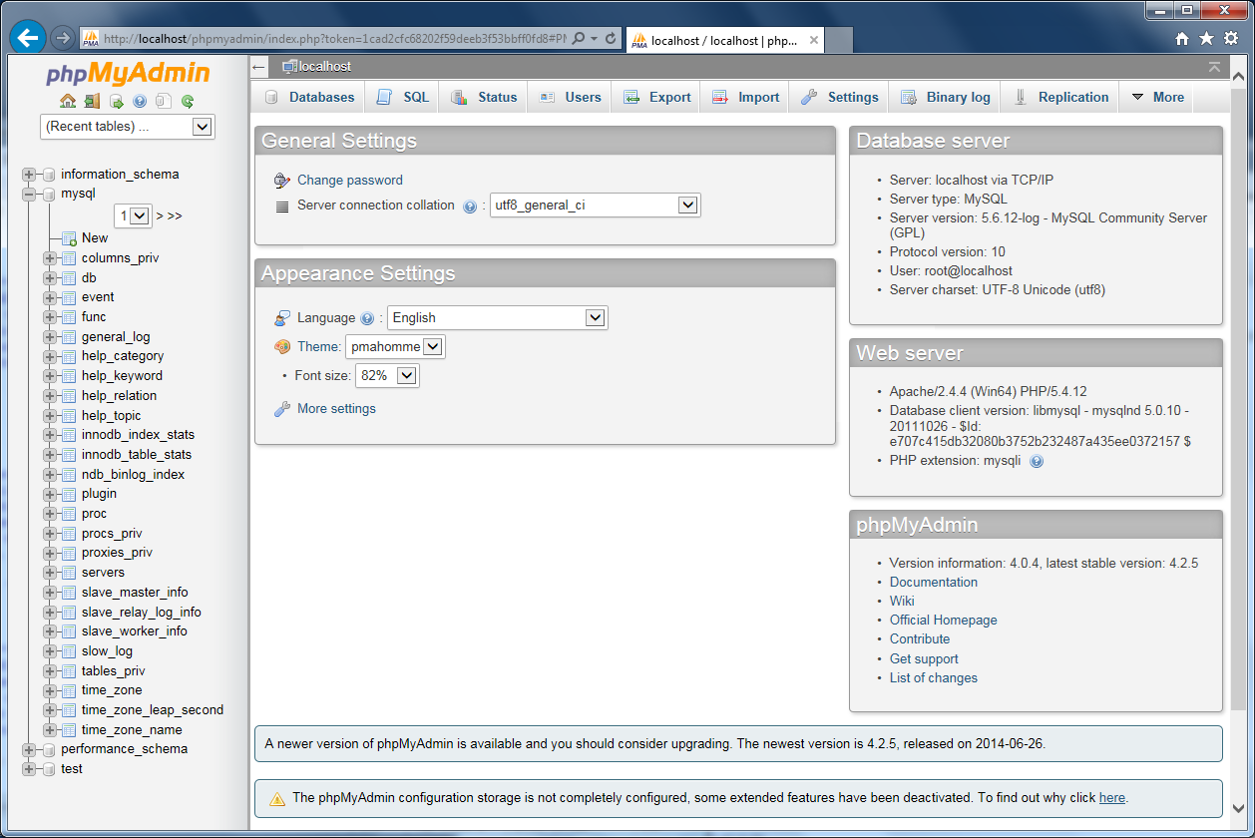

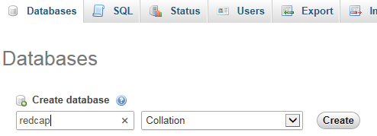

Message displays that database was created.

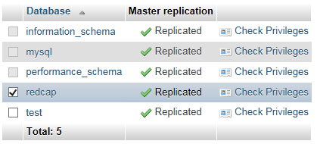

Check the *redcap* database. Click on *Check Privileges* link.

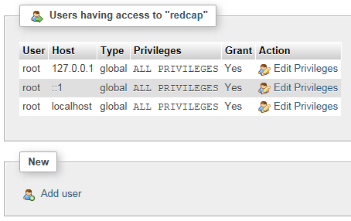

Click on *Add user*.

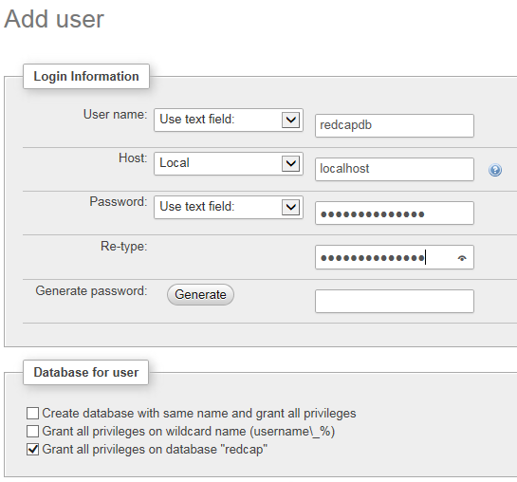

ReDcApPaSsWoRd

At the lower right



"You have added a new user"

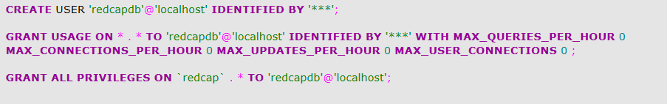

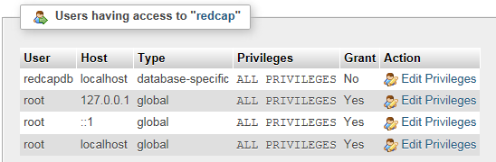

## Modify data.php

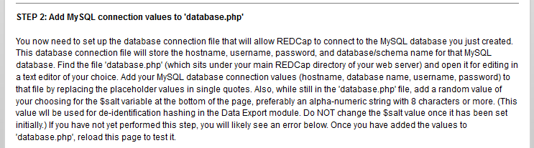



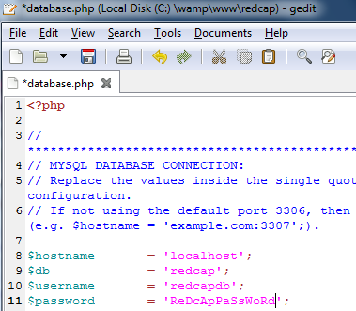

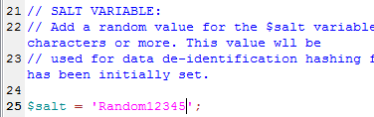

After refresh:

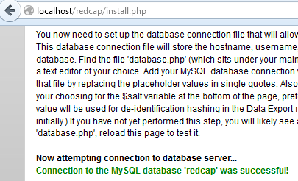

## Customize values for server and installation

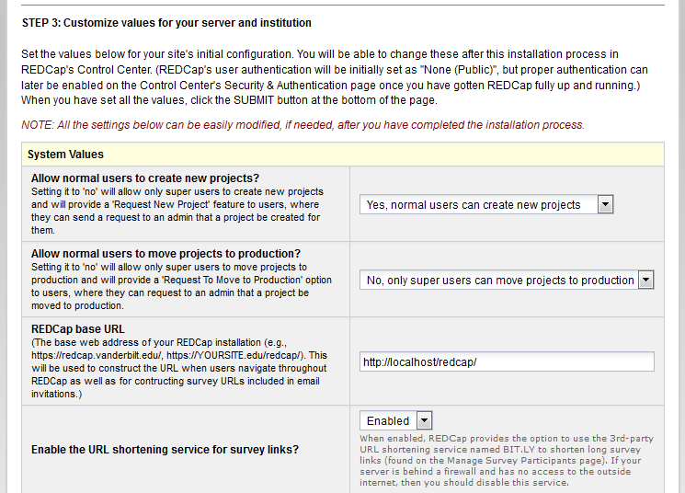

Note: Default UMKC date and time format:



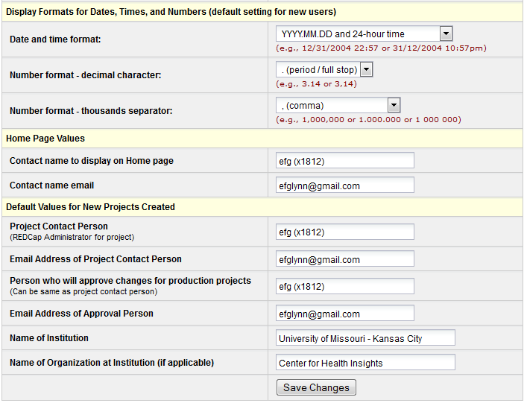

## Create REDCap database tables

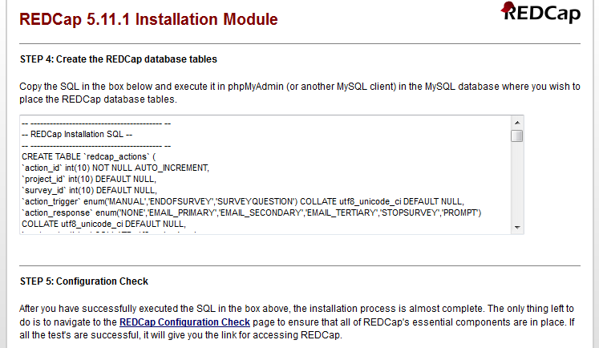

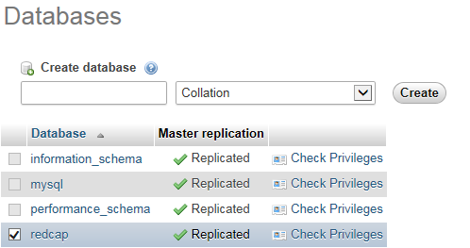

Select redcap database.

Copy and paste "REDCap Installation SQL" to phpMyAdmin. [Use Ctrl-v for paste since right-click-paste did not work.]

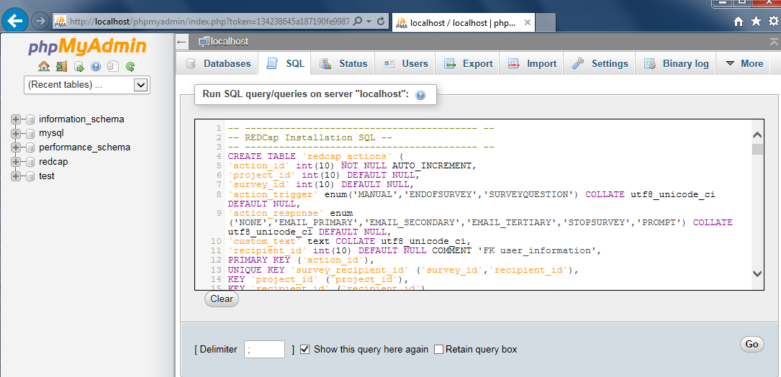

Add USE command as first line:

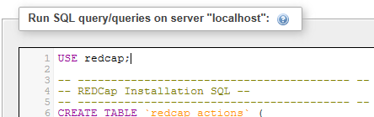





## Configuration Check

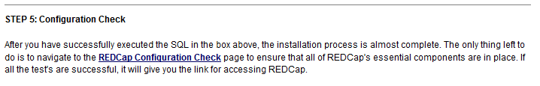

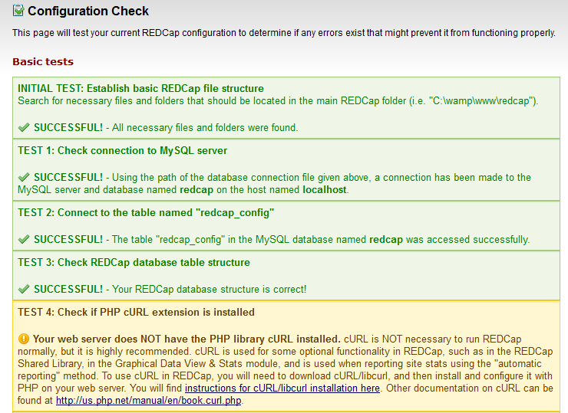

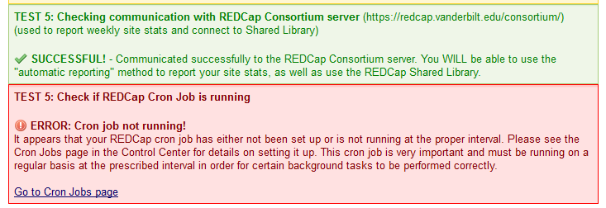

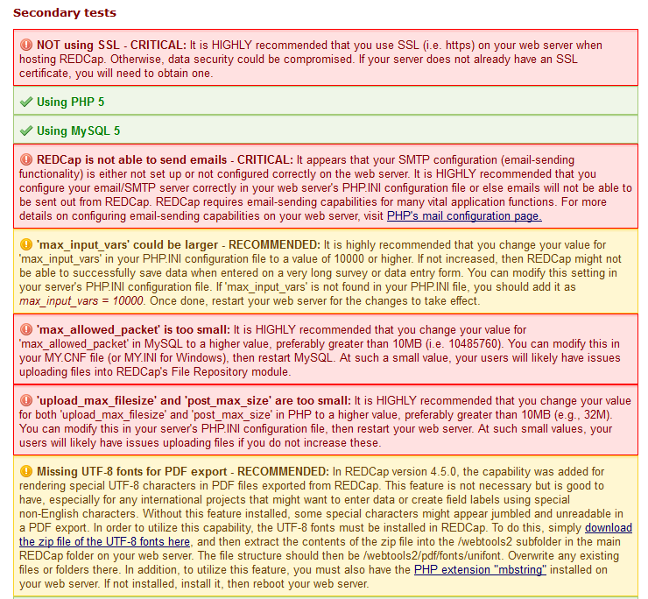

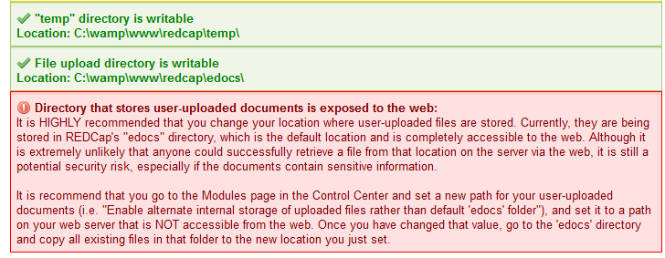

See "Fixes" section below to work around problems described above.

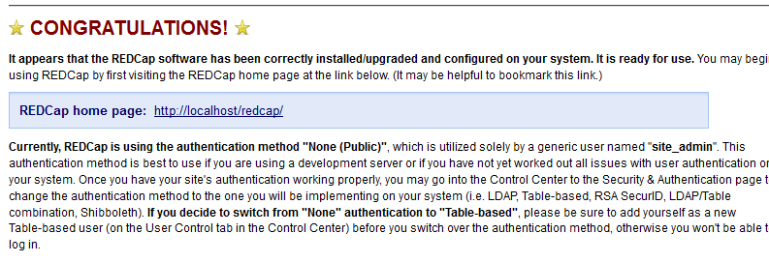

# REDCap Configuration

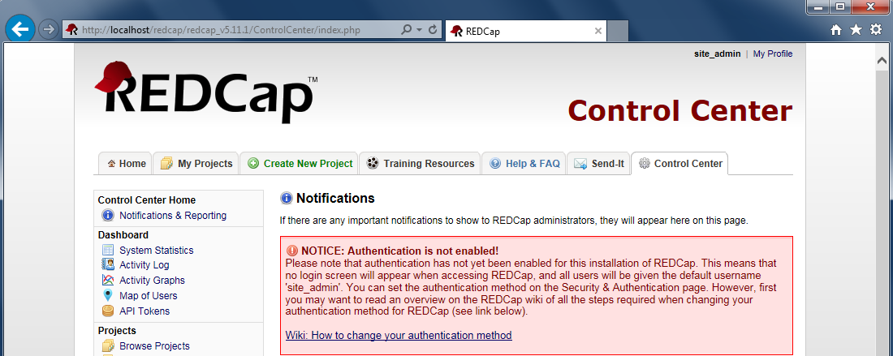

## How to change from "None (Public)" to "Table-based" authentication

<https://iwg.devguard.com/trac/redcap/wiki/ChangingAuthenticationMethod>

1. Before simply changing the authentication method, you will first need to create for yourself a new Table-based user that you yourself will use to log in to REDCap. Navigate to the Create New User page in the Control Center and create a new user (you will have to decide what your username will be). Once created, it will send an email to you with your username and a temporary password enclosed.
2. Before looking in your inbox, go to the Designate Super User page in the Control Center and add your user as a super user. This ensures that you will be able to access the Control Center again when you log in with your new Table-based user in a minute.
3. Now go to the Security & Authentication page in the Control Center and change the authentication method to Tabled-based (at top of page) and save your changes on that page. Now click on any link/tab on the page, which will now force you to log in with your new Table-based username.
4. Log in to REDCap with your new username and the password sent to you in the email. It will then ask you to set your password.
5. Now that you have logged in with your new username, go back to the Designate Super User page and remove "site_admin" as a super user.
6. You're done and can now go and begin giving other users access to REDCap by creating them a username on the Create New User page.





## Create New User

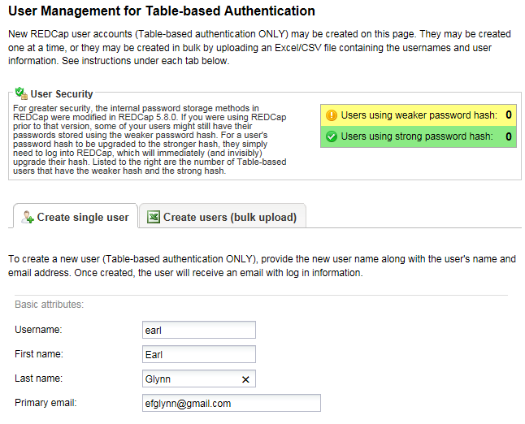

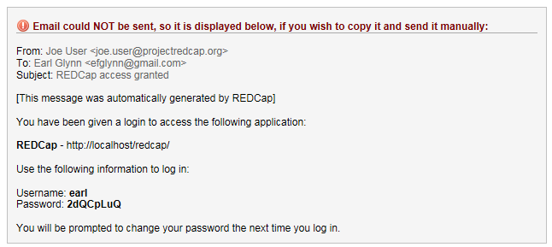

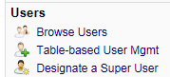

## Designate Super User

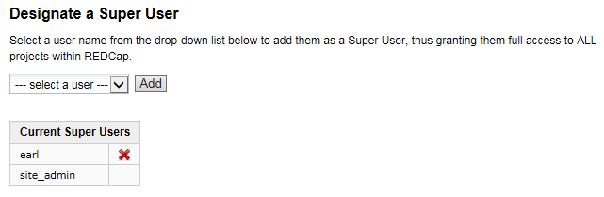

<https://iwg.devguard.com/trac/redcap/wiki/ChangingAuthenticationMethod>

**Types of Authentication Methods Available in REDCap [¶](https://iwg.devguard.com/trac/redcap/wiki/ChangingAuthenticationMethod" \l "TypesofAuthenticationMethodsAvailableinREDCap" \o "Link to this section)**

* **None (Public)**: This is technically not an authentication method but is the setting when authentication is not enabled. As mentioned above, when set to this method, anyone can fully access REDCap since no login screen appears, and all users will be given the default username "site_admin". This setting should only be used right after installing REDCap for initial testing and evaluation. However, you may utilize this method for individual projects, which makes them public and accessible, which is good when creating some demonstration projects for users without having to create a username for them and giving them rights to the project.
* **Table-based**: This method of authentication is built-in to REDCap and authenticates users by storing their name and password in a database table, which it references when a user logs in. The only thing required for this method is that PEAR be installed in PHP on the web server, as well as the two PEAR modules named Auth and Db. If these are not installed already on the web server, you likely would have been notified of this after installing REDCap when viewing the Test page.

Let's enable Table-based authentication for the REDCap Development system.

Control Center

Security & Authentication

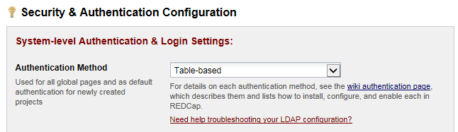

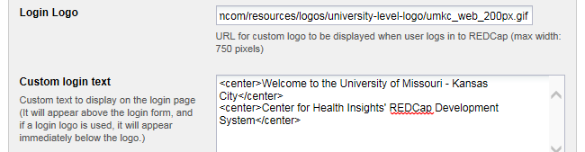

<http://www.umkc.edu/mcom/resources/logos/university-level-logo/umkc_web_200px.gif>

<center>Welcome to the University of Missouri - Kansas City</center>  
<center>Center for Health Insights' REDCap Development System</center>





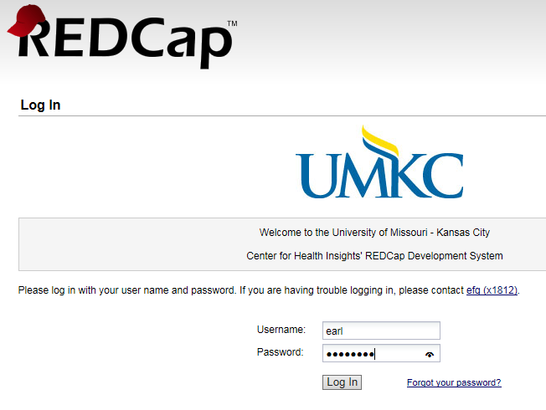

## Remove site_admin as superuser

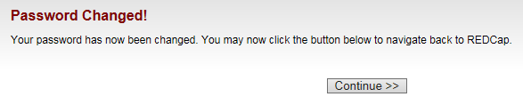

**Remove site_admin as superuser**

Control Center | Designate a Super User |

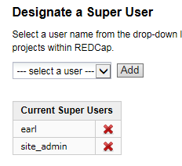

Click on red-x for site_admin

## Forgot to setup superuser before enabling table-based authentication

site_admin password

<https://iwg.devguard.com/trac/redcap/ticket/556>

site_admin does not have a password; it is for when using no authentication. To reset the system back to no authentication, execute the SQL below:

update redcap_config set value = 'none' where field_name = 'auth_meth_global';

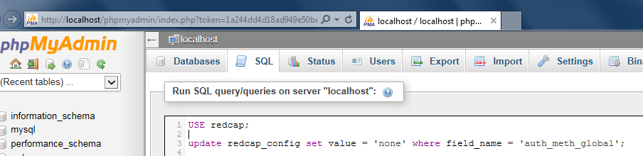

## Add New Users: superCHI and normalCHI

**Add new users**

|  |  |
| --- | --- |
| **User** | **Password** |
| superCHI | ReadingRainbow99 |
| normalCHI | SesameStreet123 |

# REDCap Fixes

## ERROR: Cron job not running!

To eliminate the error message below, this fix is needed every time the WampServer services are started.

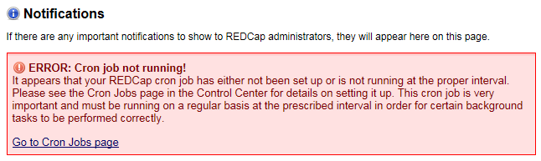

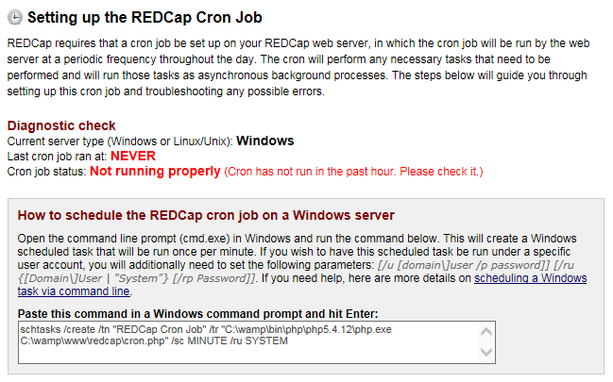

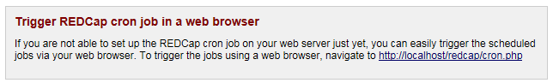

Try web browser trigger:

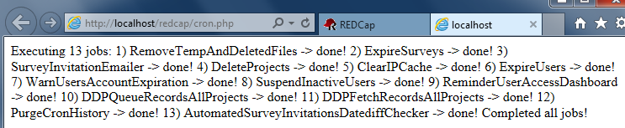

## Your web server does NOT have the PHP library cURL installed

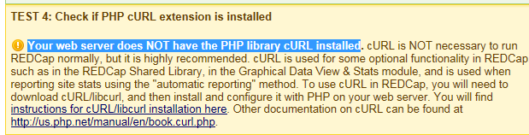

You will find [instructions for cURL/libcurl installation here](http://curl.haxx.se/libcurl/php/). Other documentation on cURL can be found at <http://us.php.net/manual/en/book.curl.php>.

<http://bx.com.au/blog/2012/08/selenium-and-phpunit-on-windows/>

Enable cURL

1. Copy php_curl.dll from the php “ext” directory to the Windows System32 directory
2. Edit php.ini and uncomment the line that references the cURL extension.

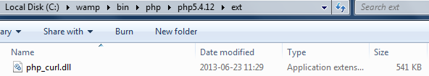

Move to C:\Windows\System32

Click on WampServer icon in system tray:



PHP | php.ini

php.ini opens in Notepad

Edit | Find… | Find what: curl | Find Next



Uncomment *php_curl.dll* line.

File | Save | File | Exit

WampServer icon

Restart all services

Start REDCap in browser

Login as superuser (superCHI) if necessary

Control Center



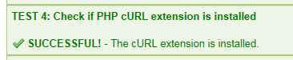

## MySQL Tweak

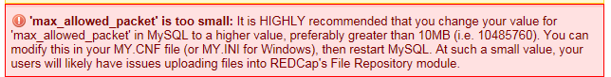

Click on WampServer icon in system tray:



MySQL | my.ini

my.ini opens in Notepad

Edit | Find … | Find what: max_allowed_packet | Find Next

Change from

max_allowed_packet = 1M

to

max_allowed_packet = 15M

File | Save | File | Exit

WampServer icon

Restart all services (Icon changes from green to yellow to red to yellow to green)

Start REDCap in browser

Login as superuser (superCHI) if necessary

Control Center



Message should no longer appear

## PHP Tweaks

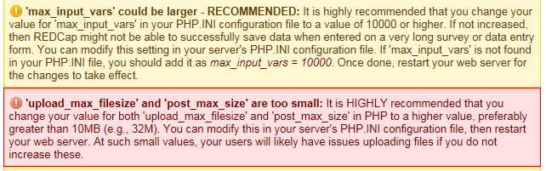

Click on WampServer icon in system tray:



PHP | php.ini

php.ini opens in Notepad

Edit | Find… | Find what: upload_max_filesize | Find Next

Change to

; Maximum allowed size for uploaded files.

; http://php.net/upload-max-filesize

upload_max_filesize = 32M

Add after the max_input_vars entry:

post_max_size = 32M  
max_input_vars = 10000

File | Save | File | Exit

WampServer icon

Restart all services (Icon changes from green to yellow to red to yellow to green)

If necessary: Start REDCap in browser

If necessary: Login as superuser (superCHI)

Control Center



Messages should no longer appear

## Missing UTF-8 fonts for PDF export

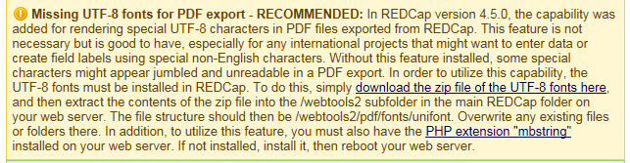

Copy pdf/font from zip

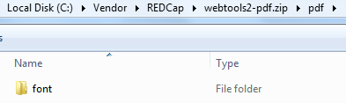

to empty pdf directory here:

C:\wamp\www\redcap\webtools2\pdf

Verify path: C:\wamp\www\redcap\webtools2\pdf\font\unifont

Is the plural "fonts" incorrect in the message?

## Validation Types

Additional validation types enabled on UMKC server:

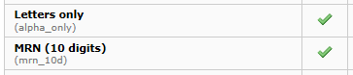











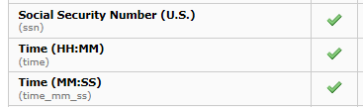

## Not using SSL

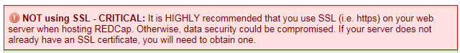

This should not be a big deal for the virtual machine run on a secure PC.

## REDCap is not able to send emails - CRITICAL

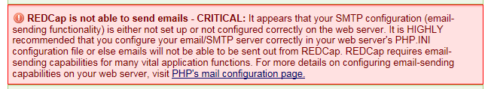

For now this will not be resolved. At some point, an E-mail server of some sort (gmail?) may be needed to test certain functionality.

## Directory that stores user-uploaded documents is exposed to the web

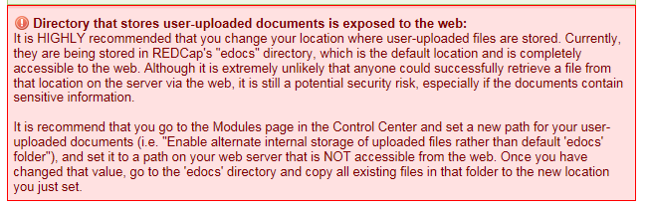

This should not be a big deal for the virtual machine run on a secure PC.