**Earl F Glynn**UMKC Center for Health Insights  
2014-01-13. Revised 2014-07-07.

Contents

Purpose 2

Starting Point 2

Building Virtual Machine 2

Start VMware Workstation 2

Use ISO file as Installation Disk 4

Virtual Machine Configuration 7

Define Number of Virtual Processors 7

Define Virtual Memory Configuration 8

Define Virtual Networking Configuration 9

Define Virtual Disk Configuration 10

Creating Virtual Machine 13

Installing Windows 15

Installing VMware Tools 18

Running Windows Update 18

Shared Folders 19

Windows 7 Virtual Machine Configuration 21

Folder Options 21

Virus Detection 22

Utility programs 22

Anaconda Python 22

Periodic Windows Updates 24

# Purpose

These instructions describe how to build a Windows 7 VMware virtual machine for use in various software experiments.

# Starting Point

1. **Windows 7** (64-bit operating system)
2. **VMware Workstation 10** for Windows or later should be installed. [VMware products are free to UMKC Faculty/Staff through this link: [www.med.umkc.edu/vmware](http://www.med.umkc.edu/vmware) . Fill out the form to order VMware Workstation for $0 and to receive a download link.]
3. **Windows 7 ISO file** (~3 GB, from Christopher Boyce on 2014-01-10):

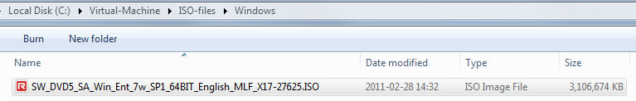

Note: Students can use the VMware software under the existing licenses, but cannot use the Windows license on a virtual machine on a PC not owned by UMKC.

# Building Virtual Machine

**2014-01-13**

## Start VMware Workstation

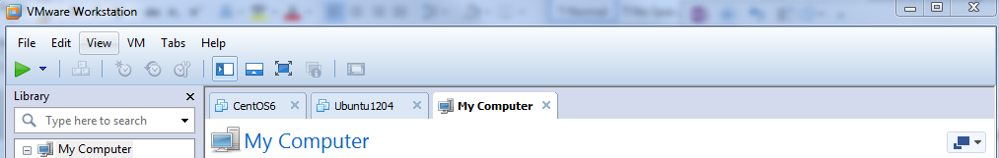

File | New Virtual Machine

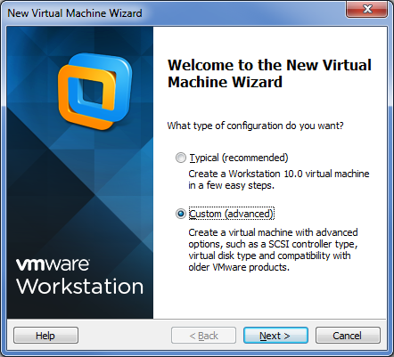  
Next

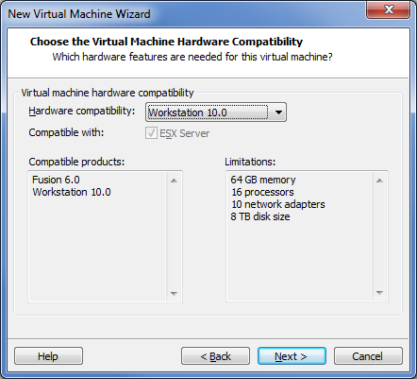  
Next

## Use ISO file as Installation Disk

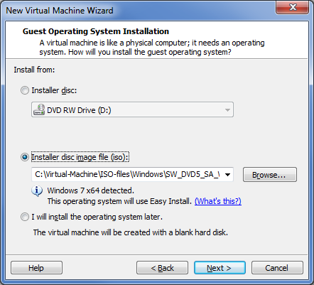

ISO file (from Christopher Boyce) is stored here:

C:\Virtual-Machine\ISO-files\Windows\**SW_DVD5_SA_Win_Ent_7w_SP1_64BIT_English_MLF_X17-27625.ISO**

Next

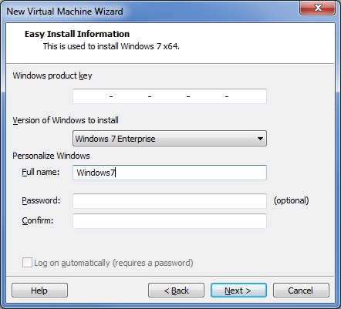

Leave Windows product key blank.

According to Christopher Boyce (2014-01-10): "There is no license key, it will activate automatically once it is on the network and finds our MAK key server."

Next

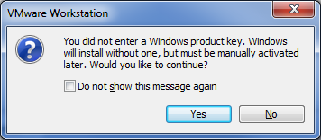

Yes

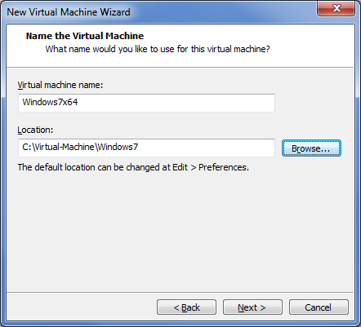

Use **C:\Virtual-Machine** folder for location of various virtual machines.

Let's put this new one in **C:\Virtual-Machine\Windows7**.

Next

## Virtual Machine Configuration

### Define Number of Virtual Processors

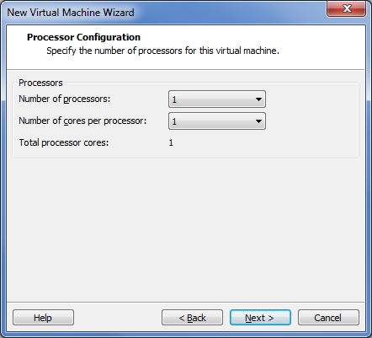

For now only use a single processor.

Next

### Define Virtual Memory Configuration

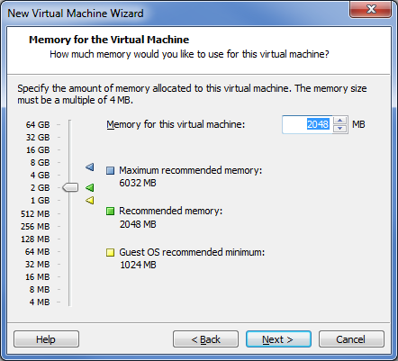

Let's assign about 25% of total memory to this virtual machine.

Next

### Define Virtual Networking Configuration

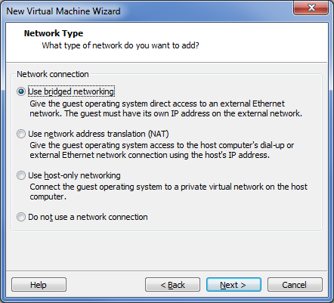

Next

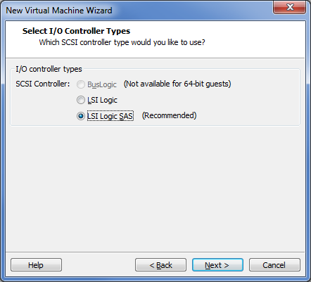

Use default for now. [Unclear why there is a different default for Windows than Linux.]

### Define Virtual Disk Configuration

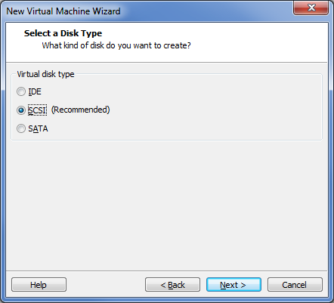

Next

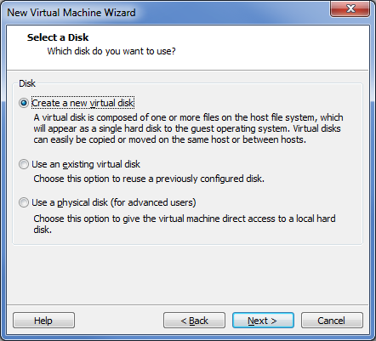

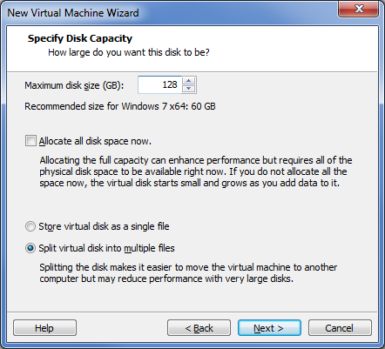

The 128 GB virtual disk is fairly large to accommodate possible software experiments. The needed space is nearly 30 GB.

Next

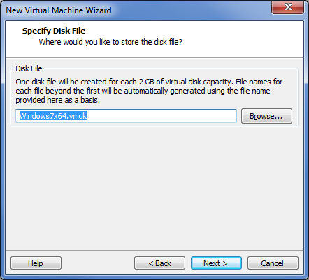

Next

## Creating Virtual Machine

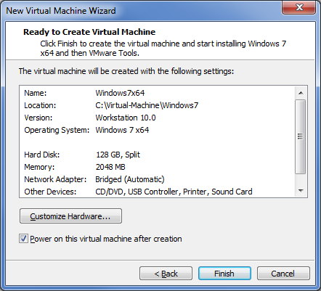

Finish

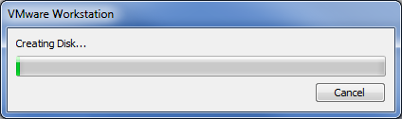

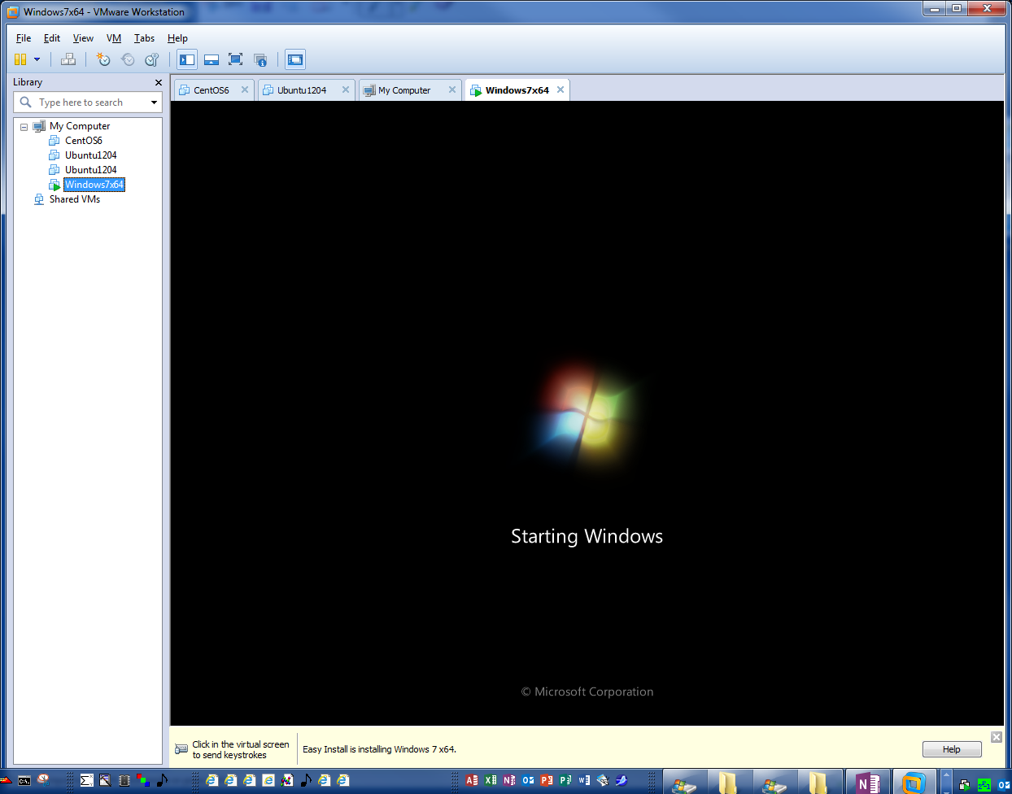



## Installing Windows

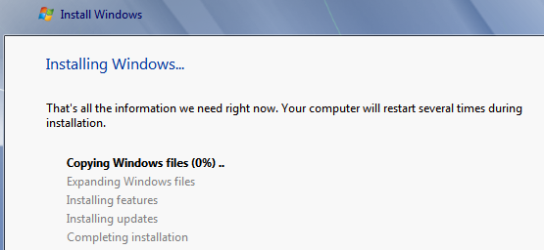

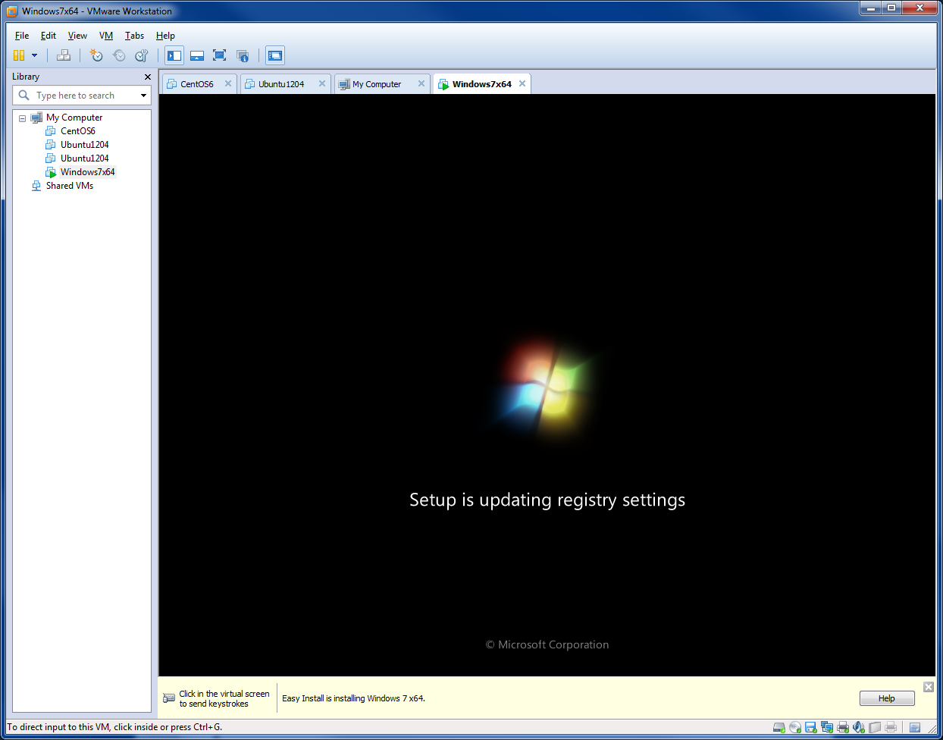

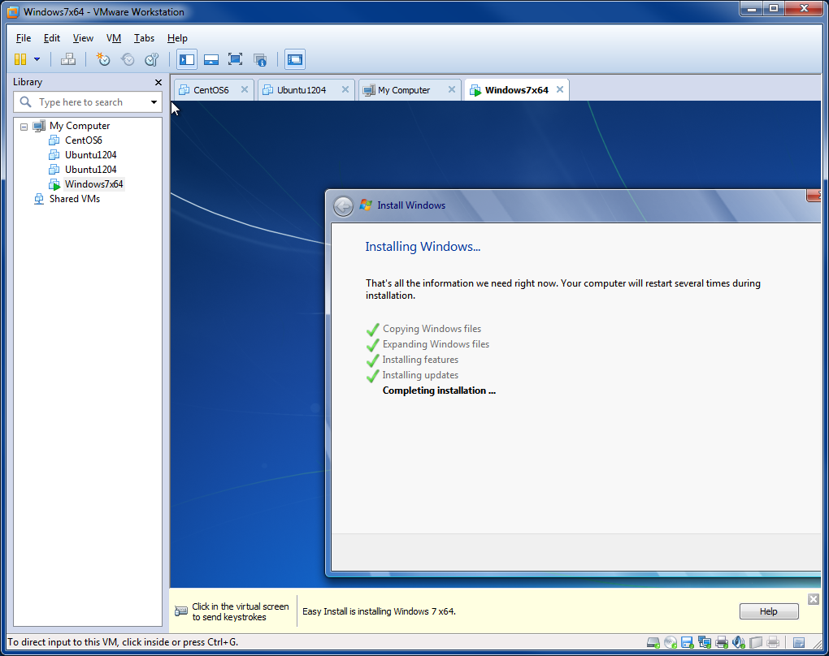

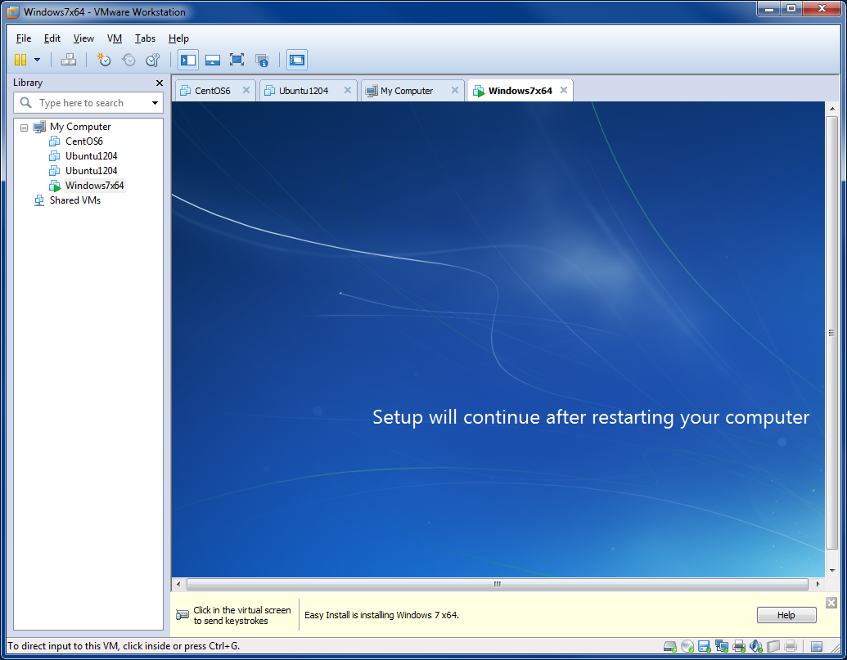

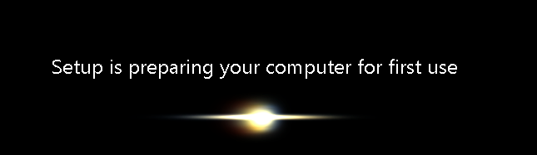

## Installing VMware Tools

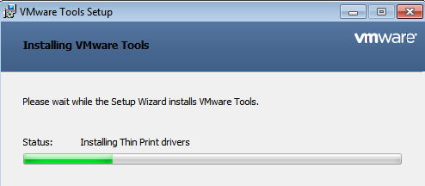

## Running Windows Update

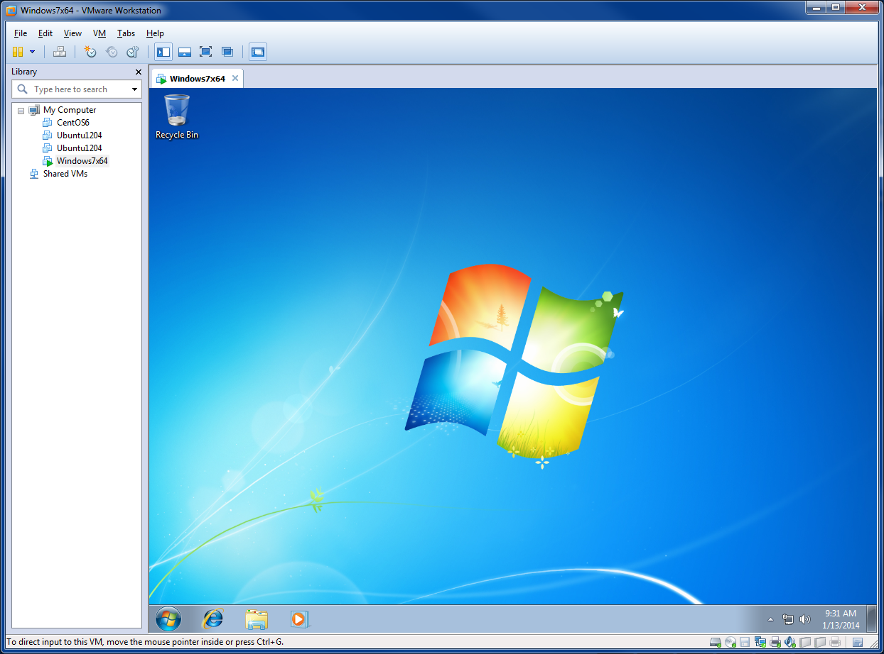

Start | Control Panel | search for Windows Update | Check for Updates

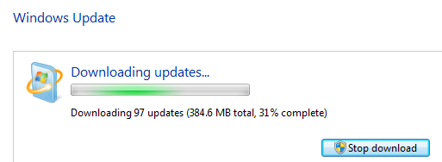

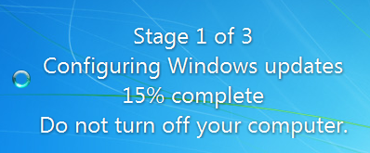

Repeat Windows Update until no updates are made.

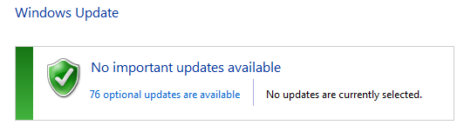

Shutdown virtual machine after updates are complete.

Save this as the base machine

# Shared Folders

Shared folders are an easy way to transfer files between the virtual machine and the host. Instead of exposing the whole host machine to the virtual machine, I normally specify only a single directory that is shared,

C:\Virtual-Machine\Transfer.

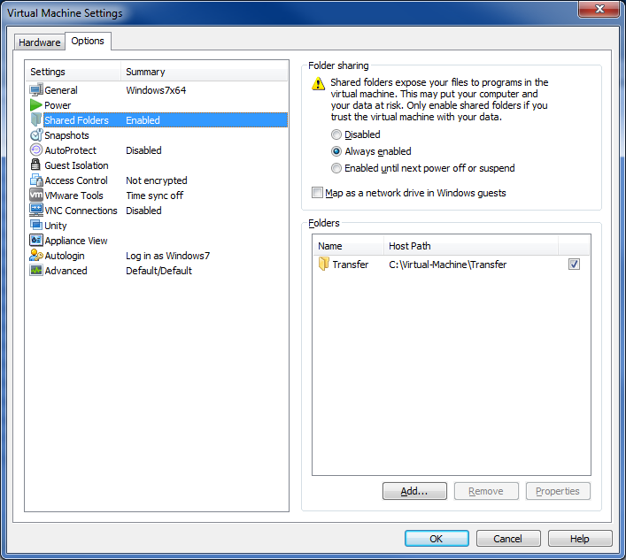

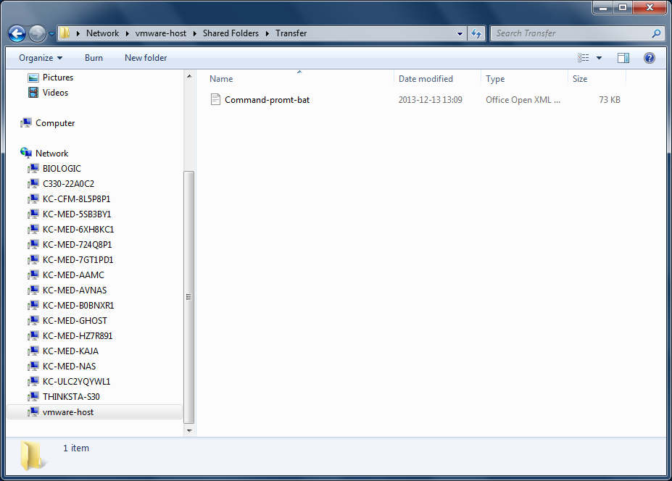

The vmware-host under network is where the shared folders can be found in the VM:

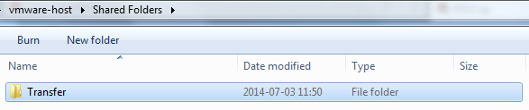

# Windows 7 Virtual Machine Configuration

## Folder Options

Search for "Folder Options" in Control Panel. On the "View" tab, make sure file extensions are always shown by unchecking:



## Virus Detection

While a virtual machine can be "thrown away" easily and re-created by copying files, having some virus detection software is still a good idea.

Install Microsoft Security Essentials: <http://windows.microsoft.com/en-us/windows/security-essentials-download>

## Utility programs

A number of utility programs may be useful for software experiments using a virtual machine.

Install these programs to create new baseline machine

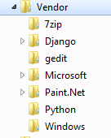

Install these applications:

* gedit
* Paint.Net
* 7zip

### Anaconda Python

The Anaconda Python distribution includes SciPy/Numpy/MatPlotLib, which is quite useful for a variety of computations. [Delete 342 MB installation file when complete.]

Because some Python packages have not been converted to Python 3, let's use Python 2 for now.

<http://docs.continuum.io/anaconda/index.html#packages-included-in-anaconda>

After Anaconda installation:

>echo %Path%

C:\Windows\system32;C:\Windows;C:\Windows\System32\Wbem;C:\Windows\System32\WindowsPowerShell\v1.0\;C:\Anaconda;C:\Anaconda\Scripts

>python

Python 2.7.5 |Anaconda 1.8.0 (64-bit)| (default, Jul 1 2013, 12:37:52) [MSC v.1500 64 bit (AMD64)] on win32

Type "help", "copyright", "credits" or "license" for more information.

Setup link to IDLE Integrated Development Environment:

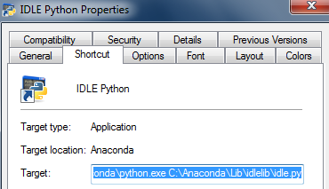

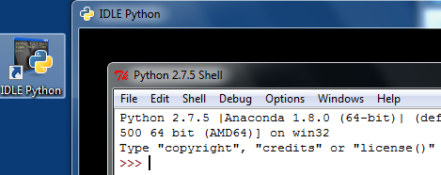

# Periodic Windows Updates

Don't let the virtual machine get too out of date, so periodically run Windows Update (sometimes multiple times) to install all recent updates.

2014-07-01

1. Control Panel | Windows Update (twice)
2. Control Panel | User Account Control Settings | Never notify

Additional applications:

1. Install Firefox browser
2. Install Chrome browser