**ITEC 106 – IT ELECTIVE 2 ( WEB SYSTEM AND TECHNOLOGIES 2)**

|  |  |
| --- | --- |
| Name : Earl Jaron Ponteras | Section : BSIT 3A |
| Assignment No : 1 | Submission Date : March 16, 2024 |
| Assignment Title: Calculator |  |

**Code :**

# HTML and JS FILE

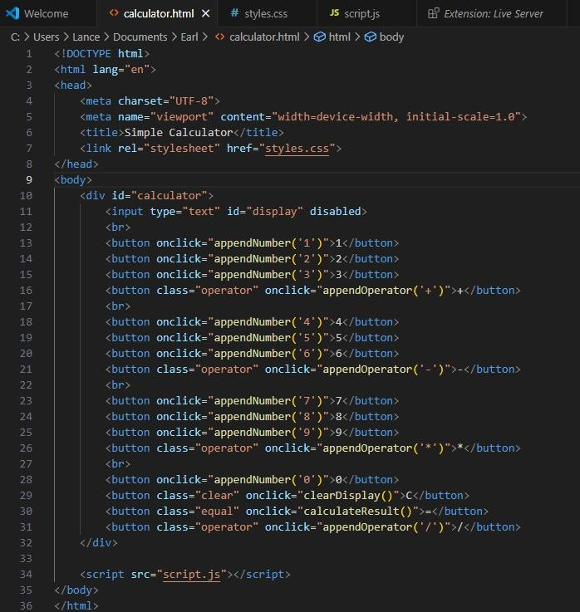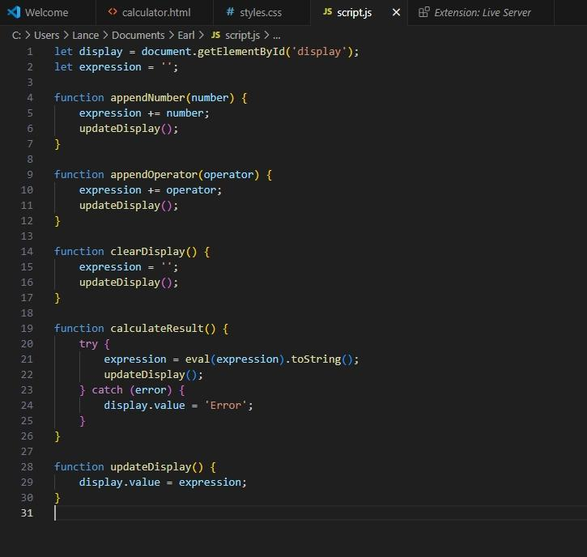

**ITEC 106– IT ELECTIVE 2 ( WEB SYSTEM AND TECHNOLOGIES 2)**

# CSS FILE

**ITEC 106 – IT ELECTIVE 2 ( WEB SYSTEM AND TECHNOLOGIES 2)** 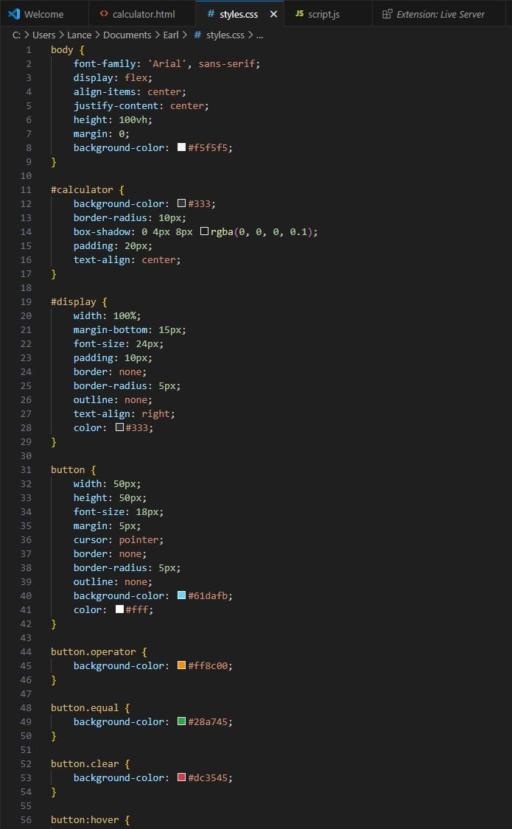

# SCREENSHOT

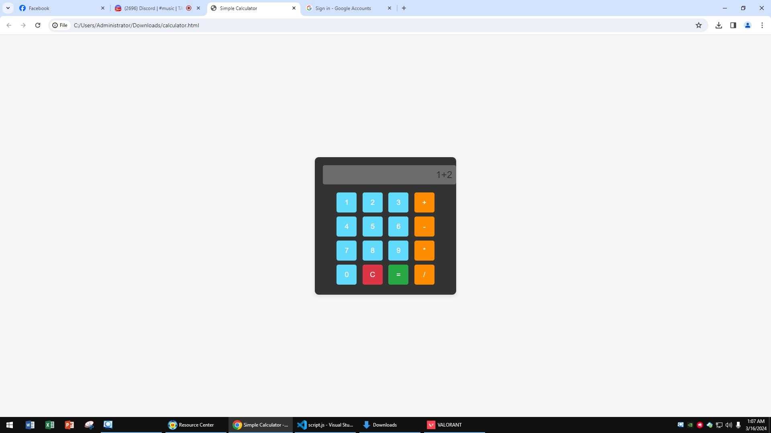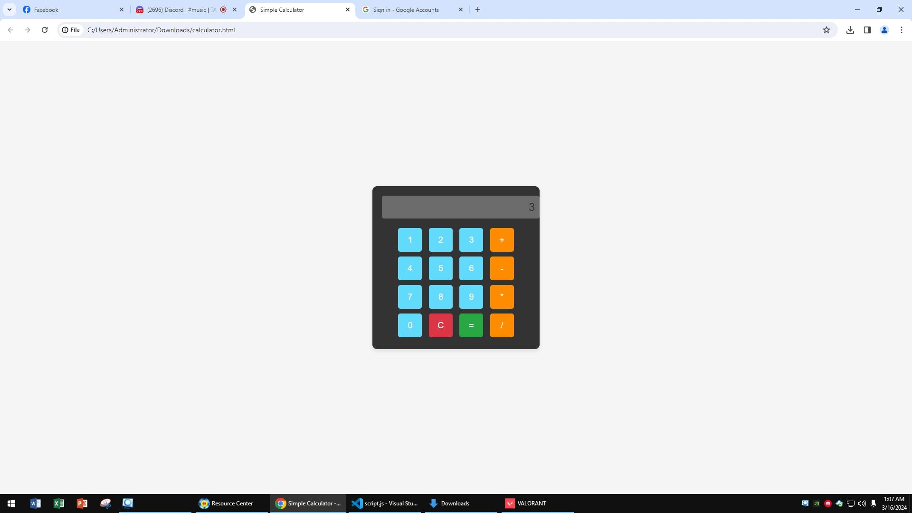

**Dictionary:**

*// List keywords, tags, or methods that are new to you and explain how they are used in the code.*

*// atleast 5 tag, methods or keyword*

*Example :*

* **eval** - method evaluates the string and takes a string as input and executes it

*Ex. var result = eval(document.getElementById('display').value);*

**Syntax** : eval(string)

**Parameter** : string (variable, or sequence of characters)

* **function -** used to encapsulate a set of statements or instructions that perform a specific task.

*Ex. function clearDisplay() { }*

**Syntax** : function function_name()

(046) 471-66-07 / (046) 471-67-70 / (046) 686- 23-49 www.cvsu.edu.ph

**DEPARTMENT OF COMPUTER STUDIES**

**ITEC 106 – IT ELECTIVE 2 ( WEB SYSTEM AND TECHNOLOGIES 2)**

* **.value -** Once the element is retrieved, *.value* is used to access its current value and represents the current value entered or displayed in the input field.
* **try -** evaluates an expression obtained from an input element and assigns the result to a variable result. Then, it sets the value of another element to result.
* **catch -** catch block contains statements that specify what to do if an exception is thrown in the try block.