|  |  |
| --- | --- |
| Name : Earl Jaron Ponteras | Section : BSIT 3B |
| Assignment No : 3 | Submission Date : February 6, 2023 |
| Assignment Title: Number Guessing Game | |

**Code :**

**HTML FILE**

**<!DOCTYPE html>**

**<html lang="en">**

**<head>**

**<meta charset="UTF-8">**

**<meta name="viewport" content="width=device-width, initial-scale=1.0">**

**<title>Number Guessing Game</title>**

**<link rel="stylesheet" href="styles.css">**

**</head>**

**<body>**

**<div class="container">**

**<h1>Number Guessing Game</h1>**

**<p>Guess a number between 1 and 10:</p>**

**<input type="number" id="guess" min="1" max="10">**

**<button id="submit" onclick="checkGuess()">Submit Guess</button>**

**<p id="message" class="message"></p>**

**</div>**

**<script src="script.js"></script>**

**</body>**

**</html>**

**CSS FILE**

**body {**

**font-family: Arial, sans-serif;**

**text-align: center;**

**background-color: #f2f2f2;**

**}**

**.container {**

**max-width: 400px;**

**margin: 0 auto;**

**padding: 20px;**

**background-color: #fff;**

**border-radius: 10px;**

**box-shadow: 0 0 10px rgba(0, 0, 0, 0.1);**

**}**

**h1 {**

**color: #212a52;**

**}**

**input[type="number"] {**

**padding: 10px;**

**width: 100%;**

**margin-bottom: 10px;**

**}**

**button {**

**padding: 10px 20px;**

**background-color: #007bff;**

**color: #fff;**

**border: none;**

**cursor: pointer;**

**margin-top: 10px;**

**border-radius: 5px;**

**}**

**button:hover {**

**background-color: #0056b3;**

**}**

**p {**

**color: #888;**

**margin-bottom: 10px;**

**}**

**.message {**

**margin-top: 20px;**

**font-weight: bold;**

**color: #333;**

**}**

**JS FILE**

**let randomNumber = Math.floor(Math.random() * 10) + 1;**

**let attempts = 3;**

**function checkGuess() {**

**const guessInput = document.getElementById('guess').value;**

**const guess = parseInt(guessInput);**

**if (isNaN(guess) || guess < 1 || guess > 10) {**

**showMessage('Please enter a valid number between 1 and 10.');**

**return;**

**}**

**if (guess === randomNumber) {**

**showMessage('Congratulations! You guessed the correct number.');**

**disableInput();**

**} else if (guess < randomNumber) {**

**showMessage('Sorry, your guess is too low. Try again.');**

**} else if (guess > randomNumber) {**

**showMessage('Sorry, your guess is too high. Try again.');**

**}**

**attempts--;**

**if (attempts === 0) {**

**showMessage(`Sorry, you have run out of attempts. The correct number was ${randomNumber}.`);**

**disableInput();**

**}**

**}**

**function showMessage(message) {**

**document.getElementById('message').textContent = message;**

**}**

**function disableInput() {**

**document.getElementById('guess').disabled = true;**

**document.getElementById('submit').disabled = true;**

**}**

**SCREENSHOT**

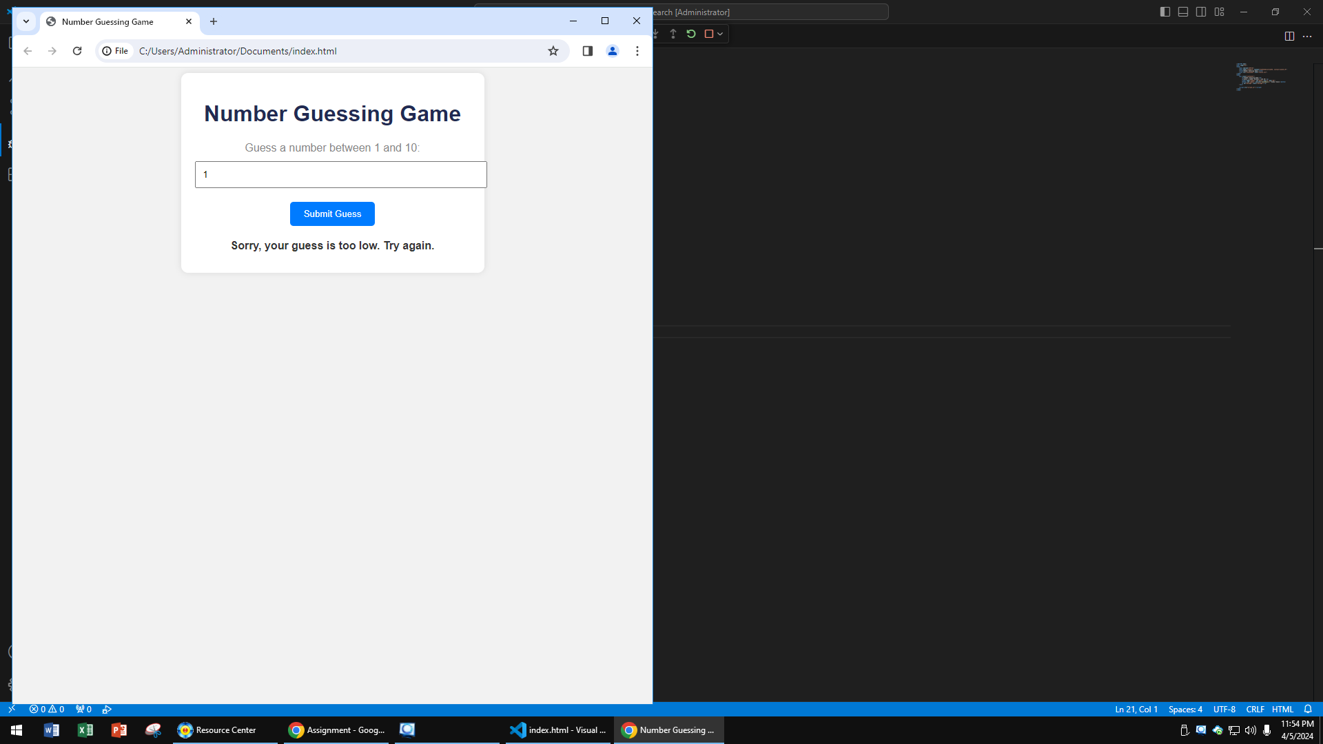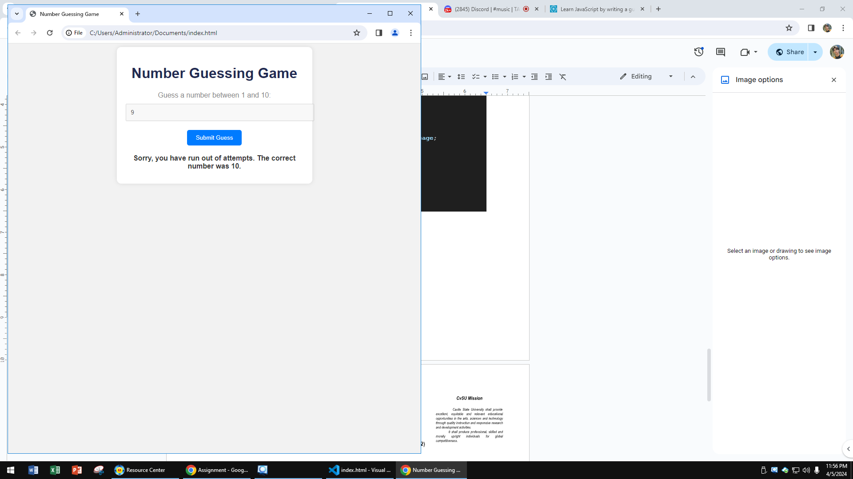

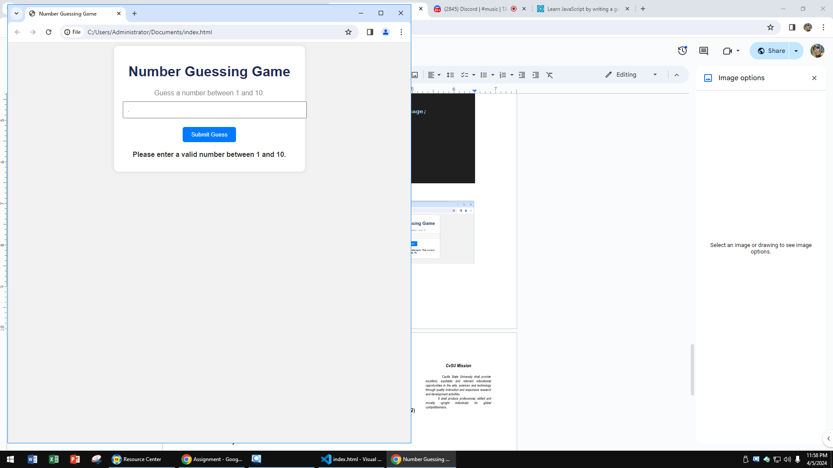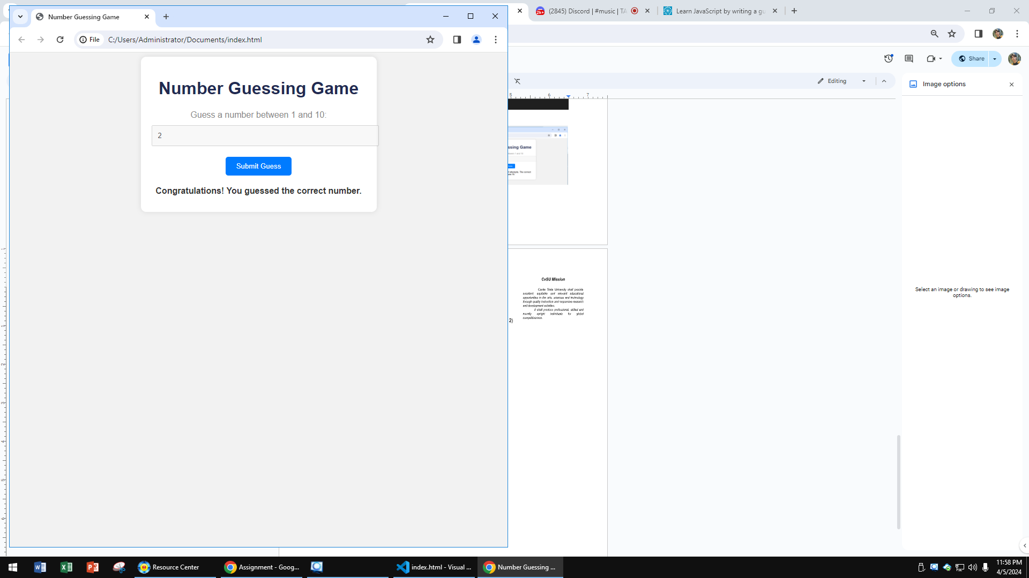

**Dictionary:**

* IsNaN - The isNaN() function determines whether a value is NaN, first converting the value to a number if necessary.
* Math.floor() - Math. floor() is a JavaScript method that returns the largest integer less than or equal to a given number. It basically rounds down a number to its nearest integer.
* Math.random() - Math.random() static method returns a floating-point, pseudo-random number that's greater than or equal to 0 and less than 1, with approximately uniform distribution over that range