Questions for team:
- is there a benefit to having the code in functions rather than as lines within the while (in stream usb?)
- potential risk is if there are buildings/other heat-emitting things in the background
- out of curiosity: why is it showing the bounding boxes over the image, as I want, in stream usb, but the same code is just showing up as boxes on a black screen in single_capture?

Notes:
- doesn’t seem to be a lot of evidence for trees being warmer than surroundings or regulating their temps, but it’s possible that they trap heat from sunlight during the day in the wood fibers, so they might be slightly warmer. Forests can also create a warmer microclimate, but I think it’s unlikely that it’s that.
- the hope for clipping the bottom temp if the difference is too high is that the trees and the background will equalize more and then people will be distinct
- 80*62 is 4960, but max area seems to be around 2350, not sure why. Current max contour for filtering is set to the latter.
- Currently, if it’s picking up more than one box, it’s going to just pick the first one. One potential way to do it in the future is to target towards the smaller one (because the larger ones tend to be noise).
- imports from senxor at the top of main don’t seem to be working bc it’s one level higher in the folder structure. Figure out how to feed it a path to go in one level.

From talking to Kene:
- read preexisting data in so don’t have to test outside
- gather data
  - different conditions:
    - target distance to camera (5, 10, 15m)
    - background conditions (how close/into vegetation is target)
- try out:
  - manual thresholding (more as a test than final?)
    - look at the data closer
  - might have to play with filtering and clipping parameters

From classmates – plan for 11/19
- make sure to push when done
- need to find centroid of bounding box
- refactor thermal_utils file to work with video
  - although current file doesn’t work, maybe work in a copy and call the current one example or something
- integrate with main.py if possible (but don’t worry too much, Brooke can do this pretty easily)
- brooke is then going to work in main.py to get it to log and record
- work on removing false positives
- if you want, you can start working on code to decide which bounding box to lock on if there are multiple, don’t need to worry about that right now
- also test what happens in negative frames (where it shouldn’t pick anything up)

--------------------------------------------------------------------------------------------------------------

Testing 11/17
- meter testing: on the great lawn
- vegetation testing: parcel b, five m
- behind bush: five m away behind bush without leaves
- behind_tree: ten m away directly behind tree

Testing 11/10
- library_2: testing in the library room temp with thermal camera handheld. Picks up on me, laptop, tea, charger, and people at other tables well. Also picks up some noise and tried to classify it.
- Outside_3: clipping at diff of 30. doesn’t work.
- Outside_4: no clipping. Doesn’t work
- On the great lawn, Jeremy was the deer. It was about 50 F out. The farthest he went was about 10 feet, and it was still bad.

Testing 11/9
- library_1: testing in the library (room temp) with thermal camera handheld. I’m sitting in the corner closest to the stairs and the plants. It picks up two people (one sitting across the table, one at the farther table), then a group of people on the other side of the room (on blue couches), then myself (selfie style), then my tea mug and laptop.
- Outside_1: testing in the oval. Ambient temp around 46 F. It identifies me quite well. Then the MAC and CC make everything blurry because they’re so much warmer than the surrounding air. It doesn’t pick up people walking between them because they’re so much closer to building temp than air temp, so they all blend together. Visually, you can sometimes see slightly brighter blobs moving between them, but only if you know that there are people there.

Initial Tests:
1. (test_1.avi): ironbow, didn’t look great. Clipping at 10 and 40
2. (test_2.avi): ironbow. Clipping at min_temp and max_temp. Brooke max 40 ft (no jacket)
3. (test_3.avi): ironbow. Clipping at -20 and 0. Looked better on color map, bad in video.

Other observations:
- left side biased warmer
- trees appear to be warmer than surroundings
- could operating temp of camera be the issue, because it was below 0 Celsius out when we tested
- absolute temp changes and becomes inaccurate with distance, so its probably a better idea to object detect based on relative temp
- consider putting acrylic over the sensor for weatherproofing (it can read through it)

-----------------------------------------------------------------------------------------------------

To run pi:
ssh ohdeer@192.168.16.93 -X
password: ohdeer

To mount USB:
ls /mnt
(If it’s mounted, the output will be ‘System Volume Information’ because that folder is on the USB. Otherwise, nothing will show up

sudo fdisk -1
to show a list of the partitions on the disk (raspi)
device list should show up with dev/sdb1, dev/sdb2, dev/sdb3. FAT32 is the USB drive. exFAT is the SD card. We want to mount whichever one the USB drive is (in this case, sdb3)

mount dev/sdb3 /mnt
If you get an error saying you must be a superuser to use mount, then use “sudo !!”.

Check with ls /mnt to check

df – h will show all the partitions
ls ~/USB will show if it’s mounted to that folder

lsblk or mount will show everything that’s mounted

mount to: home/ohdeer/USB

>>sudo nano etc/fstab (gives you a config file)

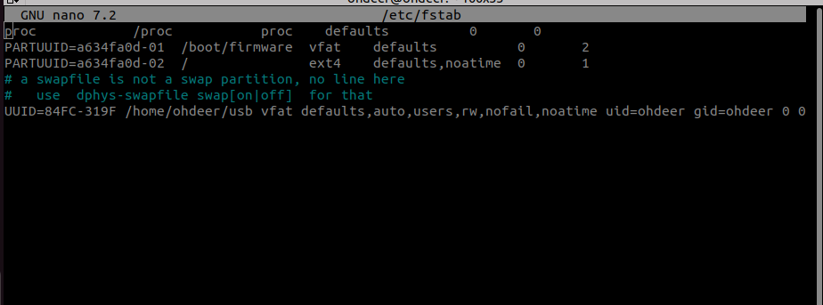
adf

11/22 19:50 -
~/oh-deer/home/ohdeer/oh-deer/auto-clips/2024-11-22_clips $ ls
16-14-57_bbox.avi 17-54-00_bbox.avi 17-54-02_bbox.avi 17-54-17_bbox.avi new_17-54-17.avi

