1.

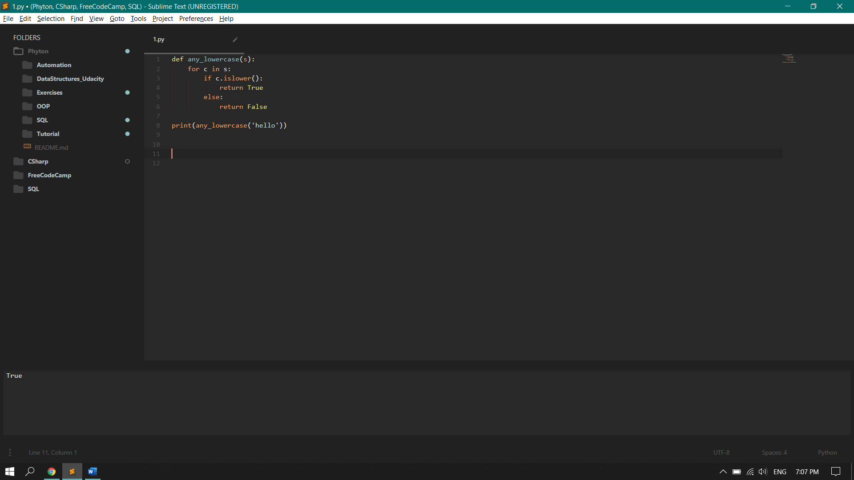

def any_lowercase1(s) checks if there is a lowercase letter in the string and returns a Boolean value if true or false.

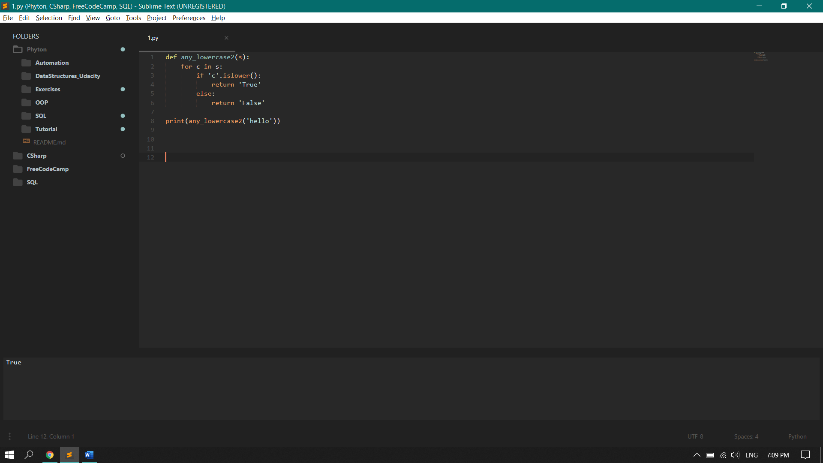

def any_lowercase2(s) checks if the ‘c’ is lowercase and returns a string of true or false.

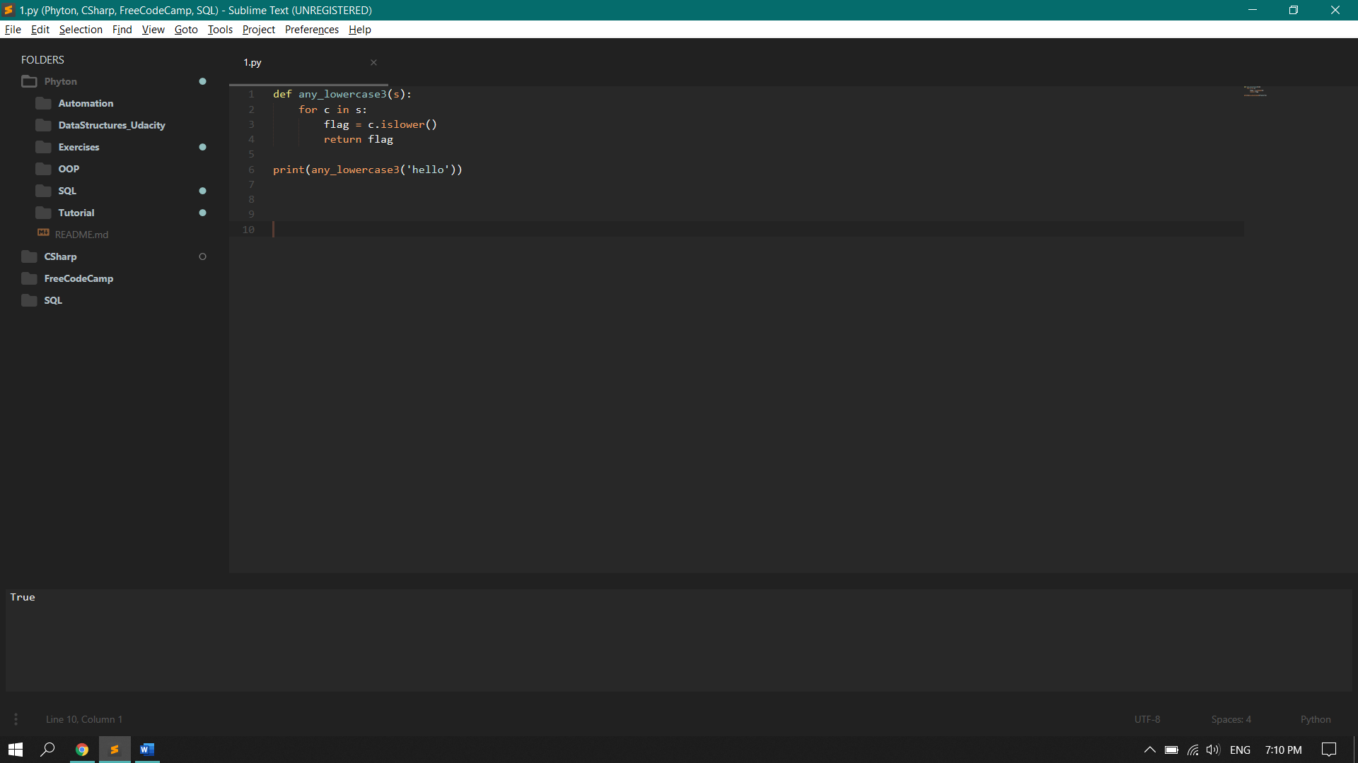

The flag is triggered so it returns true when the flag is printed.

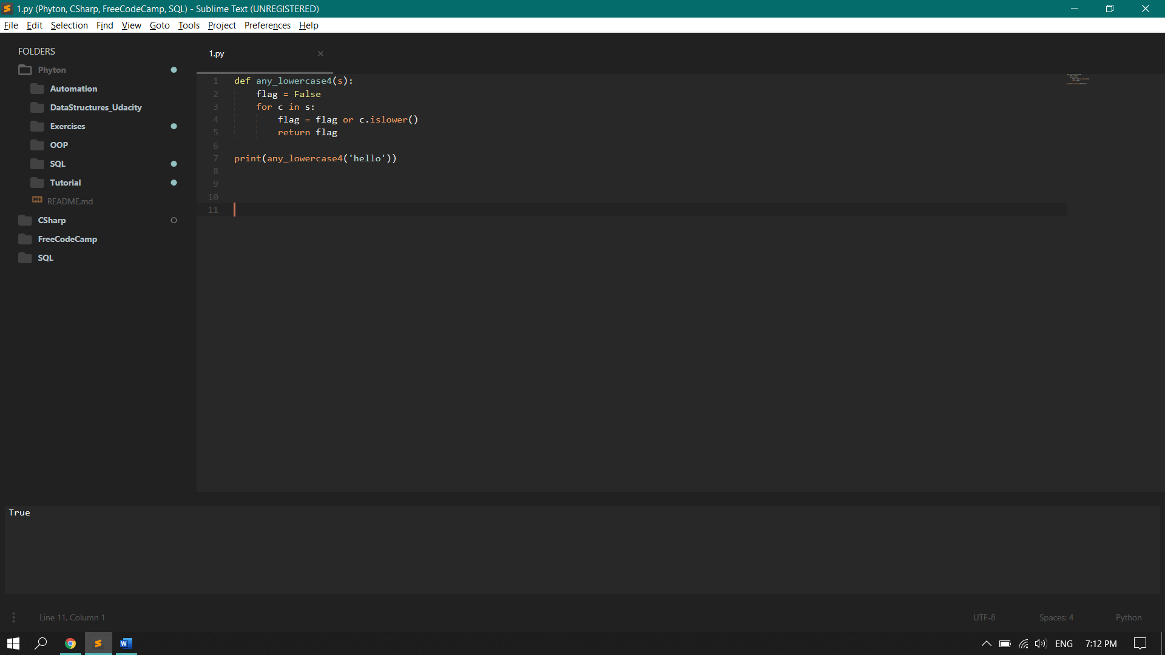

The flag is initial value is false. Once it checks for a lowercase and a lowercase is present, the flag’s value is then turned to true when there is a lowercase.

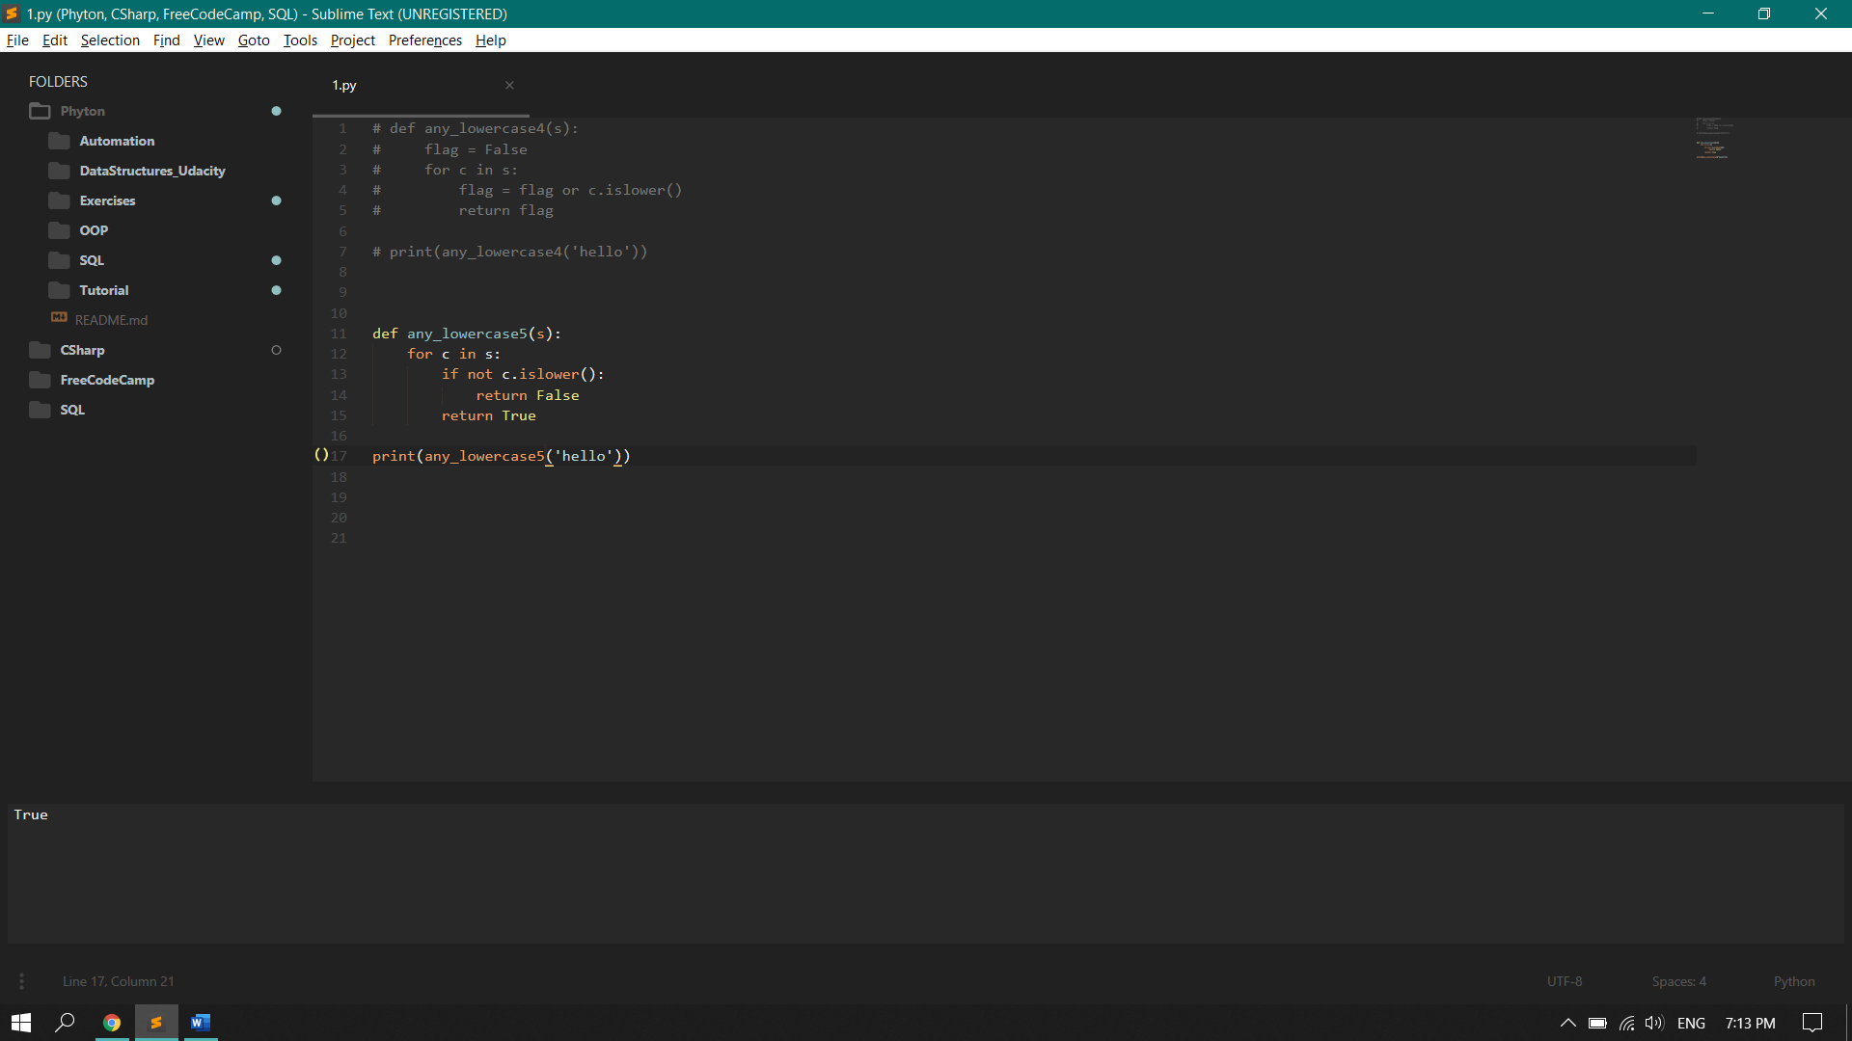

Def any_lowercase5(s) checks if there is a lowercase value. If it is not lowercase, it will return false else true.

2.