Web Application Penetration Testing Report – Elastik

Vulnerability Type: | Multiple Reflected XSS leading to Sensitive Information Exposure (Authenticated)
Affected Asset: | https://erp.elastik.mu/
Severity | High (8.2/10.0) (CVSS 3.1 score: (8.2/10.0)
OWASP Category: | A03:2021 – Injection (Cross-Site Scripting)
Status | Confirmed & Exploited (PoC Attached)

- Vulnerability & Exploitation (POC):
- We have identified a critical Reflected Cross-Site Scripting (XSS) flaw in the ERP’s routing logic. The application fails to sanitize user input in URL parameters before rendering it into the DOM.

- Vulnerable Parameters: module and tpid

- Affected URL: https://erp.elastik.mu/?module=%22%3E%3Cscript%3Ealert(%22XSS%20with%20sensitive%20data%22)%3C/script%3E&tpid=%22%3E%3Cscript%3Ealert(%22XSS%20found%22)%3C/script%3E&tcid=11

- Method: By utilizing HTML-breaking sequences such as "><script>, I achieved an attribute breakout that allowed for arbitrary JavaScript execution and the unauthorized disclosure of sensitive environment variables

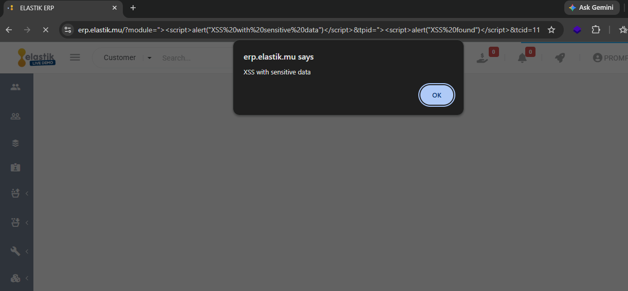

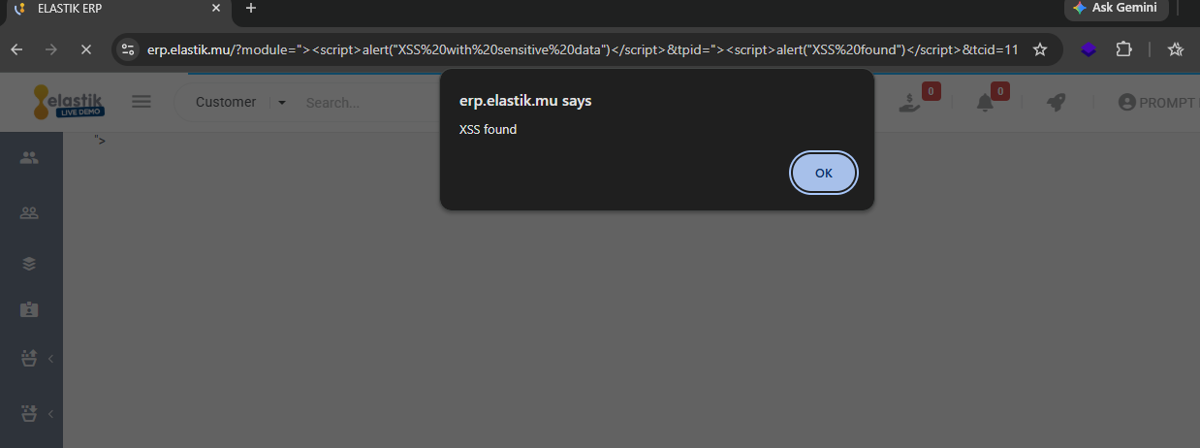

Sensitive data:

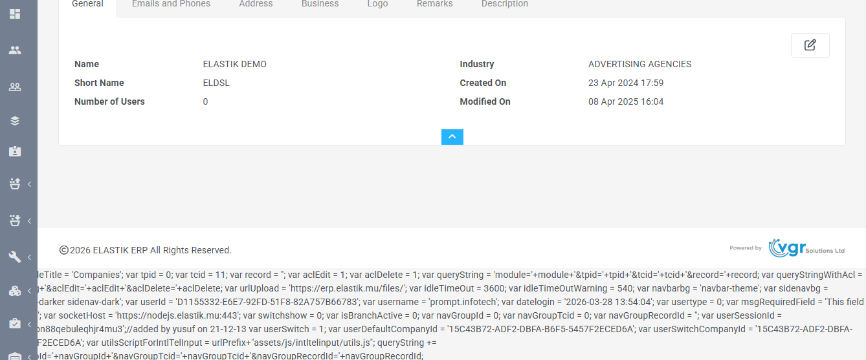

By leveraging the identified Reflected XSS vulnerability, multiple exploitation vectors are possible, including Unauthorized Open Redirection and Sensitive Data Exfiltration. These attacks allow an adversary to hijack the user session and redirect victims to malicious external domains.
i) XSS Leading to Delayed open Redirection
By utilizing a setTimeout function, the attack forces the victim's browser to navigate to an external site after a 3-second delay, masking the initial data theft.

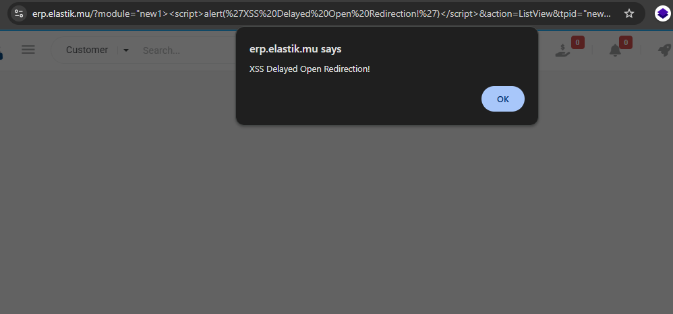

Video POC:
ii) Data Exfiltration via XSS

The payload silently captures the userSessionId and username global variables, transmitting them to a remote listener via an invisible image request.

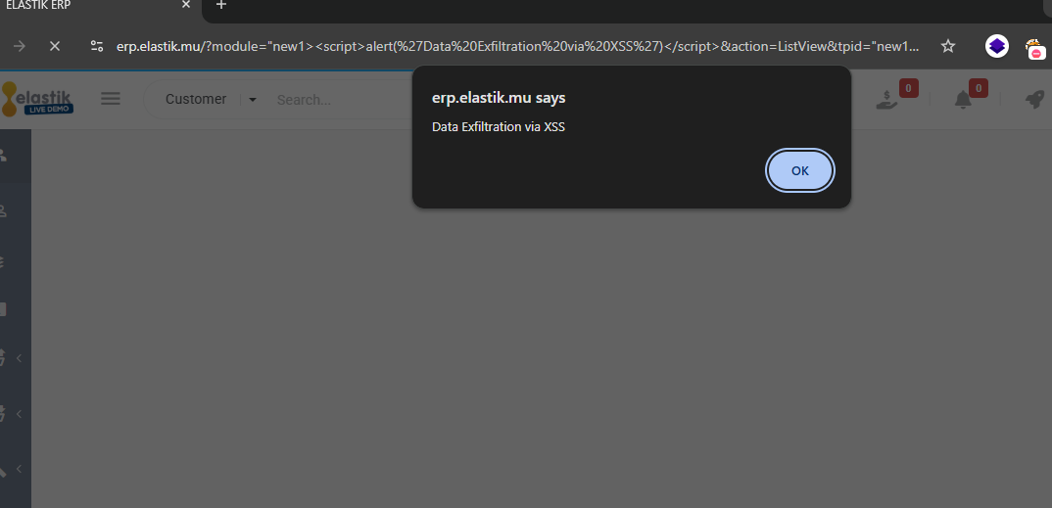

Exfiltrated data

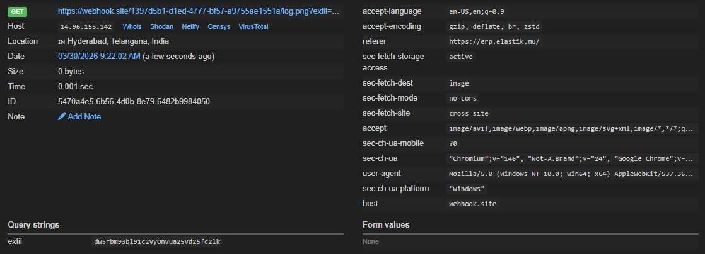

Observed Impact: The injection caused the internal JS engine to malfunction, exposing sensitive environment variables directly on the page. I successfully exfiltrated:
- userSessionId: The active session token (allowing for bypass of HttpOnly protections).
- urlUpload: The internal server path for file management.
- socketHost: Real-time backend connection strings.

- Impact Assessment
- Keylogging: By injecting malicious scripts into the affected parameters, an attacker can record keystrokes to steal sensitive user data and credentials in real-time.

- Account Takeover: The exposure of the userSessionId within the JavaScript global scope allows for immediate session hijacking, bypassing standard HttpOnly cookie protections.

- Data Exfiltration: Attackers can programmatically scrape and exfiltrate sensitive financial records, customer information, and employee data accessible to the authenticated victim.

- Attack Escalation: The leaked urlUpload path and internal logic provide a direct roadmap for chaining this vulnerability into more severe attacks, such as Remote Code Execution (RCE).

End of the Report

