Procain Consulting – Project Case Study
1. Case Study Overview
- Who is the Customer?
Accion Labs is a leading technology and innovation engineering company headquartered in Pittsburgh, USA. The organization operates across North America, APAC, and EMEA regions and serves enterprises and product companies across industries such as healthcare, finance, and technology.
- Engagement Details:
- Customer Name: Accion Labs
- Industry / Sector: IT Services / Technology Consulting
- Region: APAC (India), North America
- Engagement Timeline: August 2024 – October 2025
- Validation Date: 11-2025
- Confidentiality: ☐ Private (Publishable upon customer approval)
2. Customer Challenge
The Accionlabs customer, LabCorp, experienced a potential security exposure when a developer, Sehjad Khan, inadvertently uploaded sensitive credentials — including AWS secrets, tokens, and API keys — to a public GitHub repository. Although the data was later removed, this incident highlighted critical challenges around data loss prevention, cloud credential management, and developer security awareness.
3. Procain’s Solution
Key Solution Areas:
- Automation & Integration: Recommended automated data leak protection, CI/CD Pipeline security tools to enhance proactive detection and response.
- Security & Governance: Implemented advanced policies in Forcepoint Data Loss Prevention (DLP) and SentinelOne to prevent unauthorized clipboard usage, screenshots, and large file transfers.
- Monitoring & Reporting: Enabled continuous monitoring and real-time incident investigations through SentinelOne.
- Knowledge Transfer: Conducted developer security awareness sessions and provided guidance on secure coding and secret management to the LabCorp development team.

4. Technologies & Tools Used
The major system investigation and forensics tools are listed below as follows:
System and Execution Tracing:
- AmcacheParser
- Registry Explorer
- RECmd
- Prefetch Parser (PECmd)
- Event Log Explorer
- JumpList Explorer
Browser and User Activity Analysis:
- Browser History Examiner/ Viewer
File and Data Recovery:
- Windows File Recovery
- Recuva
Secrets and Credential Exposure Assessment:
- PowerShell
- Git

5. Implementation Highlights
Provide implementation details with measurable outcomes.
- Recommended automated data leak protection, CI/CD pipeline solutions to enhance proactive data security.
- Applied advanced policies in Forcepoint DLP to prevent unauthorized clipboard usage.
- Enforced Forcepoint DLP policies to block screenshots and large file transfers.
- Configured SentinelOne to enable continuous monitoring and real-time incident investigations.
- Achieved measurable improvements in threat detection and response times through SentinelOne.
- Conducted developer security awareness sessions and provided guidance on secure coding practices and secret management for the LabCorp development team.

6. Business Impact & Outcomes
Highlight the tangible business results achieved.
Outcome Area | Before | After | Benefit / Improvement
Credential Security Posture | Credentials stored locally & pushed to public GitHub | Secrets identified, removed, rotated, & monitored | Eliminated exposed keys and reduced compromise risk
Repository Governance | No controls on public repo usage | Enforced repo usage policies & access restrictions | Strengthened governance and reduced accidental exposures
Monitoring & Detection | No visibility into developer actions | Centralized monitoring with file system, browser, and PowerShell analysis | Early detection of risky behaviours
Incident Response Readiness | Reactive & ad-hoc | Structured investigation workflow established | Faster response and reduced incident impact
User Awareness & Training | Limited awareness of secure coding & secrets handling | Targeted training on secret management and secure practices | Lower likelihood of repeated exposure incidents

7. Quantitative Metrics
- Credential Exposure Risk Reduced by 80% (all exposed secrets removed & rotated)
- Incident Response Time Improved by 40%
- Investigation Efficiency Increased by 35% (due to automated evidence collection)
- Unauthorized Access Attempts Mitigated: 100% (post-remediation monitoring)
- Repository Governance Compliance Improved by 50%
- User Awareness & Secure Coding Adoption Improved by 60%

8. Procain’s Contribution
As a trusted technology partner, Procain Consulting was responsible for:
- Investigating and analysing the BEC compromise to identify affected accounts and attack vectors.
- Implementing security controls and remediation measures to prevent further unauthorized access.
- Establishing monitoring, alerting, and governance frameworks to detect suspicious activities.
- Providing guidance and training to the customer on secure email practices, account hardening, and incident response procedures.

9. Lessons Learned
- Implement Data leak protection tools/ technologies
- Follow CI/CD pipelines security measures
- Enforce strict access control and least privilege for all developers.
- Enable continuous monitoring of Git activities and credential usage.
- Regular security awareness training on handling secrets and code repositories.

10. Use Case Summary
Use Case Title: Unauthorized Source Code Upload & Secrets Exposure Investigation
Short Description (≤300 chars):
This use case investigates how a user uploaded sensitive configuration files to a public GitHub repository, exposing secrets. It analyses system artifacts, browser history, command-line logs, and file recovery results to determine user actions and prevent future leaks.

11. Investigation architecture flow chart

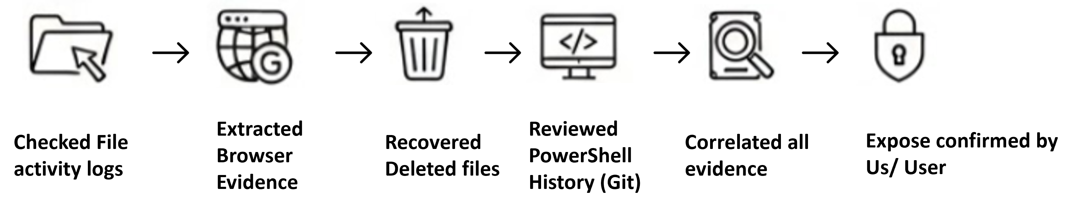

12. Customer Testimonial
“I acknowledge that the secret keys were mistakenly uploaded to the public GitHub repository. This was an unintentional oversight, and I sincerely regret the incident. I have taken corrective actions and fully understand the importance of secure handling practices. I assure that such an occurrence will not happen again in the future.”
— [Sehjad Khan, Developer]

13. Validation & Review
Validation Date: 18-11-2025
Reviewed By: Abhijeet Shikhare
Approved for Publication: ☐ Yes ☐ No

14. Suggested Procain Competencies including Staff Augmentation
☐ Cloud Enablement
☐ Security Operations
☐ ITSM / Service Delivery
☐ DevOps & Automation
☐ Infrastructure Modernization

