Investigation Report

Date: 24th June 2025
Investigated By: SOC Team

GitHub data breach analysis:

Summary:
- Username: Sehjad Khan
- Client: LabCorp
- Breached Data: Aws Secret / token / API Key
- Breached Platform: GitHub
- Content: User uploaded Sensitive data to GitHub repo (left the data as public) & later removed

Investigation:

- File Analysis:
- The investigation began by fetching recently accessed files and folders.

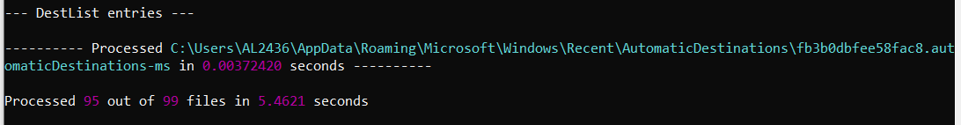

- The E:\Test\ folder was found to contain activity related to code files, so we proceeded to investigate it further.

- Browser History Analysis:

Checking Browser historical data:

- The presence of the previously existing folder named LabCity confirms that it was the deleted directory.

- PowerShell History Analysis:
- Checked PowerShell command history to verify recently used commands related to Git operations.
- During the review, a directory named LabCity was found, which had been pushed to the GitHub repository sehjad2000/LabCity.git.
- The repository was later removed by the user using the git rm command.

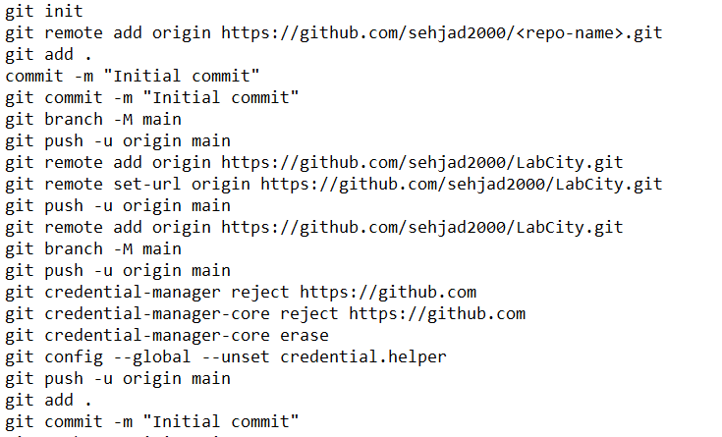

- The following two sensitive files were removed using the git rm command:

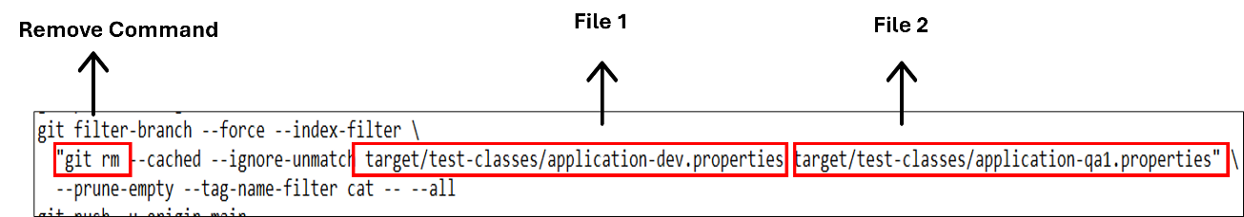

- Suspicious File Recovery:
Recovering deleted file/ folder which is common in File, browser and PowerShell analysis.
- Recovering File/ Folder via Cli tool:
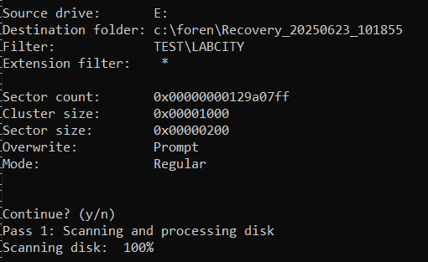

- Recovered LabCity Folder:
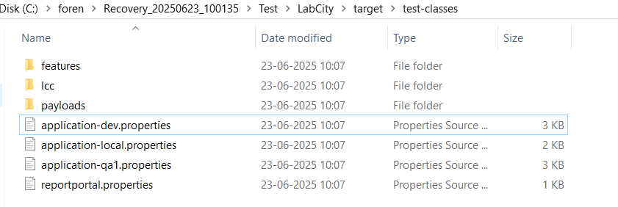

- Attempted to recover the application-dev.properties file, but the recovery was unsuccessful because the data was corrupted.
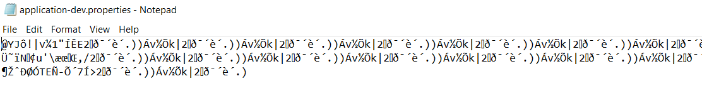

- However, the “.properties” file in the same folder revealed some sensitive keys, which confirms that the other two “.properties” files likely also contain sensitive data.

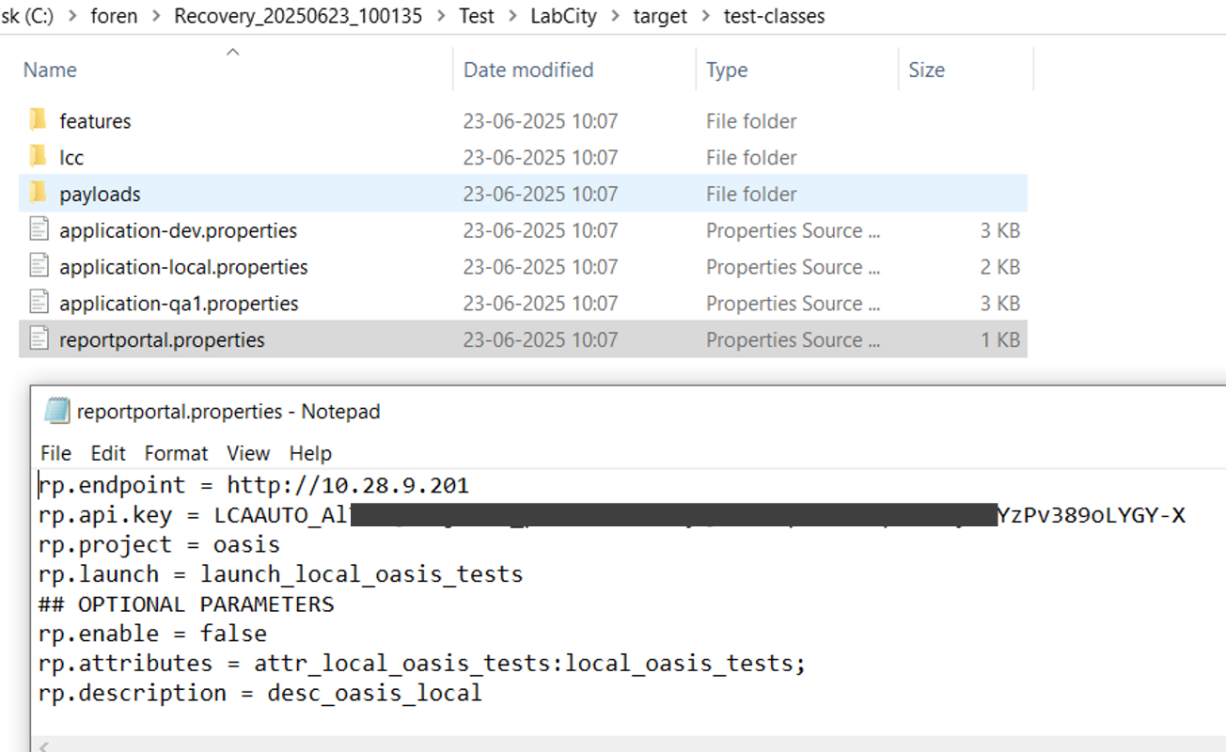

- Root Cause:
The user intentionally or unintentionally uploaded sensitive data like API Key / Token to his GitHub repository and kept as public.

- Conclusion:

Based on the investigation, it has been concluded that the user, Sehjad Khan, uploaded sensitive information—including AWS secrets, tokens, and API keys—to a public GitHub repository named LabCity.git.
The evidence was found through file system analysis, browser history, and PowerShell command history, all of which pointed to recent activities involving the folder LabCity.
Although some files were deleted, partial recovery confirmed the presence of sensitive credentials in .properties files. Upon discovery, the repository was removed by the user following internal escalation and request.

Data available in GitHub public repository
- Client: Cinch
- Breached Data: Client Secret Key/ Auth Token
- Breached Platform: GitHub
- Content: User uploaded Sensitive data to GitHub public repository
- TimeLine: Uploaded 3 years ago.

Link:
https://github.com/sehjad28/demo_karate_api/blob/master/demo-data-config-files/src/main/resources/qa/config/dbconfiguration.properties

https://github.com/sehjad28/demo_karate_api/blob/master/e2e-tests/src/main/resources/karate-config.js

