**Coding Challenges: CareerHub, The Job Board**

1. Provide a SQL script that initializes the database for the Job Board scenario “CareerHub”.

2. Create tables for Companies, Jobs, Applicants and Applications.

3. Define appropriate primary keys, foreign keys, and constraints.

4. Ensure the script handles potential errors, such as if the database or tables already exist.

**Problem Statement:**

Create SQL Schema from the application, use the class attributes for table column names.

SQL Schema:

**Table**: Companies

**Attributes:**

• CompanyID (Primary Key, int): Unique identifier for each company.

• CompanyName (string): The name of the hiring company.

• Location (string): The location of the company.

Query: create table companies(companyid int primary key, companyname varchar(20), location varchar(20));

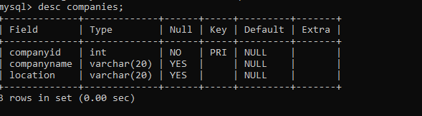

Inserting values into companies—

Query: insert into companies values(101,'hexaware','chennai'),(102,'accnture','hyderabad'),(103,'unisys','banglore'),(104,'zoho','cennai'),(105,'tcs','hyderabad'),(106,'deloitte','mumbai'),(107,'gap','hyderabad'),(108,'capgemini','chennai'),(109,'prolifics','banglore'),(110,'pennant','hyderabad');

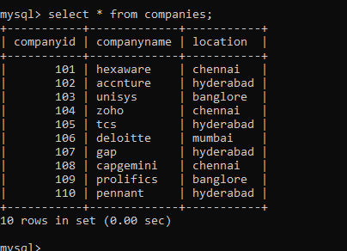

**Table: Jobs**

**Attributes:**

• JobID (Primary Key, int): Unique identifier for each job listing.

• CompanyID (Foreign Key, int): References the CompanyID of the hiring company.

• JobTitle (string): The title of the job.

• JobDescription (text): A detailed description of the job.

• JobLocation (string): The location where the job is based.

• Salary (decimal): The salary offered for the job.

• JobType (string): Type of job (e.g., Full-time, Part-time, Contract).

• PostedDate (datetime): Date and time when the job was posted.

Query : create table jobs(jobid int primary key, companyid int references companyid(companies), jobtitle varchar(20), jobdescription text, joblocation varchar(20), salary decimal, jobtype varchar(20), posteddate datetime);

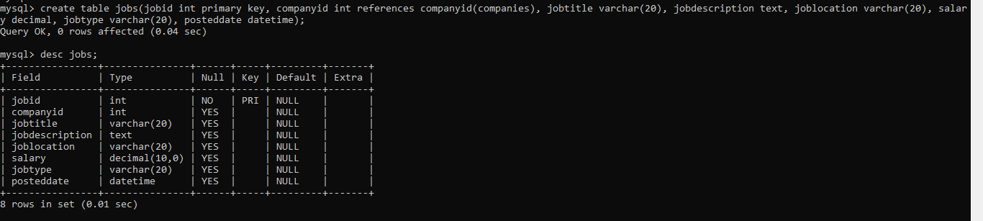

Inserting values into jobs—

insert into jobs values(01,101,'softwareTester','We are seeking a skilled tester to ensure the quality of our software products','hyderabad',30000,'contract','2023-10-11 11:40:03')

(02,102,'SoftwareDeveloper','Join our team as a Software Developer and contribute to building cutting-edge software solutions','chennai',40000,'part-time','2023-11-23 12:20:20'),(03,103,'Dataanalyst','Join our team as a data analyst and contribute to building cutting-edge software solutions','banglore',50000,'full-time','2023-12-27 11:28:21'),(04,102,'SoftwareTester','Join our team as a Software Tester and contribute to building cutting-edge software solutions','chennai',20000,'part-time','2024-01-23 09:20:20'),(05,103,'FrontendDeveloper','Join our team as a Frontend Developer and contribute to building cutting-edge software solutions','mumbai',80000,'full-time','2024-01-09 04:12:20'),(06,104,'BackendDeveloper','Join our team as a backend Developer and contribute to building cutting-edge software solutions','hyderabad',45000,'part-time','2024-01-23 12:20:30'),(07,102,'SoftwareDeveloper','Join our team as a Software Developer and contribute to building cutting-edge software solutions','banglore',90000,'full-time','2023-12-12 08:22:20'),(08,107,'BusinessAnalyst','Join our team as a Business Analyst and contribute to building cutting-edge software solutions','mumbai',25000,'contract','2023-10-24 02:28:21'),(09,102,'SoftwareDeveloper','Join our team as a Software Developer and contribute to building cutting-edge software solutions','chennai',40000,'full-time','2024-01-21 10:20:20'),(010,108,'FullstackDeveloper','Join our team as a Fullstack Developer and contribute to building cutting-edge software solutions','mumbai',950000,'full-time','2024-02-29 11:28:29');

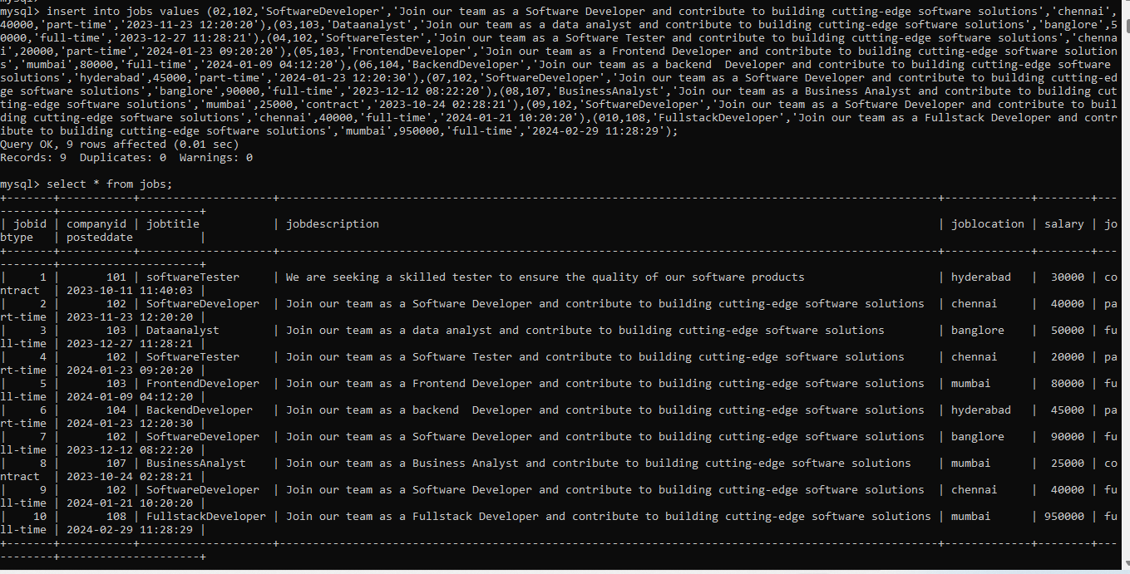

**Table: Applicants**

**Attributes:**

ApplicantID (Primary Key, int): Unique identifier for each applicant.

• FirstName (string): The first name of the applicant.

• LastName (string): The last name of the applicant.

• Email (string): The email address of the applicant.

• Phone (string): The phone number of the applicant.

• Resume (text): The applicant's resume or CV (text or file reference)

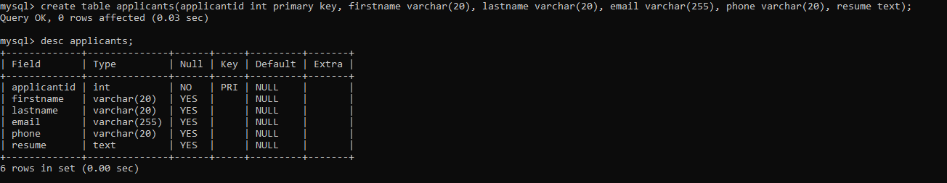Query : create table applicants(applicantid int primary key, firstname varchar(20), lastname varchar(20), email varchar(255), phone varchar(20), resume text);

Inserting values into applicants---

INSERT INTO applicants values (1, 'John', 'D', 'john@example.com', 1234123423, 'Experienced software developer with a passion for creating efficient and scalable web applications. Proficient in JavaScript, HTML, CSS, and various web frameworks. Strong problem-solving skills and ability to work in a team environment.'),

(2, 'Jane', 'S', 'jane@example.com', 8907789078, 'Results-driven marketing professional with a proven track record of successful campaigns. Skilled in digital marketing strategies, content creation, and social media management. Excellent communication and analytical skills.'),

(3, 'Michael', 'J', 'michael@example.com', 2345234578, 'Skilled project manager with experience leading cross-functional teams to deliver successful projects on time and within budget. Proven ability to communicate effectively with stakeholders and resolve issues efficiently.'),

(4, 'Emily', 'B', 'emily@example.com', '1890189078', 'Detail-oriented graphic designer with a passion for creating visually stunning designs. Proficient in Adobe Creative Suite and experienced in both print and digital design. Strong understanding of typography and color theory.'),

(5, 'David', 'W', 'david@example.com', 2345678901, 'Seasoned accountant with extensive experience in financial analysis and reporting. Skilled in budgeting, forecasting, and variance analysis. Certified Public Accountant (CPA) with a strong understanding of GAAP.'),

(6, 'Sarah', 'M', 'sarah@example.com', 5678901234, 'Dynamic sales professional with a proven track record of exceeding sales targets. Experienced in B2B and B2C sales environments. Strong negotiation and relationship-building skills.'),

(7, 'Cris', 'A', 'cris@example.com', 3456789012, 'Experienced customer support representative with a focus on delivering exceptional service and resolving customer issues efficiently. Skilled in using CRM systems and handling high-volume customer inquiries.'),

(8, 'Jessica', 'T', 'jessica@example.com', 9012345678, 'HR professional with experience in recruitment, onboarding, and employee relations. Proficient in HRIS systems and knowledgeable about employment laws and regulations.'),

(9, 'Matthew', 'T', 'matthew@example.com', 6789012345, 'Experienced data analyst with a strong background in data manipulation and visualization. Proficient in SQL, Python, and data analytics tools. Skilled in identifying trends and providing actionable insights.'),

(10, 'Amala', 'G', 'amala@example.com', 0123456789, 'Creative content writer with a passion for storytelling and brand development. Experienced in writing engaging content for various platforms including blogs, social media, and websites.');

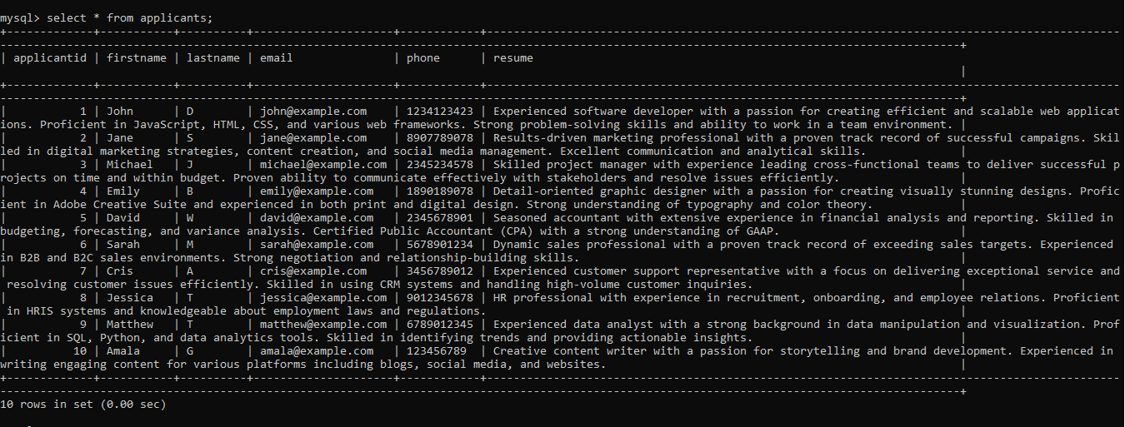

**Adding Experience column:**

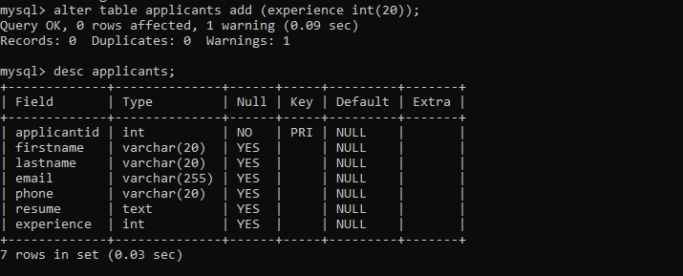alter table applicants add (experience int(20));

update applicants set experience=1 where applicantid in(1,5,10);

update applicants set experience=5 where applicantid in(2,6,9);

update applicants set experience=3 where applicantid in(3,4,7);

update applicants set experience=2 where applicantid in(8);

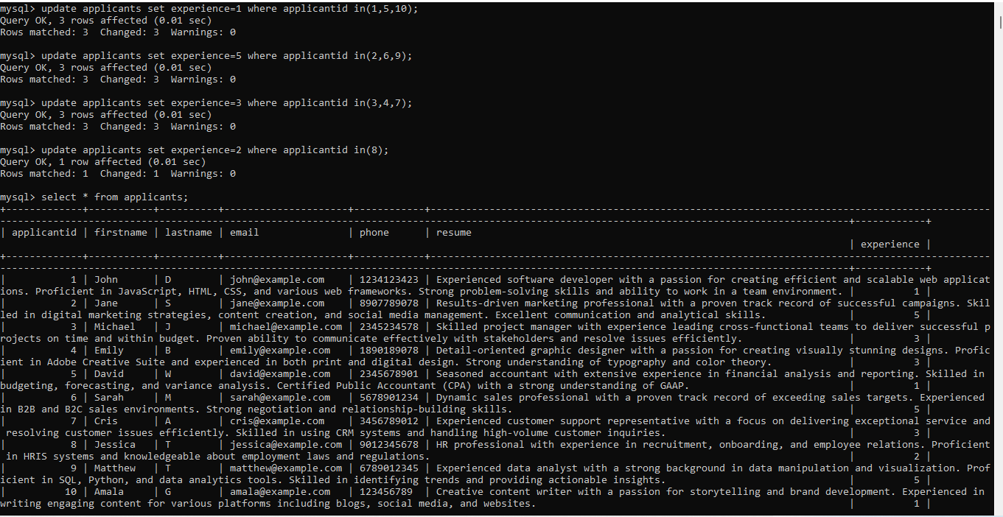

**Adding city, state column in applicants table:**

alter table applicants add (city varchar(50),state varchar(50));

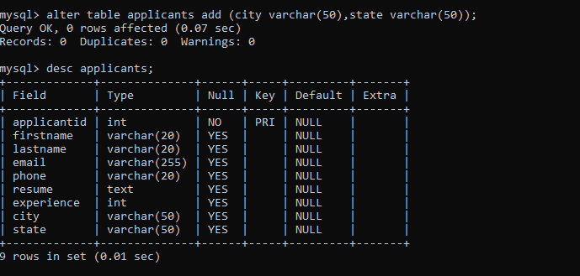

update applicants set city='Narayanapuram' where applicantid in(1,3,5);

update applicants set city='Tadepalligudem' where applicantid in(2,4,6);

update applicants set state='Andhra Pradesh' where applicantid in(1,3,5);

update applicants set city='Kodamanchali' where applicantid in(8,10);

update applicants set city='Pothavaram' where applicantid in(7,9);

update applicants set state='Telangana' where applicantid in(2,4,6);

update applicants set state='Tamil Nadu' where applicantid in(7,9);

update applicants set state='Karnataka' where applicantid in(8,10);

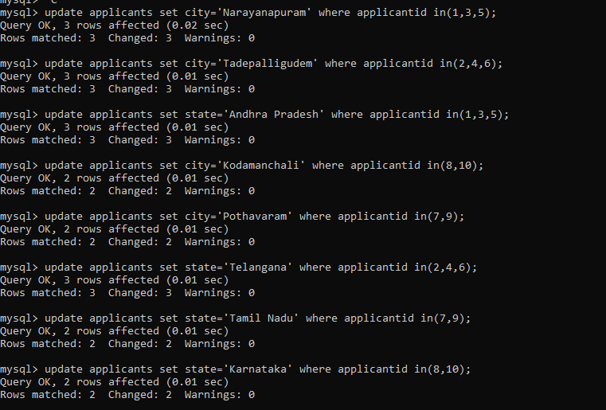

Select * from applicants;

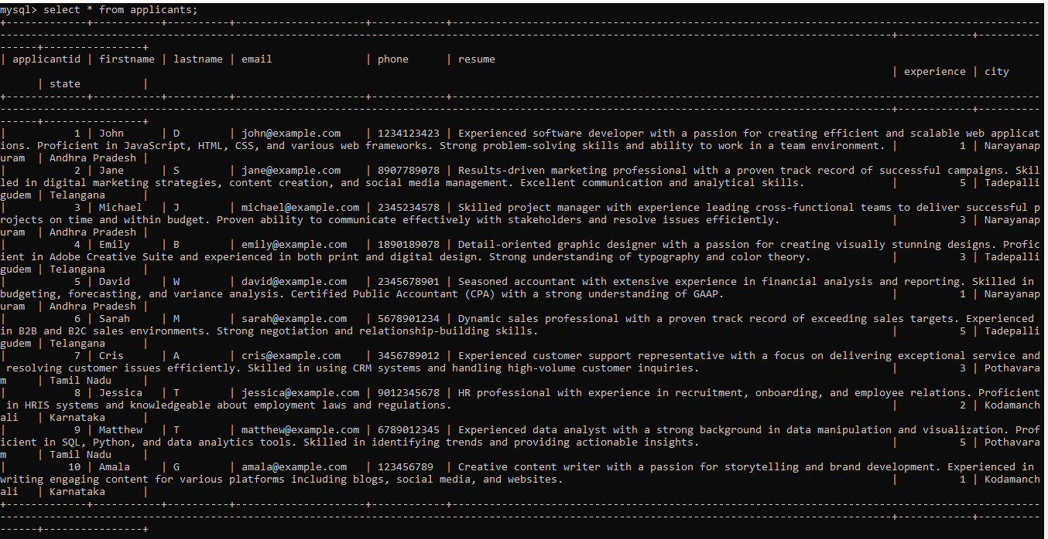

**Table: Applications**

**Attributes:**

• ApplicationID (Primary Key, int): Unique identifier for each job application.

• JobID (Foreign Key, int): References the JobID of the job listing.

• ApplicantID (Foreign Key, int): References the ApplicantID of the applicant.

• ApplicationDate (datetime): Date and time when the application was submitted.

• CoverLetter (text): The applicant's cover letter for the specific job

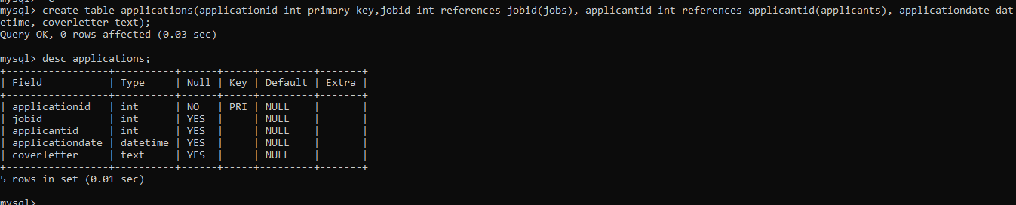Query : create table applications(applicationid int primary key,jobid int references jobid(jobs), applicantid int references applicantid(applicants), applicationdate datetime, coverletter text);

Inserting values into applications----

INSERT INTO applications values (1, 1, 1,'2023-10-18 08:00:00', 'Dear Hiring Manager I am writing to express my interest in the Software Engineer position at your company I am excited about the opportunity to contribute my skills and experience to your team.'),(2, 2, 2, '2023-11-30 09:15:00', 'To Whom It May Concern I am writing to apply for the Data Analyst position With my strong analytical skills and experience in data analysis I believe I would be a valuable addition to your team.'),(3, 3, 3, '2024-01-18 10:30:00', 'Dear Hiring Team I am enthusiastic about the Marketing Specialist role and the opportunity to leverage my marketing skills to drive growth for your company'),(4, 4, 4, '2024-01-28 11:45:00', 'Dear Hiring Manager, I am excited to apply for the Graphic Designer position. My creative skills and attention to detail make me a perfect fit for this role.'),(5, 5, 5, '2024-04-18 13:00:00', 'Dear Hiring Committee, I am writing to express my interest in the Accountant position. With my strong background in finance and accounting, I am confident in my ability to contribute effectively to your team.'),(6, 6, 6, '2024-02-18 14:15:00', 'Dear Hiring Manager, I am applying for the Project Manager position and am excited about the opportunity to lead and deliver successful projects for your company.'), (7, 7, 7, '2024-02-18 15:30:00', 'Dear Hiring Team, I am interested in the Customer Support Representative role and am confident in my ability to provide excellent customer service to your clients.'),(8, 8, 8, '2023-11-18 16:45:00', 'Dear Hiring Manager, I am excited to apply for the HR Coordinator position. I am passionate about human resources and am eager to contribute to your team.'),(9, 9, 9, '2024-02-18 17:00:00', 'Dear Hiring Committee, I am writing to express my interest in the Sales Associate position. I am confident that my sales experience and customer relationship skills make me a strong candidate for this role.'),(10, 10, 10, '2024-04-10 18:15:00', 'Dear Hiring Team, I am enthusiastic about the Content Writer role and am excited about the opportunity to create engaging content for your company.');

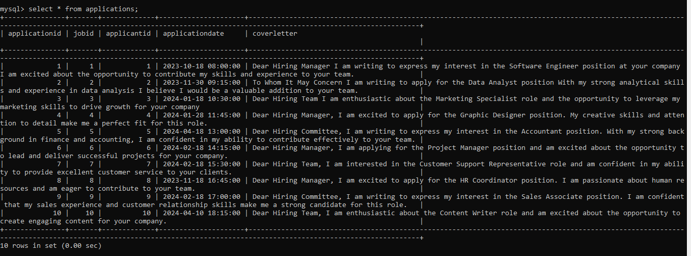

5.Write an SQL query to count the number of applications received for each job listing in the "Jobs" table. Display the job title and the corresponding application count. Ensure that it lists all jobs, even if they have no applications**.**

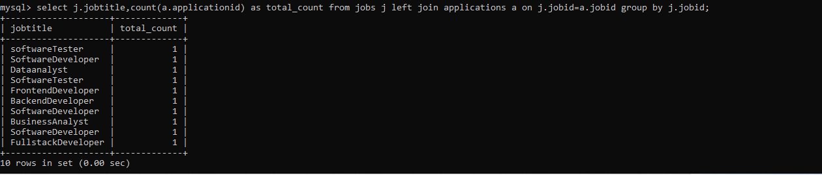Query : select j.jobtitle,count(a.applicationid) as total_count from jobs j left join applications a on j.jobid=a.jobid group by j.jobid;

6. Develop an SQL query that retrieves job listings from the "Jobs" table within a specified salary range. Allow parameters for the minimum and maximum salary values. Display the job title, company name, location, and salary for each matching job.

Query : .select j.jobtitle,c.companyname,j.joblocation,j.salary from jobs j inner join companies c on j.companyid=c.companyid where j.salary>=10000 and j.salary<=50000;

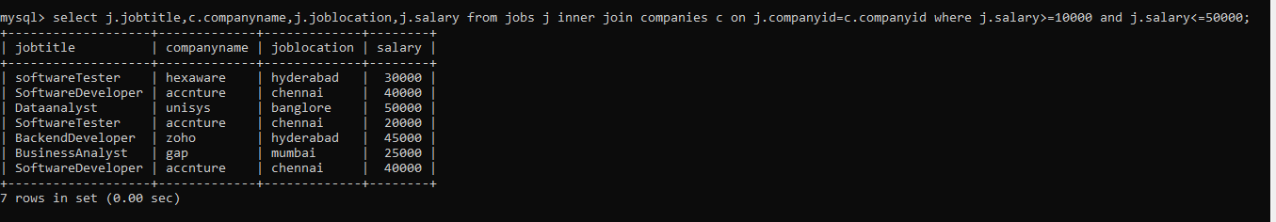

7. Write an SQL query that retrieves the job application history for a specific applicant. Allow a parameter for the ApplicantID, and return a result set with the job titles, company names, and application dates for all the jobs the applicant has applied to.

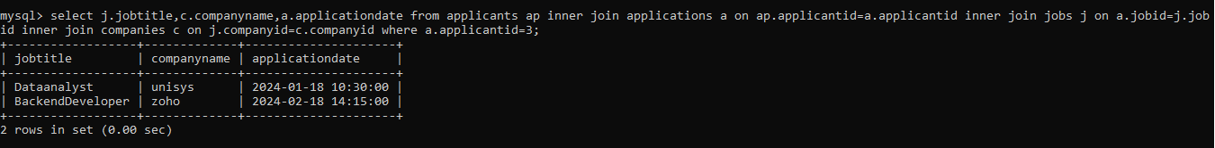Query : select j.jobtitle,c.companyname,a.applicationdate from applicants ap inner join applications a on ap.applicantid=a.applicantid inner join jobs j on a.jobid=j.jobid inner join companies c on j.companyid=c.companyid where a.applicantid=3;

8. Create an SQL query that calculates and displays the average salary offered by all companies for job listings in the "Jobs" table. Ensure that the query filters out jobs with a salary of zero.

Query : select avg(salary) as average_salary from jobs where salary>0;

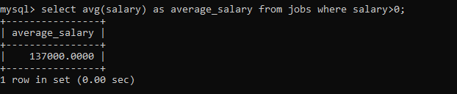

9. Write an SQL query to identify the company that has posted the most job listings. Display the company name along with the count of job listings they have posted. Handle ties if multiple companies have the same maximum count.

Query : select c.companyname, count(j.companyid) as tot_job_postings from jobs j inner join companies c on j.companyid=c.companyid group by j.companyid order by count(j.companyid) desc limit 1;

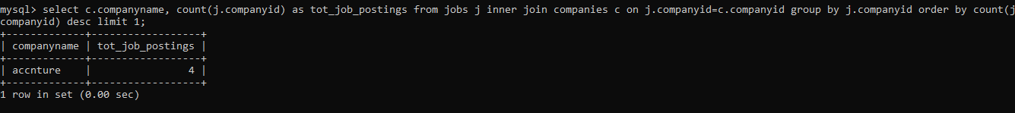

10. Find the applicants who have applied for positions in companies located in 'CityX' and have at least 3 years of experience.

Query : select applicantid, firstname from applicants where applicantid in (select applicantid from applications where jobid in (select jobid from jobs where companyid in(select companyid from companies where location='hyderabad'))and experience>=3);

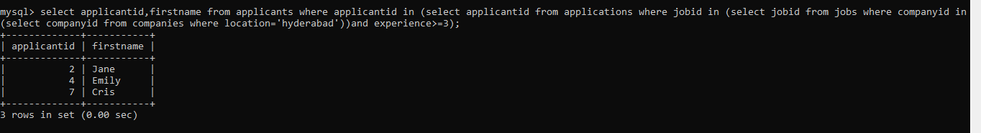

11. Retrieve a list of distinct job titles with salaries between $60,000 and $80,000.

Query : select distinct jobtitle, salary from jobs where salary>=60000 and salary<=80000;

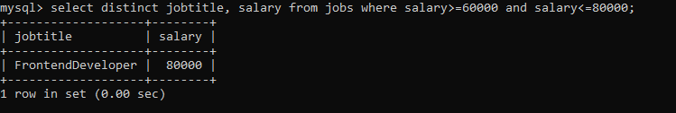

12. Find the jobs that have not received any applications.

Query : select j.jobtitle from jobs j left join applications a on j.jobid=a.jobid where a.jobid is null;

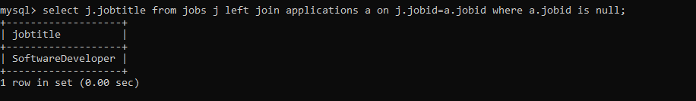

13. Retrieve a list of job applicants along with the companies they have applied to and the positions they have applied for.

Query : select ap.applicantid,concat(ap.firstname,' ',ap.lastname) as name,c.companyname,j.jobtitle from applicants ap inner join applications a on ap.applicantid=a.applicantid inner join jobs j on a.jobid=j.jobid inner join companies c on j.companyid=c.companyid;

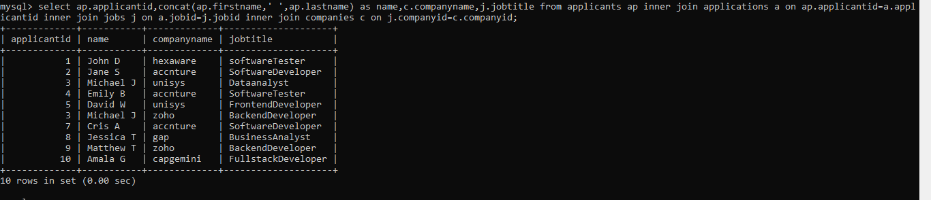

14. Retrieve a list of companies along with the count of jobs they have posted, even if they have not received any applications.

Query : select c.companyname, count(j.jobtitle) as job_count from companies c left join jobs j on c.companyid=j.companyid group by c.companyid;

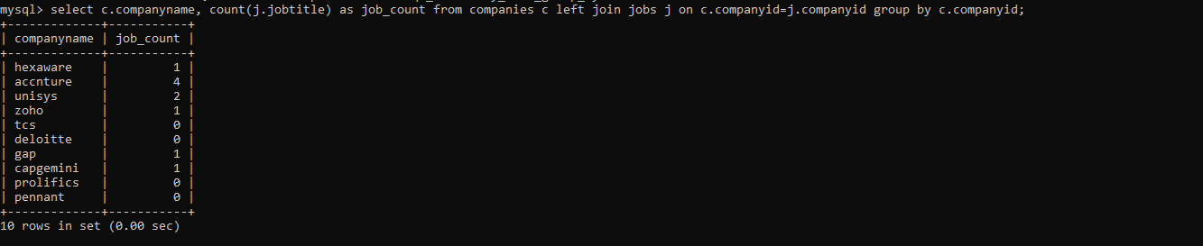

15. List all applicants along with the companies and positions they have applied for, including those who have not applied.

Query : select ap.applicantid,concat(ap.firstname,' ',ap.lastname)as name , c.companyname,j.jobtitle from applicants ap left join applications a on ap.applicantid=a.applicantid left join jobs j on a.jobid=j.jobid left join companies c on j.companyid=c.companyid;

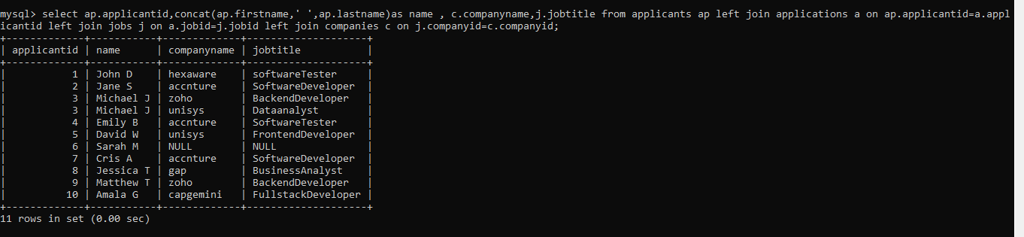

16. Find companies that have posted jobs with a salary higher than the average salary of all jobs.

Query : select c.companyname from companies c inner join jobs j on c.companyid=j.companyid where j.salary>(select avg(salary) from jobs);

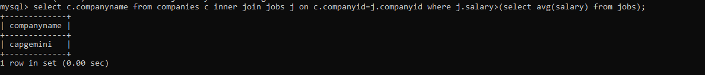

17. Display a list of applicants with their names and a concatenated string of their city and state.

Query : select concat(firstname,' ',lastname) as FulName,concat(city,',',state ) as location from applicants;

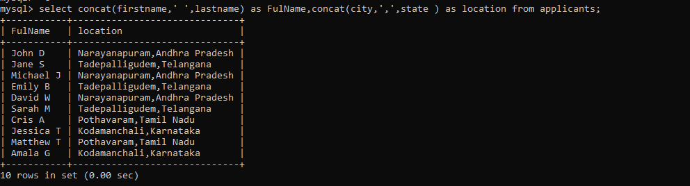

18. Retrieve a list of jobs with titles containing either 'Developer' or 'Engineer'.

Query : update jobs set jobtitle='SoftwareEngineer' where jobid=10;

select jobtitle from jobs where jobtitle like '%Developer' or jobtitle like '%Engineer';

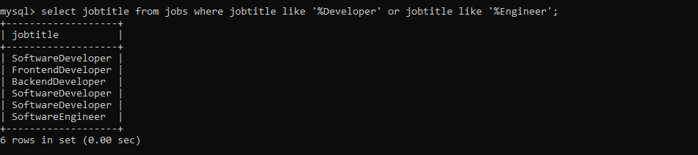

19. Retrieve a list of applicants and the jobs they have applied for, including those who have not applied and jobs without applicants.

Query : select ap.applicantid, concat(ap.firstname,' ',ap.lastname) as name, j.jobtitle from applicants ap left join applications a on ap.applicantid=a.applicantid left join jobs j on a.jobid=j.jobid;

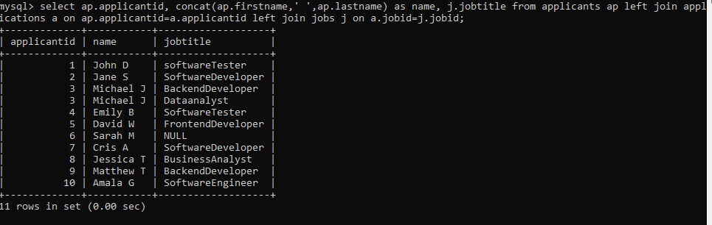

20. List all combinations of applicants and companies where the company is in a specific city and the applicant has more than 2 years of experience. For example: city=Chennai.

Query : Select a.FirstName,a.Lastname,a.Experience,c.CompanyName,c.Location from Applicants a join applications ap on a.applicantid=ap.applicantid Join jobs j on ap.jobid=j.jobid join Companies c on j.companyid=c.companyid where c.location=’chennai’ and a.Experience>2;

