 | Hacettepe University  Computer Engineering Department  BBM479/480 End of Project Report
Project Details
Title | OELLM — Observation of Earth Large Language Model: A Vision-Language Model for Urban Understanding and Cross-View Geolocalisation, with a Multi-City Dataset and Benchmark
Supervisor | Prof. Dr. Mehmet Erkut Erdem
Group Members
 | Full Name | Student ID
1 | Ezel Bayraktar | 2220356197
2 | Alperen Demirci | 2220765010
3 | Mukhamediyar Amanzhol | 2210765052
4 | Adam Sattout | 2220765061

Abstract of the Project ( / 10 Points)
Explain the whole project shortly including the introduction of the field, the problem statement, your proposed solution and the methods you applied, your results and their discussion, expected impact and possible future directions. The abstract should be between 250-500 words.
Vision-Language Models (VLMs) are now evaluated almost entirely on web-scraped imagery, leaving two abilities that matter for real-world geospatial deployment largely unmeasured: urban understanding — reading land use, building stock, transit access or the pedestrian environment from a single location — and cross-view geolocalisation — reasoning about whether an overhead satellite view and a ground-level street photograph depict the same place, and from which direction. A central weakness of current multimodal models is unimodal shortcut learning, in which the model answers from a text prior or a single modality rather than genuinely fusing the two views.
We address this with OELLM (Observation of Earth Large Language Model): a vision-language model adapted for joint satellite/street-view urban reasoning, together with the dataset and benchmark needed to train and evaluate it. The supporting corpus is produced by an end-to-end pipeline that pairs one high-resolution satellite tile with four road-aligned Google Street View images per location, across 40 cities in 32 countries on six continents. Every answer is derived deterministically from OpenStreetMap (OSM) tags and coordinate geometry rather than from human annotation or a generative model — a "zero-hallucination" design that makes each question verifiable and the data bit-exact reproducible. The corpus contains 39,155 question records over 4,168 unique locations spanning 14 task types, shipped with three split strategies (per-city, seen/unseen cities, and a disjoint held-out benchmark) so that in-distribution understanding and geographic generalisation can be measured under one taxonomy.
We fine-tune Qwen3.5-4B-VL with parameter-efficient LoRA adapters (vision and language layers, all-linear targets) using the Unsloth framework on a single RTX PRO 6000 GPU, and evaluate with strict greedy decoding against per-topic random and majority baselines. On the 5,240-record held-out benchmark our two 4-billion-parameter models lead a field of six open VLMs: the per-city model (PC-base) reaches 62.9% and the cross-city model (SU-base) 60.4%, ahead of Qwen2.5-VL-7B (52.0%), Pixtral-12B (49.6%) and LLaVA-OneVision-7B (45.3%), and far above the untrained Qwen3.5-4B base (35.5%). Reading the two models as a pair is the central finding: the gap of only 2.5 points between training on familiar cities and on eight entirely held-out cities indicates that the learned urban representation transfers across geography rather than memorising individual places.
A six-way ablation study, in which whole task families are withheld from training, reveals three distinct transfer regimes: strong within-family transfer (a model never shown the hard mismatch task still reaches 81.6% on it via its easy variant, only 9 points below the supervised ceiling); partial cross-family transfer (urban tasks recover roughly two-thirds of their ceiling under geometry-only supervision); and zero transfer (camera-direction estimation stays at chance unless trained directly). These results delineate which urban abilities a VLM can acquire by analogy and which require explicit supervision. We release the dataset, the trained adapters, the evaluation harness and a reproducible benchmark; the work is intended as a foundation for geospatial VLM research and as a practical tool for automated, scalable urban analytics, and we outline a second-generation dataset that further strengthens distributional balance.

Introduction, Problem Definition & Literature Review ( / 20 Points)
Introduce the field of your project, define your problem (as clearly as possible), review the literature (cite the papers) by explaining the proposed solutions to this problem together with limitations of these problems, lastly write your hypothesis (or research question) and summarize your proposed solution in a paragraph. Please use a scientific language (you may assume the style from the studies you cited in your literature review). You may borrow parts from your previous reports but update them with the information you obtained during the course of the project. This section should be between 750-1500 words.

The field: vision-language models for geospatial understanding
Vision-Language Models (VLMs) couple a visual encoder to a large language model so that images and text can be reasoned over jointly, and they now achieve strong results on captioning, document understanding and visual question answering. Yet the benchmarks that drive their development are dominated by web-scraped photographs of objects, charts and natural scenes. Two capabilities that are central to real-world geospatial deployment remain largely unmeasured. The first is urban understanding: inferring land use, building stock, road infrastructure, transit access or the pedestrian environment of a place from imagery — the raw material of urban planning, real-estate analytics, and socio-economic sensing. The second is cross-view geolocalisation: relating an overhead satellite view to a ground-level street photograph of the same place, deciding whether two views match, and recovering the camera's orientation. Both abilities require a model to fuse complementary modalities — the overhead view reveals macro-structure (block layout, connectivity, green cover), while the ground view reveals micro-structure (façades, surface materials, signage) — and neither is well captured by today's general-purpose evaluation suites.

Problem definition
We study whether a compact, openly-available VLM can be adapted, with modest compute, into a competent urban analyst that reasons jointly over satellite and street-level imagery. A well-documented obstacle stands in the way: unimodal shortcut learning, the tendency of multimodal models to answer from a text prior or from a single image rather than from a genuine fusion of both views. A model that names the most common land-use class, or that detects a city from vegetation and signage in a street photo, can score well without ever performing the cross-view reasoning the task is meant to probe. Concretely, the problem has three parts: (i) how to build a large, trustworthy, paired satellite/street-view VQA corpus without the cost and noise of human annotation; (ii) how to design tasks and splits that reward true multimodal reasoning and expose shortcut behaviour; and (iii) whether parameter-efficient fine-tuning of a small (4B-parameter) VLM can outperform substantially larger general-purpose models on this domain, and how far that competence generalises to cities never seen in training.

Related work
Urban multimodal models. A recent line of work adapts general VLMs to the urban domain. UrbanLLaVA [1] introduces a multi-stage training framework that decouples spatial-reasoning enhancement from domain-knowledge learning and reports gains over both open and proprietary models across single- and cross-modal urban tasks in three cities. CityLens [2] is, to date, the most extensive socio-economic sensing benchmark: it pairs satellite and street-view imagery across 17 globally distributed cities and six domains (economy, education, crime, transport, health, environment), and finds that even state-of-the-art LVLMs remain limited at predicting socio-economic indicators. CityRiSE [3] pushes further by using pure reinforcement learning with verifiable rewards to elicit structured, goal-oriented reasoning about urban socio-economic status, improving generalisation to unseen cities and indicators. These works motivate two of our design choices: initialising from a strong pretrained backbone rather than pretraining from scratch, and grounding supervision in verifiable signals. Their limitation, from our standpoint, is that they target socio-economic regression and rarely isolate the cross-view geometric reasoning that we make a first-class citizen of the task taxonomy.
Cross-view geolocalisation. Matching ground-level photographs to overhead imagery is a long-standing retrieval problem. Early large-scale benchmarks such as CVUSA and CVACT [7] paired over a million ground/aerial images under a strict one-to-one assumption. VIGOR [4] reframed the task beyond that assumption, introducing a benchmark where a query may fall anywhere in an area and several reference tiles may cover one location, together with a coarse-to-fine localisation framework. This retrieval tradition establishes cross-view correspondence as a meaningful, hard signal; our contribution is to recast it as multiple-choice VQA — mismatch detection, quadrant localisation, and camera-direction estimation — so that it can be posed to, and learned by, a language-driven model alongside semantic urban questions.
Remote-sensing VQA and grounded geospatial VLMs. The idea of deriving question-answer pairs automatically from OpenStreetMap is not new: RSVQA [5] built low- and high-resolution VQA datasets by querying OSM for the facts needed to construct questions and answers over satellite imagery, establishing the deterministic, OSM-grounded methodology we adopt and extend to the paired satellite/street-view setting. More recently, GeoChat [6] fine-tuned a LLaVA-based VLM into the first grounded remote-sensing assistant and reported that general-domain VLMs produce "inaccurate or fabricated information" on remote-sensing queries — the same shortcut/hallucination failure mode our task and split design are built to expose. Our work differs from both in coupling overhead and ground-level views of the same place and in making cross-view geometric reasoning an explicit, separately-scored task family.
Backbones and efficient adaptation. Our work builds on the Qwen-VL family of open VLMs [8], which couple a vision encoder to a strong language model and support native multi-image inputs — a prerequisite for our composites of one satellite tile and four street views. We adapt the model with Low-Rank Adaptation (LoRA) [9], which freezes the backbone and learns small rank-decomposition matrices in each linear layer, making full-resolution vision fine-tuning feasible on a single GPU. We compare against a representative slice of the open VLM landscape — Qwen2.5-VL-7B [8], Pixtral-12B [10], LLaVA-OneVision-7B [11], Gemma-3/4 multimodal [12] and Llama-3.2-Vision-11B [13] — none of which is specialised for paired satellite/street-view reasoning.
Data generation strategy. A natural way to scale instruction data is to have a large LLM generate question-answer pairs, but for imagery this is prone to hallucination — the generator invents details not present in the picture — and is costly at scale. We therefore follow a deterministic, "zero-hallucination" alternative: ground every answer in OpenStreetMap (OSM) [14] tags and coordinate geometry, so that each question has a verifiable, mathematically-checkable label. This makes the corpus reproducible and removes annotator drift, at the cost of restricting questions to what OSM and geometry can certify — a trade-off we revisit in our discussion of limitations.

Hypothesis and proposed solution
Our central hypothesis is that a 4B-parameter VLM, adapted with parameter-efficient fine-tuning on a deterministic, multimodal-by-construction corpus, can surpass much larger general-purpose VLMs on urban understanding and cross-view geolocalisation, and that the resulting urban competence transfers to previously unseen cities rather than memorising individual locations. To test it we built OELLM, an end-to-end pipeline that samples road-anchored locations in 40 cities, fetches one high-resolution satellite tile and four road-aligned street-view images per location, enriches each with OSM context, and emits 14 deterministic multiple-choice task types organised into an urban-understanding family and a cross-view geolocalisation family. We fine-tune Qwen3.5-4B-VL with LoRA under three split strategies — per-city, seen/unseen cities, and a disjoint held-out benchmark — and evaluate every model with strict greedy decoding against per-topic random and majority baselines. A six-way ablation, withholding whole task families from training, tests how far one ability transfers to another. The remainder of this report details the methodology, presents the quantitative results and their interpretation, and discusses the dataset's known limitations together with a second-generation redesign.
Methodology ( / 25 Points)
Explain the methodology you followed throughout the project in technical terms including datasets, data pre-processing and featurization (if relevant), computational models/algorithms you used or developed, system training/testing (if relevant), principles of model evaluation (not the results). Using equations, flow charts, etc. are encouraged. Use sub-headings for each topic. Please use a scientific language. You may borrow parts from your previous reports but update them with the information you obtained during the course of the project. This section should be between 1000-1500 words (add pages if necessary).

Dataset construction pipeline
The corpus is produced by a deterministic, seven-stage pipeline (Figure 1); each stage is a self-contained script that reads and enriches a shared list of sample records, and the orchestrator writes the final JSON Lines (JSONL) file. No stage depends on human annotation.
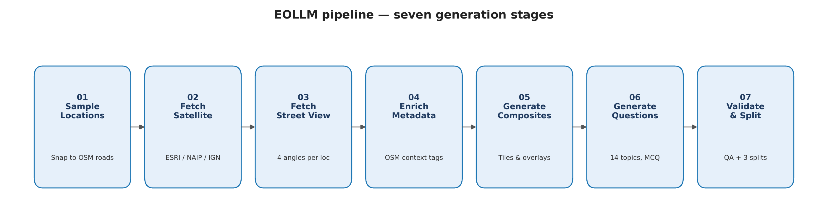
Figure 1. The seven-stage OELLM generation pipeline: OSM-anchored location sampling, satellite and Street View fetching, OSM enrichment, composite rendering, deterministic question generation, and validation/splitting.
(1) Location sampling. Points are drawn inside each city's bounding box and snapped to the nearest OSM road tagged primary, secondary, tertiary, residential or trunk; motorways are excluded because Street View along them is uninformative for urban tasks. The configured target is 120 locations per city; realised yields range from 50 (Nairobi) to 120 (Budapest), limited by road coverage, Street View availability and OSM completeness. (2) Satellite imagery. One 512×512 tile per location, with the provider auto-selected by coordinates: NAIP (~0.6 m/px) for the United States, IGN (~0.2 m/px) for France, ESRI World Imagery (~0.3–0.5 m/px) as the global default, and Sentinel-2 (10 m/px) as a fallback when a primary tile is corrupt (<5 kB). In the release ESRI covers 91% of records. (3) Street View. Four images per location at road-aligned headings (forward, backward, cross-left, cross-right); locations without outdoor coverage are dropped and an RGB-spread heuristic rejects tunnel imagery. (4) OSM enrichment. Each location is annotated with OSM context within a 100–300 m buffer — building footprints and building:levels, amenities, leisure/park polygons, water, transit stops and junction topology — which supplies the deterministic answer keys.
(5) Composite rendering. Task-specific visuals — a red marker on the satellite, directional arrows per option, 2×2 street-view grids, and 4×4 mega-grids of four candidate locations — are re-assembled on demand from the raw images by a single utility module, so the compressed release ships only raw tiles (~7 GB). (6) Question generation. Templates convert OSM-derived ground truth into four-option questions, sampling plausible distractors from the same category space. Option order is shuffled by a per-question RNG seeded from sample_id and topic, so the correct letter is stable across re-runs yet distributed across letters in the corpus. (7) Validation and splitting. Records are filtered for image availability and OSM completeness and partitioned into three disjoint split strategies (below).

Task taxonomy
The 14 task types fall into two families. The urban-understanding family (nine tasks: land_use, building_height, urban_density, road_type, road_surface, junction_type, green_space, amenity_richness, transit_density) asks a question whose answer follows from one location's OSM context, shown as a satellite tile with a red marker. The cross-view geolocalisation family (five tasks) tests the relationship between modalities: camera_direction (align a single street view with one of four arrows drawn on the satellite); mismatch_binary (does this 2×2 street-view grid belong to the satellite tile?); and mismatch_mcq (pick which of four street-view composites matches the satellite). The mismatch tasks come in easy and hard variants: easy draws the distractor from a different city, where ambient cues (vegetation, signage, vehicles) leak the answer, while hard draws it from the same city, defeating those shortcuts and isolating the geometric match. Each sample is rendered for the model through one of five image modes that determine how many images are assembled — between one (marked satellite) and five (one query plus four labelled candidates).
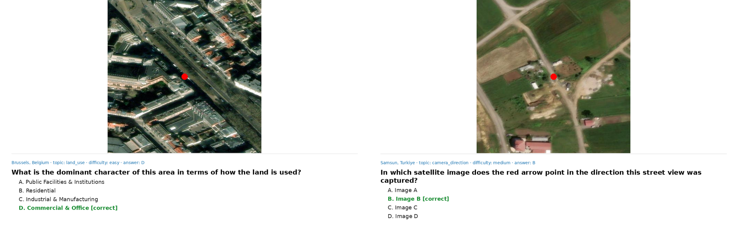
Figure 2. Two rendered examples exactly as the model receives them. Left: a land_use question (urban-understanding family) over a marked satellite tile. Right: a camera_direction question (cross-view family) asking which arrow matches the street view's heading. The gold answer is shown in green.

Split strategies
The same taxonomy is evaluated under three regimes (Table 1). per_city assigns random locations within every city to train or validation — the model sees all cities, and validation tests generalisation to new locations in familiar contexts. seen_unseen holds out eight entire cities (Cape Town, Chicago, Istanbul, Moscow, Rio de Janeiro, Seoul, Singapore, Sydney) for validation — the honest test of geographic generalisation. benchmark is a separate evaluation set shipped as two parallel files: a public copy with answers withheld and a gold-labelled twin.
Split strategy | Train | Validation | Generalisation question
per_city | 26,931 | 6,984 | new locations, seen cities
seen_unseen | 26,963 | 8,831 | 8 cities held out entirely
benchmark | — | 5,240 | disjoint held-out evaluation

Table 1. Record counts per split strategy. The two strategies share most underlying locations under different partitions; the benchmark is evaluated separately.

Model and parameter-efficient fine-tuning
We fine-tune Qwen3.5-4B-VL, an open vision-language model with native multi-image support, loaded in bfloat16 (16-bit) through the Unsloth framework [15] with gradient checkpointing; we deliberately avoid 4-bit quantisation, which degrades this backbone. Adaptation uses LoRA [9] over all linear layers with both vision and language layers trainable, rank r = 16 and scaling α = 16, zero dropout and no bias terms. Freezing the backbone and learning only the low-rank adapters keeps the trainable parameters under 1% of the model and lets full-resolution vision fine-tuning fit on a single 96 GB RTX PRO 6000. Each image is resized so its longest edge is at most 1024 px; the per-run maximum sequence length is set from the 99th percentile of tokenised training samples with a floor of 8192 tokens.
Inputs are formatted as a three-message chat (system / user / assistant). The system prompt casts the model as an urban-geography expert and instructs it to reply with only the letter of the correct answer; the user message carries the question, the four options (one per line), and the assembled image(s); the assistant target is the bare gold letter. Loss is computed only on the assistant span (response-only training), and label masking is verified before each run.

Training configuration
All runs use the AdamW optimiser, a cosine learning-rate schedule with 100 warm-up steps, weight decay 0.01, gradient clipping at 1.0, and a fixed global seed (3407) propagated to Python, NumPy, PyTorch, CUDA and the LoRA initialisation for determinism. The learning rate is 2.5×10⁻⁴ on the RTX PRO 6000 profile. Batch size is selected by a two-phase auto-probe that climbs geometrically until it approaches the memory budget, then fits a linear VRAM model and binary-searches into a target utilisation band, using worst-case (five-image) samples plus a synthetic upper-bound sample so that no later batch can overflow; gradient accumulation is then set to reach an effective batch in the 8–32 range. The two principal models — PC-base (per_city) and SU-base (seen_unseen) — were trained at batch sizes of 80 and 86 for 6 and 8 epochs respectively; the six ablations used batch size 96 for 5 epochs with early stopping (patience 2) on validation accuracy.

Evaluation protocol
Every model is evaluated with strict greedy decoding (no sampling, at most 16 new tokens), which makes scores deterministic given a fixed model and evaluation set. The predicted answer is extracted by a two-stage letter parser: a strict word-boundary match for A/B/C/D, then a punctuation-aware fallback; an unparseable output is scored as wrong rather than coerced. The metric is exact-match accuracy — a prediction is correct only if the parsed letter equals the gold letter — reported overall and per topic. Crucially, every topic is scored against two reference floors computed from the validation set itself: a random baseline (1/number-of-options, i.e. 25% for four-option tasks and 50% for binary mismatch) and a majority baseline (always predict the topic's modal answer). Reporting against these floors prevents a large headline gain from being misread when the true chance level is 50%, not 25%. The same protocol is applied to the untrained base model and to each open VLM, so all comparisons are like-for-like. Per-epoch "verdict" reports capture the full per-topic table, deltas versus base/random/majority, and an over-fitting check; these verdict files are the primary source for the numbers in this report.
Two further choices make the evaluation robust and reproducible. First, the letter parser is deliberately conservative: it requires the predicted letter to appear as a stand-alone token (a word-boundary match, with a punctuation-aware fallback) so that an answer embedded in a longer sentence is still recovered, while a response that names no option at all is counted wrong rather than being charitably mapped to a letter. This avoids inflating any model's score through lenient string matching, which matters when comparing a fine-tuned model that emits a bare letter against general-purpose VLMs that tend to answer in prose. Second, decoding is greedy and the random seed is fixed across the whole stack, so a given (model, evaluation set) pair yields identical predictions on every run; the reported accuracies are point values, not the mean of a noisy sampling distribution. Accuracy is computed both overall and grouped by topic and by the template-assigned difficulty label, and the per-topic random and majority floors are recomputed from the evaluation set itself rather than assumed, so that binary-mismatch topics are correctly scored against a 50% chance level. The same harness is used unchanged for the held-out benchmark, which keeps the benchmark numbers directly comparable to the per-epoch validation figures. Each question template carries a fixed difficulty label (easy / medium / hard) assigned at generation time — the mismatch tasks inherit the label of their easy or hard variant, while the cross-view and density tasks are labelled medium — so the difficulty breakdown reflects task design rather than a post-hoc split of scores.

Ablation design
To probe how one ability transfers to another, we run six ablations that withhold whole task families from training only, while validation retains all 14 topics so the withheld ability can still be measured. The ablations are: S-1 removes the seven urban tasks (training on geometry and mismatch only); S-2a/S-2b remove the five geo/mismatch tasks under per_city and seen_unseen respectively; S-3 removes the four mismatch tasks (testing whether camera-direction supervision transfers to mismatch); S-5 removes only camera_direction; and S-6 removes only the two hard mismatch variants while keeping their easy counterparts (testing within-family easy→hard transfer). Comparing each withheld task's accuracy to its supervised ceiling (the same topic under PC-base) yields the transfer analysis in the next section.
Results & Discussion ( / 30 Points)
Explain your results in detail including system/model train/validation/optimization analysis, performance evaluation and comparison with the state-of-the-art (if relevant), ablation study (if relevant), a use-case analysis or the demo of the product (if relevant), and additional points related to your project. Also include the discussion of each piece of result (i.e., what would be the reason behind obtaining this outcome, what is the meaning of this result, etc.). Include figures and tables to summarize quantitative results. Use sub-headings for each topic. This section should be between 1000-2000 words (add pages if necessary).

Held-out benchmark: a 4B model leads the open VLM field
We first evaluate on the 5,240-record held-out benchmark, scoring every model with the identical greedy protocol. Both of our 4-billion-parameter LoRA models lead a field of six open VLMs spanning 4–12 billion parameters (Figure 3). PC-base, trained on the per-city split, reaches 62.9% overall and SU-base, trained on the cross-city split, reaches 60.4%. They sit ahead of Qwen2.5-VL-7B (52.0%), Pixtral-12B (49.6%), LLaVA-OneVision-7B (45.3%), Gemma-4-E2B-it (42.2%) and Llama-3.2-Vision-11B (39.4%), and far above the untrained Qwen3.5-4B base (35.5%) from which they were adapted. That a 4B model fine-tuned for under a day on a single GPU outperforms a 12B general-purpose VLM underlines how much domain-matched, multimodal-by-construction supervision buys: the +27-point lift over our own base model is the clearest evidence that the gains come from learning, not from backbone capacity.
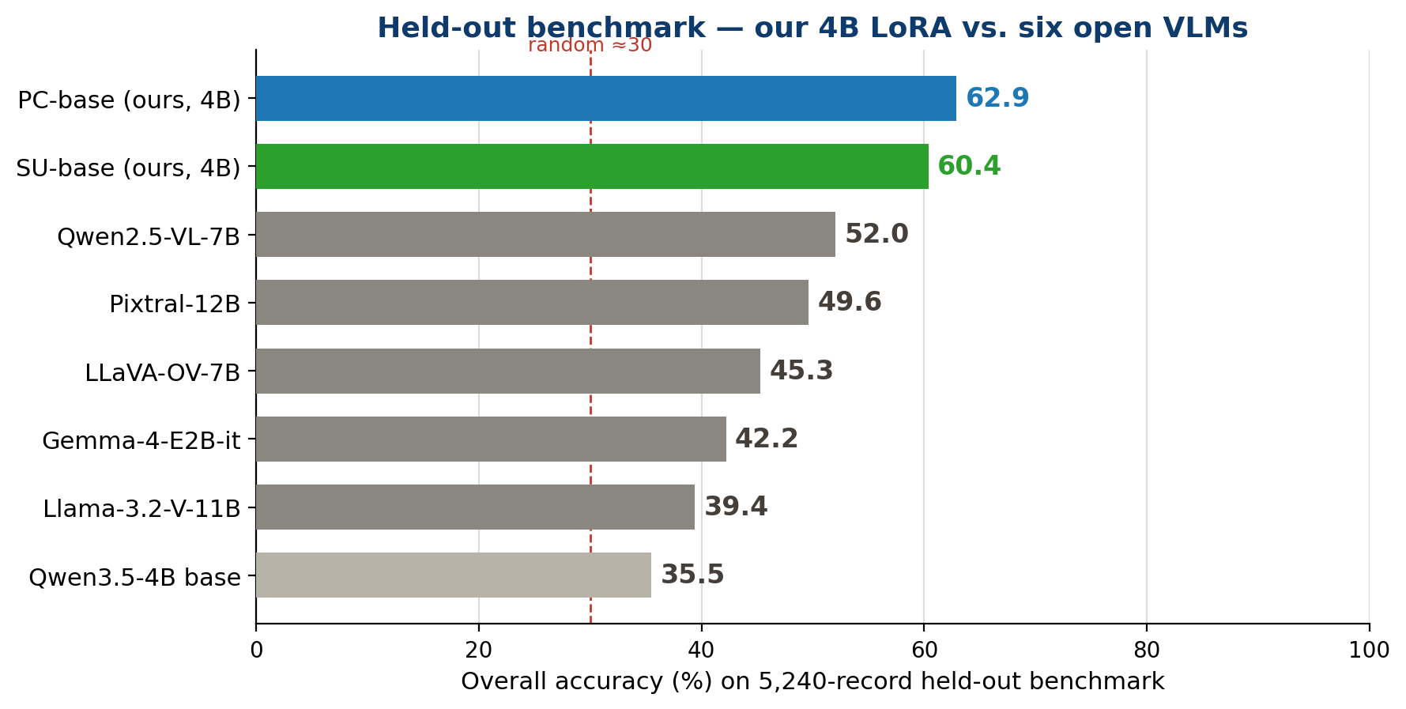
Figure 3. Overall accuracy on the 5,240-record held-out benchmark. Our PC-base (62.9%) and SU-base (60.4%) lead six open VLMs; the dashed line marks the ~30% random floor for the benchmark's option mix.

Reading the two models as a pair: geographic generalisation
The headline result is best understood as a pair rather than a single number. PC-base is the in-distribution ceiling — it has seen every city during training and is asked only about new locations within them. SU-base is the honest test of geographic generalisation — eight cities are held out entirely, so it must transfer an urban representation to places it has never observed. The gap between them is only 2.5 points on the benchmark (62.9% vs 60.4%). Within the benchmark's own seen/unseen split this is even sharper: SU-base scores 60.6% on seen cities and 59.5% on unseen cities — a generalisation gap of just 1.0 point — whereas PC-base, which was allowed to specialise to familiar cities, drops 5.0 points (63.8% → 58.9%) when moved off them. In other words, the model trained to generalise does generalise: holding out whole cities costs almost nothing, which is strong evidence that OELLM teaches transferable urban structure rather than memorised place identities. The validation training curves (Figure 4, left) tell the same story — PC-base climbs to 78.3% on per-city validation, while SU-base reaches a best of 72.4% (epoch 4) and settles at 70.8% at its final epoch on the harder cross-city validation, the expected ordering when one task is strictly harder than the other.
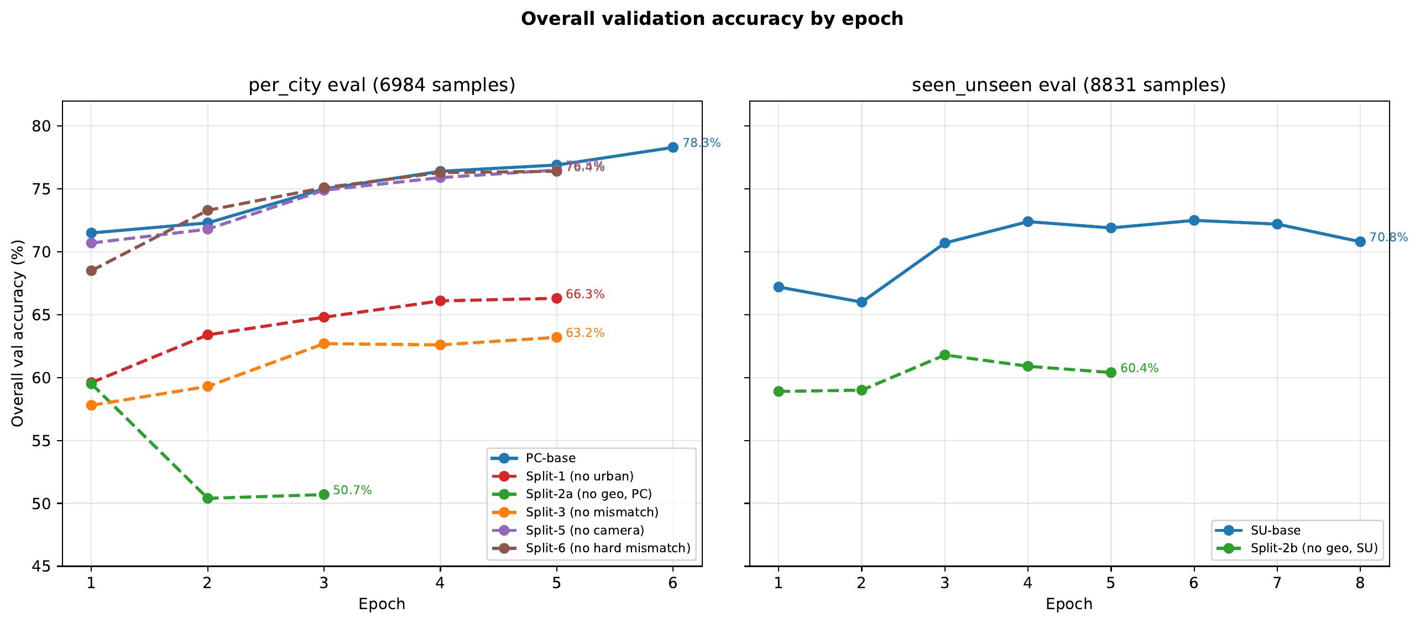
Figure 4. Validation accuracy by epoch. Left: per-city validation — PC-base reaches 78.3%; the ablations (urban-only, mismatch-removed, etc.) sit below it. Right: cross-city validation — SU-base reaches 70.8% and the geometry-removed run trails it. The benchmark numbers (62.9 / 60.4) are lower because the benchmark mixes seen and unseen cities and is scored separately.

Per-task analysis
Table 2 breaks the benchmark down by task. The pattern is interpretable. Our models dominate the semantic urban tasks that reward fused reasoning: land_use (73.6 / 75.1% vs 29–57.5% for the baselines), urban_density (71.3 / 69.8%), junction_type (75.8 / 70.4%), road_type (70.8 / 73.6%) and the harder mismatch_mcq tasks (mcq_easy 76.5 / 73.2%, mcq_hard 60.1 / 59.6% — roughly double the best baseline). The prior-heavy topics (green_space, road_surface) are discussed separately below, since their compact answer spaces make accuracy less informative there. The telling exceptions are the cross-view geometry tasks. camera_direction stays near chance for every model including ours (24.5 / 26.1%), and the binary mismatch tasks hover around their 50% floor — Pixtral-12B is actually best on mismatch_binary_hard (87.2%), the one task where a larger general encoder's fine-grained features help. These exceptions are not noise; they are the signature of abilities that our supervision does not, or cannot, instil — the subject of the ablation study.
Task | Llama-11B | LLaVA-7B | Pix-12B | Qwen2.5-7B | Qwen3.5-4B | Gemma-4 | SU (ours) | PC (ours)
amenity_richness | 24.2 | 35.2 | 32.1 | 31.4 | 24.7 | 33.2 | 56.5 | 53.2
building_height | 49.0 | 57.9 | 59.0 | 60.5 | 24.7 | 47.9 | 60.5 | 66.3
camera_direction | 25.4 | 24.9 | 20.7 | 27.8 | 7.6 | 24.0 | 26.1 | 24.5
green_space | 49.8 | 76.9 | 66.0 | 84.7 | 40.9 | 53.7 | 62.6 | 100.0
junction_type | 44.6 | 53.6 | 49.4 | 61.1 | 40.1 | 61.7 | 70.4 | 75.8
land_use | 41.1 | 57.5 | 46.3 | 53.7 | 29.0 | 45.6 | 75.1 | 73.6
mismatch_binary_easy | 53.4 | 54.4 | 82.7 | 85.5 | 51.8 | 51.8 | 55.6 | 53.0
mismatch_binary_hard | 44.2 | 44.9 | 87.2 | 64.9 | 45.1 | 43.5 | 49.6 | 44.4
mismatch_mcq_easy | 23.5 | 29.2 | 26.4 | 42.3 | 31.6 | 27.1 | 73.2 | 76.5
mismatch_mcq_hard | 20.4 | 23.8 | 28.0 | 37.3 | 30.9 | 25.2 | 59.6 | 60.1
road_surface | 86.5 | 84.5 | 86.1 | 92.4 | 71.6 | 93.1 | 75.3 | 96.0
road_type | 45.8 | 59.1 | 58.7 | 54.2 | 45.8 | 40.4 | 73.6 | 70.8
transit_density | 33.7 | 28.7 | 31.8 | 27.3 | 23.5 | 33.5 | 44.7 | 47.7
urban_density | 34.7 | 39.0 | 44.4 | 40.1 | 37.3 | 38.0 | 69.8 | 71.3
Overall | 39.4 | 45.3 | 49.6 | 52.0 | 35.5 | 42.2 | 60.4 | 62.9

Table 2. Per-task accuracy (%) on the held-out benchmark. Ours (SU-base, PC-base, 4B) versus six open VLMs. Bottom row is overall accuracy.
It is worth being explicit about why the benchmark accuracies (62.9% / 60.4%) sit below the per-city validation accuracy (78.3%). The two are not measured on the same distribution: per-city validation asks about new locations inside cities the model trained on, whereas the benchmark deliberately mixes held-out and seen cities and is weighted toward the harder task variants, so a drop is expected and is the more conservative figure to report. The difficulty breakdown supports this reading — PC-base scores 74.5% on items labelled easy but 52–54% on medium and hard items, so the benchmark headline is pulled down by the hard tail rather than by any single weak topic. Read together, the picture is consistent: the model is strongest on familiar contexts, loses a few points on unfamiliar cities, and loses more on the intrinsically hard cross-view items, which is exactly the profile a genuinely general urban representation should show.
Model | Easy | Medium | Hard
Qwen3.5-4B base (untrained) | 42.6 | 26.1 | 38.0
Gemma-4-E2B-it | 49.4 | 37.1 | 34.3
SU-base (ours) | 68.8 | 52.8 | 54.6
PC-base (ours) | 74.5 | 53.6 | 52.3
Table 3. Held-out benchmark accuracy (%) by template-assigned difficulty label, for the four models evaluated with our harness. PC-base's easy-to-hard drop is what pulls the benchmark headline below the per-city validation figure.

Ablation study: three regimes of cross-task transfer
The ablations withhold whole task families from training and measure how much of a withheld task's supervised ceiling the model still recovers. Three clearly separated regimes emerge (Figure 5).
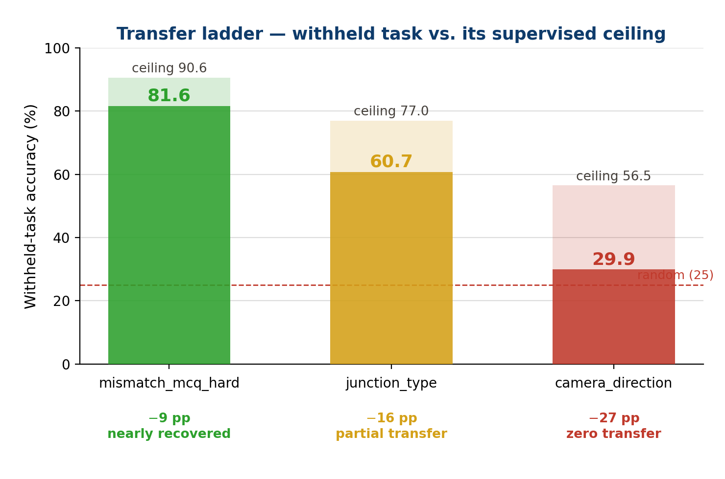
Figure 5. Transfer ladder. Each bar is a withheld task's accuracy (solid) against the ceiling reached when that task is supervised (faint). Within-family transfer nearly recovers the ceiling; cross-family transfer recovers part of it; camera_direction does not transfer at all.
Strong within-family transfer. When only the hard mismatch variants are withheld but the easy variants are kept (S-6), the model still reaches 81.6% on hard mismatch — just 9 points below the 90.6% ceiling. The easy and hard tasks share a geometric structure, and learning the easy version teaches most of what the hard version needs. Partial cross-family transfer. Urban tasks withheld from training but exposed only to geometry/mismatch supervision (S-1) recover roughly two-thirds of their ceiling — for example junction_type reaches 60.7% against a 77.0% ceiling (−16 points). Some urban competence is carried by the shared visual encoder and the demand to attend to layout, but not all of it. Zero transfer. camera_direction stays at chance (29.9% against a 56.5% ceiling, barely above the 25% floor) unless it is trained directly — no other task in the dataset supervises absolute camera orientation, so there is simply no source to transfer from.
Figure 6 shows the per-epoch view that underlies these conclusions: for the hard mismatch tasks, the run that keeps the easy variants (brown) tracks high and stable, while the runs that withhold the whole family (green/orange) sit near chance; for camera_direction every withholding run is pinned to the random line across all epochs. The ablations thus map out which urban abilities a VLM can acquire by analogy and which require explicit supervision — a practically useful result for anyone deciding how to spend annotation budget on a new geospatial task.
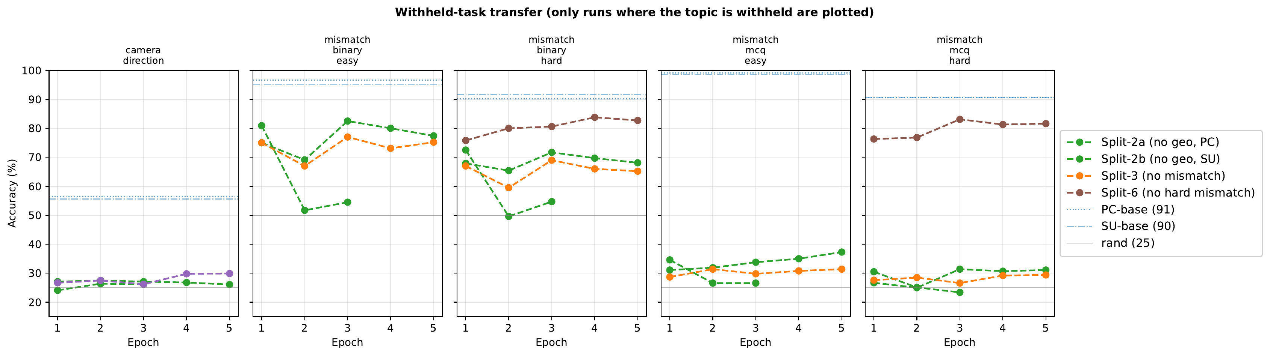
Figure 6. Per-epoch accuracy on each withheld task, plotting only the runs in which that task is withheld. Easy→hard transfer is strong (mismatch_*_hard panels); camera_direction and fully-withheld mismatch_mcq stay at the random line regardless of epoch.

Interpreting accuracy against per-topic baselines
Because every answer is OSM-derived, a few topics have naturally compact answer spaces — most road surfaces are asphalt, and accessible green space is a near-binary judgement — so a strong category prior already carries them. We therefore report every topic against both a random and a majority-class baseline rather than against chance alone, which is the conservative way to read the table: the quantity of interest is each model's margin over the majority baseline, not over the 25% floor. Two topics, green_space and road_surface, sit close to that majority ceiling for all models (Figure 7) and so speak more to prior knowledge than to perception; we keep them in the corpus for completeness but do not lean on them when characterising visual ability. This per-topic accounting is also what lets us be confident about the tasks that matter most: camera_direction and the hard mismatch variants have flat majority baselines and cannot be answered from the option text, so the model's gains there are clean evidence of genuine cross-view reasoning rather than memorised priors.
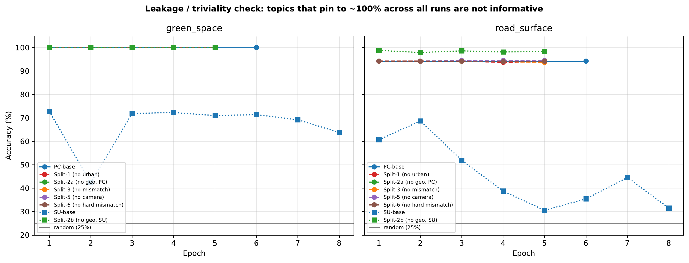
Figure 7. Per-topic accuracy against the majority-class baseline. green_space and road_surface sit near their majority ceiling for every model (curves overlap at the top), so they are interpreted as prior-driven and are reported for completeness rather than as evidence of perception. The lower SU-base curve on road_surface reflects a cross-city distribution shift.

Summary of results
In aggregate: a 4B VLM adapted with LoRA on OELLM beats every open VLM we compared against, including models three times its size; the small PC↔SU gap shows the learned urban competence generalises across geography; the ablations reveal a clean hierarchy of transferability from within-family (near-complete) through cross-family (partial) to camera orientation (none); and the per-topic baseline accounting confirms that the gains on the cross-view and semantic tasks reflect genuine perception. Taken together these results validate the approach and point to clear, incremental refinements for future work.
The Impact and Future Directions ( / 15 Points)
Explain the potential (or current if exist) impacts of your outcome in terms of how the methods and results will be used in real life, how it will change an existing process, or where it will be published, etc. Also, explain what would be the next step if the project is continued in the future, what kind of qualitative and/or quantitative updates can be made, shorty, where this project can go from here? This section should be between 250-500 words.

Impact
OELLM delivers three reusable artifacts: a deterministic, reproducible multi-city satellite/street-view VQA corpus; a pair of compact trained models that set a strong open baseline for urban VLMs; and an evaluation harness that scores any VLM against honest per-topic floors. Practically, a 4B model that runs on a single GPU yet beats 12B general-purpose VLMs lowers the barrier to automated urban analytics — screening land use, building stock, road class, green-space access or transit provision directly from imagery, at city scale and at a fraction of the cost of manual survey or larger proprietary models. Because every label is OSM-derived and the pipeline is bit-exact regenerable, the dataset can be refreshed as OSM and imagery evolve, and extended to a new city by editing a single configuration entry. Methodologically, the ablation study contributes a transferability map — which urban abilities a VLM acquires by analogy and which need explicit supervision — that can guide where future annotation effort is best spent. The model adapters, dataset and benchmark are prepared for public release alongside this report, with a poster summarising the work, contributing an open, reproducible reference point for the emerging area of geospatial vision-language modelling.

Future directions
The clearest next step is a second-generation dataset that further tightens dataset balance: broadening the answer spaces of the prior-heavy topics (green_space, road_surface) so that every question rewards perception, enlarging the inter-split geographic margin, and continuing to report results net of per-topic majority baselines so the vision-grounded signal is unambiguous. On modelling, the natural progression mirrors the urban-VLM literature: add a reinforcement-learning stage with verifiable rewards, as in CityRiSE [3], to elicit explicit cross-view reasoning and lift the tasks that currently resist transfer — above all camera_direction and the hard mismatch variants. Further avenues include scaling beyond 40 cities for broader geographic coverage; extending the taxonomy toward the socio-economic indicators of CityLens [2] so the model becomes a genuine "urban scientist" rather than only a perceptual one; replacing the four discrete headings with panoramic or denser street-level inputs; and distilling the LoRA-adapted model into a deployable, quantised form for edge inference. Each of these is incremental on the existing pipeline, which is the principal value of having built the data generation and evaluation infrastructure end-to-end.

References
[1] J. Feng et al., "UrbanLLaVA: A Multi-modal Large Language Model for Urban Intelligence with Spatial Reasoning and Understanding," ICCV 2025. arXiv:2506.23219.
[2] T. Wang et al., "CityLens: Evaluating Large Vision-Language Models for Urban Socioeconomic Sensing," ICLR 2026. arXiv:2506.00530.
[3] Authors of CityRiSE, "CityRiSE: Reasoning Urban Socio-Economic Status in Vision-Language Models via Reinforcement Learning," 2025. arXiv:2510.22282.
[4] S. Zhu, T. Yang, and C. Chen, "VIGOR: Cross-View Image Geo-localization beyond One-to-one Retrieval," CVPR 2021. arXiv:2011.12172.
[5] S. Lobry, D. Marcos, J. Murray, and D. Tuia, "RSVQA: Visual Question Answering for Remote Sensing Data," IEEE Transactions on Geoscience and Remote Sensing, 2020. arXiv:2003.07333.
[6] K. Kuckreja et al., "GeoChat: Grounded Large Vision-Language Model for Remote Sensing," CVPR 2024. arXiv:2311.15826.
[7] S. Workman, R. Souvenir, and N. Jacobs, "Wide-Area Image Geolocalization with Aerial Reference Imagery," ICCV 2015 (CVUSA dataset); L. Liu and H. Li, "Lending Orientation to Neural Networks for Cross-view Geo-localization," CVPR 2019 (CVACT dataset).
[8] Qwen Team, "Qwen2.5-VL Technical Report," 2025. arXiv:2502.13923 (Qwen-VL family of open vision-language models).
[9] E. J. Hu et al., "LoRA: Low-Rank Adaptation of Large Language Models," ICLR 2022. arXiv:2106.09685.
[10] Mistral AI, "Pixtral 12B," 2024. arXiv:2410.07073.
[11] B. Li et al., "LLaVA-OneVision: Easy Visual Task Transfer," 2024. arXiv:2408.03326.
[12] Gemma Team, Google DeepMind, "Gemma 3 Technical Report," 2025. arXiv:2503.19786 (multimodal Gemma models).
[13] Meta AI, "The Llama 3 Herd of Models" (Llama-3.2 Vision), 2024. arXiv:2407.21783.
[14] OpenStreetMap contributors, OpenStreetMap, https://www.openstreetmap.org, data © OpenStreetMap contributors, ODbL.
[15] D. Han, M. Han, and Unsloth team, "Unsloth: 2× faster, memory-efficient LLM/VLM fine-tuning," https://github.com/unslothai/unsloth.

