CodingLab
  - A Coding Practice Platform for University Students
Final Project Report
SWE 4404: Software Project Lab II
Islamic University of Technology (IUT)
Organisation of Islamic Cooperation (OIC)
Department of Computer Science and Engineering
Group 10
Team member | Student ID
Rakibur Rahman Ananta | 230042128
SM Raiyan Al Arafat | 230042134
Nafian Nazat Mahid | 230042144

Supervisor: Samia Nawsheen, Junior Lecturer, Department of CSE, IUT
Repository: https://github.com/EarthBoundBroccoli/CodingLab
Report evidence date: 31 October 2026
Implementation reviewed: local revision 2b10da7, including the application changes through dbc66d0. Repository links for implementation evidence use dbc66d0 and its original src/ paths; the same application files now reside under code/. The subsequent commits reorganize and clean the repository.

Table of Contents

List of Figures
Figure 1. Implemented system architecture from the final presentation.
Figure 2. Original context-level data-flow diagram.
Figure 3. Original collection and data-flow design.
Figure 4. Original entity-relationship diagram.
Figure 5. Original problem-approval process.
Figure 6. Original code-execution process.
Figure 7. Original role-change process.
Figure 8. Original contest-management process.
Figure 9. Team responsibility allocation from the final presentation.

1. Executive Summary
Learning programming requires more than understanding a lecture or reading a solution. Students need regular opportunities to solve problems, find out why their programs fail, and see whether their skills are improving. In a university setting, these activities can become fragmented across programming environments, problem websites, contest systems, and informal progress records. CodingLab brings the main activities together in a browser-based platform intended for university students.
A student signs in, chooses a problem, writes a solution in an editor on the same page, and submits it for evaluation. The platform sends the program to an external execution service and compares its output with the problem's expected results. The student receives a result such as Accepted, Wrong Answer, or Time Limit Exceeded. These results help students decide whether to correct their logic, improve their algorithm, or investigate a compilation error. Saved submissions and progress charts make practice visible over time.
CodingLab also provides a controlled way to maintain the problem collection. Approved problem setters can submit new exercises with descriptions, sample cases, hidden tests, and execution limits. Administrators review submissions, manage user access, decide applications for the problem-setter role, and organize timed contests. Contest standings, individual ratings, and university leaderboards add a competitive element, while growth statistics keep attention on personal improvement.
The implemented system uses a React interface, a Node.js/Express application server, and MongoDB for persistent records. Better Auth manages sign-in sessions, JDoodle executes submitted programs, and Cloudinary stores uploaded test-case files. These components allow a three-member team to build the essential workflow without operating its own compiler infrastructure. The design also introduces dependencies on network availability, external quotas, and correct service configuration.
The final reviewed application supports authenticated practice, C++, Java and Python editing and judging, moderated problem publication, contest participation, rating updates, growth tracking, recent submission review, profiles, notifications, and support workflows. Verification recorded 269 passing backend tests and 39 passing frontend tests, with no failures or skipped tests, and a successful production frontend build. These results demonstrate the behavior covered by the tests; they do not establish production-scale capacity, measured learning gains, or continuous availability.
Some original requirements remain incomplete. Bookmarks and dedicated setter analytics are absent. Full problem editing, rejection feedback, email notifications, and some profile-security controls require further work. The original five-second verdict target, support for more than 100 simultaneous users, and 99.9% contest-hour availability have not been demonstrated. CodingLab is therefore a functioning academic project with a tested core workflow and a clearly identified path toward a more complete production service. [R1–R4]

CO6 self-assessment
Can the project be communicated effectively to a non-technical audience without unexplained jargon? Yes. The overview describes the student's actions, the feedback received, and the responsibilities of setters and administrators before naming implementation technologies. The glossary defines specialist terms, and Section 11 distinguishes implemented results from future work.

2. Problem Domain and Background

2.1 Domain, users, and problem statement
CodingLab belongs to the domain of educational programming practice and online judging. Its intended users are university students who need structured practice, students approved to contribute exercises, and administrators who maintain the quality and fairness of the platform. The supplied design identifies curriculum-oriented practice as the motivation. The current implementation supports topics and difficulty levels, but it does not implement formal course enrollment, syllabus mapping, assignment grading, or a learning-management-system integration. [R1, R2]
The project addresses three connected needs. First, students need a short path from reading a problem to testing a solution. Second, they need consistent records of attempts and progress rather than relying on memory or disconnected screenshots. Third, a university community needs mechanisms for admitting content contributors, reviewing exercises, and organizing contests. A working solution must connect these needs while protecting account permissions, hidden tests, and contest results.
Stakeholder | Primary need | Project response
Student | Practice and understand mistakes | Searchable problems, editor, run/submit actions, verdicts, saved attempts
Student | Understand improvement | Solved counts, difficulty breakdown, activity history, progress charts
Problem setter | Contribute suitable exercises | Role application, structured creation form, administrator review
Administrator | Maintain trustworthy content and access | Review queues, role decisions, account moderation, contest management
University community | Compare participation and performance | Campus and university rankings based on eligible contest-rated users
Maintainer | Diagnose failures and evolve the system | Layered modules, automated tests, Git history, environment templates

2.2 Fundamental concepts
Concept | Why it matters | Concrete implementation evidence
Functions and modular decomposition | Keep display, request handling, judging and storage responsibilities understandable | React components; controller modules; services/judgingService.js
Arrays, maps and sets | Represent test batches, participants, identity lookups and unique solved problems | inputsArray/outputsArray in judging; Map and Set in contestRatings.js
Sorting and ranking | Produce stable standings and consistent ties | contestStandings.js and leaderboard.js
Binary search and probability | Estimate performance relative to contest opponents | getPerformanceRating and getWinProbability in eloCalculator.js
Database schemas, references and indexes | Persist related entities and support efficient access | models/Submission.js, Notification.js and StudentStats.js
Transactions and concurrency | Prevent partial updates and duplicate scoring | withSubmissionTransaction and processContestRatingsAtomic
State transitions | Restrict when problems, applications and contests can change | pending/approved/rejected problems; pending/accepted/rejected applications; contest lifecycle
Validation and access control | Keep malformed or unauthorized requests from changing records | middleware/auth.js, accountAccess.js, schedule and pagination validation
Asynchronous programming | Coordinate network requests without treating an unfinished request as a completed result | async/await controllers, fetch cancellation, service timeouts

2.3 Specialist knowledge
Online judging requires distinguishing compilation failure, runtime failure, incorrect output, excessive time, and excessive memory. A single generic error is insufficient because each result suggests a different corrective action. CodingLab's judging service normalizes line endings and outer whitespace, uses language-specific wrappers, and interprets execution diagnostics. Its batch delimiter and wrappers also impose limitations that require testing with realistic programs.
Contest engineering adds timing, eligibility, tie handling, and repeat-submission problems. The implementation ranks by score and penalty, prevents repeated accepted solutions from adding a second solve, and records contest ratings once. Identity handling is also important: Better Auth identifiers and legacy MongoDB identifiers must refer to the same person without creating duplicate progress records.
Educational feedback requires distinguishing effort from achievement. Repeated accepted submissions can count as activity without becoming additional distinct problems solved. The growth utilities and tests enforce this distinction. The system therefore combines general software concepts with domain-specific judging, competition, and learning-progress rules. [R4, R5]

CO1 self-assessment
Can the underlying programming, data-structure, database and design concepts be explained? Yes. Section 2.2 connects each concept to a named implementation location. Can relevant specialist knowledge be identified and justified? Yes. Section 2.3 explains why verdict interpretation, contest consistency, identity resolution and distinct-solve accounting are necessary for this particular application.

3. Literature and Existing Solutions

3.1 Review of existing approaches
The review considers three established approaches: competitive contests, topic-based practice, and course-organized exercises. It evaluates their relevance to CodingLab rather than claiming that a small academic project replaces their scale or maturity.
Source or solution | Relevant observed approach | Lesson for CodingLab | Project distinction
Codeforces contest catalogue [R6] | Upcoming and past competitive rounds | Treat scheduling, participation and standings as connected workflows | CodingLab combines contests with local content moderation, growth tracking and campus rankings
HackerRank practice catalogue and challenge guidance [R7] | Practice organized by programming topics and concepts | Make discovery and feedback accessible to learners | CodingLab gives approved community setters and administrators a local content workflow
CS50 problem sets [R8] | Exercises organized as a course sequence | Practice benefits from a clear learning context | CodingLab is a reusable platform rather than one course's exercise sequence; formal syllabus mapping is future work

The comparison is qualitative. No controlled usability study, performance comparison, or learning-outcome experiment against these services was supplied. It does not imply that the existing services lack features beyond those discussed here.

3.2 Technical sources and their influence
React's component guidance explains a way to divide an interface into focused components and connect them through data flow. CodingLab applies that approach to its pages, shared editor components and growth widgets. The large components reported in Section 6 indicate where this separation should be improved. [R9]
MongoDB's transaction documentation explains why related writes sometimes need to succeed or fail together. This is relevant to contest scoring, rating histories and role decisions. The project uses Mongoose transaction calls for these operations; its deployment must provide a MongoDB topology that supports them. [R10]
Better Auth documents its email/password authentication capability. CodingLab enables this capability and configures Google and GitHub providers. Library support alone does not demonstrate that every account-security requirement has been implemented; application configuration and deployment remain part of the assessment. [R11]

3.3 Relationship to the submitted SRS
The supplied SRS is a requirements-and-user-story table. It does not contain a literature-review section or citations demonstrating an earlier comparison of alternatives. This report supplies that missing discussion and connects it to the original problem statement. The project builds on established practice and contest patterns while emphasizing a university community, reviewed content, and personal growth. That is the intended contribution, not a claim of a novel judging algorithm.

CO2 self-assessment
Does the SRS discuss prior solutions or credible technical sources and explain the distinction? Not in the supplied SRS artifact. Sections 3.1–3.3 address this documentation gap using official sources and a bounded comparison. The source SRS should be read as the requirements baseline, with this report providing the supporting review.

4. Requirements (SRS Session)

4.1 Baseline and interpretation
The original identifiers FR-01 through FR-22 are retained throughout the report. The SRS contains user stories with acceptance criteria and historical status labels. Those labels are not assumed to describe the final code: some items marked “In Progress” are now implemented, while some marked “Done” contain acceptance criteria that remain incomplete. The six non-functional requirements are taken from physical page 13 of design.pdf. [R1, R2]
Functional requirements describe actions and services. Non-functional requirements describe qualities such as response time, security, usability and availability. Stakeholder traceability identifies why each requirement matters; Section 11 separately evaluates completion against the implemented system.

4.2 Functional requirement traceability
ID | Requirement | Stakeholder need | Implementation or verification anchor
FR-01 | Registration and authentication | Students and admins need controlled account access | Auth.jsx; lib/auth.js; adminAuthorization.test.js
FR-02 | Discover and filter problems | Students need suitable exercises | Problems.jsx; problemController.js; publicProblems.test.js
FR-03 | Browser editor | Students need to write code within the problem page | WorkspaceEditor.jsx; useProblemEditor.js
FR-04 | Submit and receive verdicts | Students need automated correctness feedback | judgingService.js; submissionPersistence.test.js
FR-05 | Progress dashboard | Students need visible learning progress | Growth.jsx; growth-progress.test.js
FR-06 | Submission history | Students need to review earlier attempts | SubmissionHistory.jsx; recent-submission API
FR-07 | Bookmarks | Students need to save exercises for later | No bookmark model, route or page found
FR-08 | Leaderboard | Students need comparable performance records | leaderboard.js; leaderboard.test.js; scoring policy changed
FR-09 | Create and manage problems | Setters need to contribute and maintain content | AddProblem.jsx; creation endpoint; management incomplete
FR-10 | Submit and track review | Setters and admins need controlled publication | pending creation and administrator queue
FR-11 | Moderate with feedback | Admins need quality control; setters need correction guidance | updateProblemStatus; feedback workflow incomplete
FR-12 | Topic tags | Setters classify exercises; students find topics | Problem schema; AddProblem.jsx; Problems.jsx
FR-13 | Difficulty levels | Students need an appropriate challenge level | Easy/Medium/Hard schema and filtering
FR-14 | Setter analytics | Setters need evidence about their content | Dedicated setter analytics not found
FR-15 | Contests | Admins organize events; students compete fairly | contestController.js; schedule and registration tests
FR-16 | Notifications | Users need timely decisions and event information | Notification model; Inbox.jsx; reminder tests
FR-17 | Role requests | Students need a reviewed path to become setters | setterController.js; setter decision/reapplication tests
FR-18 | Problem details and samples | Students need clear task expectations | ProblemWorkspace.jsx; publicProblem.js
FR-19 | Profiles and updates | Students need an accurate identity and history | Profile.jsx; Settings.jsx; userSettings.test.js
FR-20 | Compilation diagnostics | Students need actionable error feedback | judgingRuntime.js; runtime and judging tests
FR-21 | Admin difficulty review | Admins need consistent classification | Difficulty visible; overwrite workflow absent
FR-22 | Time-limit feedback | Students need to identify inefficient solutions | judgingService.js; executionTimeout.test.js

4.3 Non-functional requirements and evidence
ID | Original target | Observed evidence | Assessment and acceptance work remaining
NFR-01 | Verdict within 5 seconds | External judging request has a 30-second timeout; remote test retrieval has 15-second timeouts | Not demonstrated. Measure end-to-end latency by language and input size; report percentiles, not only averages
NFR-02 | Concurrent submissions from 100+ users | Concurrency regression tests exercise duplicate and racing writes using controlled test doubles | Capacity unverified. Run a staged load test with quota-aware external-service handling
NFR-03 | Hashed passwords and 30-minute session timeout | Better Auth email/password integration; role and account guards | Partial. No explicit 30-minute expiry configuration was found; verify hashing behavior and session policy in deployment
NFR-04 | Intuitive navigation for all roles | Role-specific pages, editor, labels and feedback controls | Implemented design intent; no formal usability/accessibility study supplied
NFR-05 | 99.9% uptime during contests | Server starts even when database connection fails; failures have response paths | Availability unverified. Process startup is not service readiness; monitoring and outage evidence are needed
NFR-06 | Modular extension to Java and Python | Language configuration and wrappers already support C++, Java and Python | Implemented for these languages; each additional language still requires wrapper and regression work

4.4 Main use cases
The supplied materials include user stories and process diagrams rather than a separate complete use-case specification. The following use cases consolidate that evidence and describe the reviewed implementation.
Use case | Actor and precondition | Main flow | Failure or alternate flow | Result
UC-01 Authenticate | Visitor with credentials or configured provider | Submit login; validate session; open permitted pages | Invalid credentials, unavailable provider or blocked account denies access | Authenticated identity, FR-01
UC-02 Practice a problem | Signed-in student; approved problem | Read samples; edit code; run custom input; submit; view verdict | Invalid language, execution failure or timeout produces an error; a service timeout is not scored | Submission and applicable progress saved, FR-02/03/04/18/20/22
UC-03 Contribute a problem | Approved problem setter | Enter statement and tests; upload hidden data; create pending problem | Missing fields or unsuitable sample count rejected | Problem awaits review, FR-09/10/12/13
UC-04 Review a problem | Authenticated administrator | Open review queue; inspect details; approve or reject | Invalid decision or missing problem rejected | Publication status updated, FR-10/11
UC-05 Become a setter | Active student | Apply; administrator decides; record decision and notify applicant | Duplicate pending application blocked; rejected student may reapply | Role changes only after approval, FR-17
UC-06 Compete | Active student; eligible contest | Register; submit selected problems during the time window; view standings | Closed contest, unregistered user or unrelated problem rejected | Scores and finalized rating history, FR-15
UC-07 Review growth | Signed-in student | Open growth/profile; inspect first solves, activity and recent code | Empty history displays a zero-data state | Understand progress without fabricated activity, FR-05/06/19

4.5 Context and sustainability
The intended setting includes students with different skill levels and network conditions. The browser editor reduces local setup, but internet access and a usable device remain necessary. Plain descriptions, examples, readable errors and visible empty states reduce ambiguity. English is the current interface/documentation language; multilingual explanations and formal accessibility testing are future improvements.
Educational access is consistent with the intent of Sustainable Development Goal 4, but no measured social impact is claimed. Shared external execution and batched tests may reduce repeated service requests. This is a resource-use design choice, not a measured reduction in energy or emissions. Quotas, data retention and unnecessary resubmissions should be considered before wider deployment.

4.6 SRS-session feedback and resulting development priorities
No dated SRS-session minutes or signed feedback record accompanies the submitted artifacts. The defensible account is therefore a trace of requirements into subsequent work: secure authentication was implemented early; a growth dashboard connected practice to visible progress; and ranking evolved into contest-rating and university/campus views. Commits 15585d0, 72fb92f, bc8b3bc, 8ebf9d8 and 9226ca1 support that progression. These changes can be discussed as project review priorities, but the repository does not establish who requested them or at which formal session. [R4, R5]

CO2 self-assessment
Are functional and non-functional requirements distinguished and traceable to stakeholder needs? Yes. Sections 4.2 and 4.3 separate user actions from quality targets, retain source identifiers, and connect them to stakeholder needs and implementation evidence. Section 11 prevents traceability from being mistaken for complete satisfaction of every acceptance criterion.

5. System Design (Design Session)

5.1 Architecture and responsibilities
CodingLab uses a three-layer application structure. The presentation layer contains React pages and shared components. The application layer exposes HTTP routes, checks access, coordinates domain operations, and calls external services. The data layer uses Mongoose models and the Better Auth MongoDB adapter. The application is a modular server, not a collection of separately deployed microservices.
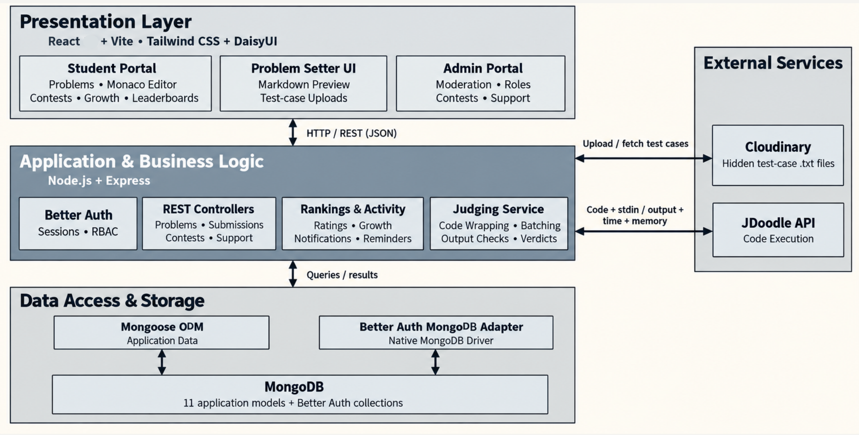
Figure 1. Implemented system architecture. Source: final-presentation.pdf, physical page 6. The source diagram describes 11 application model definitions; this does not establish that all 11 are actively used. In particular, the legacy UserStats definition in Leaderboard.js is distinct from the current StudentStats-based ranking path.
The separation serves stakeholder needs directly. Students interact with the editor and results; they do not receive hidden test data. Administrators use controlled endpoints rather than direct database access. External execution happens before submission persistence so a database retry does not automatically execute the student's program again. Shared ranking and activity utilities keep values consistent across pages. [R3, R4]

5.2 Context, data flow and entity relationships
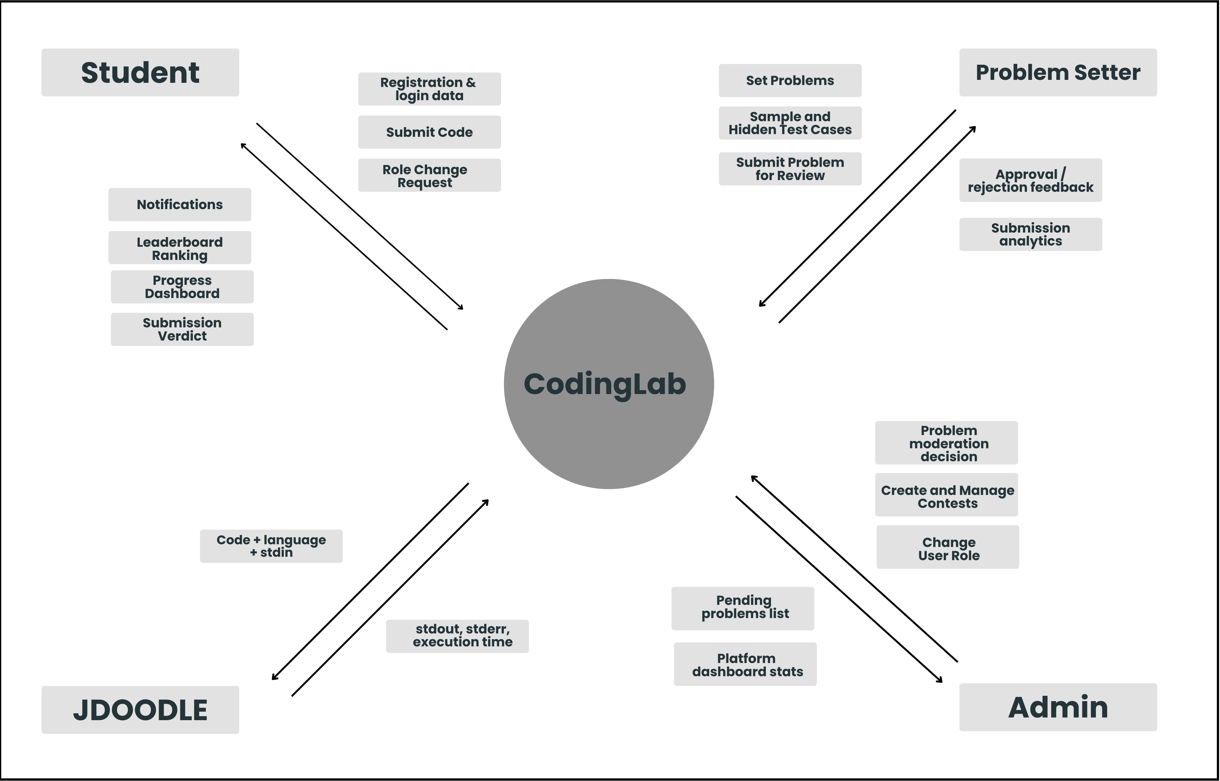
Figure 2. Original context-level data-flow diagram. Source: design.pdf, physical page 5. This is the intended design: setter analytics shown here are not implemented, and current capabilities must be read with Section 11.
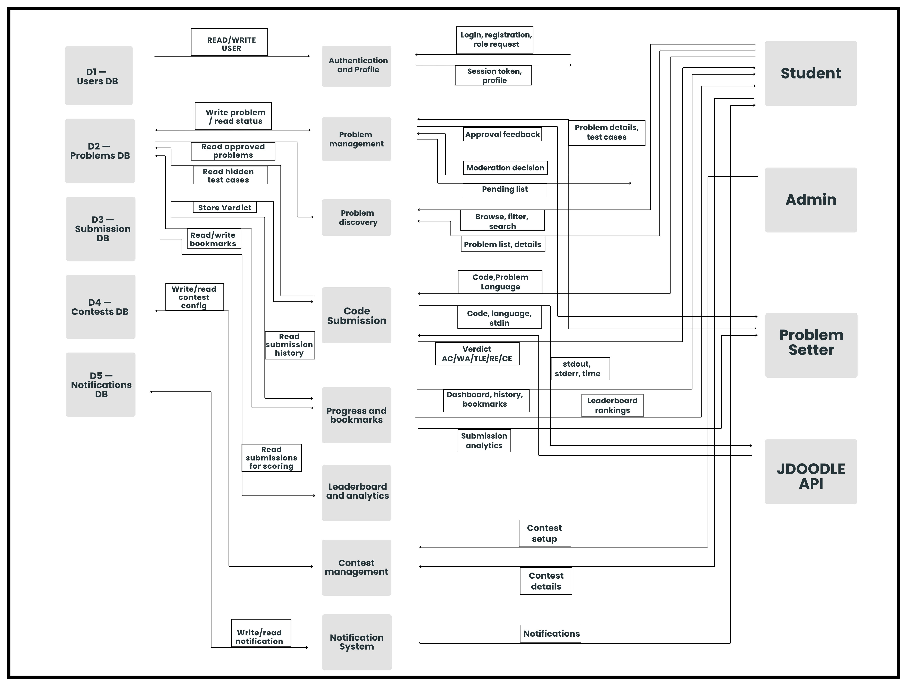
Figure 3. Original collection/data-flow design. Source: design.pdf, physical page 6. The diagram records the design-stage separation of users, problems, submissions and contests. The implemented authentication collections and additional entities are described below.
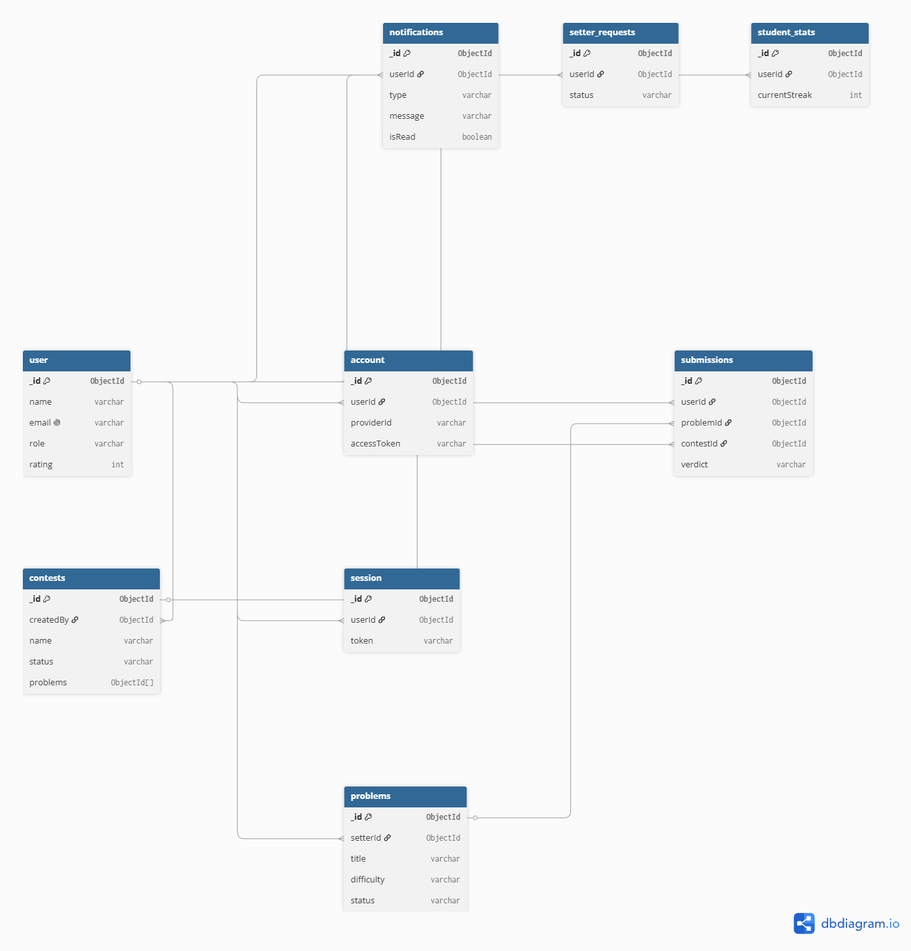
Figure 4. Original entity-relationship diagram. Source: design.pdf, physical page 7. Relationships are logical references, not SQL-enforced foreign keys. The current implementation adds universities and support records and permits multiple historical setter applications for one user.
Entity/model | Important fields | Relationships and design purpose
User | name, email, role, image, university, banned, disabledAt | Central identity; Better Auth fields coexist with application profile/access data
Problem | title, statement, difficulty, tags, samples, hiddenInput, hiddenOutput, setterId, status | Setter creates content; samples are public and hidden tests remain server-side
Submission | userId, problemId, contestId, code, language, verdict, timeTaken, memoryUsed | Each attempt links a user and problem; contestId is optional for practice
Contest | startTime, endTime, problems, participants, ratingsCalculated | Embeds participation and score state; references approved problems
StudentStats | userId, solvedProblems, attemptedProblems, activityHistory, contestRating, ratingHistory | Per-user aggregation; userId is unique; rating history identifies contests
University | name, shortName, totalRating | Institution identity used by campus and university ranking queries
SetterRequest | userId, qualifications, status, decisionReason, decidedAt, decidedBy | Historical application decisions; reapplication does not erase a rejection
Notification | userId, title, message, note, type, isRead, contestId | Private event information and optional navigation to a contest
SupportRequest | name, email, message, optional userId, status | Public contact workflow with resolution metadata
SupportTicket | userId, subject, message, status, adminReply | Authenticated support workflow with ownership checks
Better Auth account/session records | Authentication-provider and session data | Managed by the authentication library, not by custom password fields in User.js

Submission indexes include problem/user and contest lookup paths; notifications index user and creation time. User emails and StudentStats user identifiers are unique. MongoDB references require application-level validation. In particular, the code resolves both authentication IDs and legacy database IDs rather than assuming that every user identifier can be converted into an ObjectId.
The ER diagram's one-to-one setter-request description is superseded by the reapplication workflow: one user can have multiple historical requests, while the application prevents another pending request. Similarly, “all relationships use ObjectId” is not true of the implemented schemas; several user references are strings.

5.3 Process designs and implementation qualifications
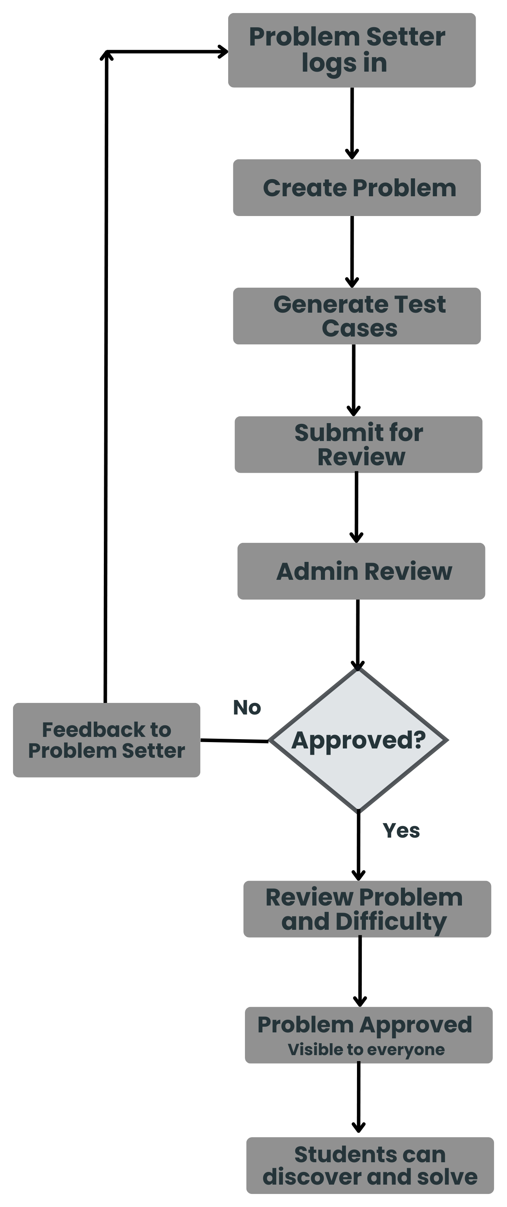
Figure 5. Original problem-approval process. Source: design.pdf, physical page 9. In the implementation, setters supply test data and new problems are saved as pending. Automatic test generation, persistent drafts, setter editing/resubmission, rejection-feedback delivery and administrator difficulty override are not demonstrated.
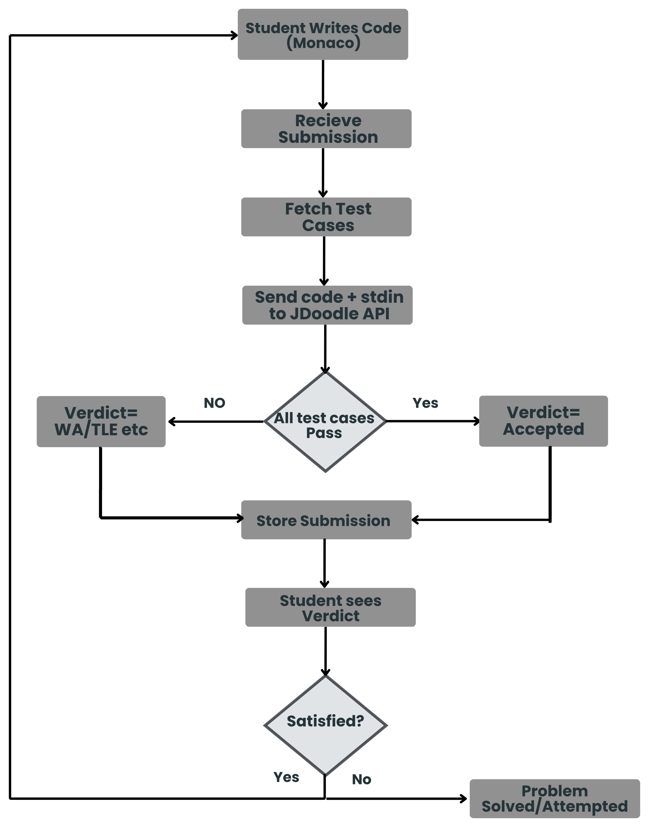
Figure 6. Original code-execution process. Source: design.pdf, physical page 10. The implemented service batches hidden cases, distinguishes compilation/runtime/resource failures, and persists the result transactionally with applicable statistics. Dedicated setter analytics at the end of the original diagram remain future work.
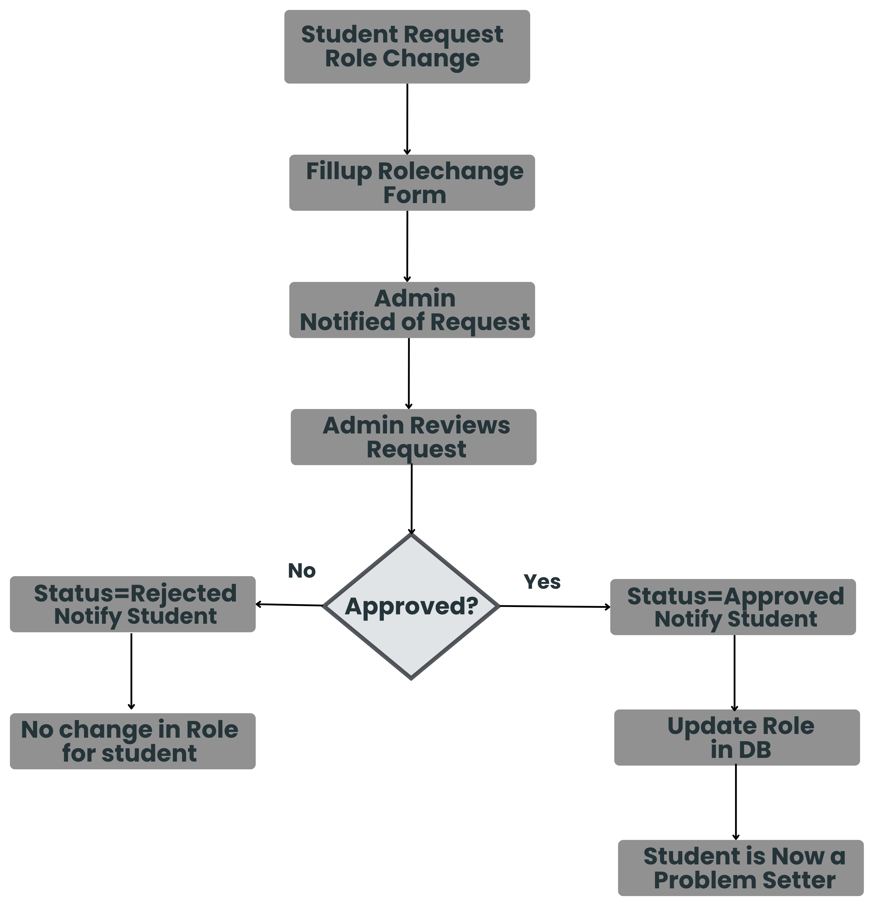
Figure 7. Original role-change process. Source: design.pdf, physical page 11. Approval, rejection and applicant notifications are implemented. The diagram's administrator notification and accompanying text's email delivery are not established by the reviewed code.
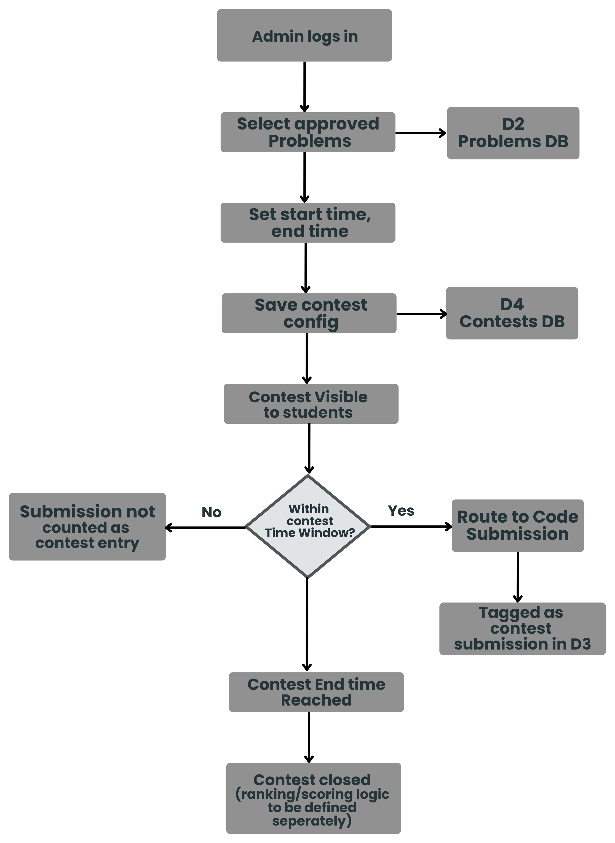
Figure 8. Original contest-management process. Source: design.pdf, physical page 12. The implementation additionally checks registration, validates selected approved problems, prevents changes to finalized rounds, and finalizes ratings in chronological order.

5.4 Design alternatives and rationale
The following comparisons are retrospective engineering evaluations of the implemented choices; no dated alternatives-decision record was supplied.
Decision | Selected approach | Plausible alternative | Justification and trade-off
Application organization | React client and modular Express server | Microservices with a message broker | One server simplifies debugging and integration for three developers; independent scaling and fault isolation are more limited
Persistence | MongoDB with schemas and embedded participant data | PostgreSQL with normalized tables and foreign keys | Document shapes suit samples and contest participants; application validation and transaction-capable deployment are essential. SQL would offer stronger relational constraints
Code execution | JDoodle compiler API | Self-hosted isolated judge workers | External execution reduces compiler/sandbox maintenance; latency, quota, privacy and vendor dependence remain. Self-hosting gives control but adds substantial security and operational work
Standings updates | HTTP polling every ten seconds | WebSocket or server-sent event updates | Polling is simpler to operate and adequate for a small demonstration; it adds repeated reads and up to a polling interval of visible delay
Test-case storage | Cloudinary raw-file upload | Private object storage with signed URLs | Reuses an existing upload integration; access control, URL disclosure and lifecycle policies need hardening for sensitive tests

Against stakeholder needs, these choices favor a usable end-to-end demonstration and manageable lifecycle effort. Against scalability and resource use, the main limitations are external judge capacity, repeated polling, growing embedded arrays, and expensive aggregate queries. The selected architecture leaves room to introduce a queue, stronger storage controls, or a different persistence strategy when usage justifies them.

5.5 Design-session feedback and changes
No dated design-session feedback record is supplied. The artifacts show a verifiable evolution: the original diagram contains broad services and planned modules; the final architecture and code use concrete controllers, a shared judging service, shared editor components, and separate ranking/activity helpers. Commit 40a8938 records judging/editor refactoring, while the rating and authorization tests substantiate additional consistency boundaries. These are observable design improvements, not attributed quotations from a supervisor. [R2–R5]

CO3 self-assessment
Does the design include a justified architecture and appropriate models traced to the SRS? Yes, with the stated qualifications. Figures 1–8, the entity table, and the requirement anchors describe the architecture and model relationships while identifying outdated design claims. Were plausible alternatives compared against stakeholder needs, usability, scalability, resource use and lifecycle cost? Section 5.4 makes that comparison explicitly and explains the remaining trade-offs.

6. Implementation (Implementation Session)

6.1 Project structure
CodingLab/
README.md
doc/
srs.pdf
design.pdf
final-presentation.pdf
final-report-source.md
final-report.docx
code/
package.json shared development/build/test commands
package-lock.json
backend/
index.js HTTP application and route mounting
routes/ endpoint definitions
middleware/ identity and access checks
controllers/ request coordination
services/judgingService.js shared verdict evaluation
models/ Mongoose data definitions
utils/ ratings, standings, transactions, activity
lib/ authentication and external integrations
data/ starter problem definitions
scripts/ explicit problem import utility
tests/ backend regression suites
.env.example
frontend/
src/
App.jsx routing and page composition
pages/ student, setter and admin pages
components/ shared UI, growth and editor components
hooks/ editor, access, growth and pagination logic
lib/ HTTP, authentication and pure data helpers
assets/ runtime branding asset
public/ favicon
tests/ frontend logic tests
vite.config.js
eslint.config.js
.env.example
The file tree describes the working submission layout. A PDF should be exported from the completed Google Doc for classroom submission as doc/final-report.pdf. Dependencies and generated build files are excluded from version control; example environment files document configuration without publishing credentials.

6.2 Communication between components
React pages call HTTP endpoints and exchange JSON objects with Express. Routes direct a request to access checks and controllers. Controllers retrieve domain records, call shared services or utilities, and return a response. Mongoose serializes application records to MongoDB; Better Auth uses its own adapter for authentication state. JDoodle receives execution requests from the backend, and Cloudinary supplies uploaded hidden-test files.
The system predominantly uses functions, object literals and schema-defined documents, not a class hierarchy of domain transfer objects. The following “data classes” therefore describe the actual logical contracts rather than invented JavaScript classes.
Exchange | Key data | Boundary rule
Login/session | Credentials or provider flow; authenticated user/session | Session identifies the caller; ordinary signup cannot choose an administrator role
Problem read | title, statement, difficulty, tags, limits, sample input/output | Public projection excludes hiddenInput and hiddenOutput
Practice submission | problemId, code, language | Backend validates identity and approved problem before judging
Contest submission | contest ID in route; problemId, code, language in body | Must belong to a registered participant, active contest and selected problem
External execution | script, language, versionIndex, stdin and server-held service credentials | Credentials are backend configuration, not part of frontend responses
Judge result | verdict codes, timeTaken, memoryUsed, compilation/runtime diagnostics | Seconds are converted to milliseconds; memory is interpreted in KB against MB limits
Progress/profile | solved/attempted records, activity, difficulty counts, rating history | Distinct solves differ from repeated activity; private data requires careful projection
Moderation | decision/status and target ID | Administrator access is checked by shared middleware
Notification | title, message, type, isRead, optional contestId | Reads and mark-read updates are scoped to the authenticated user

For a scored submission, the controller first validates the request and loads the approved problem. The judging service fetches hidden cases if stored remotely, wraps the program for its language, and submits a batch to JDoodle. It normalizes output and determines a verdict. Persistence then runs inside a transaction so the attempt, progress and contest score cannot partially update. If the database retries a transaction, the already obtained judging result is reused. If judging times out, the controller returns an error and does not record a scored attempt. [R4]

6.3 Core algorithms and rules
Contest standings use descending score and ascending penalty, with shared competition ranks for ties. A first accepted solve adds 100 points and elapsed minutes; a non-accepted attempt on an unsolved problem adds 20 penalty minutes immediately. This is an ICPC-inspired policy, but it is not identical to classic ICPC accounting, which commonly associates wrong-attempt penalties with eventually solved problems. The report records the implemented rule rather than treating the SRS label as proof of exact equivalence.
Contest ratings start at 1000. The calculator estimates pairwise win probabilities, sums them into an expected rank, combines actual and expected rank using their geometric mean, and uses 40 binary-search iterations to estimate performance rating. It then applies a damped change and a population adjustment, with a lower rating bound of 1. This is an Elo-inspired contest rating algorithm, not a claim of exact equivalence to another platform's implementation. Pairwise rank estimation makes the calculation approximately quadratic in the number of participants, with a fixed search multiplier.
Finalization uses an atomic claim and a transaction to prevent duplicate rating changes. Earlier ended rounds are processed before later rounds. The university leaderboard totals the top ten eligible students' contest ratings; eligibility requires an actual finalized rated contest, not merely a default balance or standalone history entry. Banned, disabled and administrator accounts are excluded by the ranking policy.
Progress helpers build UTC-based daily records and distinguish first solves from repeat accepts. Recent history lets students inspect saved code and retry it. Dates displayed to the user can be localized, while daily activity calculations use a consistent UTC boundary. Regression cases cover empty histories, leap days, repeated submissions and invalid future timestamps.

6.4 Division of functions, methods and models
Controllers coordinate requests and responses; they delegate judging, identity resolution, ranking and transaction behavior to reusable modules. Models specify persistence structure and validation. React pages compose task-specific interfaces, shared components provide repeated visual behavior, and hooks manage reusable stateful logic. This division allows a judging change to affect both practice and contests and an editor change to affect both workspaces.
The only explicit custom class in the measured runtime source is JudgingConfigurationError. It carries an HTTP status and message for configuration or language errors. Mongoose model declarations are not counted as hand-written classes; React function components are counted as functions. This distinction is necessary to answer the course's class/method question accurately for a function-oriented JavaScript project.

6.5 Measured code size
Measurement | Count | Average lines | Maximum lines | Median lines
Functions and methods, including callbacks | 916 | 18.74 | 670 | 3
Explicit JavaScript classes | 1 | 7.00 | 7 | 7
Runtime JavaScript/JSX modules | 105 | 131.87 | 678 | 63

Total physical module lines in this scope: 13,846. Measurement date: 31 October 2026; source revision: 2b10da7. The parser identifies function declarations, expressions, arrow functions, object methods and class methods. Each span includes its opening and closing lines, comments, blank lines and JSX. Nested callbacks are counted separately, so summed function spans must not be interpreted as a non-overlapping source-line total.
The scope includes backend runtime JavaScript and frontend/src JavaScript/JSX. It excludes tests, dependencies, build output, CSS, seed.js, import scripts and build/lint configuration. The largest function is AddProblem at code/frontend/src/pages/AddProblem.jsx:7 (670 lines). Other large components include AdminDashboard (553 lines), AdminContests (537) and AdminProblemRequests (482). The explicit class is JudgingConfigurationError in services/judgingService.js (7 lines).
Presentation page 7 reports 911 functions, 104 modules and 13,802 source lines. Those are preserved as earlier presentation figures; this report uses the freshly measured values and an explicit counting definition. Long JSX components inflate physical span, but they still represent maintenance work. Further decomposition of forms, tables and dialogs is justified; the average alone should not hide the largest components.

6.6 Refactoring and implementation evolution
Change | Reason and effect | Version-control evidence
Shared judging service | Consolidates practice and contest evaluation; avoids duplicated verdict logic | 40a8938
Shared editor components and hook | Reuses editor state, actions and preferences across workspaces | 40a8938
Transactional scoring and rating safeguards | Prevents repeated requests and concurrent writes from corrupting statistics | 3b5d58c; 7f4c3fd; related persistence tests
Support ownership and admin checks | Prevents supplied identities or stale privileges from granting access | e17e6cb
Execution timeouts and atomic announcements | Makes service failure explicit and links contest creation with announcements | a00f60e
C++ wrapper fixes | Corrects execution behavior in the judging path | 287f7a4
Avatar persistence and editor-option cleanup | Aligns displayed settings with persisted and supported behavior | dbc66d0

These are documented implementation changes. The exact Implementation-session date was not provided, so they cannot all be labelled “after the session” with certainty. They provide the evidence for the refactoring discussion without inventing a session chronology.

CO1 and CO3 self-assessment
How do the fundamentals from Section 2 appear in code? Sections 6.2–6.3 show arrays for test batches, maps for identity resolution, sorting for standings, binary search for rating estimation, schema validation, and transactions for consistent persistence. Does implementation follow the design? It retains the three layers and central use cases, while justified additions include shared judging/editor modules and atomic persistence. Missing planned modules and changed ranking rules are explicitly recorded rather than concealed.

7. Tools, Version Control, Testing, and CI/CD

7.1 Tools and alternatives
Versions below are selected resolved versions from the committed lockfiles, not merely version ranges in package.json.
Tool | Resolved version | Purpose and choice | Alternative and limitation
React / React DOM | 19.2.6 | Component-based browser interface | Vue is plausible; React requires deliberate state/effect discipline
Vite | 8.3.4 | Development server and production bundle | A full-stack framework could unify routing/deployment; this project retains a separate API
Express | 5.2.1 | Lightweight HTTP routing and middleware | NestJS provides stronger conventions but more framework structure
Mongoose | 9.11.2 | Document schemas and database integration | SQL ORM with PostgreSQL offers relational constraints; MongoDB references need validation
Better Auth | 1.7.10 | Sessions and authentication providers | Custom authentication adds security/maintenance burden; library defaults still need review
Monaco React integration | 4.7.0 | Browser code editor | CodeMirror is an alternative; editor payload and accessibility need consideration
Tailwind CSS / DaisyUI | 4.3.0 / 5.5.19 | Styling and component conventions | Handwritten CSS offers control but increases repeated styling work
Recharts | 2.15.0 | Growth charts | Chart.js is plausible; charts need textual context and accessible alternatives
Axios | 1.20.0 | External-service HTTP requests | Native fetch reduces dependencies but requires equivalent timeout/error handling
Node test runner | Node runtime | Existing unit and regression suites | Vitest/Jest provide broader tooling; browser interaction tests remain separate work

JDoodle and Cloudinary are external services, not guarantees of free unlimited infrastructure. Their SDK/API integration simplifies the prototype but requires provider configuration and operational review.

7.2 Version control and integration
The Git history shows feature branches, incremental commits and merges. Examples include raks-career for growth/leaderboard integration, feat-profile-elo for profile/rating work, and the contest and administration contributions visible in merged commits. Pull requests #5, #6, #7 and #8 appear in merge history. These are evidence of incremental integration; they are not evidence of automated review approval or CI runs unless such records are supplied separately.
The repository was reorganized into code/ and doc/ at 704516d. The cleanup at 2b10da7 removes screenshots, development notes and unused artifacts while preserving runtime assets and tests. At the report evidence point, 2b10da7 was a local cleanup commit; its publication must be checked before citing it as an accessible GitHub commit. Implementation links therefore use the already published dbc66d0 baseline. [R4, R5]

7.3 Verification approach and results
Verification | Result on 31 October 2026 | What the evidence supports
Backend: npm run test --prefix backend | 269 passed; 0 failed; 0 skipped | Tested authorization, transactions, scheduling, judging, rankings, moderation and support behavior
Frontend: npm run test --prefix frontend | 39 passed; 0 failed; 0 skipped | Tested pure helpers for archives, growth, notifications, editor preferences, profiles and run-code requests
Production frontend: npm run build | Successful | Source compiles and assets are produced
Coverage measurement | Not collected | No numerical code-coverage claim is made
Browser end-to-end/user acceptance | No signed execution record supplied | UI behavior is not certified solely by helper tests or build success
Load, latency and availability | Not measured | Original numerical NFRs remain unverified

The backend tests combine pure-function tests, controller/middleware tests with controlled dependencies, and transaction simulations using Mongoose serialization. Some judging-wrapper tests execute local Python, C++ and Java programs. They are not equivalent to a real MongoDB replica-set integration suite or a live JDoodle end-to-end test. No production database mutation is needed for the reported regression suite.
Representative evidence includes adminAuthorization.test.js for role enforcement; publicProblems.test.js for approved-only visibility and hidden-field exclusion; submissionPersistence.test.js for atomic scoring; contestRatingPersistence.test.js for repeat and concurrent finalization; contestSchedule.test.js for invalid dates; userSettings.test.js for avatar persistence; and growth-progress.test.js for first-solve calculations.
The production build reports a JavaScript chunk larger than 500 kB after minification. This is a successful build with a performance warning, not a passing performance benchmark. Route splitting, deferred editor loading and asset analysis are reasonable next steps.
For a complete acceptance exercise, the team should demonstrate login, an approved problem, correct and incorrect submissions, contest registration, a closed-contest rejection, role approval, problem moderation, saved-code review and support ownership. Each run should record browser, date, expected result and actual result. This is a recommended checklist, not a claim that a documented manual session has already occurred.

7.4 CI/CD status and proposed pipeline
No tracked .github workflow was found. Testing and building are reproducible locally, but automated CI/CD is not yet established. A proposed pipeline would check out the revision, install locked dependencies with npm ci in each package, run backend and frontend tests, build the frontend, and retain the reports as artifacts. Compiler-wrapper tests require the appropriate Python, C++ and Java tools on the runner.
Deployment should be a separate stage with protected credentials and a transaction-capable database. A staging smoke test should cover authentication, database readiness and external execution before release. A rollback procedure and monitoring should precede any availability promise. These steps are proposed work and are not represented as existing configuration.

CO4 self-assessment
Are frameworks and tools justified against alternatives and limitations? Yes, Section 7.1 and the design comparison provide that justification. Is the code under meaningful version control, and are testing and CI/CD appropriate? The commit history and passing suites demonstrate version control and regression testing. CI/CD is explicitly planned, while browser, load, security and deployment verification remain necessary.

8. Professional, Ethical, and Legal Considerations

8.1 Dependency and asset licensing
The committed lockfiles record MIT licenses for React, Express, Mongoose, Better Auth, Axios, the Cloudinary SDK, Vite, Tailwind, DaisyUI, Recharts and the Monaco React integration. The MongoDB Node.js driver is recorded as Apache-2.0; dotenv as BSD-2-Clause; lucide-react as ISC. These are package-metadata observations, not a complete legal audit of every transitive package or service agreement. MongoDB server/hosting terms and third-party API terms must be reviewed separately from the driver and SDK licenses.
No repository-wide LICENSE or complete third-party notice inventory was found. The backend package's ISC field alone does not settle licensing of all code, branding, figures and problem statements. The team should confirm ownership of CodingLab's logo and original problems, preserve required dependency notices, and record permission or attribution for reused content. The report's diagrams are attributed to the team's supplied documents. No unverified ownership claim is made for the branding asset.

8.2 Data handling and privacy
The application stores personal and activity information: account details, institution, optional profile information, submitted programs, rating history, setter applications and support messages. Submitted code and test input pass to the external execution service; test-case files are uploaded to Cloudinary. A deployment privacy notice should explain these transfers, the purpose of collection, retention periods, deletion requests, and which profile fields are public.
Public-profile responses currently include email, which warrants a privacy review before broad release. Setter applications collect academic and profile information and should have a defined access and retention policy. No implemented consent register, formal retention schedule or user-data export/deletion workflow is demonstrated. The project should not be described as legally compliant solely because login and database access are implemented.

8.3 Security controls and remaining risks
Implemented controls include authenticated sessions, server-side administrator checks, account bans/disabling, role restrictions on signup input, hidden-test field exclusion, private notification ownership, support-ticket ownership, and transactional consistency for selected multi-record workflows. Tests exercise important negative cases, including stale roles and attempted identity substitution.
Remaining deployment concerns include the development fallback authentication secret, permissive local-network CORS rules, public-profile data exposure, unvalidated external profile URLs, logging of hidden-test URLs, and the lack of demonstrated private access controls for uploaded raw files. Remote test retrieval accepts HTTP(S) URLs and needs a host/access review. These findings are not a penetration-test result; they are concrete reasons for a deployment security review.
NFR-03's thirty-minute session policy must be configured and tested explicitly. Global execution-rate limiting and abuse protection need attention, especially because compiler calls consume external resources. The public contact form has a process-local limit, which does not provide a shared limit across multiple server instances. Infrastructure secrets should be supplied through protected configuration, never committed to Git.

8.4 Professional ethics and fairness
Ratings should be described as contest-performance indicators, not as comprehensive measures of student ability. Network reliability, prior experience and available devices can influence participation. Students should understand the scoring policy, the ten-second refresh interval, and how unsuccessful service requests are treated. A support and correction process is important when a verdict or contest result is disputed.
Problems and solutions must respect authorship and academic-integrity rules. No plagiarism-detection or proctoring capability is demonstrated. Role and moderation decisions should remain explainable; the setter-decision history supports this, while problem-rejection feedback needs further work. The report distinguishes evidence from assumptions so that evaluators can assess the project fairly.

CO4 self-assessment
Have license, privacy, security, legal and professional-ethics requirements been checked? An initial evidence-based review has been completed using dependency metadata, configuration, routes and tests. It identifies controls and unresolved obligations. Full license clearance, provider-term review, privacy policy, jurisdiction-specific legal review and deployment security certification are not claimed.

9. Project Management and Feasibility

9.1 Milestones: intended sequence and recorded work
The supplied artifacts identify SRS, design and final-presentation stages, but do not supply a dated original schedule or formal session calendar. Consequently, exact planned-versus-actual delay cannot be calculated. The table compares intended milestone outcomes with the earliest or relevant recorded implementation periods; commit dates are evidence of repository activity, not automatically the dates on which a task began or finished.
Milestone | Intended outcome | Recorded actual evidence | Assessment
Requirements/SRS session | Define actors, stories and acceptance criteria | srs.pdf; 22 FR identifiers and story priorities | Artifact available; session date and original deadline unrecorded
Design session | Establish architecture, stores and flows | design.pdf; eight diagrams and six NFRs | Artifact available; session date unrecorded
Initial UI/authentication | Establish entry pages, login and role interfaces | 25–29 May 2026: 19dd7b3, 15585d0, ea17373 | Initial application foundation recorded
Provider login/content creation | Enable social login and submitted problems | 11 June: 72fb92f, 4d6ea4f, 1f02ee1 | Core integration developed incrementally
Judging/editor implementation | Connect browser coding with evaluation | 8–9 July: 749b0bf, c39391b, 5d04754, 7e1fbb0 | Working evaluation path and fixes recorded
Growth/ranking/contest integration | Connect practice records and competitions | 10–19 July: bc8b3bc, 8ebf9d8, c7ba152, dacac87 | Cross-module work integrated
Profile/rating and reliability review | Improve correctness, moderation and persistence | 12–28 October: 9226ca1 through dbc66d0 | Tests, refactoring and bug fixes recorded
Final packaging | Align code/doc layout and report artifacts | 31 October: 704516d, 2b10da7; supplied final presentation | Packaging completed locally; report prepared from supplied evidence

9.2 Scope changes and prioritization
The original leaderboard criterion ranked students by solved problems and success rate. The final system emphasizes contest ratings, eligible campus ranks and top-ten university totals. The growth dashboard retains practice-focused feedback, allowing learning activity and competitive performance to be treated separately. Commit 9226ca1 and subsequent rating tests provide evidence of this evolution.
The implementation also prioritizes reliable authentication and data consistency: stale-role checks, repeated rating finalization, timeout handling and transaction rollback appear in the test suite. Lower-priority bookmarks and setter analytics remain absent. This is consistent with prioritizing a dependable core workflow, but no meeting record establishes the exact discussion or vote behind the prioritization.
Git commits, branches and merges provide task-level progress evidence. No exported GitHub Projects/Trello/Jira board or dated meeting log was supplied. A task-board screenshot must not be invented. Formal schedule changes, review attendance and communication records would strengthen this section if available.

9.3 Effort and cost feasibility
Actual hours, invoices and paid-plan selections were not supplied. The following is an illustrative planning scenario for reproducing a student prototype, not a retrospective claim of expenditure or recorded team effort.
Work area | Illustrative team-hours | Basis
Requirements, review and design | 30–45 | Actors, stories, models, diagrams and review iterations
Interface and application workflows | 70–100 | Student/setter/admin pages, editor and shared components
API, persistence and integrations | 60–90 | Authentication, judging, contests, storage and notifications
Testing, fixes and refactoring | 45–70 | Authorization, edge cases, consistency and regression work
Documentation and demonstration | 25–40 | Report, presentation, evidence and delivery preparation
Total planning envelope | 230–345 | Rough estimate; three members over twelve active weeks implies about 6.4–9.6 hours per person per week

The twelve-week scenario is an estimation assumption, not the actual May–October schedule. A retrospective actual-hours total cannot be derived reliably from commit counts or line changes.
Infrastructure costs depend on usage and provider choices. The budget should account for frontend hosting, the API server, a transaction-capable database, execution credits, test-file storage and transfer, a domain if required, and any future email service. A suitable budget formula is: fixed hosting/database charges + execution usage + storage/transfer usage + optional communication/domain charges. No current price or zero-cost claim is made without a selected plan and invoice.
For example, a planning workload of 100 students each making 10 judged submissions per week produces 1,000 execution requests before custom runs and retries. Batched cases can reduce the number of external requests per submission, but do not remove the need to verify provider limits. This estimate illustrates how to size the budget rather than claiming that such usage occurred.

9.4 Feasibility and risk management
The successful build, connected application layers and passing regression suites support technical feasibility for an academic prototype. They do not prove production affordability or scale. Key risks are external-service quota, transaction deployment requirements, hidden-test access, incomplete acceptance criteria, oversized UI modules, and absent monitoring.
The next planning cycle should prioritize explicit production configuration, representative load and end-to-end tests, private test storage, and closure of high-priority partial requirements before optional features. Each task should have a responsible member, acceptance criterion and evidence link. That would convert the existing implementation history into a stronger auditable project-management record.

CO7 self-assessment
Is there evidence of iterative planning, milestones, task tracking and review? Requirements, design, presentation and incremental Git history show iteration; formal board/session records are missing. How were scope or schedule changes reprioritized and communicated? Code and merges show the resulting priorities and integration, but the exact communication channel and schedule decisions are not documented. Are effort and cost estimates reasonable? Section 9.3 supplies a transparent planning scenario while distinguishing it from actual records; the supplied SRS/design do not contain a verified budget. Is the solution feasible within resources? A working prototype is demonstrated; production feasibility remains conditional on quota, deployment, security and load validation.

10. Teamwork and Individual Contributions

10.1 Responsibility allocation and evidence
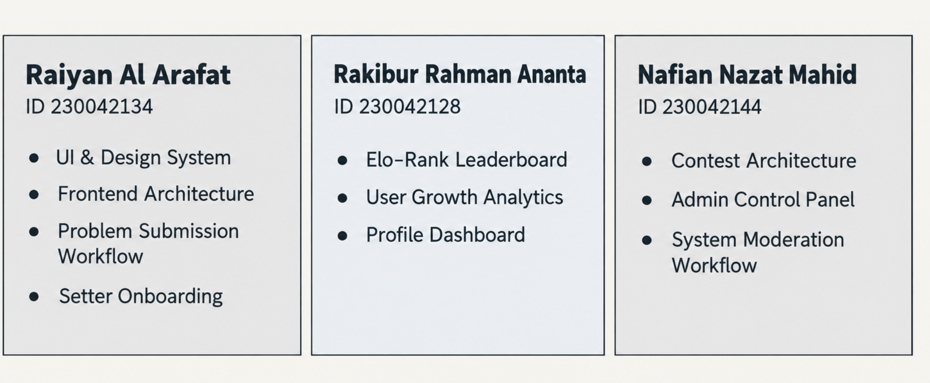
Figure 9. Team responsibility allocation. Source: final-presentation.pdf, physical page 8. The following table connects the declared responsibilities with representative Git evidence rather than inferring contribution only from line counts.
Member | Responsibilities supported by presentation and history | Representative evidence
Rakibur Rahman Ananta, 230042128 | Growth analytics, leaderboard/rating, profile/settings, integration and later regression work | bc8b3bc; 8ebf9d8; 9226ca1; 7f4c3fd; dbc66d0
SM Raiyan Al Arafat, 230042134 | UI/design system, frontend architecture, authentication, problem submission/editor and setter onboarding | f4bcbf0; 15585d0; 72fb92f; 749b0bf; c39391b; 287f7a4
Nafian Nazat Mahid, 230042144 | Contest architecture, administrator interfaces, moderation and support features | ea17373; db8e4db; f066c49; c7ba152; dacac87; eec80ed

Repository aliases include anantaGTX, Raiyan Al Arafat/S. M. Raiyan Al Arafat, and Nafian-23/Nafian Nazat Mahid. The mapping is consistent with the supplied presentation and commit history. It is a record of attributed commits and declared responsibilities, not proof that all work was performed independently or equally. [R3, R5]

10.2 Coordination of interdependent modules
The modules depend on shared contracts. Authentication provides the user identity required by submissions and contests. Judging produces the verdict needed by persistence. Saved submissions supply growth views, while finalized contest results supply ratings and campus standings. Administration decides who may contribute problems and which problems may appear publicly.
Feature-branch merges and the extracted shared judging/editor components show how these dependencies were integrated. Shared model fields, consistent identity helpers, and regression tests provide a technical basis for coordination. A change to user identity, verdict format or rating semantics should therefore be reviewed by the members responsible for the consuming modules.

10.3 Blockers, disagreements and inclusion
Recorded fixes show concrete technical blockers: C++ execution behavior, avatar persistence, contest announcement consistency, account authorization and editor state. The history demonstrates fixes and integration, but it does not document interpersonal disagreements, meeting attendance or a formal conflict-resolution procedure. No such incident is invented here.
The contribution table makes the division of work visible. Fair participation should be reviewed through explanation of assigned modules, issue/commit evidence and shared review of integration decisions rather than raw commit counts. For unresolved decisions, a suitable process is to describe the options, test them against requirements, record the chosen trade-off and request supervisor guidance when necessary. This is a recommended practice, not a claim of a documented past meeting.

CO5 self-assessment
Can each member explain assigned tasks and show their reflection in version control? The responsibility/evidence table provides specific starting points for each member's explanation. How were disagreements and blockers resolved, with fair participation? Technical fixes are visible; social-process and fairness evidence is insufficient for a stronger claim. How were interdependent modules coordinated? Shared API/data contracts, feature merges, reusable judging/editor logic and regression tests connect the separately developed areas.

11. Results, Limitations, and Future Work

11.1 Final requirement status
“Completed” means the reviewed code implements the stated core requirement. “Partial” means one or more original acceptance criteria are missing or the implementation materially changes the original requirement. “Not done” means no implementation of that requirement was found. This is a source-and-test assessment, not signed user acceptance.
ID | Status | Final result and qualification
FR-01 | Completed | Email/password and configured social authentication; separate administrator entry and server-side authorization. Live provider setup remains deployment-dependent
FR-02 | Completed | Approved problem list with title search, topics and difficulty filtering
FR-03 | Completed | Integrated Monaco editor, language templates and supported preferences
FR-04 | Completed | Editor submission and judged verdicts; external failures reported explicitly. The heading's “upload” is implemented as editor-code submission, consistent with its acceptance criteria
FR-05 | Completed | Growth dashboard, success/solve metrics, difficulty breakdown and progress charts
FR-06 | Partial | Recent 50 attempts and saved-code inspection; a complete paginated archive of all attempts is not provided
FR-07 | Not done | No bookmark storage, toggle workflow or bookmark page
FR-08 | Partial / changed | Ranking exists, but uses contest ratings and institution aggregates rather than solved-count/success-rate ordering specified in the SRS
FR-09 | Partial | Creation with test cases and pending review works; drafts, setter edit/delete management and video-link workflow are incomplete
FR-10 | Partial | Creation enters the review queue and admin review works; separate draft submission, setter status dashboard and feedback/resubmission loop are incomplete
FR-11 | Partial | Admin can review and approve/reject; the reviewed status handler does not persist or deliver problem-rejection feedback
FR-12 | Completed | Topic tags stored and used for discovery
FR-13 | Partial | Difficulty is assigned, displayed and filtered; later setter difficulty editing is not implemented
FR-14 | Not done | Dedicated setter problem analytics and common-error breakdown absent
FR-15 | Partial | Contest CRUD, registration, timed submissions, standings and automatic polling implemented; scoring differs from strict ICPC acceptance wording
FR-16 | Partial | In-app contest, role-decision and support notifications; email delivery and full problem/admin event coverage absent
FR-17 | Partial | Applications, transactional decisions, applicant notifications and reapplication work; new-request admin notification criterion is not demonstrated
FR-18 | Completed | Problem details, formatting, samples, tags and limits visible without hidden tests
FR-19 | Partial | Profiles, avatars, bios, institution and social links; password/email-change verification acceptance criteria not demonstrated
FR-20 | Partial | Compilation diagnostics displayed; special common-error highlighting and universally correct original-source line mapping are not verified
FR-21 | Partial | Admin sees proposed difficulty during review; no difficulty overwrite/assignment endpoint found
FR-22 | Partial | TLE verdict and timeout messaging exist; strict immediate per-test-case interruption is not demonstrated by aggregate external batch timing

Against the original acceptance wording, this yields 7 completed, 13 partial/changed and 2 not-done functional requirements. Counts group all stories under each FR and do not count a useful alternative implementation as complete satisfaction of an unchanged original criterion.
The system also adds useful support, account moderation, campus/university ranking, contest reminders, and stronger consistency controls beyond the summarized original functional list. These additions improve the project but do not cancel unfulfilled baseline requirements.

11.2 Main limitations
The strongest demonstrated result is a connected and regression-tested practice/contest workflow. The principal limitations are incomplete setter lifecycle features, dependence on external execution and storage, unverified quantitative NFRs, incomplete deployment privacy/security controls, and a lack of automated CI/CD and formal user evaluation.
The judge uses a text delimiter to batch cases and a shared execution result for resource interpretation. Programs interacting unexpectedly with the wrapper or delimiter require further testing. Memory/time reporting is tied to the external service, and the application does not implement its own secure sandbox. Automated correctness checks also cannot assess code originality, explanatory quality or whether a student learned the intended concept.
The original design and final-presentation claims are not all equally current. This report therefore treats diagrams as design evidence, source code as implementation evidence, and tests as evidence for the behaviors they actually exercise. No claim of complete NFR compliance, production readiness or measured educational improvement is made.

11.3 Prioritized future work
Priority | Work | Acceptance evidence to collect
1 | Harden deployment secrets, origins, profile privacy and hidden-test storage | Configuration review, negative access tests, private-file retrieval tests
1 | Validate real database transactions and external judging end to end | Replica-set integration results and controlled provider-backed demonstrations
1 | Reconcile SRS with final scoring and timeout policies | Reviewed requirement changes with supervisor/team confirmation
2 | Complete problem drafts, edit/delete, feedback and resubmission | Setter/admin end-to-end acceptance tests
2 | Measure latency, capacity and availability | Reproducible load report, percentile latencies, monitoring history
2 | Add CI and complete browser/accessibility testing | Passing pipeline artifacts and documented user tasks
3 | Add full submission archive, bookmarks and setter analytics | Requirement-linked automated and manual checks
3 | Improve notifications, profile security and optional video support | Delivery/configuration tests and complete account workflows
3 | Reduce large components and bundle size | Component review, production bundle comparison, performance measures

CO6 self-assessment
Would an informed reader understand the problem, requirements, decisions, implementation and limitations from the documents alone? This report brings those elements together with source identifiers, diagrams, data contracts, measured statistics, test results, contribution evidence and explicit limitations. Undocumented session feedback and actual costs remain visible evidence gaps rather than unsupported claims of completeness.

12. Glossary and References

12.1 Glossary
Term | Plain-language meaning
AC / Accepted | The judged output satisfied the expected results under the implemented checks
API | A defined way for one software component to request data or an action from another
Authentication | Establishing which account is making a request
Authorization / RBAC | Deciding what an identified account may do, including role-based permissions
CE / Compilation Error | The submitted program could not be compiled or parsed successfully
CI/CD | Automated checks and controlled delivery of software changes
CO | Course Outcome used to assess the project
Component | A reusable part of the interface or system with a defined responsibility
DFD | Data-flow diagram showing external actors, processes and information movement
Elo-inspired rating | A score adjusted according to performance relative to expected competitive results
ER diagram | A diagram of data entities and their relationships
FR / NFR | Functional requirement / non-functional quality requirement
Hidden test | Evaluation input/output withheld from the public problem page
HTTP / REST / JSON | Web communication protocol / resource-oriented API style / structured exchange format
Idempotent operation | An operation whose repeated execution does not repeat its intended effect
Integration test | A test involving interactions between components; the report identifies mocked boundaries
MLE | Memory Limit Exceeded
MongoDB / Mongoose | Document database / JavaScript schema and database-access library
OAuth provider | External identity provider used to authorize a sign-in flow
Polling | Periodically requesting updated information
RE / Runtime Error | A program failure that occurs while the program executes
Regression test | A repeatable check intended to catch the return of a previously addressed failure
SRS | Software Requirements Specification
TLE | Time Limit Exceeded
Transaction | Related database changes that commit together or roll back together
UTC | Common time reference used for consistent activity-day calculations
Verdict | The judge's result for a submitted solution
WA / Wrong Answer | The program's output does not match the expected result

12.2 Project sources
[R1] CodingLab team. Software requirements and user stories. Supplied doc/srs.pdf, 5 physical pages. Original FR-01–FR-22 identifiers and acceptance criteria retained. The source serial numbering skips 36; this does not introduce another FR.
[R2] CodingLab team. Software Design Report: SWE 4404, Group 10. Supplied doc/design.pdf, 14 physical pages. Cover details: page 1; architecture: pages 3–4; DFD: page 5; collection design: page 6; ER diagram: pages 7–8; process flows: pages 9–12; NFRs: page 13. Physical PDF pages are used to avoid confusion with printed page numbers.
[R3] CodingLab team. Final Presentation. Supplied doc/final-presentation.pdf, 10 physical pages. Architecture: page 6; earlier code-size figures: page 7; responsibility allocation: page 8.
[R4] CodingLab source repository. https://github.com/EarthBoundBroccoli/CodingLab. Published implementation snapshot: https://github.com/EarthBoundBroccoli/CodingLab/tree/dbc66d0/src. Subsequent code/ layout: https://github.com/EarthBoundBroccoli/CodingLab/tree/704516d/code. Local cleanup revision reviewed: 2b10da7.
[R5] Selected commit evidence, linked below. Commit titles and dates support development history; they are not substitutes for session minutes or actual-hours records.
Evidence | Link
Initial authentication | https://github.com/EarthBoundBroccoli/CodingLab/commit/15585d0
Google/GitHub login | https://github.com/EarthBoundBroccoli/CodingLab/commit/72fb92f
Editor integration | https://github.com/EarthBoundBroccoli/CodingLab/commit/749b0bf
JDoodle execution integration | https://github.com/EarthBoundBroccoli/CodingLab/commit/c39391b
Growth dashboard connection | https://github.com/EarthBoundBroccoli/CodingLab/commit/bc8b3bc
Leaderboard and growth | https://github.com/EarthBoundBroccoli/CodingLab/commit/8ebf9d8
Contest model/controller | https://github.com/EarthBoundBroccoli/CodingLab/commit/db8e4db ; https://github.com/EarthBoundBroccoli/CodingLab/commit/f066c49
Contest integration | https://github.com/EarthBoundBroccoli/CodingLab/commit/c7ba152
Profile/settings/rating | https://github.com/EarthBoundBroccoli/CodingLab/commit/9226ca1
Rating and dependency fixes | https://github.com/EarthBoundBroccoli/CodingLab/commit/7f4c3fd
Support feature | https://github.com/EarthBoundBroccoli/CodingLab/commit/eec80ed
Support ownership/security | https://github.com/EarthBoundBroccoli/CodingLab/commit/e17e6cb
Timeouts and atomic announcements | https://github.com/EarthBoundBroccoli/CodingLab/commit/a00f60e
Shared judging/editor refactor | https://github.com/EarthBoundBroccoli/CodingLab/commit/40a8938
C++ judging fix | https://github.com/EarthBoundBroccoli/CodingLab/commit/287f7a4
Avatar persistence | https://github.com/EarthBoundBroccoli/CodingLab/commit/dbc66d0

12.3 External references
The following official pages were consulted on 31 October 2026. Their relevance is explained in Section 3; live documentation may describe versions newer than the repository's locked dependencies.
[R6] Codeforces. Contests. https://codeforces.com/contests
[R7] HackerRank. Algorithms Practice; Introduction to Coding Challenges. https://www.hackerrank.com/domains/algorithms ; https://help.hackerrank.com/articles/7845849982-introduction-to-challenges
[R8] Harvard CS50. CS50x Problem Sets. https://cs50.harvard.edu/x/psets/
[R9] React. Thinking in React. https://react.dev/learn/thinking-in-react
[R10] MongoDB. Transactions, Database Manual. https://www.mongodb.com/docs/manual/core/transactions/
[R11] Better Auth. Email & Password. https://better-auth.com/docs/authentication/email-password

12.4 Reproducibility and evidence index
The accompanying doc/report-evidence folder contains backend/frontend test output, production build output, measured source statistics and the metric script. The test output records a combined npm test run; the statistics script parses runtime JavaScript/JSX and reports its inclusion rules. Both the diagram sources and the code snapshot should accompany this report so a reviewer can reproduce or inspect the claims.
Useful implementation anchors at the published baseline are:
- Judging: https://github.com/EarthBoundBroccoli/CodingLab/blob/dbc66d0/src/backend/services/judgingService.js
- Rating calculation: https://github.com/EarthBoundBroccoli/CodingLab/blob/dbc66d0/src/backend/utils/eloCalculator.js
- Rating consistency: https://github.com/EarthBoundBroccoli/CodingLab/blob/dbc66d0/src/backend/utils/contestRatings.js
- Eligibility and university ranking: https://github.com/EarthBoundBroccoli/CodingLab/blob/dbc66d0/src/backend/utils/leaderboard.js
- Authorization tests: https://github.com/EarthBoundBroccoli/CodingLab/blob/dbc66d0/src/backend/tests/adminAuthorization.test.js
- Submission persistence tests: https://github.com/EarthBoundBroccoli/CodingLab/blob/dbc66d0/src/backend/tests/submissionPersistence.test.js
- Recent submission review: https://github.com/EarthBoundBroccoli/CodingLab/blob/dbc66d0/src/frontend/src/components/growth/SubmissionHistory.jsx

CO6 self-assessment
Have the documents considered the audience's background, language and learning needs? The executive summary begins with familiar student activities; diagrams explain structure; tables connect requirements to evidence; technical terms are defined here. The report keeps limitations visible and provides precise sources for readers who need more detail.

