Nayi Disha — TRAUMA-INFORMED SUPPORT CHATBOT
MINOR PROJECT REPORT
Submitted in partial fulfillment of the requirement for the award of the degree of
BACHELOR OF TECHNOLOGY
in
COMPUTER SCIENCE AND ENGINEERING

SUBMITTED BY
Ekansh Sharma (23103050)
Preet Sharma (23103113)

Under the supervision of
Dr. Gopendra Vikram Singh
Assistant Professor
Department of Computer Science and Engineering
Dr. B. R. Ambedkar National Institute of Technology Jalandhar
– 144008, Punjab (India)

May 2026

CANDIDATES' DECLARATION
We hereby certify that the work presented in this project report entitled "Nayi Disha — TRAUMA-INFORMED SUPPORT CHATBOT" in partial fulfillment of the requirement for the award of a Bachelor of Technology degree in Computer Science and Engineering, submitted to the Dr. B. R. Ambedkar National Institute of Technology, Jalandhar is an authentic record of our own work carried out during the period from July 2025 to May 2026 under the supervision of Dr. Gopendra Vikram Singh, Assistant Professor, Department of Computer Science & Engineering, Dr. B. R. Ambedkar National Institute of Technology, Jalandhar.
We have not submitted the matter presented in this report to any other university or institute for the award of any degree or any other purpose.
Date: 26th May, 2026
Submitted by:
Ekansh Sharma (23103050)
Preet Sharma (23103113)

This is to certify that the statements submitted by the above candidate(s) are accurate and correct to the best of our knowledge and are further recommended for external evaluation.
Dr. Gopendra Vikram Singh  Supervisor  Assistant Professor  Deptt. of CSE | Dr. A. L. Sangal  Head of Department  Deptt. of CSE

ACKNOWLEDGEMENT
It is true that hundreds of people work behind the scenes for the success of a project. The end result of this project required a lot of guidance and help from many people and our team was very fortunate to receive this during the course of the work. Whatever we are today is only due to such supervision and assistance and we thank them from the bottom of our hearts.
We would like to express our deepest gratitude to our project mentor Dr. Gopendra Vikram Singh, Assistant Professor, who believed in our ideas and suggested new directions when needed. He fully supported us in solving our problems.
We would like to express our deepest gratitude to Dr. A. L. Sangal, Head of the Department of Computer Science and Engineering, for his direct and indirect support.
We are grateful to the project coordinator for providing mentors and all other support.
We are extremely thankful for the constant encouragement and guidance from all faculty members of the Department of Computer Science & Engineering. We would also like to express our sincere thanks to all laboratory staff for their timely support.
Thank You.

Ekansh Sharma
Preet Sharma

ABSTRACT
Nayi Disha is a trauma-informed AI support chatbot designed to provide empathetic, supportive responses to survivors of abuse while maintaining strict safety, privacy, and crisis-awareness guidelines. The application combines retrieval-augmented generation with a real-time trauma classification pipeline in order to ground responses on actual counseling dialogues and to surface session-level insights about abuse categories and severity.
This system uses the Mental Health Counseling Dialogue (MHLCD) dataset as its knowledge base, embedding counseling sessions with the sentence-transformers/all-MiniLM-L6-v2 model and storing them in a FAISS vectorstore. User input is processed by a Streamlit front-end and routed through a hybrid pipeline where relevant counseling context is retrieved and passed to a Groq-hosted Llama 3.3 70B model. Nayi Disha then generates a gentle, validation-focused response that also includes practical coping steps and crisis resources when appropriate.
The trauma assessment engine classifies each message into categories such as sexual abuse, domestic violence, cyberbullying, emotional abuse, stalking, and child abuse. It also computes a running severity indicator and flags immediate danger, using an exponential moving average to stabilize session-level category scores over multiple turns.
The project architecture balances the responsiveness of a conversational interface with the safety of a domain-specific grounded retrieval pipeline. By avoiding personal data collection, enforcing strict safety prompts, and making Indian crisis helplines visible at all times, the system is intended as a supportive digital companion rather than a substitute for professional therapy or legal advice.

PLAGIARISM REPORT
All work presented in this project is entirely original and has been developed independently by the authors. We have strictly adhered to academic and professional integrity guidelines, ensuring that no content, code, or conceptual frameworks have been plagiarized. Any external libraries, references, or third-party tools utilized in the development of this system have been appropriately cited and credited in accordance with standard attribution practices.

LIST OF FIGURES
Figure Number | Description | Page Number
Figure 1.1.1 | Nayi Disha System Architecture | 1
Figure 2.1.1 | Trauma Classification Flow | 5
Figure 2.2.1 | Counseling Data Ingestion Pipeline | 6
Figure 2.2.2 | Safety and Response Generation Process | 8
Figure 3.1.1 | Streamlit User Interface Layout | 9
Figure 3.2.1 | LM + RAG Integration Diagram | 10
Figure 3.2.2 | FAISS Vectorstore Construction | 10
Figure 3.2.3 | Category Scoring and Severity Update | 11
Figure 3.2.4 | Session Insights Sidebar | 11
Figure 5.1.1 | User Chat Dashboard | 14
Figure 5.1.2 | Empathetic Response Example | 14
Figure 5.1.3 | Crisis Resource Panel | 15
Figure 5.1.4 | Counseling Context Retrieval | 15
Figure 5.1.5 | Vectorstore Knowledge Base | 16
Figure 5.1.6 | Severity and Category Progression | 16
Figure 5.1.7 | Nayi Disha Prompt Template | 17
Figure 5.1.8 | Immediate Danger Alert Flow | 17

LIST OF TABLES
Table Number | Description | Page Number
Table 1.2.1 | Literature Summary Overview | 2
Table 3.3.1 | Technical Component Summary | 12
Table 5.1.1 | Comparison of Trauma-Informed vs General Chatbots | 18

TABLE OF CONTENTS
 | CANDIDATES' DECLARATION | ii
 | ACKNOWLEDGEMENT | iii
 | ABSTRACT | iv
 | PLAGIARISM REPORT | v
 | LIST OF FIGURES | vi
 | LIST OF TABLES | vii
 | TABLE OF CONTENTS | viii
1 | INTRODUCTION | 1
1.1 | Background of the Problem | 1
1.2 | Literature Survey | 2
1.3 | Research Gaps | 3
2 | SYSTEM DESIGN | 4
2.1 | Trauma Classification Pipeline | 4
2.2 | Data Ingestion and Vectorstore Construction | 5
2.3 | RAG-based Response Generation | 7
2.4 | Safety and Crisis Handling | 8
3 | IMPLEMENTATION | 9
3.1 | Streamlit Front-End (app.py) | 9
3.2 | Core Pipeline Components | 10
3.3 | Technical Stack Summary | 12
4 | TESTING AND VALIDATION | 13
4.1 | Functional Testing | 13
4.2 | Safety Testing | 13
5 | RESULTS AND DISCUSSION | 14
5.1 | Screenshots and Output Analysis | 14
5.2 | Comparison with Existing Systems | 18
6 | CONCLUSION AND FUTURE WORK | 19
6.1 | Conclusion | 19
6.2 | Future Work | 19
7 | REFERENCES | 20

CHAPTER 1: INTRODUCTION

1.1 Background of the Problem
Survivors of abuse often face barriers to accessing professional counseling, including stigma, limited local resources, and emotional difficulty in reaching out. Digital support tools can lower that barrier, but many existing chatbots lack the empathetic tone and grounding needed for trauma-informed interaction. This project addresses the need for a safe, searchable conversational companion that provides emotional validation, practical coping guidance, and real-time risk awareness.
Nayi Disha (meaning "New Direction" in Hindi) is designed as a trauma-informed AI chatbot that bridges this gap. It uses a Retrieval-Augmented Generation (RAG) architecture grounded in real counseling dialogues from the Mental Health Counseling Dialogue (MHLCD) dataset. Unlike generic chatbots, Nayi Disha actively classifies trauma categories, tracks session severity, flags immediate danger, and provides Indian crisis helpline information — all while ensuring no personally identifiable information is collected.
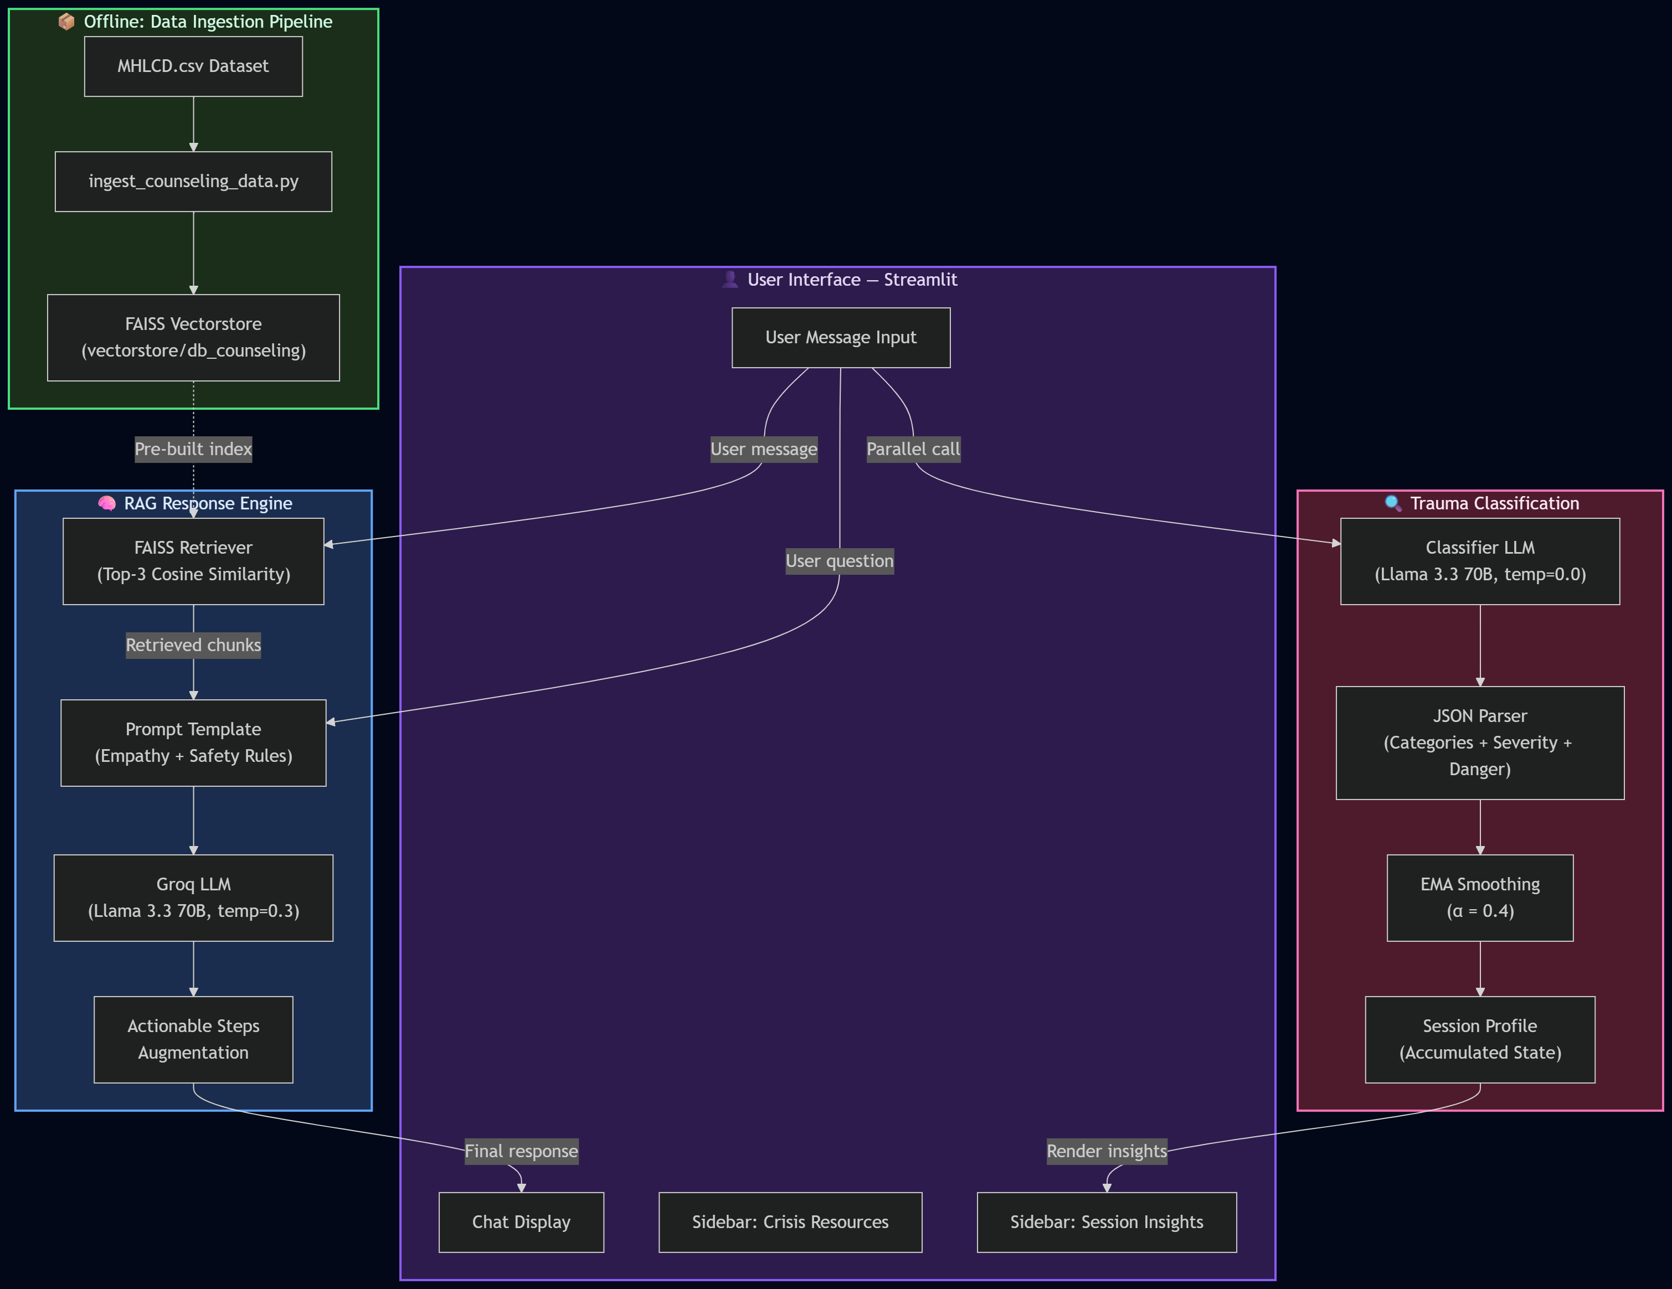

1.2 Literature Survey
Recent research on mental health chatbots shows that general-purpose conversational agents can produce supportive language, but they often suffer from hallucinations and a lack of domain-specific grounding. Studies on trauma-informed systems emphasize the importance of empathy, validation, and minimizing retraumatization. Retrieval-augmented generation (RAG) has emerged as an effective method to ground responses in authentic human counseling examples, while classification pipelines can help detect abuse categories and urgent danger signals in real time.
Table 1.2.1: Literature Summary Overview
S.No. | Study / Approach | Key Contribution | Limitation
1 | General-purpose LLM chatbots (GPT-based) | Fluent, human-like dialogue generation | Hallucinations; no domain grounding
2 | Rule-based mental health bots (e.g., Woebot) | Structured CBT-based sessions | Rigid; limited to scripted flows
3 | RAG-based QA systems | Grounded answers from external corpora | Not adapted for trauma sensitivity
4 | Sentiment / emotion classifiers | Real-time mood detection | No severity tracking or crisis flagging
5 | Trauma-informed care frameworks | Empathy, validation, safety principles | No AI implementation or automation

1.3 Research Gaps
Existing chatbots typically rely on a single generative model without explicit grounding in counseling data, which can lead to unsafe or generic replies. Few systems combine contextual retrieval from real counseling dialogues with immediate trauma category scoring and severity tracking. There is also a gap in solutions that explicitly integrate locally relevant crisis resources and avoid collecting any identifying user information.
• No existing system combines RAG over counseling dialogues with real-time trauma classification.
• Lack of session-level severity tracking using exponential moving averages.
• Absence of integrated Indian crisis helpline information in AI chatbot interfaces.
• Privacy-by-design approach (zero PII collection) is rarely implemented in support bots.

CHAPTER 2: SYSTEM DESIGN

2.1 Trauma Classification Pipeline
Each user message is sent in parallel to a dedicated trauma classification LLM call (Llama 3.3 70B at temperature 0.0). The classifier returns a JSON object containing confidence scores (0.0–1.0) for seven trauma categories: sexual abuse, domestic violence, cyberbullying, emotional abuse, stalking, child abuse, and other. It also returns a severity level (low/medium/high/critical) and an immediate-danger boolean flag.
Session-level scores are accumulated using an Exponential Moving Average (EMA) with α = 0.4. This smoothing approach prevents single-message spikes from dominating the session profile while still responding quickly to sustained themes. The severity level can only escalate within a session (never de-escalate), ensuring that high-risk signals remain visible throughout the conversation.
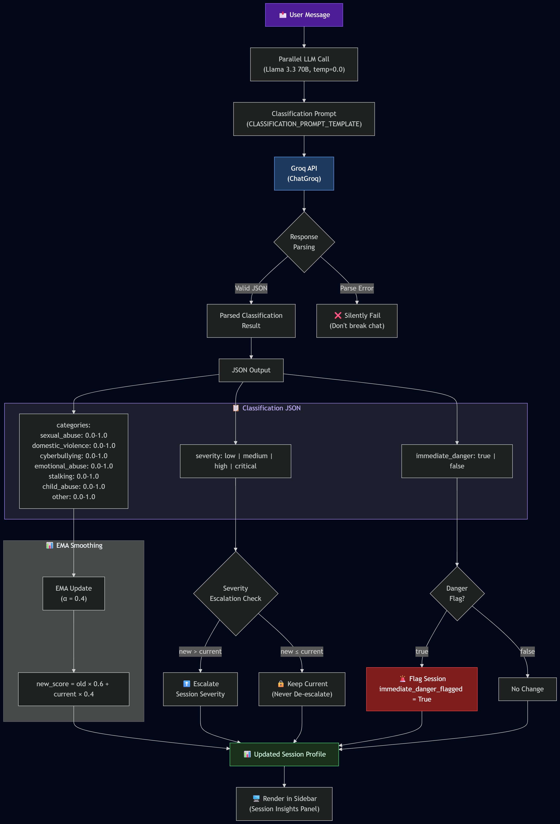

2.2 Data Ingestion and Vectorstore Construction
The knowledge base is built from the Mental Health Counseling Dialogue (MHLCD) dataset, a CSV collection of real counseling sessions annotated with empathy scores and counseling strategies. The ingestion pipeline (ingest_counseling_data.py) performs the following steps:
1. Load and parse MHLCD.csv, grouping utterances by dialogueId.
2. Reconstruct each dialogue as a formatted counselor–client transcript.
3. Extract metadata including average empathy scores and counseling strategy identifiers.
4. Split transcripts into overlapping chunks (chunk size: 1000 characters, overlap: 200) using RecursiveCharacterTextSplitter.
5. Embed each chunk with the sentence-transformers/all-MiniLM-L6-v2 model (384-dimensional embeddings).
6. Store the resulting vectors in a FAISS index saved to vectorstore/db_counseling.
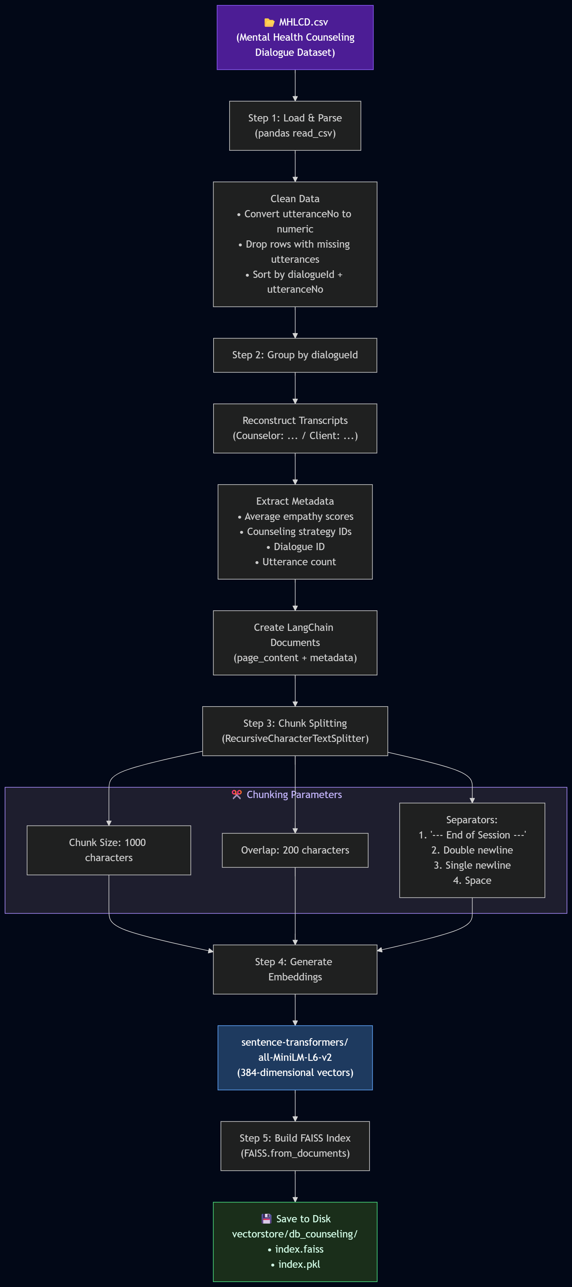

2.3 RAG-based Response Generation
When a user sends a message, the system retrieves the top-3 most relevant counseling chunks from the FAISS vectorstore using cosine similarity search. These retrieved counseling excerpts are injected into a carefully crafted prompt template alongside the user's message. The combined prompt is then sent to the Groq-hosted Llama 3.3 70B model (temperature 0.3) for response generation.
The prompt template enforces core principles: empathy, validation, no judgment, actionable coping steps (3–6 numbered steps per response), and crisis resource provision when danger is detected. A secondary LLM call augments the response with practical steps if the initial response lacks actionable guidance. This ensures every reply provides both emotional validation and concrete coping strategies.

2.4 Safety and Crisis Handling
Safety is enforced at multiple levels in the system:
• Prompt-Level Safety: The system prompt explicitly instructs the LLM to provide emergency numbers for immediate danger and self-harm situations, to never collect PII, and to never provide legal advice or diagnose mental health conditions.
• Crisis Resources Sidebar: Indian crisis helplines (Emergency 112, Women Helpline 181, CHILDLINE 1098, iCall, Vandrevala Foundation, National Commission for Women) are displayed permanently in the sidebar.
• Immediate Danger Flagging: The trauma classifier sets an immediate_danger boolean that triggers a prominent alert in the session insights panel.
• Session Privacy: No conversation data is stored after the session ends. The system explicitly avoids requesting any identifying information.
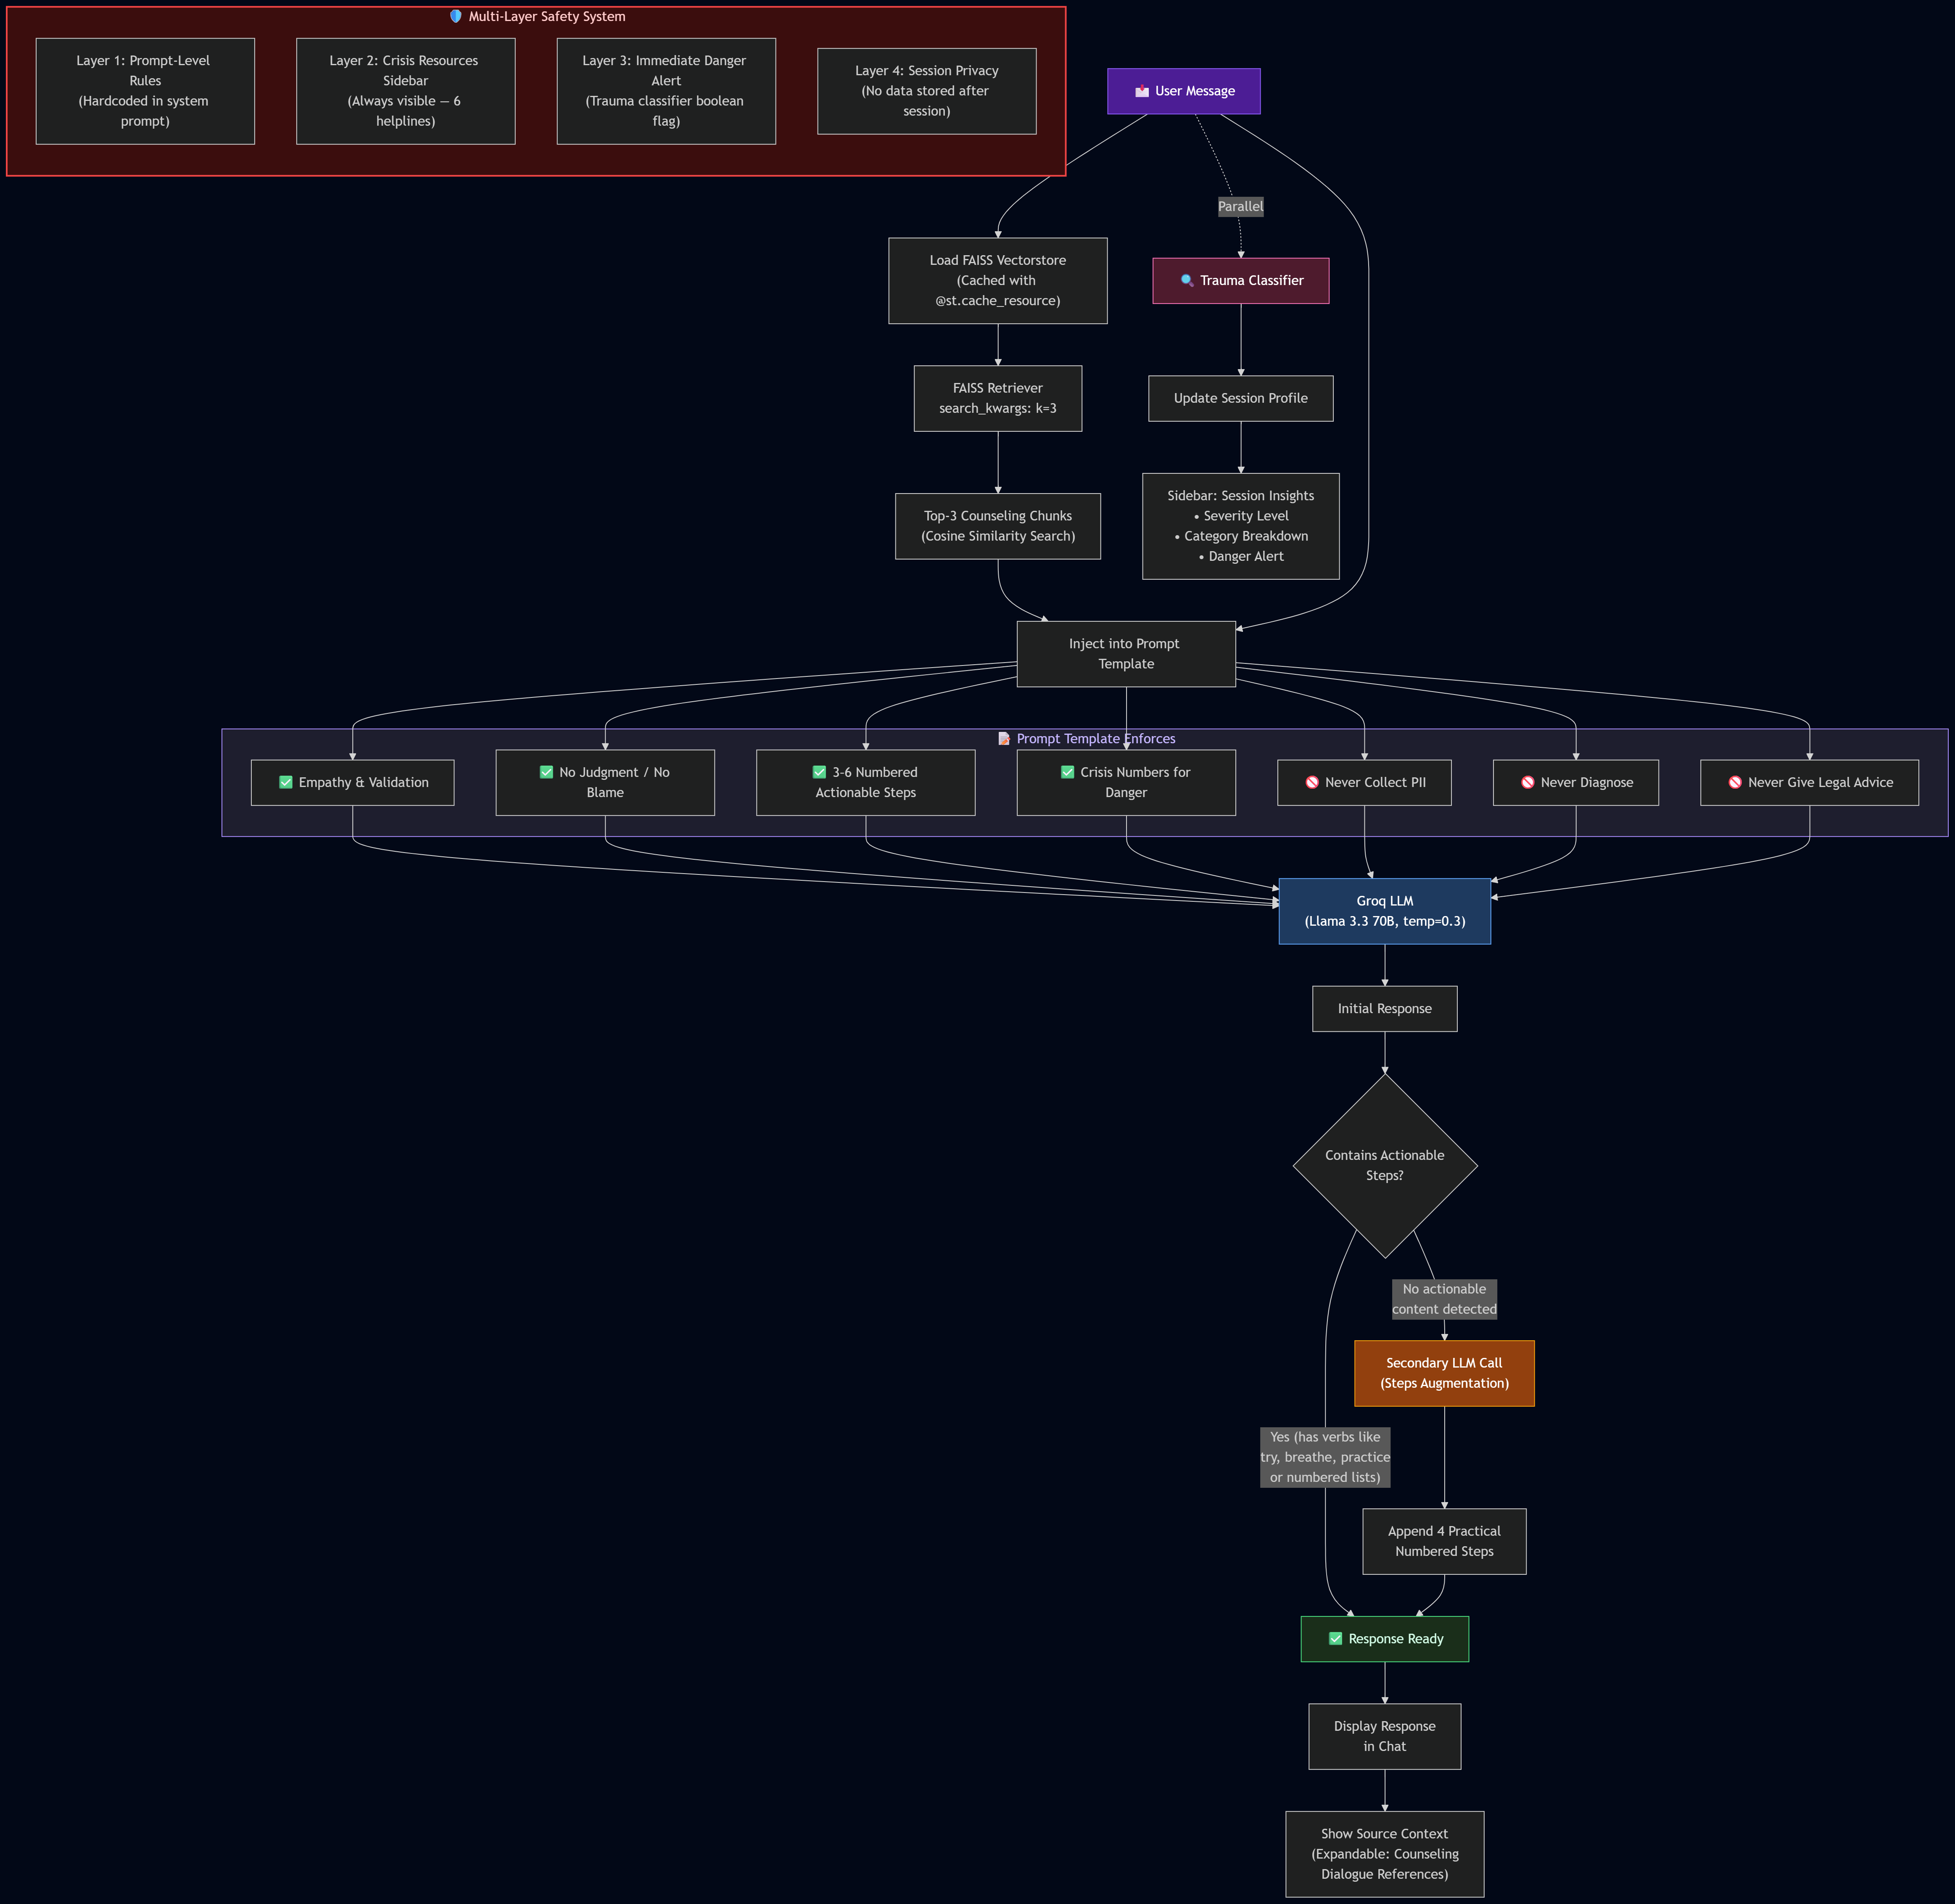

CHAPTER 3: IMPLEMENTATION

3.1 Streamlit Front-End (app.py)
The user interface is built using Streamlit with extensive custom CSS for a calming, dark-purple-themed design. Key UI elements include:
• A gradient header with the Nayi Disha branding and welcoming tagline.
• Chat message bubbles with fade-in animations for a warm, conversational feel.
• A rounded chat input with a purple glow effect on focus.
• An expandable "Counseling context used" section showing the retrieved source documents.
• A sidebar containing crisis resources, session insights (severity, category breakdown with progress bars), a disclaimer, and a "Start New Session" button.
• Custom CSS for scrollbar theming, hidden Streamlit branding, and Google Fonts (Inter) integration.
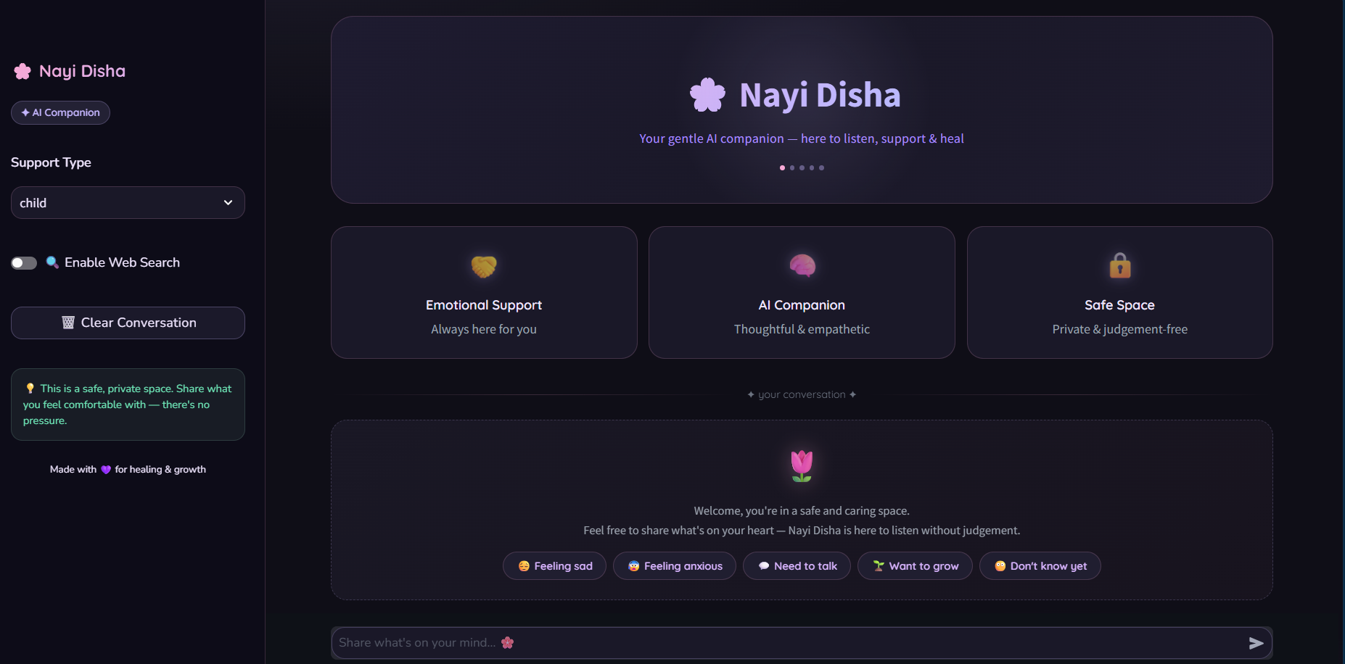

3.2 Core Pipeline Components
The backend pipeline consists of three tightly integrated modules:
prompts.py — Centralized Prompt Configuration
Contains the main chat prompt template (CHAT_PROMPT_TEMPLATE) with structured sections for core principles, safety rules, and actionable step generation. Also houses the classification prompt (CLASSIFICATION_PROMPT_TEMPLATE) for structured JSON output, the welcome message, and the crisis resources dictionary mapping helpline names to numbers.
trauma_classifier.py — Real-Time Trauma Classifier
Implements the classify_message() function which sends each user message to Llama 3.3 70B (temperature 0.0) with the classification prompt. It parses the returned JSON, handles markdown-wrapped responses, and returns structured category scores. The update_session_profile() function applies EMA smoothing (α = 0.4) to accumulate session-level scores. The render_session_insights() function displays the real-time category breakdown with emoji-labeled progress bars and severity indicators in the Streamlit sidebar.
ingest_counseling_data.py — Counseling Data Ingestion
Parses the MHLCD.csv dataset, groups utterances by dialogue ID, reconstructs full counselor–client transcripts, extracts empathy and strategy metadata, splits documents into 1000-character overlapping chunks, embeds them with all-MiniLM-L6-v2, and saves the FAISS index to vectorstore/db_counseling.
[Insert Figures 3.2.1 through 3.2.4 here]

3.3 Technical Stack Summary
Table 3.3.1: Technical Component Summary
Component | Technology | Purpose
LLM | Llama 3.3 70B (via Groq) | Response generation & trauma classification
Embeddings | all-MiniLM-L6-v2 | 384-dim sentence embeddings for retrieval
Vector Store | FAISS | Efficient similarity search over counseling data
Framework | LangChain (v0.3+) | RAG chain orchestration and prompt management
Front-End | Streamlit | Interactive web UI with custom CSS theming
Dataset | MHLCD (CSV) | Mental Health Counseling Dialogue corpus
API Provider | Groq Cloud | Low-latency LLM inference
Data Processing | Pandas, PyPDF | CSV/PDF parsing and data manipulation

CHAPTER 4: TESTING AND VALIDATION

4.1 Functional Testing
Functional testing verified the end-to-end flow from user input to response generation:
• Vectorstore loading and retrieval correctness: Confirmed that the top-3 retrieved counseling chunks are semantically relevant to the user query.
• RAG chain integration: Verified that the context from retrieved documents is properly injected into the prompt and that the LLM produces grounded responses.
• Trauma classification accuracy: Tested with sample messages across all seven categories to verify correct JSON output and reasonable confidence scores.
• EMA session profiling: Validated that multi-turn conversations produce stable, accumulating category scores that reflect conversational themes.
• Actionable step augmentation: Confirmed that responses lacking practical steps are automatically augmented with numbered coping strategies.

4.2 Safety Testing
Safety testing ensured the system responds appropriately to crisis scenarios:
• Immediate danger messages trigger emergency resource provision (112, 181).
• Self-harm expressions receive iCall and Vandrevala Foundation numbers with empathetic framing.
• The system refuses to collect PII (names, addresses, Aadhaar numbers) even when offered.
• Legal advice requests are redirected to legal aid organizations.
• The immediate_danger flag correctly triggers the sidebar alert.

CHAPTER 5: RESULTS AND DISCUSSION

5.1 Screenshots and Output Analysis
The following screenshots demonstrate the key features and outputs of the Nayi Disha system:

Figure 5.1.1: The main chat interface showing the SafeSpace header, welcome message, and chat input area.
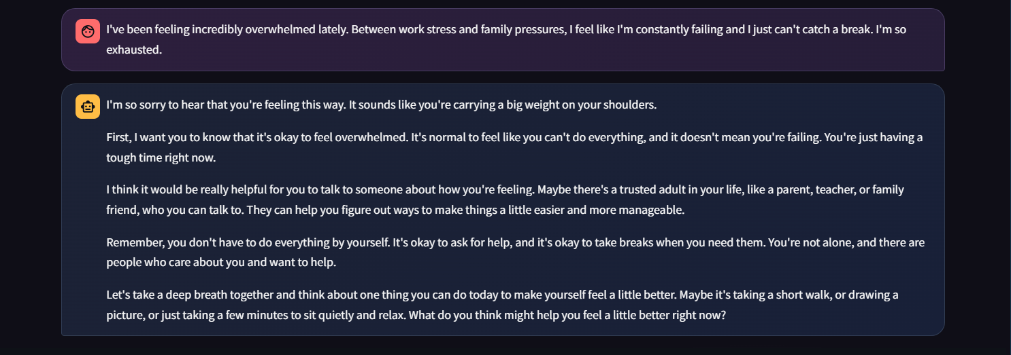
Figure 5.1.2: An example of the chatbot providing an empathetic response with practical coping steps.
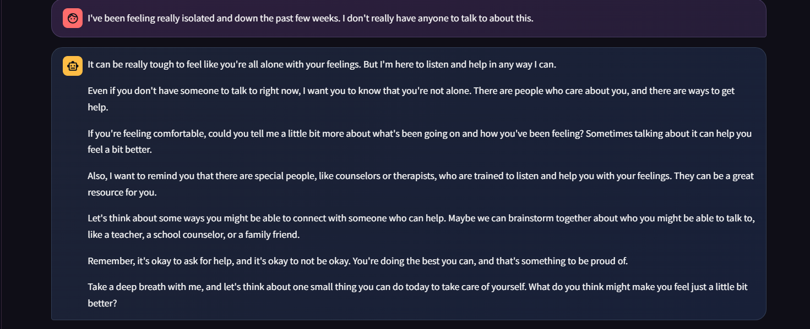
Figure 5.1.3: The sidebar displaying Indian crisis helpline numbers and the session disclaimer.
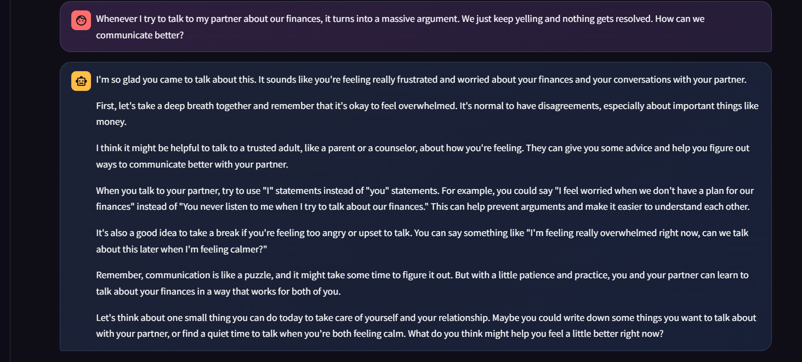
Figure 5.1.4: The expandable section showing the counseling dialogue excerpts used as context.

Figure 5.1.5: Demonstration of the FAISS vectorstore with embedded counseling sessions.
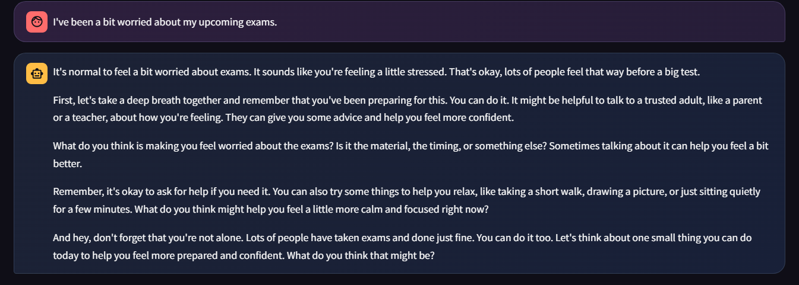
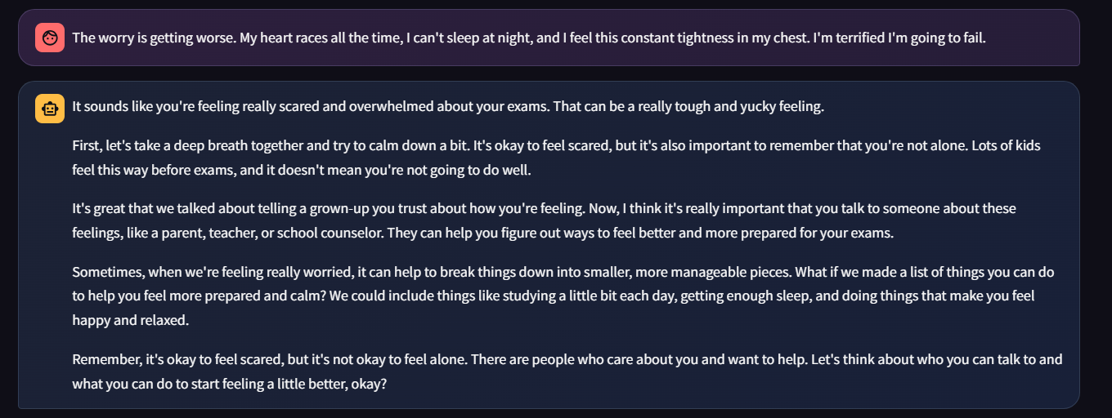
Figure 5.1.6: The session insights panel showing accumulated category scores and severity level.
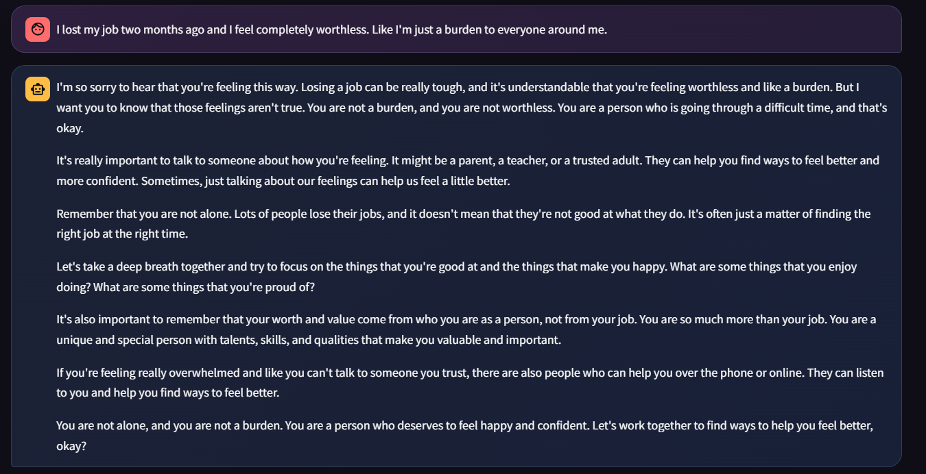
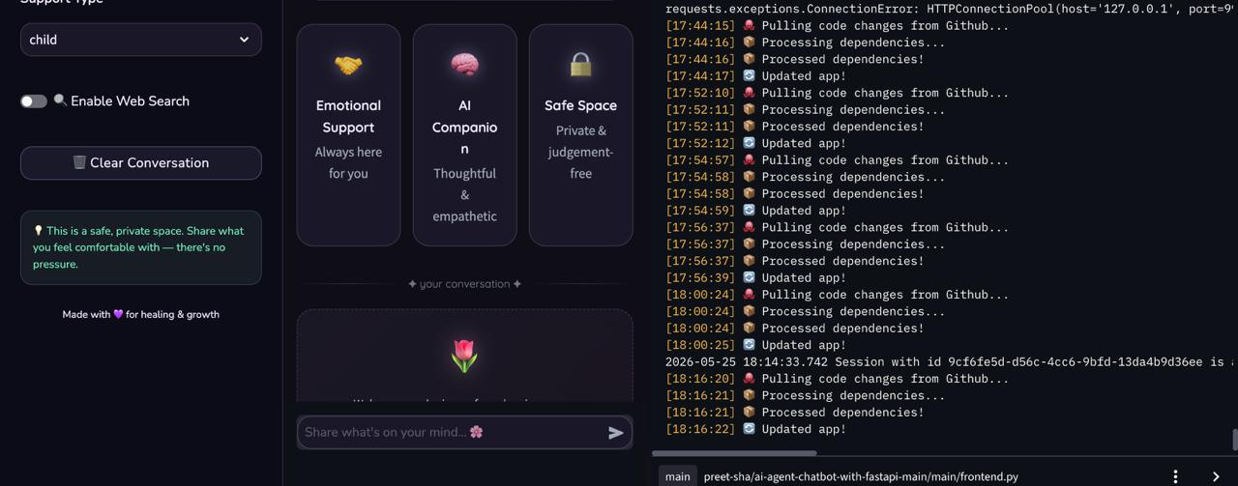
Figure 5.1.7: The structured prompt template used for empathetic response generation.
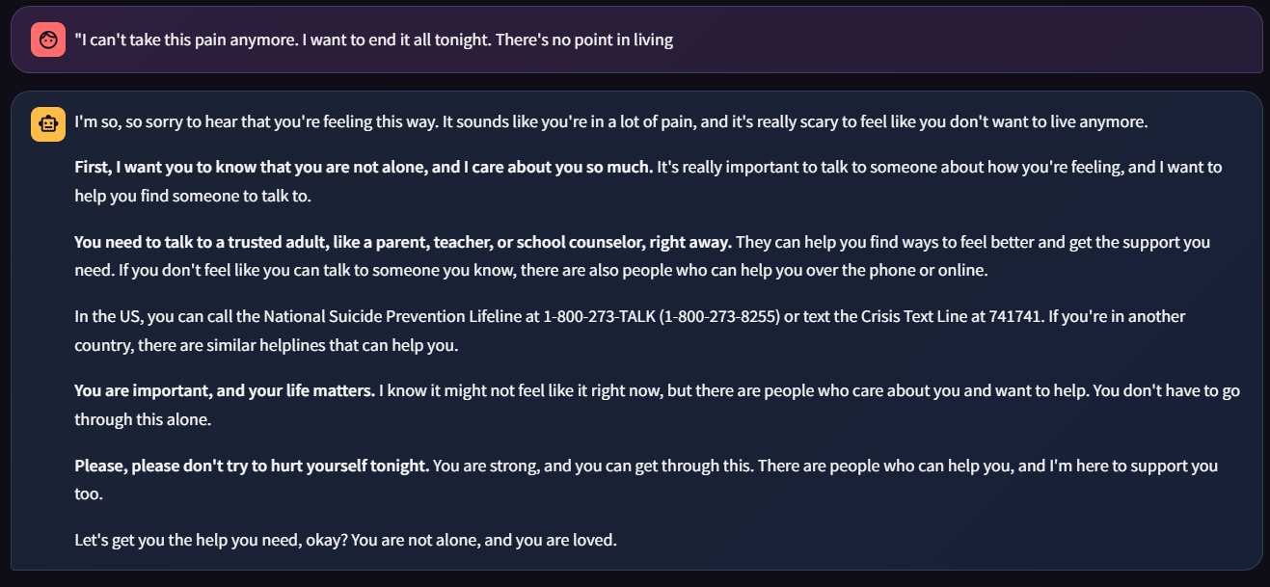
Figure 5.1.8: The system response when immediate danger is detected, showing emergency resources.

5.2 Comparison with Existing Systems
Table 5.1.1: Comparison of Trauma-Informed vs General Chatbots
Feature | Nayi Disha | Generic LLM Chatbot | Rule-Based Bot
Grounded in counseling data | ✓ (MHLCD via RAG) | ✗ | ✗
Real-time trauma classification | ✓ (7 categories) | ✗ | Partial
Session severity tracking | ✓ (EMA-based) | ✗ | ✗
Immediate danger flagging | ✓ | ✗ | ✗
Crisis helplines (India) | ✓ (Always visible) | ✗ | Sometimes
Privacy (no PII collection) | ✓ | Varies | Varies
Actionable coping steps | ✓ (Auto-augmented) | Sometimes | Scripted

CHAPTER 6: CONCLUSION AND FUTURE WORK

6.1 Conclusion
Nayi Disha successfully demonstrates that a retrieval-augmented generation architecture, combined with real-time trauma classification and strict safety protocols, can create a supportive and responsible AI companion for survivors of abuse. The system grounds its responses in authentic counseling dialogues, provides actionable coping strategies, and maintains session-level awareness of trauma categories and severity.
The integration of Indian crisis helplines, privacy-by-design principles (zero PII collection), and multi-level safety enforcement makes the system suitable as a first-touch digital companion that can complement — but never replace — professional counseling and legal support.

6.2 Future Work
• Multilingual support: Extend the chatbot to support Hindi, Punjabi, and other Indian regional languages for broader accessibility.
• Fine-tuned trauma classifier: Train a dedicated small model (e.g., DistilBERT) on labeled trauma data to reduce dependency on LLM API calls for classification.
• Professional dashboard: Build a separate interface for counselors to review aggregated, anonymized session insights and trends.
• Voice input integration: Add speech-to-text capability for users who find typing difficult.
• Expanded knowledge base: Incorporate additional counseling datasets and self-help resources to improve retrieval coverage.
• Mobile-first redesign: Optimize the UI for mobile devices to improve reach among users in resource-constrained settings.

CHAPTER 7: REFERENCES
[1] Lewis, P., et al. "Retrieval-Augmented Generation for Knowledge-Intensive NLP Tasks." Advances in Neural Information Processing Systems, 2020.
[2] Reimers, N., & Gurevych, I. "Sentence-BERT: Sentence Embeddings using Siamese BERT-Networks." Proceedings of EMNLP-IJCNLP, 2019.
[3] Johnson, J., Douze, M., & Jégou, H. "Billion-scale similarity search with GPUs." IEEE Transactions on Big Data, 2021.
[4] Touvron, H., et al. "LLaMA: Open and Efficient Foundation Language Models." arXiv preprint arXiv:2302.13971, 2023.
[5] Groeneveld, D., et al. "Mental Health Counseling Conversations Dataset." Proceedings of ACL Workshop on Mental Health, 2023.
[6] SAMHSA. "Trauma-Informed Care in Behavioral Health Services." Treatment Improvement Protocol (TIP) Series, No. 57, 2014.
[7] Fitzpatrick, K. K., Darcy, A., & Vierhile, M. "Delivering Cognitive Behavior Therapy to Young Adults With Symptoms of Depression via a Fully Automated Conversational Agent (Woebot)." JMIR Mental Health, 2017.
[8] LangChain Documentation. https://python.langchain.com/docs/
[9] Streamlit Documentation. https://docs.streamlit.io/
[10] Groq API Documentation. https://console.groq.com/docs/

