**GIS Processing Steps for Alaska NPLCC LandCarbon Cover Types**

**Overview**

A modified land cover is needed to assign known values for carbon stock and flux to landscape units across the Alaska coastal forest region. We integrated information from existing data sources to obtain a useful landscape stratification to address the need for an adequate land cover designation. The following review provides information on the input data, processing steps, and results.

We have carbon data for three functional landscape types in southeast Alaska (SEAK): upland forests, forested wetlands, and fens. Sites for which we have carbon data are located in the eastern portion of the Alaska North Pacific Landscape Conservation Cooperative (AK NPLCC; Figure 1). We will use these data to estimate carbon across the entire AK NPLCC extent. In this document we will refer to the eastern portion of the AK NPLCC as SEAK, and the western portion as south-central Alaska (SCAK; Figure 1). The GIS steps below use the National Land Cover Dataset (NLCD) to partition the AK NPLCC into the three land cover classes (upland forest, forested wetland, and fen) for subsequent inclusion in TEM. The GIS processing steps were developed using ArcMap version 10.1 software. We would like to find a more efficient processing structure, but have used the ArcMap approach in the present example. The description of the processing steps contains sufficient information to modify the procedure for use with alternative software or programming methods.

NLCD does a very poor job mapping forested wetlands and fens in SEAK within its “woody wetland” and “emergent herbaceous wetland” classes. These classes are vastly under-mapped in the NLCD over the SEAK landscape. Instead, forested wetland is represented most by the NLCD class “mixed forest”, and also as “shrub/scrub.” Fens in SEAK most commonly appear within the NLCD class “shrub/scrub.” Although the NLCD description for “woody wetland” describes a forested wetland, the actual areas on the landscape (when overlaid on an orthophoto) are usually fens. Many fens are also mapped as NLCD class “dwarf scrub.” The “shrub/scrub” and “dwarf/scrub” classes also cover large areas of rock, second-growth (logged areas), alpine, brush, high elevation forest, and alder slopes. The NLCD class “deciduous forest” is highly variable and appears to incorrectly identify with many cover types: rock, second-growth (logged areas), high elevation forests, evergreen and mixed forests, forested wetlands and fens (as well as riparian, alder and brush areas).

To better separate out the alder, brush, willow, and alpine types from upland forests, forested wetlands, and bogs in SEAK, we used the Tongass National Forest’s (TNF; Figure 1) cover type map (TNFCoverType). Areas in TNFCoverType mapped as alder, brush, willow, alpine, and slide zones were used to classify areas in our final raster as “Other Veg”. The NLCD “pasture/hay” and “cultivated crops” cover types occur in SCAK and were also assigned to the Other Veg class. Note that pasture/hay and cultivated crops only account for 109 hectares of the AK NPLCC. We do not have carbon data for the Other Veg class, so Other Veg was assigned conservative values in our landscape partitioning by treating these areas as fens.

We were not able to evaluate the effectiveness of the NLCD in identifying upland forests, forested wetlands, and fens across SCAK. We were also unable to find any ancillary vegetation datasets with wide SCAK coverage useful for refining the NLCD classes. Although a detailed, high accuracy vegetation map exists for the Copper River Delta, the map only covers a small portion of SCAK. The NLCD is considered the best land cover map available spanning the Chugach National Forest (CNF; DeVelice, 2012), which makes up about half of SCAK. For SCAK and the other portions of the AK NPLCC falling outside of the TNF, only the NLCD is used for classifying vegetation. The *Issues and Additional Information* section at the end of this document contains a list of other vegetation map sources that, if needed, could be used to refine the cover type classes used in LandCarbon for various portions of SCAK and SEAK.

To better distinguish AK NPLCC upland forests and forested wetlands from fen cover types, we used the NLCD percent tree canopy raster. NLCD vegetation classes with <= 20% tree canopy cover were classified in our final raster as fens. Areas with > 20% were classified as forested wetlands or uplands.

To identify areas of second-growth forests, we combined GIS datasets of timber harvest from several sources:

1. a USFS GIS layer of logging activities within the TNF,
2. a Nature Conservancy GIS layer of harvest in SEAK on non-USFS land,
3. GIS datasets from the State of Alaska of harvests on State, Mental Health Trust, and UA land from Yakataga/Icy Bay through SEAK, and
4. Screen digitizing from high resolution digital orthophotos

Because the NLCD does not do a good job classifying vegetation cover in second-growth forest stands, we will use the harvest for two purposes: 1) to assign a value of upland forest where timber harvest has occurred, and 2) to create a separate raster dataset identifying second-growth areas on the landscape with a value for the year harvested. A carbon accretion curve that uses stand age to assign carbon stock values will provide the carbon estimates for these cells at some point within the TEM model. No second-growth areas were included west of Yakataga/Icy Bay (i.e., west of approximately 142.55° W longitude). Although we obtained a harvest activity GIS layer from the CNF, we were unable to assess the data quality and some of the harvest date information was missing. The amount of area mapped as harvested is relatively small in the CNF (about 64 km2), so we chose to ignore second-growth west of Yakataga/Icy Bay.

A GIS layer depicting the mean high water (MHW), or estimated MHW, shoreline was used to mask out pixels falling below mean high water for the AK NPLCC. Comparing land cover visible in ortho-imagery against NLCD classifications revealed many errors in the NLCD values for land cover and percent canopy in areas normally below MHW.

The final AK NPLCC LandCarbon raster values are:

|  |  |
| --- | --- |
| **Cell Value** | **Description** |
| 1 | No Veg (rock, snow/ice, saltwater, freshwater, developed areas, sand, clay) |
| 2 | Upland |
| 3 | Forested Wetland |
| 4 | Fen |
| 5 | Other Veg |
| 6 | Alpine (optional) |
| NoData | Areas of no data (cells outside project area) |

**Abbreviations**

***NLCD*** = USGS 2001 National Land Cover Dataset (Ver. 1.0) for Alaska. A 30-meter resolution raster dataset based on 2001 Landsat satellite data. Available from <http://www.mrlc.gov/nlcd01_data.php>.

***NLCDCanopy*** = NLCD Percent Tree Canopy (Ver. 1.0) for Alaska, <http://www.mrlc.gov/nlcd01_data.php>.

***AKNPLCC\_Saltwater***= A saltwater polygon representing MHW or estimated MHW shoreline for SEAK, available from Frances Biles. For SCAK the saltwater polygon was taken from the National Hydrography Dataset (NHD; NHDArea, FType=SeaOcean and NHDFlowline, FType=coastline). NHD datasets are available for download from <http://nhd.usgs.gov/data.html>. The SEAK and SCAK saltwater polygons were combined to achieve full coverage across the AK NPLCC.

***AKNPLCC\_2ndGrowth*** = Timber harvest boundaries for the AK NPLCC east of 142.55°. This data comes from the USFS, TNF “Activities\_Polygon” feature class. Also included are harvest polygons on non-FS land from a 2007 GIS layer produced by The Nature Conservancy and timber harvest from the State of Alaska. The field “year” represents the year a stand was harvested.

***TNFCoverType*** = Feature class of land cover types over SEAK. This layer comes from the USFS TNF CoverType feature class in the ExistingVeg geodatabase. This map covers the majority of SEAK, the most notable exceptions being NW Lynn Canal, Glacier Bay National Park, and Metlakatla.

**Processing Steps**

1. Clip extent of NLCD and NLCDCanopy to the AK NPLCC extent. Specify the original rasters as the snap raster so resampling of cell values does not occur. **[DONE]**
2. Re-project all GIS data sets to Alaska Albers, NAD83(1986). **[DONE]**
   1. The NLCD grids are in WGS84. In ArcMap, use the WGS\_1984\_To\_NAD\_1983\_5 transformation method. Make sure resampling is set to Nearest Neighbor. Cell size = 30m.

\*\*In all subsequent raster processing, be sure to specify these re-projected grids as the snap raster so the grid cells remain in alignment and do not go through additional resampling.

1. Reclassify ***NLCDCanopy*** raster values:

|  |  |
| --- | --- |
| **OLD VALUE** | **NEW VALUE** |
| 0 – 20 | 1 |
| 20 – 100 | 2 |
| NoData | NoData |

1. Reclassify ***NLCD*** raster:

|  |  |  |
| --- | --- | --- |
| **OLD VALUE** | **NEW VALUE** | **Description** |
| 0, 11, 12, 21, 22, 23, 24, 31 | 1 | No Veg (0 carbon) |
| 42 | 2 | Upland or Fen |
| 41, 43, 51, 52, 71, 72, 90, 95 | 3 | Forested Wetland or Fen |
| 81,82 | 5 | Other Veg |
| NoData | NoData |  |

1. Combine the 2 reclassed rasters from Steps 3 & 4 (ArcMap “combine”). The operation creates a new raster with an attribute table containing a value for each unique combination of reclassed NLCD land cover type and NLCD percent canopy cover:

|  |  |  |  |
| --- | --- | --- | --- |
| **NEW VALUE** | **InRaster1** *(reclassed land cover)* | **InRaster2** *(reclassed %canopy)* | **Description** |
| 1 | 1 | 1 | No Veg |
| 2 | 1 | 2 | No Veg |
| 3 | 2 | 1 | Fen |
| 4 | 2 | 2 | Upland |
| 5 | 3 | 1 | Fen |
| 6 | 3 | 2 | Forested Wetland |
| 7 | 5 | 1 | Other Veg |
| 8 | 5 | 2 | Other Veg |

1. Reclass the combined raster from Step 5:

|  |  |  |
| --- | --- | --- |
| **OLD VALUE** | **NEW VALUE** | **Description** |
| 1,2 | 1 | No Veg |
| 4 | 2 | Upland |
| 6 | 3 | Forested wetland |
| 3,5 | 4 | Fen |
| 7,8 | 5 | Other Veg |
| NoData | NoData |  |

1. Using ***TNFCoverType***, identify non-conifer forest areas dominated by alder, brush, willow, slide zones, and optionally, alpine, in the raster output from Step 6. Change these cell values to Other Veg (5) or Alpine (6) [Optional class].
   1. Create a new field in TNFCoverType called “covcls.” **[DONE, fc name is *TNFCoverType\_OtherVeg\_and\_Alpine*]**
      1. Code *covcls* = 5 (i.e., Other Veg) where NFCON = A, B, S, T. or W. Translation: “non-forested condition = alder brush, brush, recurrent slide, willow, or mass wasting.”
   2. OPTIONAL: Code *covcls* = 6 (i.e., Alpine) where NFCON = H. Translation: “non-forested condition = alpine.” Dave McGuire indicated he had information that TEM could apply to alpine areas. Skip this step if choosing not to identify alpine areas in the TNF. **[DONE, fc name is *TNFCoverType\_OtherVeg\_and\_Alpine*]**
   3. Convert the TNFCoverType polygon feature class to a raster. Choose the *covcls* field to assign cell values to the output raster. Set the cell size to 30m. Specify the raster output from Step 6 (or either of the re-projected NLCD rasters) as the snap and extent raster. Use Nearest Neighbor for resample method. All polygons without a *covcls* value will be assigned a NoData value.
   4. Use the Raster Calculator to enter an expression that will create a new raster where all the cells coincident with a coded value in the TNFCoverType raster will have a value=5 (or 6 if alpine is included).

*Con(IsNull(NameOfTNFCoverTypeRaster), NameOfRasterFromStep6, NameOfTNFCoverTypeRaster)*

That is, where the TNFCoverType raster is equal to NoData, use the grid cell value from the raster output from Step 6. Otherwise use the grid cell value from the TNFCoverType raster. Don’t forget to specify the snap & extent raster.

1. Using ***AKNPLCC\_2ndGrowth***, change all cell values in the raster output from Step 7 that coincide with logged areas to **2** (Upland). At the same time, create a harvest layer raster for later use in TEM for assigning carbon stock values in second-growth stands.
   1. Convert the *AKNPLCC\_2ndGrowth* polygon feature class to a raster. Choose the “year” field to assign values to the output raster. Set the cell size to 30m. Specify the raster output from Step 7 (or either of the re-projected NLCD rasters) as the snap and extent raster. Use Nearest Neighbor for resample method. All areas without a *year* value will be assigned a NoData value. This raster will be used in TEM to assign carbon values to second-growth stands based on stand age (i.e., the value in the *year* field).
   2. Use the Raster Calculator to enter an expression that will create a new raster where all the cells coincident with a harvested area in the AKNPLCC\_2ndGrowth raster will be assigned a value of 2 (Upland).

*Con(IsNull(NameOf AKNPLCC\_2ndGrowth Raster), NameOfRasterFromStep7, 2)*

That is, where the *AKNPLCC\_2ndGrowth* raster is equal to NoData, use the grid cell value from the raster output from Step 7. Otherwise assign a value of 2 (Upland). Don’t forget to specify the snap & extent raster.

1. Using ***AKNPLCC\_Saltwater***, change all cell values in the raster output from Step 8 that fall below MHW to 1 (No Veg).
   1. Create a new field in the saltwater polygon attribute table, e.g., “covcls”.
      1. Code *covcls* = 1 for the saltwater polygon.
   2. Convert the *AKNPLCC\_Saltwater* polygon feature class to a raster. Choose the *covcls* field to assign cell values to the output raster. Set the cell size to 30m. Specify the reclassed raster from Step 8 (or either of the re-projected NLCD rasters) as the snap and extent raster. Use Nearest Neighbor for resample method. All areas outside the saltwater polygon will be assigned a NoData value.
   3. Use the Raster Calculator to enter an expression that will create a new raster where all the cells in the raster output in Step 8 coincident with saltwater will have a value=1 (i.e., No Veg).  
      *Con(IsNull(NameOfSaltwaterRaster), NameOfRasterFromStep8, 1)*

That is, where the saltwater raster is equal to NoData, use the grid cell value from the raster output from Step 8. Otherwise assign a grid cell value of 1. Don’t forget to specify the snap & extent raster.

**Issues and Additional Information**

* The polygons in TNFCoverType are shifted about 50 to 125 meters on the landscape from where they should be when compared with current high resolution orthophotos and other GIS layers. Some of the second-growth polygons, especially those originating from *NonNFS\_Past\_Harvest\_10\_2007* are quite shifted as well. Using ancillary data layers to inform the NLCD that are not well vertically integrated with the NLCD will result in incorrect classifications in areas where the ancillary datasets are mis-aligned.
* The TNFCoverType map covers land under TNF ownership, and some lands under other ownership. Glacier Bay National Park (GLBA) and Northwest Lynn Canal are not included. It would be useful if we could identify an ancillary veg layer to help separate out the “Other Veg” class (see Step 7) and to distinguish between forested wetland, fen, rock, alder, brush, and alpine for these areas. A 2007 GIS data set of cover type for GLBA. The classification is quite detailed, but this may be a useful layer for identifying “Other Veg.” Does the State of Alaska have a cover type data set we could use for NW Lynn Canal?
* From Glacier Bay north and west, along the Yakutat forelands and including SCAK, large areas of mixed and deciduous forest exist (spruce/black cottonwood, tall alder, willow) that are quite different from the typical upland and forested wetlands in SEAK.
* *AKNPLCC\_2ndGrowth* is a combination of GIS data from 4 different sources: 1) The USFS TNF’s *Activities\_Polygon* layer, 2) The Nature Conservancy’s *NonNFS\_Past\_Harvest\_10\_2007* GIS layer, 3) three GIS layers obtained from the State of Alaska, *Icy\_Bay\_Poly\_1\_15\_14\_Final\_draft* (Yakataga-to-Icy Bay harvests), TotalForOracle\_20140131 (SEAK harvests), and *SOA\_harv* (Haines State Forest harvests), and 4) screen digitizing from high resolution orthophotos of some harvests not included in the previously listed sources. In addition, editing was applied to the first three sources using high resolution orthophotos to improve some of the boundary delineations. *Activities\_Polygon* contains logging up through mid-2013 and also maps some logged areas outside TNF boundaries. *NonNFS\_Past\_Harvest\_10\_2007* contains areas logged outside TNF boundaries up to 2007. Second-growth stands due to logging account for about 3.8% of the SEAK landscape. Looking at orthophotos across SEAK shows logged areas of varying ages that have not been captured in any of the harvest layers. However, the amount of harvest not mapped is relatively small and would likely have little effect on the modelling.

Of the 79955 ha of second-growth in *NonNFS\_Past\_Harvest\_10\_2007*, only 50% of the area contained a stand age (year harvested). 37% had no stand age information at all. 12% had a stand age descriptor of either small saw timber, sapling, recent, old, new, or <1980. For these polygons, stand ages were assigned the following values:

New or recent = 2000

Old = 1975

<1980 = 1975

Sapling = 1985

Small saw timber = 1970

In the *Activities\_polygon* layer about 7.5% of the harvested area had no age information. After the *Activities\_polygon* and *NonNFS\_Past\_Harvest*  layers were combined, the polygons having no age attribute were assigned the average value of all the existing stand ages (1984).

Large-scale natural disturbance to vegetation in SEAK is largely limited to windthrow events. The TNFCoverType layer contains about 2,385 hectares of mapped windthrow stands. Because 1) this is such a small portion of the SEAK landscape, 2) the windthrow only appears to have been mapped in the south half of SEAK, and 3) stand ages were not available for windthrow, we did not include natural disturbance in the SEAK\_2ndGrowth layer.

Second-growth stands are often represented in the NLCD in the “shrub/scrub” class. Therefore, the majority of the *unmapped* second-growth stands will end up in the forested wetland or fen LandCarbon cover types.

* Using NLCD for the Upland-FW-Fen-OtherVeg classification may not work as well in the Yakutat area in SEAK or in SCAK.
* Additional land cover GIS datasets exist for smaller areas within the AK NPLCC. If later model refinements are needed, these could be used to help inform the NLCD classifications:
  + Copper River Delta map of existing vegetation, produced in 2013, USDA, Forest Service
  + Chugach National Forest Cover Type map, interpreted from 1950’s – 1970’s air photos
  + Glacier Bay National Park 2007 Land Cover map
* We also considered two land cover datasets with continuous coverage across the AK NPLCC: The North American Land Change Monitoring System (NALCMS, 250 meter resolution) and the LANDFIRE (30-meter) existing vegetation map. The NALCMS dataset was not highly resolved enough to distinguish between the upland forest, forested wetland, and fen vegetation types. LANDFIRE was not used due to its low accuracy compared to the NLCD (DeVelice, 2012).

Two available land cover datasets with continuous coverage that were not assessed are:

1. *Transboundary LandCover*: produced in 2012 by Nathan Walker of the Audubon Society for the Transboundary Data Integration Workshop. Available as polygons or 30-meter pixels. Covers SEAK and part of B.C. and has three levels of land cover classification.
2. The Southern Alaska and Aleutian Island Vegetation Map (Boggs, K., T.V. Boucher, and T.T. Ku, 2014), produced by the Alaska Natural Heritage Program (AKNHP, UAA). Available as a 30-meter resolution raster and has two levels of land cover classification. The AKNHP has produced vegetation maps that have statewide coverage.

DeVelice, R.L. *Accuracy of Chugach National Forest Land Cover Maps*. Available from: [www.landfire.gov/downloadfile.php?file=accuracy\_of\_cnf\_landcover\_maps\_021612\_rld.pdf](http://www.landfire.gov/downloadfile.php?file=accuracy_of_cnf_landcover_maps_021612_rld.pdf)

Homer, C., Dewitz, J., Fry, J., Coan, M., Hossain, N., Larson, C., Herold, N., McKerrow, A., VanDriel, J.N., and Wickham, J. 2007. [Completion of the 2001 National Land Cover Database for the Conterminous United States](http://www.asprs.org/a/publications/pers/2007journal/april/highlight.pdf" \t "_blank). *Photogrammetric Engineering and Remote Sensing*, Vol. 73, No. 4, pp 337-341.

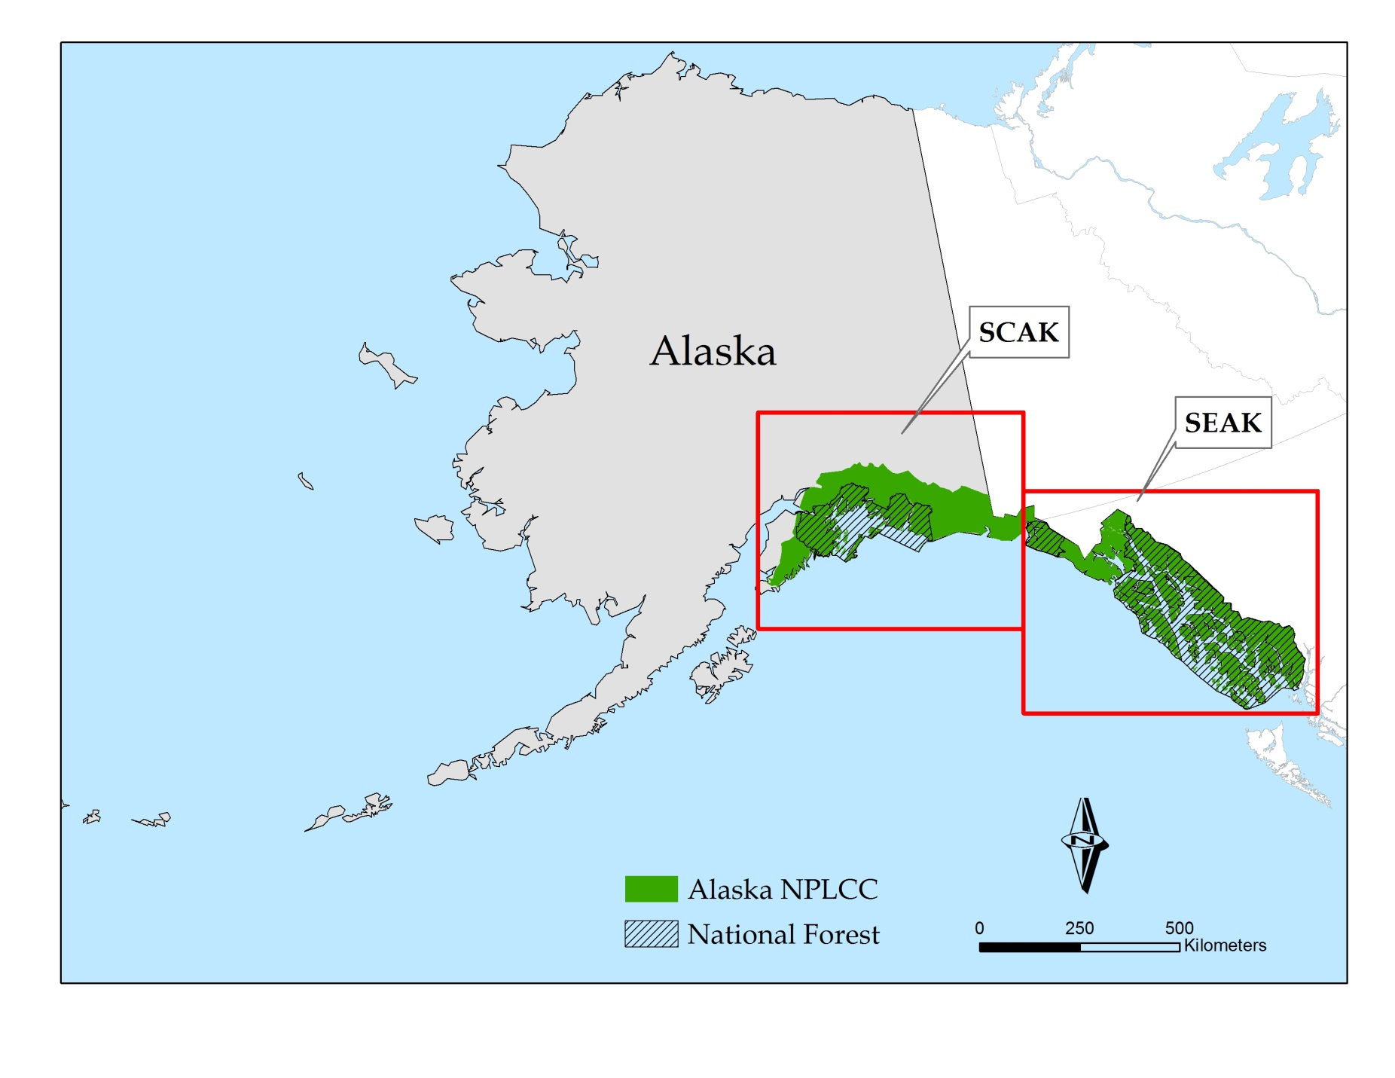

Figure 1. Boundary of Alaska North Pacific Landscape Conservation Cooperative (AK NPLCC) LandCarbon project area. The red boxes define the southeast Alaska (SEAK) and south-central Alaska (SCAK) extents within the AK NPLCC. Cross-hatching shows the location of the Tongass National Forest (TNF) with SEAK and the Chugach National Forest in SCAK.