**C S I T**

**( Continuous System Integration and Testing )**



Contents

**I. Introduction** 4

1.1 description 4

1.2 test execution walk-through 4

**II. Run CSIT** 5

2.1 Topology 5

2.2 download CSIT source 5

2.3 set CSIT environment 5

2.4 start test suite 6

**III. Appendix** 6

3.1. how to install scipy on Centos7.5 6

3.2. RF file format 6

3.3. references 7

***\* Release note \****

|  |  |  |
| --- | --- | --- |
| ***version*** | ***release date*** | ***content*** |
| *v1.0* | *2019-03-\*\** | *first edition* |
|  |  |  |
|  |  |  |
|  |  |  |
|  |  |  |

***\* Release Copyleft©free \****

**I. Introduction**

1.1 description

a. Development of software code for fully automated VPP code testing, functionality, performance, regression and new functions.

b. Execution of CSIT test suites on VPP code running on virtual and physical compute environments.

c. Integration with continuous integration systems.

d. Identified existing project dependencies and interactions.

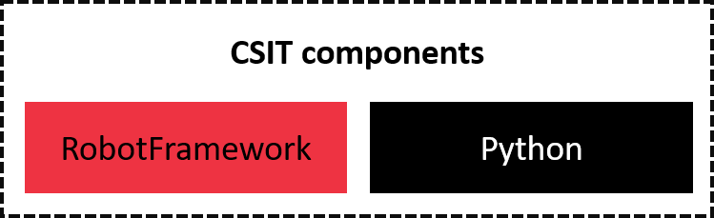

Figure 1 CSIT components

* Robot Framework(RF): a test automation tool that allows to select and run a set of test suites and test cases on selected target topology and provide output logs in a readable and parse-able form. It includes two types of RF files: resource files and test suites. RF provides Python executable pybot that is currently the main entry point to all CSIT tests.
* Python: use to perform tasks or write library for RF.

|  |  |
| --- | --- |
|  | when translate the name of function to RobotFramework formatting. every Python underscore is translated to space in RobotFramework, and case don't matter. |

1.2 test execution walk-through

1. RF looks recursively for files in this directory and naturally it comes to tests/suites/__init__.robot. which acts as initialization file for all suites in given directory.
2. setup framework:

* executed only and exactly once before any test case execution.
* uploads the whole CSIT directory to every ${node}/tmp/openvpp-testing directory
* make sure all dependencies are installed on Nodes
* this last step is done parallel for each topology Node to save up time

1. setup all DUTs:

* executed in most cases before any test case.
* restart VPP instances, make sure VPPs are up, performs common setup
* initialize TG

1. update all interface Data on all nodes:

* downloads VPP interfaces data from each DUT, and stores sw_if_index of interfaces into the topology information file for later use.

**II. Run CSIT**

2.1 Topology



Figure 2 CSIT topology with 2 nodes

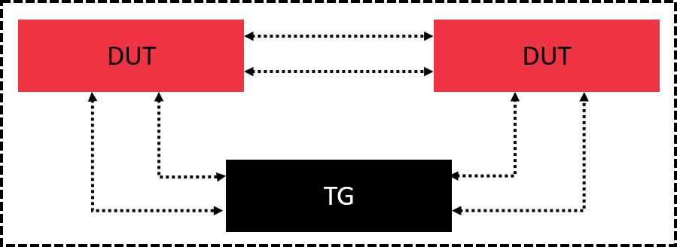

Figure 3 CSIT topology with 3 nodes

* TG : Traffic Generator
* DUT : Device Under Test
* SUT : System Under Test

2.2 download CSIT source

|  |
| --- |
| # git clone https://gerrit.fd.io/r/csit |

2.3 set CSIT environment

|  |
| --- |
| # yum -y install libpcap-devel  # cd $CSIT_ROOT  # virtualenv env  # source env/bin/activate  # pip install -r requirements.txt  //configure CSIT topology with two nodes  # cd topologies/available/ |

2.4 start test suite

|  |
| --- |
| # cd $CSIT_ROOT  # source env/bin/activate  # pybot --version  Robot Framework 2.9.2 (Python 2.7.5 on linux2)  # pybot -L TRACE -v TOPOLOGY_PATH:topologies/available/my_topo.yaml -s ipv4 tests |

**III. Appendix**

3.1. how to install scipy on Centos7.5

|  |
| --- |
| # yum -y install gcc-gfortran python3-devel python2-devel openblas-devel lapack-devel Cython  # wget https://github.com/scipy/scipy/archive/v1.2.1.tar.gz  # tar -zxvf v1.2.1.tar.gz  # cd scipy-1.2.1/  # python setup.py build  # python setup.py install  //https://raspberrypi.stackexchange.com/questions/8308/how-to-install-latest-scipy-version-on-raspberry-pi  //https://www.scipy.org/install.html |

3.2. RF file format

* test suite: Settings and Test Cases section.

|  |
| --- |
| *** Settings ***  | Resource | resources/libraries/robot/default.robot  | Suite Setup | Setup all TGs before traffic script  | Test Setup | Setup all DUTs before test  …  *** Test Cases ***  | Key Word  | | |

* resource file: Settings and Keywords section.

|  |
| --- |
| *** Settings ***  | Resource | resources/libraries/robot/default.robot  | Suite Setup | Setup all TGs before traffic script  | Test Setup | Setup all DUTs before test  …  *** Keywords ***  | Key Word  | | [Documentation] | “Description”  | | [Arguments] | ${arg1} | $(arg2) | … |

3.3. references

[1] [Robot Framework Quick Start Guide](https://github.com/robotframework/QuickStartGuide/blob/master/QuickStart.rst#viewing-results)

[2] [CSIT/Documentation](https://wiki.fd.io/view/CSIT/Documentation#CSIT_Jobs)

[3] [Robot Framework documentation](http://robotframework.org/robotframework/#user-guide)

*NDR:* No Drop Rate

*PPS:* Packets Per Second